Joshua Bilsland

Candidate Number: 6061

Draughts With AI

AQA A-Level Computer Science NEA

Contents

Analysis 5

Overview 5

Aims/Problems to be Solved 5

End Users 5

New Players 5

Experienced Players 6

Examples of Existing Games 6

Needs Determined by Intended Users 9

Questionnaire 10

Objectives 20

Modelling of the Project 25

ERD and Entity Descriptions 25

Class Diagram 26

Window Flow Chart 26

Design 29

Page/Window Navigation 29

Flowcharts 31

Main Menu flowchart 31

Game Area flowchart 33

Account Area flowchart 34

The Game Flowchart 40

Data Storage 42

Database Design 42

Internal Data Storage and Processing 42

Class Diagram 42

Algorithm Design 48

Database Connection/Cursor & SQL queries (Python & MySQL) 48

Diagram Examples 51

1.1 - Old Way of Passing Slots & How Back Button Events Would be Handled (Linked to Pseudocode Examples 1.1 & 1.2) 51

1.2 - New Way of Passing Slots & How Back Button Events Will be Handled (Linked to Pseudocode Examples 1.1 & 1.2) 53

Pseudocode Examples 55

1.1 - Old Way of Handling Values Returned from Page Subroutines (Linked to Diagram Examples 1.1 & 1.2) 55

1.2 - New Way of Handling Values Returned from Page Subroutines (Linked to Diagram Examples 1.1 & 1.2) 56

2 - ‘Man’ Class 57

3 - ‘AccountSlot’ Class 59

4 – Start-MainMenuWindow 62

5 – ‘Button’ Class 64

6 – DisplayMessageWindow 65

7 – ChooseSlotWindow 67

8 – GetUsernameAndPasswordWindow 68

9 – AccountAreaWindow 71

10 – ‘Database’ Class 77

11 - ‘Queue’ Class 81

12 - ‘TreeNode’ Class 82

13 – ChooseGameModeWindow 83

14 – ChooseGameOptionsWindow 85

15 – Constants 89

16 – ‘Board’ Class 90

17 – GameAreaWindow 92

18 – ‘Game’ Class 102

19 – Minimax 110

Technical Solution 116

Other 116

Directory Structure 116

Constants.py 116

Minimax.py 117

Class Files 125

QueueClass.py 125

TreeNodeClass.py 127

AccountSlotClass.py 129

ButtonClass 134

DatabaseClass.py 137

ManClass.py 142

BoardClass.py 145

GameClass.py 154

Window Files 162

Start-MainMenuWindow.py 162

AccountAreaWindow.py 164

ChooseSlotWindow.py 168

GetUsernameAndPasswordWindow.py 169

DisplayMessageWindow.py 171

GameAreaWindow.py 173

ChooseGameModeWindow.py 181

ChooseGameOptions.py 182

Graphical User Interface 186

Testing 187

Testing Evidence 189

Test 1 189

Test 2 190

Test 3 190

Test 4 190

Test 5 191

Test 6 192

Test 7 193

Test 8 194

Test 9 195

Test 10 196

Test 11 197

Test 12 197

Test 13 198

Test 14 198

Test 15 199

Test 16 199

Test 17 200

Test 18 201

Test 19 202

Test 20 203

Test 21 203

Evaluation 203

Evaluation of Success Criteria 203

Potential Improvements to the Program 210

Password Reset/Recovery 210

Show Individual Moves the AI Made in a Turn 211

Hosting the Database Online Not Locally 211

Improve Menu Graphics and Page Animations 211

Full Code 212

Constants.py 212

Minimax.py 213

QueueClass.py 217

TreeNodeClass.py 218

AccountSlotClass.py 219

ButtonClass.py 222

DatabaseClass.py 224

ManClass.py 228

BoardClass.py 230

GameClass.py 237

Start-MainMenuWindow.py 243

AccountAreaWindow.py 245

ChooseSlotWindow.py 248

GetUsernameAndPasswordWindow.py 250

DisplayMessageWindow.py 252

GameAreaWindow.py 253

ChooseGameModeWindow.py 261

ChooseGameOptionsWindow.py 262

# Analysis

## Overview

For my project I will be creating a draughts game that lets you play against an AI opponent or a real player using the same computer. The AI will have different levels of difficulty which the player can choose from when they start a game. The player will have to create an account which will be stored in a database. This account is used to store a player’s wins and losses so they can see how well they are doing and if they are improving. When a player completes a game, their W/L will be updated accordingly.

## Aims/Problems to be Solved

One problem with draughts is that it requires someone else to play against you if you want to practice and improve. You can find draughts games online that have an AI that you can play against but the problem with these is that the majority of them lack features such as choosing different AI difficulty levels. This is a problem because it means that players who are new to draughts might struggle to beat the AI and players who are experienced at playing draughts will be able to win easily. Some of them do allow you to choose different difficulty levels for the AI but they usually lack other features such as having the option to play against a real player or the ability to create an account which can be used to store and display different stats (For example, wins and losses). The aim of my project is to create a draughts game which combines some of these different features together and to allow me to learn how AI works and how I can implement different difficulty levels for it.

## End Users

There are no specific end users for this project as it is meant for anyone who wants to play or practice draughts and there already are similar programs that exist. The fact that my program will allow users to choose different difficulty levels means that it is more open to players of different skill levels and the combining of different features from existing games means that my program will be more of a ‘complete package’ which might be appealing to potential end users since existing games lack features that other games have.

### New Players

New players will like the fact that there are different difficulty levels for the AI because it means that they can start by playing against a relatively easy AI opponent and increase its difficulty level as they improve. They can view their accounts to get an idea of how well they have been doing by viewing statistics like their Win/Loss ratio. The ability to play against other players will be useful as they can have someone talk them through different strategies and learn from other players.

### Experienced Players

Experienced players will like that they can choose different difficulty levels for the AI as they can play against a difficult AI rather than having to play against an AI that is universal/’intended for everyone’ and is quite easy for them to beat. They will also like the ability to play against other players as it will be more competitive to play against other people of a similar skill level. They can then compare their account stats with other people.

## Examples of Existing Games

The first example of an existing game is the website <https://draughts.org/> which is one of the first results if you search for ‘draughts online’ using google. Below is a cropped image of the first part of the game that you are shown.

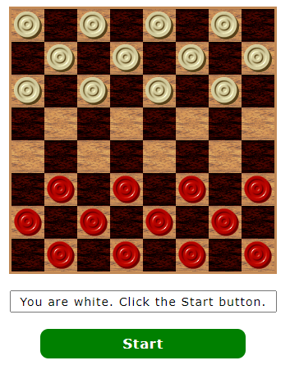

The game doesn’t have any menu system and doesn’t have any section to allow you to create an account. The game also doesn’t let you have the option of selecting a difficulty for the AI or choosing the colour you want to play as and forces you to play as white. The image below shows the next part of the game (what happens once you press start).

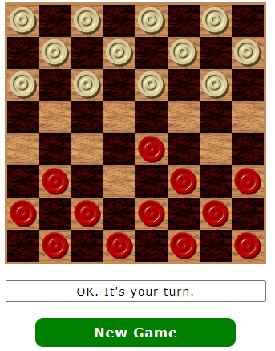

Once you press the start button, the game starts immediately without first letting you choose your colour, choose the AI’s difficulty, etc.

The disadvantage of this game is that it lacks the features already mentioned which makes it not ideal for both new and experienced players since you can’t do things such as select the AI’s difficulty, choose your colour or play with another player (Online or using the same computer).

__________________________________________________________________

The second example of an existing game is the website **TEMP** which is another of the first results on google. The image below is the first thing that is displayed.

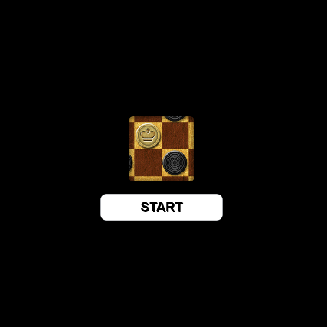

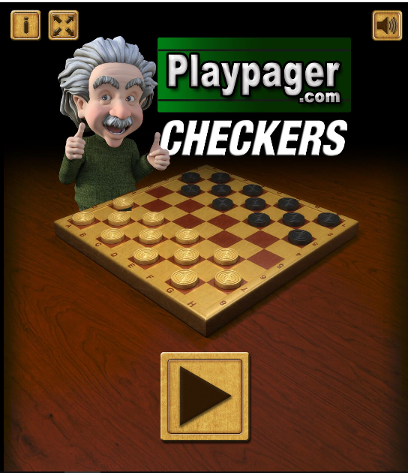

This second image shows the menu that the game displays after clicking to start the game (Image above). Unlike the first game, this game has a menu with a few options on it such as the option to mute the sound or display information about how to play draughts.

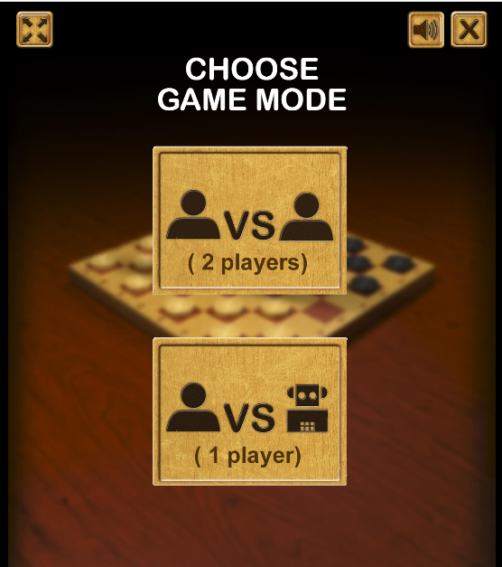

This image shows what is displayed after clicking the ‘play’ button. This game also lets you choose between playing against an AI or a real player. However, the game still doesn’t let you choose which colour you want to play as or what difficulty you want the AI to have.

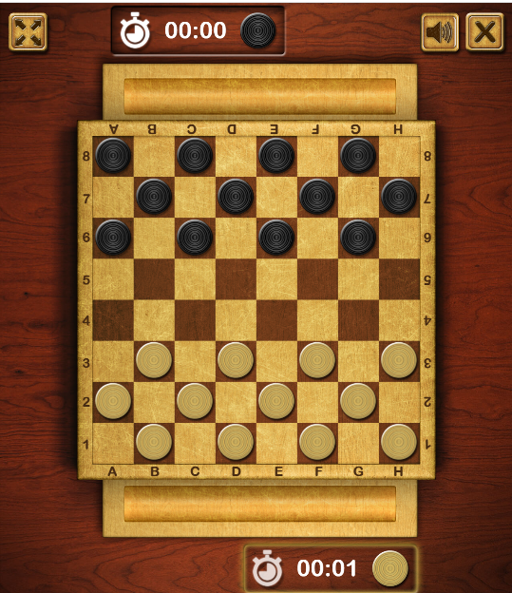

This image shows that once you click to play against an AI, the game is immediately started without giving you any option to choose colour or AI difficulty.

This game is better than the previous example, since it has features such as a menu, playing against another player or an AI, a better-looking UI. Some of the negatives of this game are that it doesn’t have an account feature and you can’t change the AI’s difficulty.

## Needs Determined by Intended Users

One way that I collected information about what features people would like a draughts game to have is by reading reviews that people have written for other draughts games. This helped me learn which things people liked about existing games and what they would like them to add in the future.

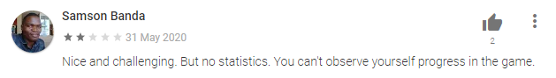This review talks about how there is no way for a player to track their progress. My game will require users to make an account which can then be used to see different information about them. This could be things such as total number of wins, total number of losses, average number of moves to win, etc.

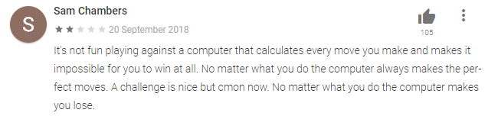This review shows that lots of people were annoyed by the ’static’ difficulty for the AI. This links back to one of the problems of existing draughts games being that if they lack a choice of difficulty, some players will find it too easy, and others will think it's too hard and not be able to play and might stop playing.

## Questionnaire

I have decided to use a questionnaire to do my primary research. My aim with the questionnaire is to find out about problems other people have with existing draughts games and what features they feel are important to them. I have decided to use this method because I can make use of different types of questions. For example, I can use ‘likert’ questions to see how useful or important people find something on a scale. I will use the results of the questionnaire to make an updated version of the initial objectives which includes changes based off of the responses to the questionnaire.

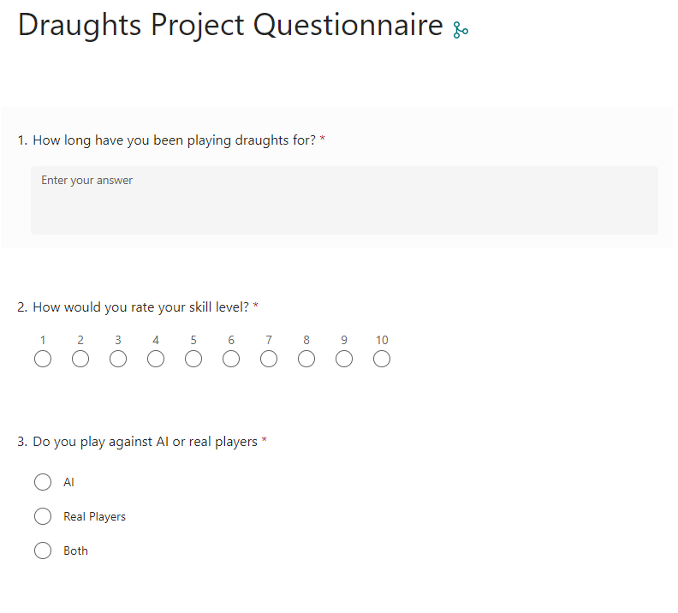

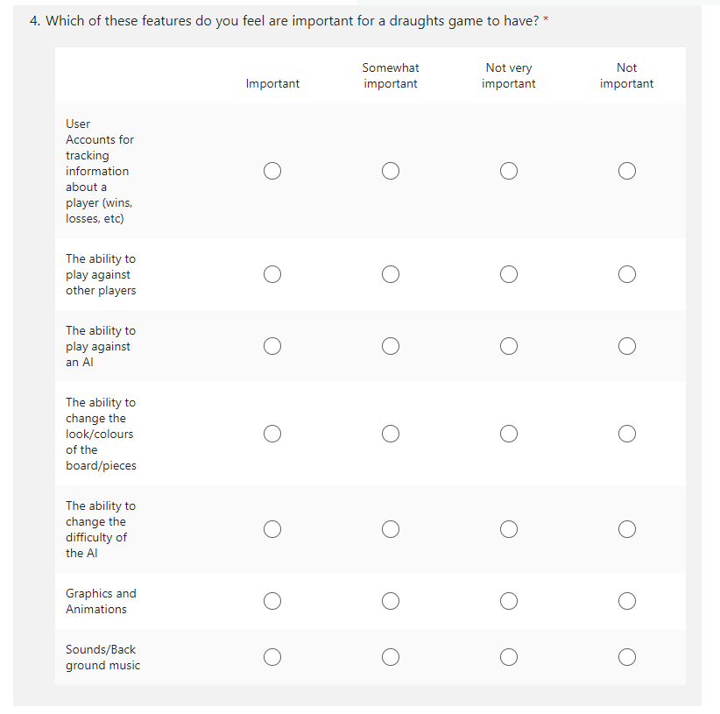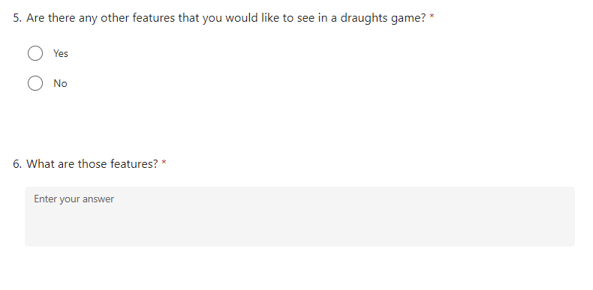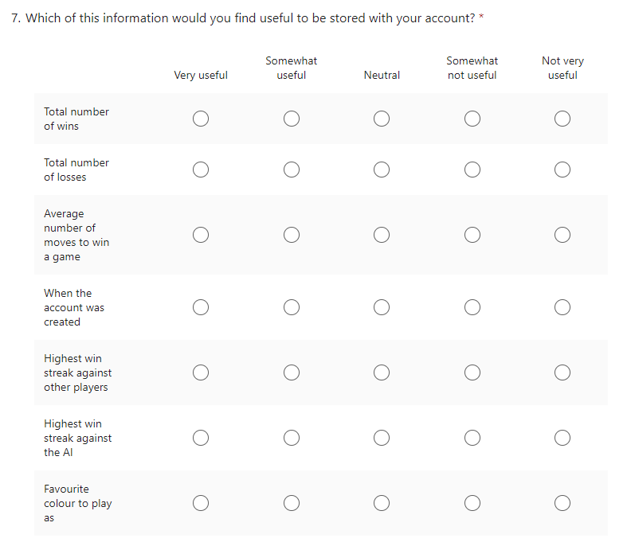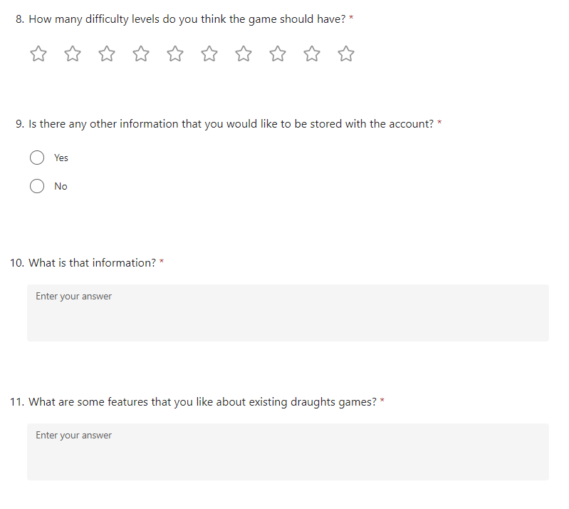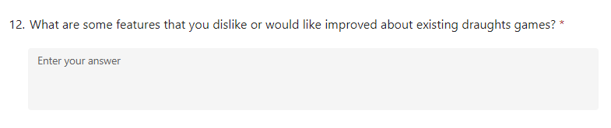

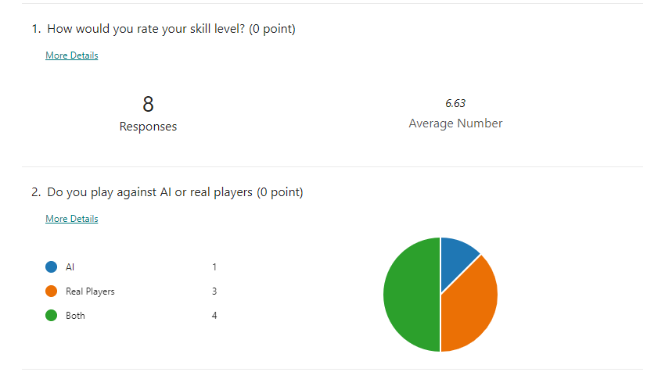

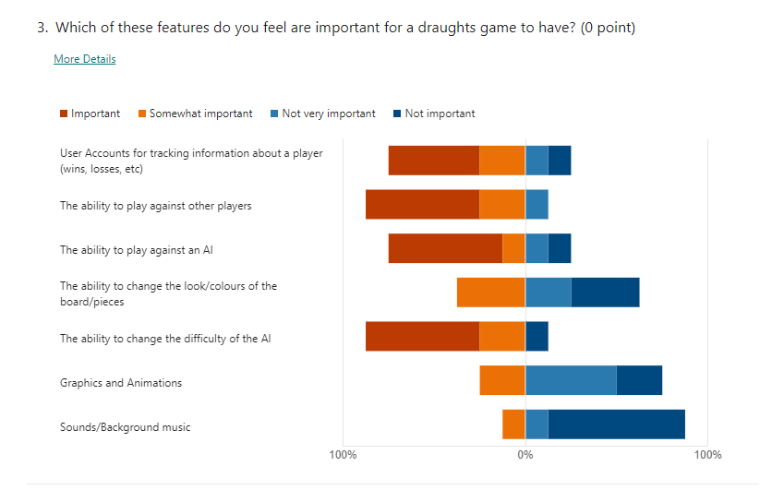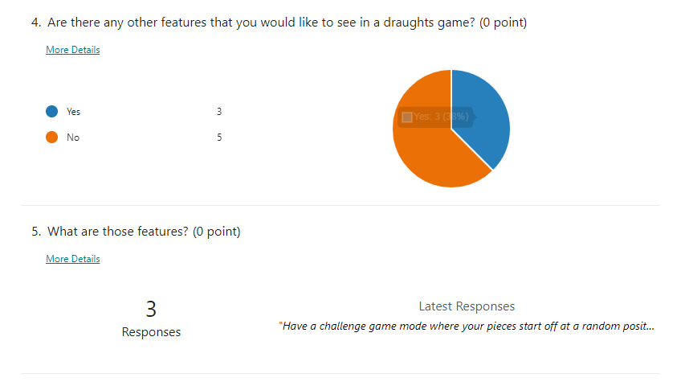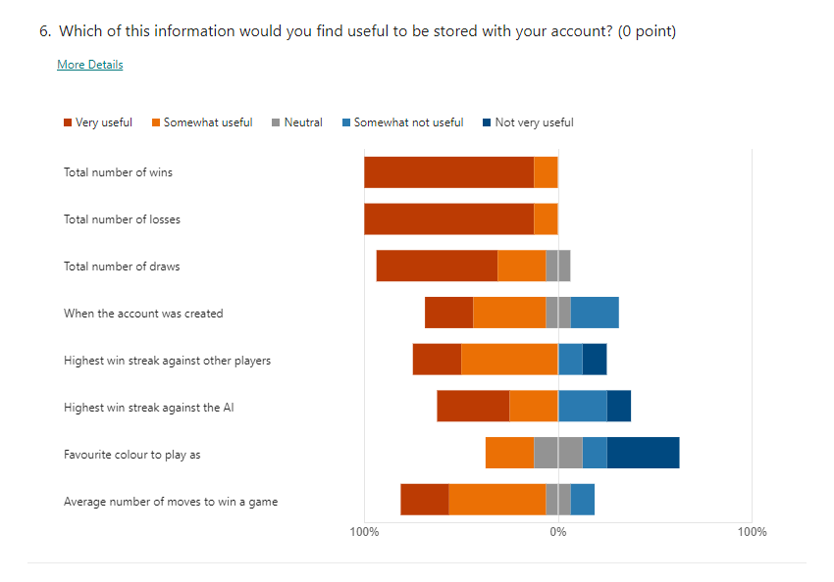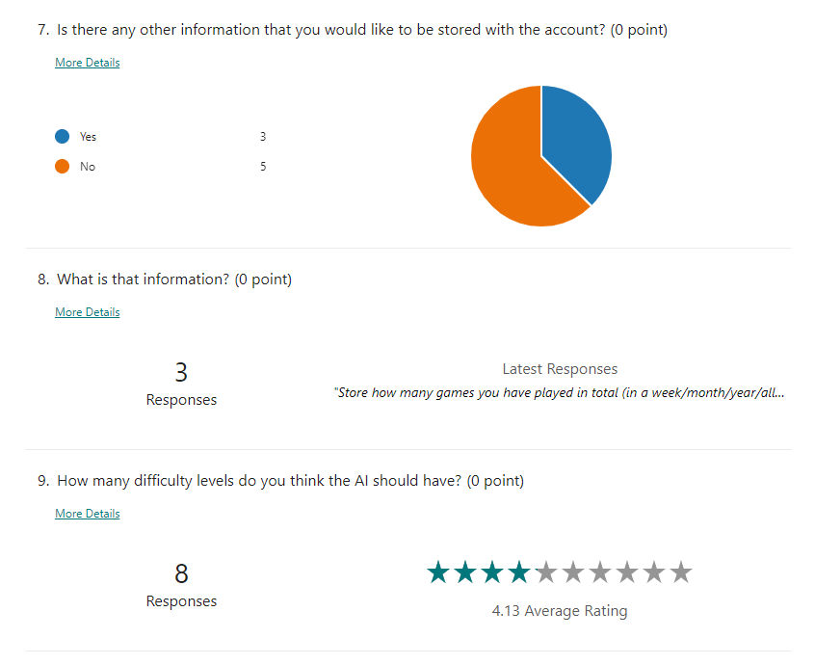

The results of the questionnaire and the reviews I found will be useful for creating my objectives for the program. An example of this is Question 3 which has shown what features people would like a draughts game to have. The ability to play against AI, ability to play against players, the ability to change the difficulty of the AI and the ability to have an account which stores statistics about the players were all very popular. User accounts and AI difficulty were put down as very important by people that said they have a lower skill level at the game which shows that newer/inexperienced players would find them useful for learning and improving. The majority of people said that they do not think sounds/music or graphics/animations were very important so I will not focus on them. However, they could be things that are added later to make the game more appealing to players. Question 6 showed that everyone found the total number of wins, losses and draws to be useful to store if there was an account feature. Many people also said that storing a win streak against players, storing a win streak against AI, when the account was created, and when the average number of moves they make to win a game to be useful things to track. A few people suggested storing information about how many games they have played to be useful.

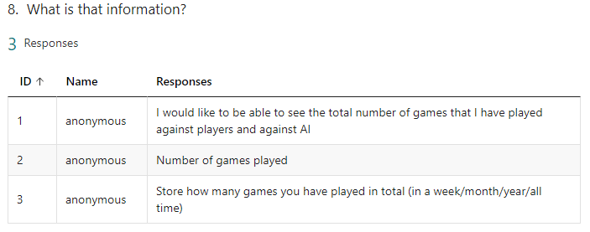

The average of what people said the difficulty of the AI should be was 4. This means that I will make it so that the game has 4 different difficulty levels to choose from. These difficulty levels could be “Easy”, “Average”, “Hard”, “Expert”.

## Objectives

1. When the game is launched, the pygame window should be created, two account slot objects should be created, the database object should be created (database is connected to), and the slot objects updated to store the database object for future use.
2. When connecting to the database, if the tables do not exist in the database then they should be created. There should be a “UserAccount” table which has the columns: AccountID, Username, Password, DateCreated. There should also be a “UserStats” table which has the columns: AccountID, StatsID, TotalNumberOfWinsAgainstAI, TotalNumberOfDrawsAgainstAI, TotalNumberOfLossesAgainstAI, TotalNumberOfGamesPlayedAgainstAI, HighestWinStreakAgainstAI, CurrentWinStreakAgainstAI, AverageNumberOfMovesToWinAgainstAI, AverageNumberOfMovesToWinAgainstAICount, AverageNumberOfMovesToWinAgainstAISum, TotalNumberOfWinsAgainstPlayers, TotalNumberOfDrawsAgainstPlayers, TotalNumberOfLossesAgainstPlayers, TotalNumberOfGamesPlayedAgainstPlayers, HighestWinStreakAgainstPlayers, CurrentWinStreakAgainstPlayers, AverageNumberOfMovesToWinAgainstPlayers, AverageNumberOfMovesToWinAgainstPlayersCount, AverageNumberOfMovesToWinAgainstPlayersSum.
3. The ‘Close’ button of the pygame window should stop the program running throughout the program.
4. **Main Menu** 
   1. When the game is launched, the window should be updated to display the main menu. It should have the options which resemble: ‘Start Game’, ‘Account Area’, and ‘Quit’.
   2. The ‘Start Game’ button should take the user to the game area (should call the game area subroutine which will setup and carry out a game).
   3. The ‘Account Area’ button should take the user to the account area (should call the account area subroutine which will be used to let a user sign in, sign up, etc.
   4. The ‘Quit’ button should be used to quit the program.
5. **Account Area**
   1. The Account Area should display options that resemble: ‘Sign In’, ‘Sign Up’, ‘Sign Out’, and ‘View Account’.
   2. There should be a ‘back’ button which takes the user back to the main menu
   3. **Sign In**
      1. If the user clicks the ‘Sign In’ button, the window should be updated to show a ‘Account Slot One’ button and a ‘Account Slot Two’ button (‘Choose Slot’ window) which will be used to decide which slot the user wants to use/sign in to. It should also display a ‘back’ button which allows the user to return to the previous window (Account Area)
      2. If the slot is in use, an error window should be displayed to tell the user that the slot already has an account signed into it. There should be a ‘back’ button on this window so that the user can go back to the ‘Choose Slot’ window.
      3. If the slot is not in use, the window should be updated to show a username field, password field, ‘submit’, and a ‘back’ button.
      4. When the user submits a username and password, a check should be made to see if an account exists in the database that uses that username and password.
      5. If there is, the account should be signed into the slot (using the account slot objects methods). This will involve retrieving data from the database to the account slot object stores the username, AccountID, a dictionary of all the stats stored, etc.
      6. If there isn’t, an error message window should be displayed. It should have a ‘Back’ button which takes the user back to the page with the username and password field.
   4. **Sign Up**
      1. If the user clicks the ‘Sign Up’ button, the window should be updated to show a username field, password field, ‘submit’, and a ‘back’ button.
      2. When the user submits a username and password, the account should be created in the database (new record required in each table) as long as the username is not already in use.
      3. When the account has been created, then an appropriate message window should be displayed which includes a ‘Menu’ button. The ‘Menu’ button should take the user back to the main menu.
   5. **Sign Out**
      1. If the user clicks the ‘Sign Out’ button, the window should be updated to show a ‘Account Slot One’ button and a ‘Account Slot Two’ button (‘Choose Slot’ window) which will be used to decide which slot the user wants to sign an account out of. It should also display a ‘back’ button which allows the user to return to the previous window (Account Area)
      2. When the user has chosen a slot, the account slot object should be ‘cleared’/the account in that slot should be signed out (using the signOut() method in the account slot class) and the window should be updated to show an appropriate message window which includes a ‘Menu’ button. The ‘Menu’ button should take the user back to the main menu.
   6. **View Account**
      1. If the user clicks the ‘View Account Information’ button, the window should be updated to show the ‘choose slot’ window.
      2. If the user chooses a slot which doesn’t have an account signed into it, an appropriate message window should be displayed which includes a ‘back’ button. The window should tell them that an account is not signed into the chosen slot.
      3. If the user chooses a slot which does have an account signed into it, the stats that are stored about the account (using the dictionary inside the account slot class and the object’s variables) should be displayed to the user.
6. **The Game**
   1. **Setting Up the Game**
      1. After the ‘Start Game’ button is clicked, the window should be updated to show two new buttons. The window should be updated to show a ‘Play against an AI’ button and a ‘Play against a Player’ button.
      2. There should be a ‘Back’ button which takes the user back to the main menu
      3. **Setting Up a Game Against the AI (PvAI)**
         1. If the ‘Play Against an AI’ button is clicked, the window should be updated to show the ‘choose slot’ window which allows the user to choose which slot (and therefore account) they want to use to play against the AI.
         2. If the user chooses a slot that does not have an account signed into it, an appropriate message window should be displayed which includes a ‘back’ button. The message should tell the user they have chosen an empty account slot.
         3. If the user chooses a slot that does have an account signed into it, the window should be updated to show the different game options. The user should be able to choose the colour that they want to play as and the difficulty for the AI (there should be 4 options “Easy”, “Average”, “Hard”, “Expert”.
         4. When the user chooses an option, the option should change appearance to show that it is currently selected (for example, it should be given a red border). If they already had an option of the same type selected, that option should have the ‘selected effect’ removed from it. (For example, if they selected “Easy” for the AI but then click on “Average”, “Easy” should no longer have the red line effect.)
         5. There should be a ‘Start Game’ button that starts the game if the game start conditions have been met (the user has chosen a colour to play as and they have chosen a difficulty for the AI) The game object, board object, etc should be created and the game board displayed to the user. If the conditions are not met, then an error message window should be displayed to tell the user the error.
      4. **Setting Up a Game Against another Player (PvP)**
         1. If the ‘Play against a Player’ button is clicked, a check should be made to make sure that an account in signed into each of the account slots. If one or both the slots does not have an account signed into it/them then an error message window should be displayed. If both the slots do have an account signed into them, the window should be updated to show the game options for setting up a game against the AI (the only option is what colour slot one wants to play as).
         2. When the user chooses an option, the option should change appearance to show that it is currently selected (for example, it should be given a red border). If they already had an option of the same type selected, that option should have the ‘selected effect’ removed from it.
         3. There should be a ‘Start Game’ button that starts the game if the game start conditions have been met (the user has chosen a colour for slot one to play as) The game object, board object, etc should be created and the game board displayed to the user. If the conditions are not met, then an error message window should be displayed to tell the user the error.
   2. **Playing the Game**
      1. If a (human) player clicks on a man/king on the board then that piece should be ‘selected’ this means that its legal moves should be found, and it should have a ring drawn around it to show that it is selected. This should happen unless the man/king is not of the colour whose turn it is or the player has a man/king already selected **that has already made a move this turn (this means that if they select a man which is able to capture two opponent men one after the other (this would be two separate moves within one turn) and they make the first move (capture the first opponent man) they should NOT then be able to select a different man/king and move that. They must complete a ‘path’ of legal moves until the man/king cannot make any more moves this turn (in this case, make the two captures) and which point their turn ends.**
      2. Referring to the ‘path’ concept made in the previous point, when a man/king is selected and its legal moves have been found it should have the next moves of every possible path displayed on the board as smaller circles on the board to show the user where to click to make that move with the selected man/king. When the user clicks on one of these small circles, the move should be made (the man/king moved and the opponents man/king removed from the board if a capture was made) Using the example from the point above, a small circle should be displayed where the player’s man would land after making the first capture. Once they have made this move, another small circle should now be displayed which shows where the player’s man would land after making the second capture.
      3. When a player has completed one of these ‘move paths’ and there are no more legal moves for them to make with the selected man/king this turn, their turn should end. A check should be made to see if the game is over. It should be made the other players turn if the game mode is ‘PvP’ otherwise it should be made the AI’s turn. Once the turn has been changed, a check should be made to see the results of the check to see if the game is over. If the game is over, the game loop should be ended. [see point 6.2.6]
      4. For an AI’s turn, the minimax algorithm should be used to work out the best possible move the AI can make. The algorithm should return a board object that has had those moves applied to it. The game object should overwrite the board object it is currently storing (the board at the beginning of the AI’s move) and replace it with what the minimax algorithm worked out as the best possible board for the AI. This should update the pygame window to show the new board. The AI’s turn should end and like in the previous point, a check should be made to see if the game is over, the turn should be changed back to the slot that is being used to play against the AI, a check should be made to see the results of the check to see if the game is over. If the game is over, the game loop should be ended [see point 6.2.6]
      5. The minimax algorithm should use a different depth depending on the difficulty chosen for the AI. The harder the difficulty, the higher the depth.
      6. When the game loop is ended, the account stats should have their dictionary of account stats as needed. The changes to the dictionaries should then be made to the account stats in the database.
      7. The window should be updated to display who won the game. The window should have a ‘back to menu’ button which when clicked will take the user back to the main menu.

## Modelling of the Project

### ERD and Entity Descriptions

UserAccount(AccountID, Username, Password, DateCreated)

UserStats(

AccountID, StatsID,

TotalNumberOfWinsAgainstAI,

TotalNumberOfDrawsAgainstAI,

TotalNumberOfLossesAgainstAI,

TotalNumberOfGamesPlayedAgainstAI,

HighestWinStreakAgainstAI,

CurrentWinStreakAgainstAI,

AverageNumberOfMovesToWinAgainstAI,

AverageNumberOfMovesToWinAgainstAICount,

AverageNumberOfMovesToWinAgainstAISum,

TotalNumberOfWinsAgainstPlayers,

TotalNumberOfDrawsAgainstPlayers,

TotalNumberOfLossesAgainstPlayers,

TotalNumberOfGamesPlayedAgainstPlayers,

HighestWinStreakAgainstPlayers,

CurrentWinStreakAgainstPlayers,

AverageNumberOfMovesToWinAgainstPlayers

AverageNumberOfMovesToWinAgainstPlayersCount,

AverageNumberOfMovesToWinAgainstPlayersSum,

)

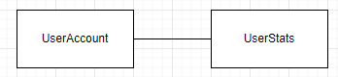

### Class Diagram

This diagram shows my initial ideas for the different classes in the program and the relationship between them.

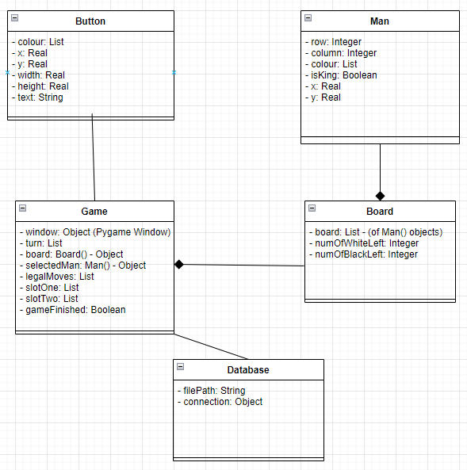

### Window Flow Chart

This diagram shows what actions trigger the window to be changed and what it will be changed to. Most windows will have a go back button which will set the window to the previous window whereas others will jump directly to a set window (For example, go back to the main menu).

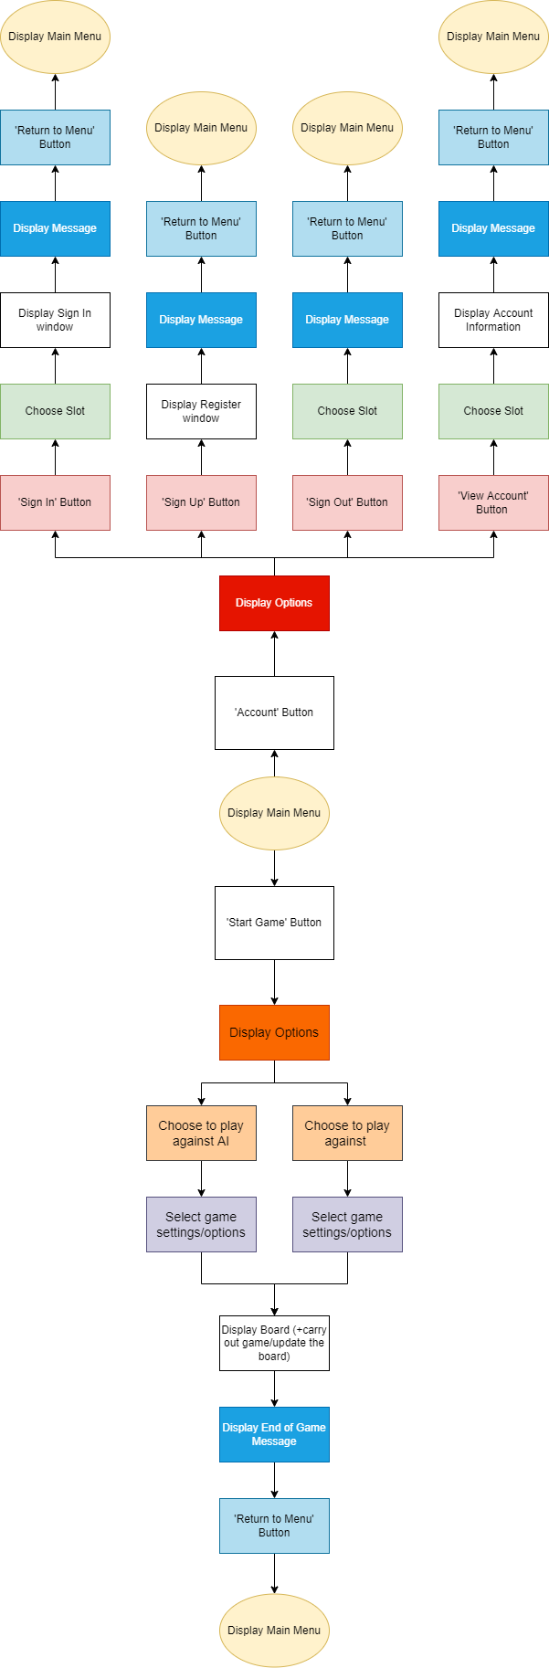

# Design

## Page/Window Navigation

This diagram shows an idea of what pages will be displayed at what points in the program/after what actions by the user. The squares represent windows/pages that will be displayed, the arrows show which way the user will be taken from page to page, the text gives information (mostly explaining each arrow), other shapes are used to give extra information.

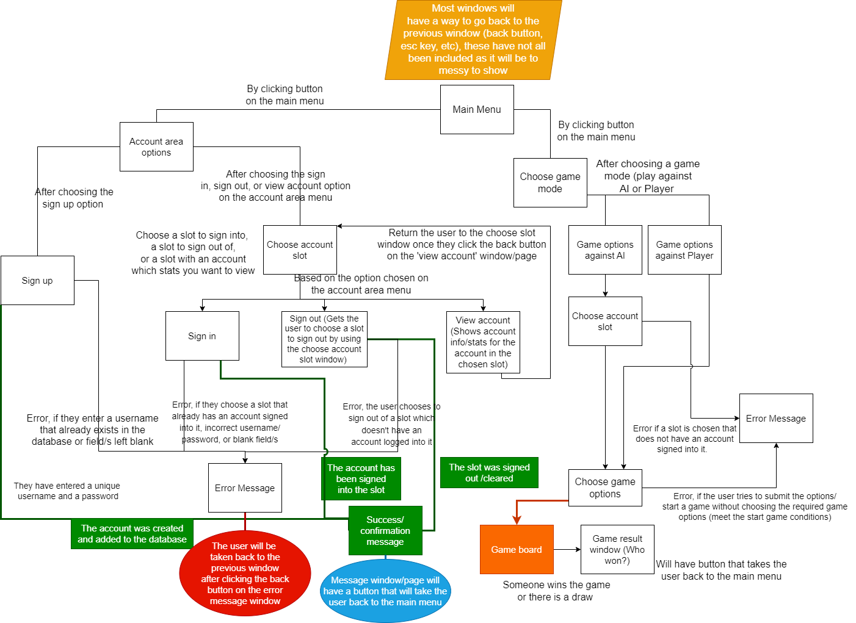

## Flowcharts

### Main Menu flowchart

This flowchart shows what will happen when the program is launched. It will start at the main menu and allow the user to go to other ‘areas’ of the program using the options on the menu. The account area and game area will be individual subroutines that run a pygame event loop similar to the main menu but will display different menus/things to the window.

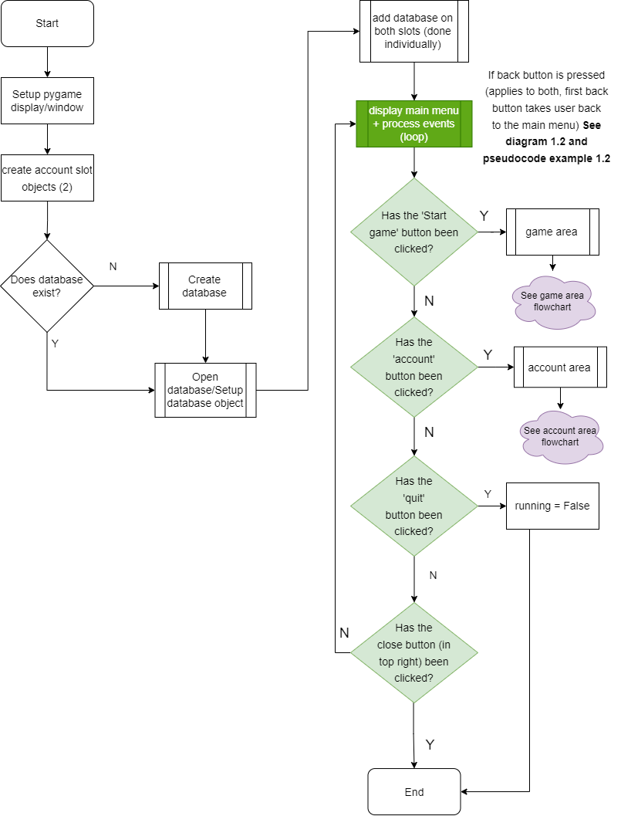

### Game Area flowchart

This flowchart shows the game area which is accessed when the user clicks the ‘Start Game’ button. This area lets the user choose the game mode they want to play and choose the setting to apply to the game (For example, AI difficulty and colour to play as). It will be implemented as a separate subroutine which, like the main menu, uses a pygame event loop to display different things to the window such as buttons and text.

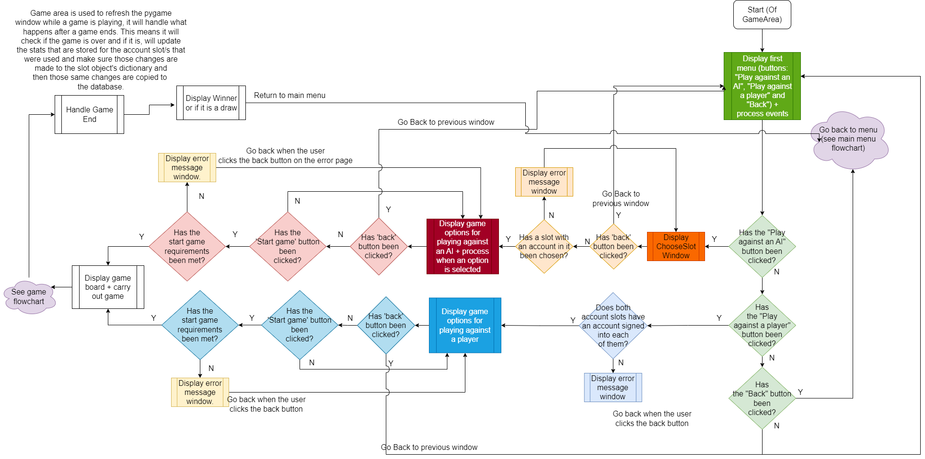

### Account Area flowchart

This flowchart shows the account area which is used to sign in, sign up, sign out, and view information about an account. This area is accessed from the main menu.

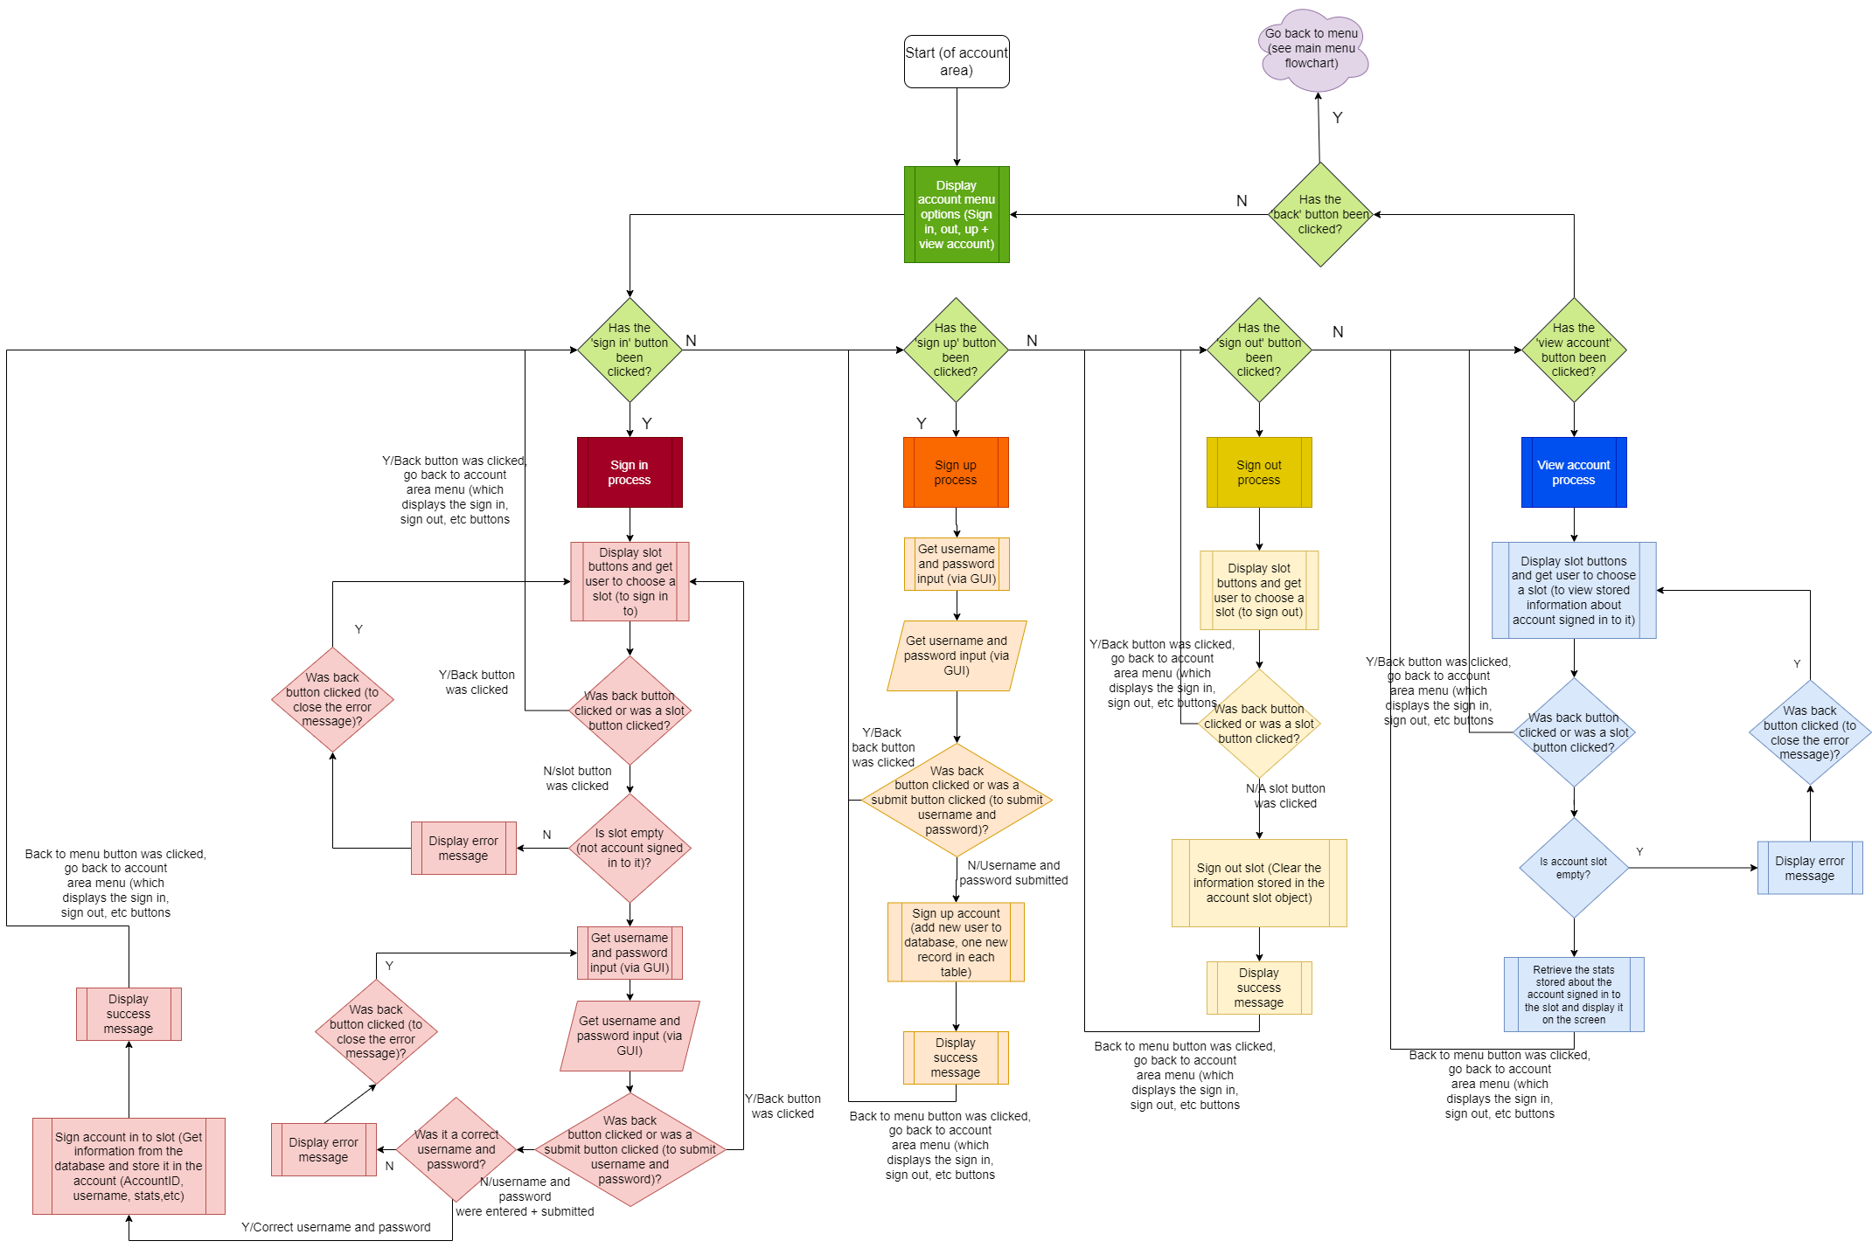**(Below is the above screenshot but broken up to make it easier to read)**

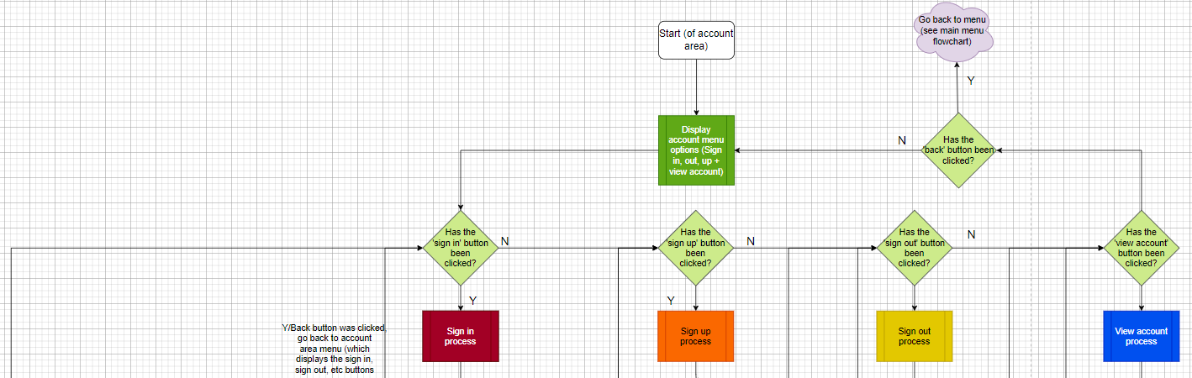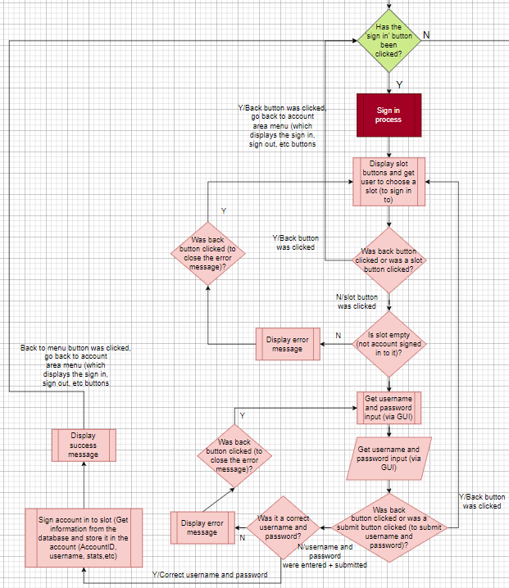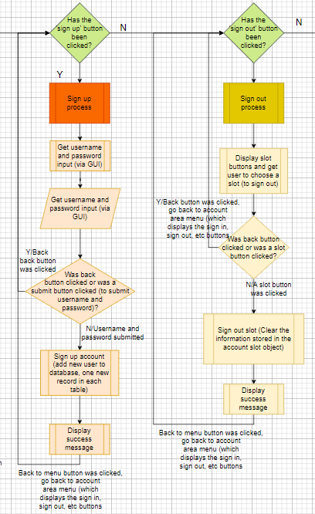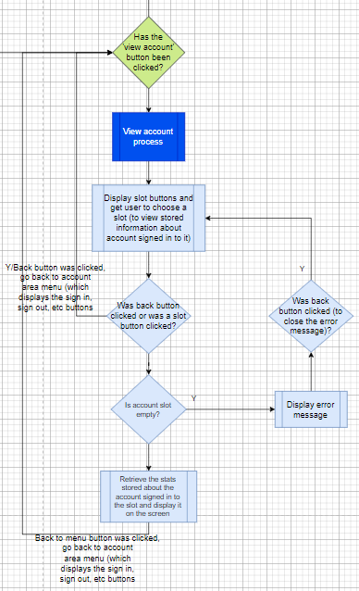

### The Game Flowchart

This flowchart shows a basic idea of how a game loop works which is used to carry out a game.

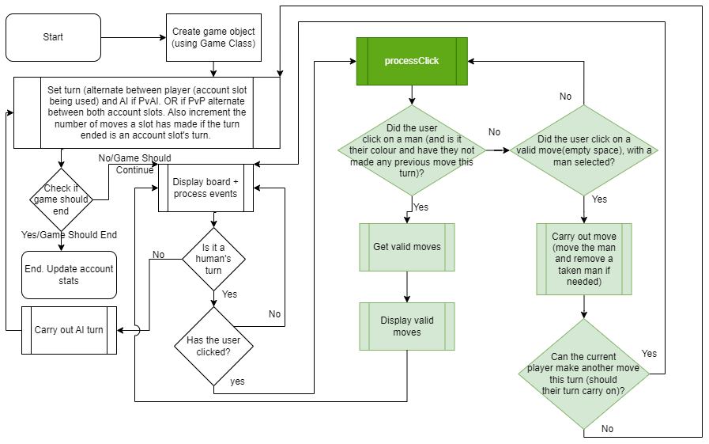

## Data Storage

The game itself will be stored within a folder (which will have other folders inside it, for code and for images) The game will be divided into separate files to break the program down into different areas. For example, there is a file which creates the main menu and handles the events (what to do when a button is clicked, etc), a file which creates the board and makes changes to it, etc. This folder will be stored locally on the user’s computer. The database will also be created and stored on the user’s computer. When the game is launched, a check will be made to see if the database exists. If it doesn’t, the database will be created. Otherwise, it will be connected to and used. A future upgrade to the game would be to store the database remotely so that all users can access the same database rather than having it stored on their computer. This would also mean that all accounts would be stored together, and someone could login to their account from any computer. Other than python (.py), PNGs, and database files (.db/.sqlite), there are no other types of files that are used.

## Database Design

  
This database will have a table which stores the user’s account and another table which stores the user’s stats. The ’UserAccount’ table will store user’s usernames, passwords, and when the account was created. The ’UserStats’ table will store stats about the user. This includes things such as the number of wins against the AI, highest win streak against the AI, total number of games played against other players, etc.

I have decided to use a MySQL database. MySQL allows you to create a database on a server which can be connected to by client devices, to send SQL queries to and receive results from. For this project, the database will be stored locally. However, the code can be modified easily to connect to a remote database if the database was stored on an actual (remote) server instead.

## Internal Data Storage and Processing

### Class Diagram

This diagram is an improved version of the class diagram from the analysis section, which now shows the methods that the classes will have.

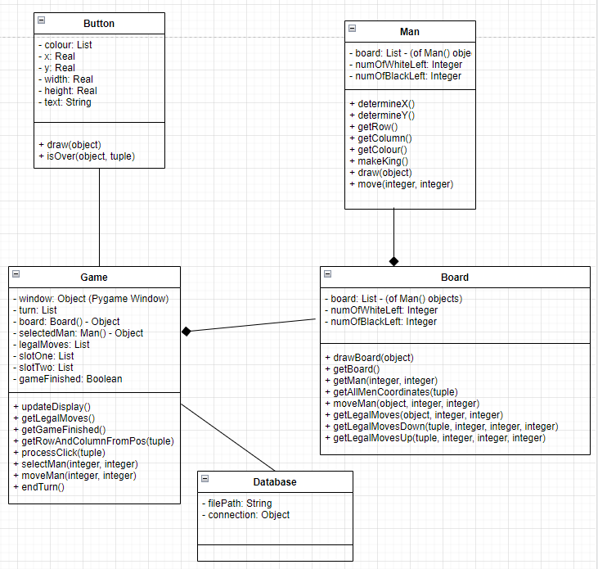

I have further improved this diagram and added a new class “AccountSlot”. I decided it would be better to have the account slots as objects rather than as lists of values. The objects will be passed ‘forward’ as each subroutine is called. This is so that the next subroutine (for example, a page) will have access to the slot objects and can modify them. By making the slots as objects, I will not need to pass the slot variables ‘back’ and update that previous subroutine’s copy of the list of values that each slot variable would store. The objects are separate entities that exist outside of the subroutine and so only need to be passed forward (so that the next subroutine has access to them). This will save time as previously the lists would be returned and the previous copies of them (stored in the previous subroutine) would need to be overwritten with the new copy. Additionally, by using classes/objects, it will clean up the rest of my code since if a subroutine wants to make changes to the object, it must use the object’s methods rather than carry out the change on its own. This will make the code easier to maintain since if you want to change how a method works (such as getting or setting an account stat in the database), you will only need to update the method.

**These changes will mean that the flowcharts will need to be updated as what values are passed around and returned is now different. There is also a new way of seeing if the previous subroutine should continue running (depending on if the “back” button has been clicked or if the “Return to menu” button has been clicked. This old and new handling of the back/back to menu button and the old way of passing the slots around will be shown in pseudocode examples.)**

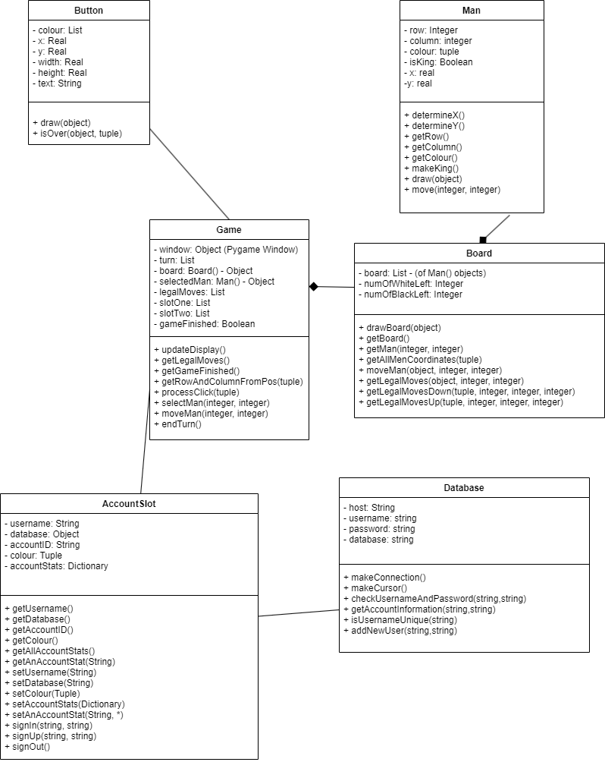

This is my final class diagram. On top of the previous changes, I have added in the methods for the AI, changed some existing ones, and added and removed some of the other methods.

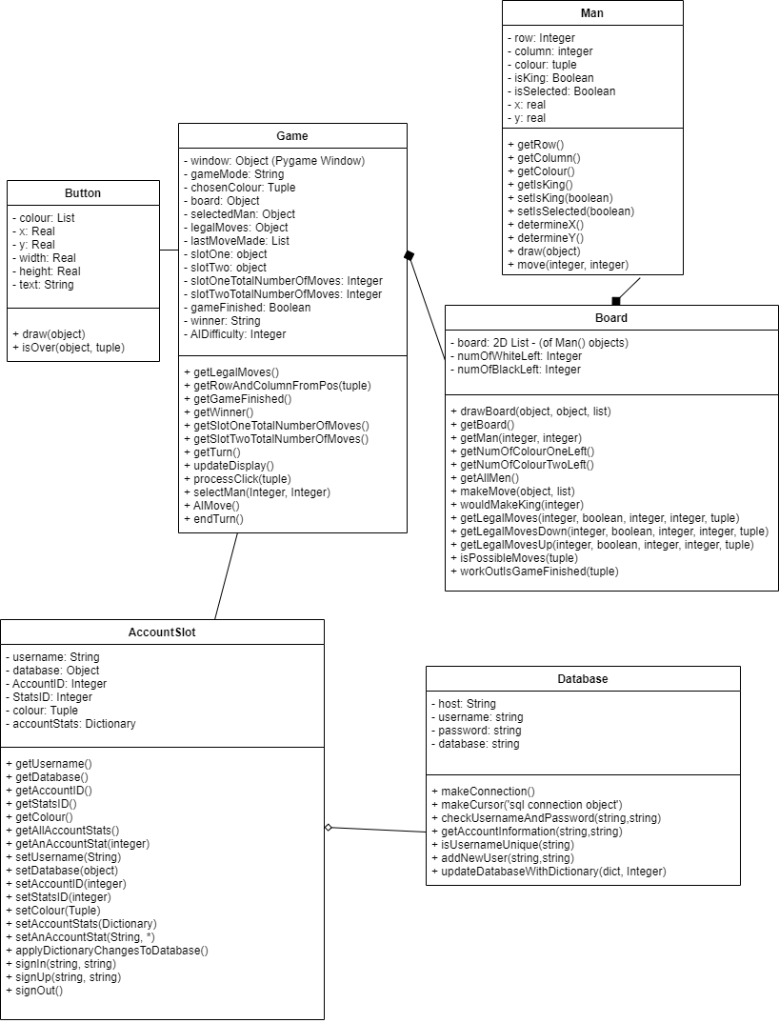

## Algorithm Design

### Database Connection/Cursor & SQL queries (Python & MySQL)

|  |  |
| --- | --- |
| Connecting to the database | databaseConnection = mysql.connector.connect(host=self.__host, user=self.__username, password=self.__password) |
| Create the Cursor | databaseCursor = databaseConnection.cursor() |
| Reconnect to the database (once the database has been created) | databaseConnection = mysql.connector.connect(host=self.__host, user=self.__username, password=self.__password, database=self.__database) |

|  |  |
| --- | --- |
| **Purpose of Query** | **Example SQL Statements** |
| Create database if it doesn’t exist | databaseCursor.execute(“CREATE DATABASE IF NOT EXISTS DraughtsGame”) |
| Create UserStats table if it doesn’t exist | databaseCursor.execute(""" CREATE TABLE IF NOT EXISTS UserStats (  StatsID INT NOT NULL AUTO_INCREMENT,  TotalNumberOfWinsAgainstAI INT UNSIGNED NOT NULL,  TotalNumberOfDrawsAgainstAI INT UNSIGNED NOT NULL,  TotalNumberOfLossesAgainstAI INT UNSIGNED NOT NULL,  TotalNumberOfGamesPlayedAgainstAI INT UNSIGNED NOT NULL,  HighestWinStreakAgainstAI INT UNSIGNED NOT NULL,  CurrentWinStreakAgainstAI INT UNSIGNED NOT NULL,  AverageNumberOfMovesToWinAgainstAI DECIMAL(6,3) NOT NULL,  AverageNumberOfMovesToWinAgainstAICount INT UNSIGNED NOT NULL,  AverageNumberOfMovesToWinAgainstAISum INT UNSIGNED NOT NULL,  TotalNumberOfWinsAgainstPlayers INT UNSIGNED NOT NULL,  TotalNumberOfDrawsAgainstPlayers INT UNSIGNED NOT NULL,  TotalNumberOfLossesAgainstPlayers INT UNSIGNED NOT NULL,  TotalNumberOfGamesPlayedAgainstPlayers INT UNSIGNED NOT NULL,  HighestWinStreakAgainstPlayers INT UNSIGNED NOT NULL,  CurrentWinStreakAgainstPlayers INT UNSIGNED NOT NULL,  AverageNumberOfMovesToWinAgainstPlayers DECIMAL(6,3) NOT NULL,  AverageNumberOfMovesToWinAgainstPlayersCount INT UNSIGNED NOT NULL,  AverageNumberOfMovesToWinAgainstPlayersSum INT UNSIGNED NOT NULL,  PRIMARY KEY (StatsID))  """) |
| Create UserAccount table if it doesn’t exist | databaseCursor.execute("""CREATE TABLE IF NOT EXISTS UserAccount (  AccountID INT NOT NULL AUTO_INCREMENT,  Username varchar(255) NOT NULL,  Password varchar(255) NOT NULL,  DateCreated DATE NOT NULL,  StatsID INT NOT NULL,  PRIMARY KEY (AccountID),  FOREIGN KEY (StatsID) REFERENCES UserStats(StatsID))  """) |
| Check if a username correct username and password have been given | preparedQuery = "SELECT AccountID FROM UserAccount WHERE Username=%s AND Password=%s"  databaseCursor.execute(preparedQuery, (username, hashedPassword.hexdigest())) |
| Get the account information/stats about an account (used to display the stats/information when the user clicks on the ‘View Account’ option on the account area window) | preparedQuery = "SELECT * FROM UserAccount, UserStats WHERE Username=%s AND Password=%s"  accountInformation = databaseCursor.execute(preparedQuery, (username, hashedPassword.hexdigest())) |
| Check if a given username is unique (used when the user tries to sign up a new account) | preparedQuery <- "SELECT * FROM UserAccount WHERE Username=%s"  usernameForPlaceholder <- (username,)  databaseCursor.execute(preparedQuery,usernameForPlaceholder) |
| Create a new account in the database | if self.isUsernameUnique(username):  databaseCursor.execute(""" INSERT INTO UserStats (  TotalNumberOfWinsAgainstAI,  TotalNumberOfDrawsAgainstAI,  TotalNumberOfLossesAgainstAI,  TotalNumberOfGamesPlayedAgainstAI,  HighestWinStreakAgainstAI,  CurrentWinStreakAgainstAI,  AverageNumberOfMovesToWinAgainstAI,  AverageNumberOfMovesToWinAgainstAICount,  AverageNumberOfMovesToWinAgainstAISum,  TotalNumberOfWinsAgainstPlayers,  TotalNumberOfDrawsAgainstPlayers,  TotalNumberOfLossesAgainstPlayers,  TotalNumberOfGamesPlayedAgainstPlayers,  HighestWinStreakAgainstPlayers,  CurrentWinStreakAgainstPlayers,  AverageNumberOfMovesToWinAgainstPlayers,  AverageNumberOfMovesToWinAgainstPlayersCount,  AverageNumberOfMovesToWinAgainstPlayersSum)  VALUES (0,0,0,0,0,0,0,0,0,0,0,0,0,0,0,0,0,0)  """)  databaseConnection.commit()    preparedQuery = "INSERT INTO UserAccount (Username, Password, DateCreated, StatsID) VALUES(%s,%s,NOW(),LAST_INSERT_ID())"  databaseCursor.execute(preparedQuery, (username, hashedPassword.hexdigest()))  databaseConnection.commit() |

## Diagram Examples

### 1.1 - Old Way of Passing Slots & How Back Button Events Would be Handled (Linked to Pseudocode Examples 1.1 & 1.2)

This diagram shows an example of how the old plan would pass the slots around. It also shows how the return values change depending on if the user clicks a regular ‘back’ button (which would take them back to the previous page/end the subroutine and go back to the previous one) or if the clicked a ‘back to menu’ button (which keep going backwards until the menu page is reached/end every subroutine until the menu subroutine is reached). - **Pseudocode examples have also been created to help explain this.**

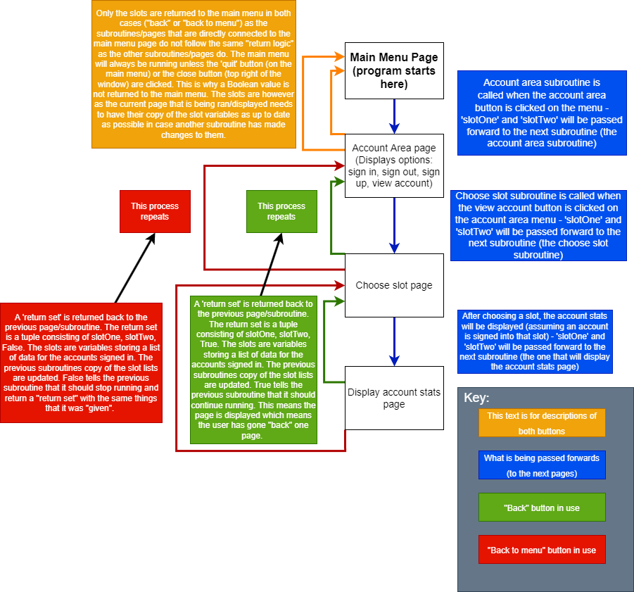

### 1.2 - New Way of Passing Slots & How Back Button Events Will be Handled (Linked to Pseudocode Examples 1.1 & 1.2)

This diagram shows the new plan of how the slots will be passed around and how the different types of back buttons will affect the program/page subroutines. The slots are now objects and not just lists. This means they no longer need to be passed backwards since the changes made to the objects are made to the objects themselves and not local variables that store a list (which need to be passed back so the previous subroutine’s copy of the lists can be updated). Additionally, the objects have their own methods for “getting or setting” the data stored about the slots. This makes the code of the program less messy as it means that the methods can be used rather than copying the same code across the different subroutines (the methods use the code and the subroutines will use the methods rather than making the changes directly themselvs). **- Pseudocode Example 1.2 explains in more detail how this new way will work.**

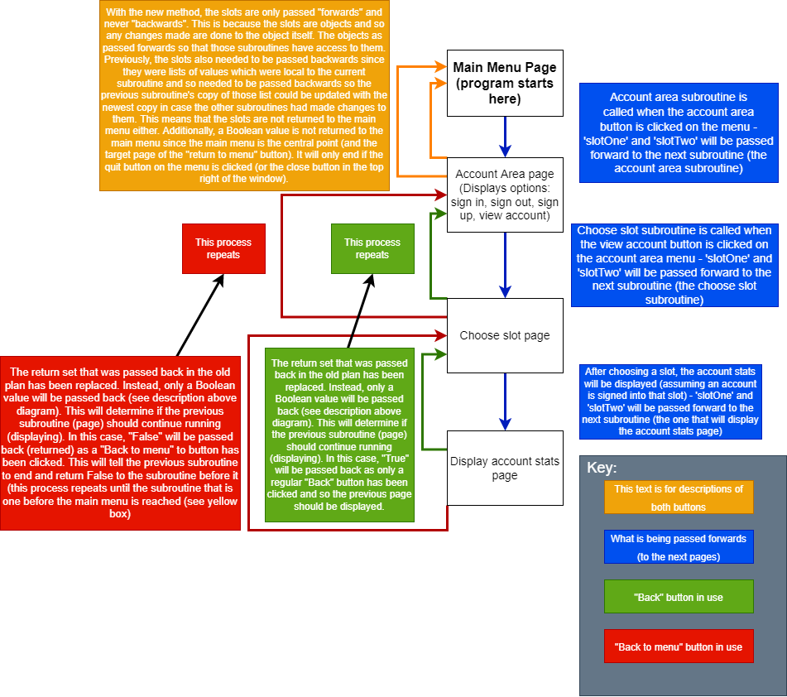

## Pseudocode Examples

### 1.1 - Old Way of Handling Values Returned from Page Subroutines (Linked to Diagram Examples 1.1 & 1.2)

This pseudocode shows the old plan for how a subroutine would pass slots forward and how that same subroutine would handle the values returned. In this version, the slots variables store a list of data from the database (username, total games played, etc). The slots would be passed forwards (given as arguments) and returned backwards. The returned slots would then be used to update the subroutine’s copy of the subroutines in case the subroutines that have had the slots passed forward to them have made changes to them. As well as the slots, a Boolean value is returned to tell the subroutine if it should continue running or not (depending on how the “forward” subroutine ended. A regular back button was pressed, a back to menu button was pressed, etc.). - **Pseudocode Example 1.2 shows the newer plan and explains how and why it is better.**

*This example has been shortened down just to show how the slots and Boolean value are handled*

|  |
| --- |
| SUBROUTINE accountAreaWindow(window, slotOne, slotTwo)  running <- True  while running = True  # Code would be here (not relevant for what this is showing) – things like creating and drawing # the buttons, “flipping” the display, etc  FOR event IN pygame.event.get()  # more event handling would be here. Just one is needed for this example  IF event.type = pygame.MOUSEBUTTONDOWN THEN  mousePos <- pygame.mouse.get_pos()  IF signInButton.isOver(window, mousePos) THEN  returnSet <- signIn(window, slotOne, slotTwo)  slotOne <- returnSet[0] # Update this subroutine’s copy of the slotOne list  slotTwo <- returnSet[1] # Update this subroutine’s copy of the slotTwo list  running <- returnSet[2] # Boolean. Depends on if the user clicked a “back” button  # or a “back to menu” button on the subroutine that was  # ahead (signIn() in this case)- See Diagrams  ENDIF  ENDIF  ENDFOR  ENDWHILE  RETURN slotOne,slotTwo,False  # Return only reached if running = False. False will tell previous subroutine to end (as this one has # been told). If returnSet[2] (running) was True, this page would continue running (this page would # be displayed). |

### 1.2 - New Way of Handling Values Returned from Page Subroutines (Linked to Diagram Examples 1.1 & 1.2)

This pseudocode shows the new plan for how the slots/data from the database will be passed around. Rather than using list stored in variables, the slots are a dictionary of data that is stored as part of an object (objects which are then stored in “slot” variables). Using objects will make the program much more efficient. It will mean that the slots/objects will only need to be passed forward and not backwards since any changes to the data will be made to the object itself and not lists that are local to the current subroutine. This will mean that the slots will not need to be returned backwards. This will mean that you do not need to update the previous subroutines copy of the data/lists. Additionally, using objects will remove lots of repeated code and will be better practice. The objects will have “get and set” methods which will allow the different subroutines to interact with the data without needing to retrieve or make the changes itself. It will just have to use the methods and not worry about how that “get or set” is carried out. - **Pseudocode Example 1.1 shows the older plan.**

*This example has been shortened down just to show how the slots and Boolean value are handled*

|  |
| --- |
| *SUBROUTINE accountAreaWindow(window, slotOne, slotTwo)*  *running <- True*  *while running = True*  *# Code would be here (not relevant for what this is showing) – things like creating and drawing*  *# the buttons, “flipping” the display, etc*  *FOR event IN pygame.event.get()*  *# more event handling would be here. Just one is needed for this example*  *IF event.type = pygame.MOUSEBUTTONDOWN THEN*  *mousePos <- pygame.mouse.get_pos()*  *IF signInButton.isOver(window, mousePos) THEN*  *running <- signIn(window, slotOne, slotTwo)*  *ENDIF*  *ENDIF*  *ENDFOR*  *ENDWHILE*  *RETURN False*  *# Return only reached if running = False. False will tell previous subroutine to end (as this one has # been told from the return from the signIn() subroutine).* |

### 2 - ‘Man’ Class

This pseudocode shows the class variables and methods which will be used in the ‘Man’ class. The man in draughts is the name for the starting piece on the board. When these men get to the other side of the board, they are ‘crowned’ and become kings. Kings are able to move one space in any direction or jump over a piece in any direction (provided that the enemy piece is in the correct space and has a free ‘landing’ space on the other side of it). The Board() object will store a 2D list of Man() objects.

|  |
| --- |
| IMPORT pygame  FROM Constants IMPORT (  SQUARE_SIZE,  CROWN  )  CLASS Man:  SUBROUTINE __init__(self, row, column, colour)  private row <- row  private column <- column  private colour <- colour  private x <- self.determineX()  private y <- self.determineY()  private isKing <- False  Private isSelected <- False  ENDSUBROUTINE  SUBROUTINE getRow(self)  RETURN self.__row  ENDSUBROUTINE  SUBROUTINE getColumn(self)  RETURN self.__column  ENDSUBROUTINE  SUBROUTINE getColour(self)  RETURN self.__colour  ENDSUBROUTINE  SUBROUTINE getIsKing(self)  RETURN self.__isKing  ENDSUBROUTINE  SUBROUTINE setIsSelected(self, boolean)  self.__isSelected <- boolean  ENDSUBROUTINE  SUBROUTINE setIsKing(self, boolean)  self.__isKing <- boolean  ENDSUBROUTINE  SUBROUTINE determineX(self)  RETURN SQUARE_SIZE * self.__column + SQUARE_SIZE / 2  ENDSUBROUTINE  SUBROUTINE determineY(self)  RETURN SQUARE_SIZE * self.__row + SQUARE_SIZE / 2  ENDSUBROUTINE  SUBROUTINE draw(self, window)  radius <- (SQUARE_SIZE/2)-10  IF self.__isSelected == True THEN  Pygame.draw.circle(window, RED, (self.__x, self.__y), (radius+5))  ENDIF  pygame.draw.circle(window, self.__colour, (self.__x, self.__y), radius)  IF self.__isKing == True THEN  window.blit(CROWN, (self.__x – CROWN.get_width()/2, self.__y – CROWN.get_height()/2))  ENDIF  ENDSUBROUTINE  SUBROUTINE move(self, newRow, newColumn)  self.__row <- newRow  self.__column <- newColumn  self.__x <- self.determineX()  self.__y <- self.determineY()  ENDSUBROUTINE |

### 3 - ‘AccountSlot’ Class

This pseudocode is for the ‘AccountSlot’ class. Two AccountSlot objects will be used to store the data about the accounts (which will be retrieved from the database). The user will be able to sign into the slots with an account (that exists in the database) by entering a username and password (and choosing which slot to sign into). If the user wants to play against another player (using the same computer), accounts will need to be signed into both slot objects. If the user only wants to play against an AI, the user will be able to choose which slot to play as (assuming that the chosen slot has an account signed into it). The reason the slots are used is so that a copy of the user's stats can be retrieved from the database and updated as they play games. For example, when the user wins a game against the AI, the dictionary will be updated so that stats such as how many games the user has won against the AI can be incremented by one. When a change is made to the account in the accountSlot, the change is automatically made to that same data in the database (for that account).

|  |
| --- |
| CLASS AccountSlot  SUBROUTINE __init__(self)  private username <- None  private database <- None  private AccountID <- None  private StatsID <- None  private colour <- None  private RECORD accountStats  Date Created : None  Total Number of Wins Against AI : None  Total Number of Draws Against AI : None  Total Number of Losses Against AI : None  Total Number of Games Played Against AI : None  Highest Win Streak Against AI : None  Current Win Streak Against AI : None  Average Number of Moves to Win Against AI : None  Average Number of Moves to Win Against AI Count : None  Average Number of Moves to Win Against AI Sum : None  Total Number of Wins Against Players : None  Total Number of Draws Against Players : None  Total Number of Losses Against Players : None  Total Number of Games Played Against Players : None  Highest Win Streak Against Players : None  Current Win Streak Against Players : None  Average Number of Moves to Win Against Players : None  Average Number of Moves to Win Against Players Count :None  Average Number of Moves to Win Against Players Sum": None  ENDRECORD  ENDSUBROUTINE  SUBROUTINE getUsername(self)  RETURN self.__username  ENDSUBROUTINE  SUBROUTINE getDatabase(self)  RETURN self.__database  ENDSUBROUTINE  SUBROUTINE getAccountID(self)  RETURN self.__AccountID  ENDSUBROUTINE  SUBROUTINE getStatsID(self)  RETURN self.__StatsID  ENDSUBROUTINE  SUBROUTINE getColour(self)  RETURN self.__colour  ENDSUBROUTINE  SUBROUTINE getAllAccountStats(self)  RETURN self.__accountStats  ENDSUBROUTINE  SUBROUTINE getAnAccountStat(self, statKey)  TRY  RETURN self.__accountStats.statKey  EXECEPT KeyError  RETURN None  ENDSUBROUTINE  SUBROUTINE setUsername(self, username)  self.__username <- username  ENDSUBROUTINE  SUBROUTINE setDatabase(self, databaseObject)  self.__database <- databaseObject  ENDSUBROUTINE  SUBROUTINE setAccountID(self, ID)  self.__AccountID <- ID  ENDSUBROUTINE  SUBROUTINE setStatsID(self, ID)  Self.__StatsID <- ID  ENDSUBROUTINE  SUBROUTINE setColour(self, colour)  self.__colour <- colour  ENDSUBROUTINE  SUBROUTINE setAccountStats(self, accountStatsDictionary)  self.__accountStats <- accountStatsDictionary  ENDSUBROUTINE  SUBROUTINE setAnAccountStat(self, key, value)  self.accountStats.key <- value  ENDSUBROUTINE  SUBROUTINE applyDictionaryChangesToDatabase(self)  self.__database.updateDatabaseWithDictionary(self.__accountStats, self.__StatsID)  ENDSUBROUTINE  SUBROTUINE signIn(self,username,password)  checkUsernameAndPassword <- self.__database.checkUsernameAndPasword(username,password)  IF NOT checkUsernameAndPassword THEN  RETURN None  ELSE  accountInformation <- self.__database.getAccountInformation(username,password)  self.setUsername(accountInformation[0][1])  self.setAccountID(accountInformation[0][0])  self.setStatsID(accountInformation[0][4])  self.setAnAccountStat("Date Created", accountInformation[0][3])  self.setAnAccountStat("Total Number of Wins Against AI", accountInformation[0][6])  self.setAnAccountStat("Total Number of Draws Against AI", accountInformation[0][7])  self.setAnAccountStat("Total Number of Losses Against AI", accountInformation[0][8])  self.setAnAccountStat("Total Number of Games Played Against AI", accountInformation[0][9])  self.setAnAccountStat("Highest Win Streak Against AI", accountInformation[0][10])  self.setAnAccountStat("Current Win Streak Against AI", accountInformation[0][11])  self.setAnAccountStat("Average Number of Moves to Win Against AI", accountInformation[0][12])  self.setAnAccountStat("Average Number of Moves to Win Against AI Count", accountInformation[0][13])  self.setAnAccountStat("Average Number of Moves to Win Against AI Sum", accountInformation[0][14])  self.setAnAccountStat("Total Number of Wins Against Players", accountInformation[0][15])  self.setAnAccountStat("Total Number of Draws Against Players", accountInformation[0][16])  self.setAnAccountStat("Total Number of Losses Against Players", accountInformation[0][17])  self.setAnAccountStat("Total Number of Games Played Against Players", accountInformation[0][18])  self.setAnAccountStat("Highest Win Streak Against Players", accountInformation[0][19])  self.setAnAccountStat("Current Win Streak Against Players", accountInformation[0][20])  self.setAnAccountStat("Average Number of Moves to Win Against Players", accountInformation[0][21])  self.setAnAccountStat("Average Number of Moves to Win Against Players Count", accountInformation[0][22])  self.setAnAccountStat("Average Number of Moves to Win Against Players Sum", accountInformation[0][23])  RETURN False  ENDIF  ENDSUBROUTINE  SUBROUTINE signUp(self, username, password)  signedUp <- self.__database.addNewUser(username,password)  IF signedUp == True THEN  RETURN True  ELSE  RETURN False  ENDIF  ENDSUBROUTINE  SUBROUTINE signOut(self)  private username <- None  private AccountID <- None  private StatsID <- None  private colour <- None  private accountStats <- (None,None,…, None) # Make all values for all keys None  ENDSUBROUTINE |

### 4 – Start-MainMenuWindow

This pseudocode shows the code for the main menu file. This file will contain the code that will ‘start the program’ and that subroutine that will display the main menu. This is the file is the file that should be run first. It will set up the program. This involves things such as creating the account slot objects, connecting to the database, creating the database and tables if they do not exist, making the pygame ‘window’, etc. After the setup is done, it will call the mainMenuWindow subroutine which will display the main menu. The main menu is the central point in the program and all the other pages will be reached by initially starting from the main menu.

|  |
| --- |
| IMPORT pygame  IMPORT ButtonClass  IMPORT DatabaseClass  IMPORT GameWindow  IMPORT AccountAreaWindow  IMPORT AccountSlotClass  FROM Constants IMPORT (  WIDTH,  HEIGHT,  REGULAR_BUTTON_WIDTH,  REGULAR_BUTTON_HEIGHT,  REGULAR_BUTTON_X,  REGULAR_BUTTON_Y,  BEIGE,  MENU_BACKGROUND_IMAGE  )  # Set up the window  pygame.init()  window <- pygame.display.set_mode((WIDTH,HEIGHT))  # Display Main Menu and handle events  SUBROUTINE mainMenuWindow(window, slotOne, slotTwo)  running <- True  WHILE running == True  # Draw/Make the main menu  window.blit(MENU_BACKGROUND_IMAGE, (0,0))  mainTitleFont <- pygame.font.SysFont(“britannic”, REAL_TO_INT(WIDTH*0.1))  mainTitle <- mainTitleFont.render(“Draughts With AI”, 1, BEIGE)  window.blit(mainTitle, mainTitle.get_rect(center=(WIDTH*0.5, HEIGHT*0.1)))  startGameButton <- ButtonClass.Button(BEIGE, REGULAR_BUTTON_X, REGULAR_BUTTON_Y+(HEIGHT*0.15),  REGULAR_BUTTON_WIDTH, REGULAR_BUTTON_HEIGHT, “Start Game”)  startGameButton.draw(window)  accountsButton <- ButtonClass.Button(BEIGHT, REGULAR_BUTTON_X, REGULAR_BUTTON_Y+(HEIGHT*0.35),  REGULAR_BUTTON_WIDTH, REGULAR_BUTTON_HEIGHT, “Account Area”)  accountsButton.draw(window)  quitButton <- ButtonClass.Button(BEIGE, REGULAR_BUTTON_X, REGULAR_BUTTON_Y+(HEIGHT*0.55),  REGULAR_BUTTON_WIDTH, REGULAR_BUTTON_HEIGHT, “Quit”)  quitButton.draw(window)  pygame.display.flip()  FOR event IN pygame.event.get()  IF event.type == pygame.QUIT THEN  quit()  ELSE IF event.type == pygame.MOUSEBUTTONDOWN THEN  mousePos <- pygame.mouse.get_pos()  IF startGameButton.isOver(window, mousePos) THEN  GameWindow.gameWindow(window, slotOne, slotTwo)  ELSE IF accountsButton.isOver(window, mousePos) THEN  AccountAreaWindow.accountAreaWindow(window, slotOne, slotTwo)  ELSE IF quitButton.isOver(window, mousePos) THEN  running <- False  ENDIF  ENDIF  ENDWHILE  ENDSUBROUTINE  slotOne <- AccountSlotClass.AccountSlot()  slotTwo <- AccountSlotClass.AccountSlot()  database <- DatabaseClass.Database(“localhost”, “DraughtsGame”, “DgDbPd2!”)  slotOne.setDatabase(database)  slotTwo.setDatabase(database)  mainMenuWindow(slotOne, slotTwo) |

### 5 – ‘Button’ Class

This pseudocode is for the button class. The button class is used to create button objects. The button objects are required for the various menus throughout the game. It will create the buttons and draw them on the ‘window’. It also contains a method which works out if the user has clicked on the button. This is done by working out where the cursor is and if it ‘isOver’ the button.

|  |
| --- |
| IMPORT pygame  FROM Constants IMPORT (  WHITE,  BLACK,  )  CLASS Button  SUBROUTINE __init__(self, colour, x, y, width, height, text)  private colour <- colour  private x <- x  private y <- y  private width <- width  private height <- height  private text <- text  ENDSUBROUTINE  SUBROUTINE draw(self, window)  pygame.draw.rect(window, self.__colour, (self.__x, self.__y, self.__width, self.__height), 0)  IF self.__colour != BLACK and self.__colour != WHITE THEN  pygame.draw.line(window, WHITE, (self.__x, self.__y), (self.__x + self.__width, self.__y),2)  pygame.draw.line(window, WHITE, (self.__x, self.__y), (self.__x, self.__y + self.__height), 2)  pygame.draw.line(window, BLACK, (self.__x, self.__y + self.__height), (self.__x + self.__width, self.__y + self.__height), 2)  pygame.draw.line(window, BLACK, (self.__x + self.__width, self.__y), (self.__x + self.__width, self.__y + self.__height), 2)  ENDIF  IF self.__text != “Back” or self.__text == “Back to Menu” THEN  font <- pygame.font.SysFont(“britannic”, REAL_TO_INT(self.__width*0.15))  text <- font.render(self.__text, True, BLACK)  window.blit(text, (self.__x + (self.__width/2 - text.get_width()/2), self.__y + (self.__height/2 - text.get_height()/2)))  ELSE IF self.__text != “” THEN  font <- pygame.font.SysFont(“britannic”, REAL_TO_INT(self.__width*0.1))  text <- font.render(self.__text, True, BLACK)  window.blit(text, (self.__x + (self.__width/2 - text.get_width()/2), self.__y + (self.__height/2 - text.get_height()/2)))  ENDIF  ENDSUBROUTINE  SUBROUTINE isOver(self, window, mousePos)  IF mousePos[0] > self.__x and mousePos[0] < self.__x + self.__width THEN  IF mousePos[1] > self.__y and mousePos[1] < self.__y + self.__height THEN  RETURN True  ENDIF  RETURN False  ENDIF  ENDSUBROUTINE  SUBROUTINE drawSelectedLines(self,window,colour)  pygame.draw.line(window, colour, (self.__x, self.__y), (self.__x + self.__width, self.__y),2)  pygame.draw.line(window, colour, (self.__x, self.__y), (self.__x, self.__y + self.__height), 2)  pygame.draw.line(window, colour, (self.__x, self.__y + self.__height), (self.__x + self.__width, self.__y + self.__height), 2)  pygame.draw.line(window, colour, (self.__x + self.__width, self.__y), (self.__x + self.__width, self.__y + self.__height), 2)  ENDSUBROUTINE |

### 6 – DisplayMessageWindow

This pseudocode is for the subroutine which will display a message window to the user. This window will have many uses such as displaying an error or success message, displaying who has won a game, etc. For example, when the user successfully signs into an account, a message window will be displayed which tells the user that they have signed in successfully. The message window can have a regular ‘back’ button or a ‘back to menu’ button or it can have both.

|  |
| --- |
| IMPORT pygame  IMPORT ButtonClass  FROM Constants IMPORT (  WIDTH,  HEIGHT,  BACK_BUTTON_WIDTH,  BACK_BUTTON_HEIGHT,  BACK_BUTTON_X,  BACK_BUTTON_Y,  BEIGE,  MENU_BACKGROUND_IMAGE,  )  SUBROUTINE displayMessage(window, enableBackButton, enableBackToMenuButton, text)  running <- True  WHILE running == True  window.blit(MENU_BACKGROUND_IMAGE, (0,0))  messageFont <- pygame.font.SysFont(“britannic”, REAL_TO_INT(WIDTH*0.04))  message <- messageFont.render(text, 1, BEIGE)  window.blit(message, message.get_rect(center=WIDTH*0.5, HEIGHT*0.5)))  IF enableBackButton == True THEN  backButton<-ButtonClass.Button(BEIGE,BACK_BUTTON_X,BACK_BUTTON_Y,BACK_BUTTON_WIDTH,BACK_BUTTON_HEIGHT, “Back”)  backButton.draw(window)  ENDIF  IF enableBackToMenuButton == True AND enableBackButton == False THEN  backToMenuButton <- ButtonClass.Button(BEIGE, BACK_BUTTON_X, BACK_BUTTON_Y, BACK_BUTTON_WIDTH,  BACK_BUTTON_HEIGHT, "Back to Menu")  backToMenuButton.draw(window)  ENDIF  IF enableBackToMenuButton == True AND enableBackButton == True THEN  backToMenuButton <- ButtonClass.Button(BEIGE,(WIDTH – BACK_BUTTON_X – BACK_BUTTON_WIDTH), BACK_BUTTON_Y,  BACK_BUTTON_WIDTH, BACK_BUTTON_HEIGHT, “Back to Menu”)  backToMenuButton.draw(window)  ENDIF  pygame.display.flip()  FOR event IN pygame.event.get()  IF event.type == pygame.QUIT THEN  quit()  ELSE IF event.type == pygame.MOUSEBUTTONDOWN THEN  mousePos <- pygame.mouse.get_pos()  IF enableBackButton == True THEN  IF backButton.isOver(window, mousePos) THEN  RETURN True  ENDIF  ENDIF  IF enableBackToMenuButton == True THEN  IF backToMenuButton.isOver(window, mousePos) THEN  RETURN False  ENDIF  ENDIF  ENDIF  ENDFOR  ENDWHILE  ENDSUBROUTINE |

### 7 – ChooseSlotWindow

This pseudocode is for the subroutine which will display two buttons labelled “Slot One” and Slot Two”. The user will be able to select the account slot that they want to use. This subroutine will be used in many places throughout the program. For example, some subroutines (such as signIn, signOut, viewAccount) require the user to choose which slot (An account should be signed into a slot) they want to apply the subroutine to. For example, when the user wants to view stats about an account, they will be making use of the viewAccount subroutine which will get them to choose the slot (which should have an account signed into it, otherwise they will get an error message for choosing an empty slot) and then display the stats stored about the account in that slot currently.

|  |
| --- |
| IMPORT pygame  IMPORT ButtonClass  FROM Constants IMPORT (  WIDTH,  HEIGHT,  REGULAR_BUTTON_WIDTH,  REGULAR_BUTTON_HEIGHT,  REGULAR_BUTTON_X,  REGULAR_BUTTON_Y,  BACK_BUTTON_WIDTH,  BACK_BUTTON_HEIGHT,  BACK_BUTTON_X,  BACK_BUTTON_Y,  BEIGE,  MENU_BACKGROUND_IMAGE  )  SUBROUTINE chooseSlot(window, slotOne, slotTwo)  running <- True  WHILE running == True  window.blit(MENU_BACKGROUND_IMAGE, (0,0))  slotOneButton <- ButtonClass.Button(BEIGE, REGULAR_BUTTON_X-(HEIGHT*0.25), REGULAR_BUTTON_Y+(HEIGHT*0.3),  REGULAR_BUTTON_WIDTH, REGULAR_BUTTON_HEIGHT, "Slot One")  slotOneButton.draw(window)  slotTwoButton <- ButtonClass.Button(BEIGE, REGULAR_BUTTON_X+(HEIGHT*0.25), REGULAR_BUTTON_Y+(HEIGHT*0.3),  REGULAR_BUTTON_WIDTH, REGULAR_BUTTON_HEIGHT, "Slot Two")  slotTwoButton.draw(window)  backButton <- ButtonClass.Button(BEIGE, BACK_BUTTON_X, BACK_BUTTON_Y, BACK_BUTTON_WIDTH,  BACK_BUTTON_HEIGHT, "Back")  backButton.draw(window)  pygame.display.flip()  FOR event in pygame.event.get()  IF event.type == pygame.QUIT THEN  quit()  ELSE IF event.type == pygame.MOUSEBUTTONDOWN  mousePos <- pygame.mouse.get_pos()  IF slotOneButton.isOver(window, mousePos) THEN  RETURN slotOne  ELSE IF slotTwoButton.isOver(window, mousePos) THEN  RETURN slotTwo  ELSE IF backButton.isOver(window, mousePos) THEN  RETURN True  ENDIF  ENDIF  ENDFOR  ENDWHILE  ENDSUBROUTINE |

### 8 – GetUsernameAndPasswordWindow

This pseudocode is for the subroutine which will display a page which is used to allow the user to enter a username and password. This subroutine is used for signing an account into an account slot (by getting the user to enter a correct and username and password for an account in the database) and for getting the user to enter a username and password if they are trying to create a new account (sign up). It displays two text input boxes/bars which can be clicked on to start entering text onto. It will have a button that says “sign in” or “sign up” depending on how the subroutine is being used. When this button is clicked, the username and password that the user has entered will be returned. It also has a back button which can be used to return to the previous window.

|  |
| --- |
| IMPORT pygame  IMPORT ButtonClass  FROM Constants IMPORT (  MENU_BACKGROUND_IMAGE,  WIDTH,  HEIGHT,  WHITE,  BLACK,  BEIGE,  REGULAR_BUTTON_HEIGHT,  REGULAR_BUTTON_WIDTH,  REGULAR_BUTTON_X,  REGULAR_BUTTON_Y,  BACK_BUTTON_HEIGHT,  BACK_BUTTON_WIDTH,  BACK_BUTTON_X,  BACK_BUTTON_Y  )  SUBROUTINE getUsernameAndPassword(window, textForButton, slotOne, slotTwo)  running <- True  inputFont <- pygame.font.SysFont(“britannic”, 20)  # Text is only entered into a field/box if it is selected  usernameInputSelected <- False  passwordInputSelected <- False  #Create the rect objects which text is ‘entered into’ (displayed on)  usernameInputBox <- pygame.Rect(WIDTH*0.125, HEIGHT*0.2, WIDTH*0.75, 40)  passwordInputBox <- pygame.Rect(WIDTH*0.125, HEIGHT*0.5, WIDTH*0.75, 40)  # Strings for storing user input  usernameInputString <- “”  passwordInputString <- “”  passwordInputStringHidden <- “”  # Allow keys/backspace to be held down  pygame.keys.set_repeat(250,150)  WHILE running == True  Window.blit(MENU_BACKGROUND_IMAGE,(0,0))  # Generate hidden version of password  passwordInputStringHidden = “”  FOR char IN passwordInputString  passwordInputStringHidden += “*”  ENDFOR  # Draw buttons  mainButton <- ButtonClass.Button(BEIGE, REGULAR_BUTTON_X, REGULAR_BUTTON_Y+(HEIGHT*0.55), REGULAR_BUTTON_WIDTH,  REGULAR_BUTTON_HEIGHT*0.75, textForButton)  mainButton.draw(window)  backButton <- ButtonClass.Button(BEIGE, BACK_BUTTON_X, BACK_BUTTON_Y, BACK_BUTTON_WIDTH, BACK_BUTTON_HEIGHT, “Back”)  backButton.draw(window)  # Draw username and password headings  headingFont <- pygame.font.SysFont(“britannic”, int(WIDTH*0.08))  usernameHeading <- headingFont.render(“Username”,1,BEIGE)  passwordHeading <- headingFont.render(“Password”,1,BEIGE)  window.blit(usernameHeading, usernameHeading.get_rect(center=(WIDTH*0.5, HEIGHT*0.1)))  window.blit(passwordHeading, passwordHeading.get_rect(center=(WIDTH*0.5, HEIGHT*0.4)))  # Draw the text input boxes  pygame.draw.rect(window, WHITE, usernameInputBox)  pygame.draw.rect(window, WHITE, passwordInputBox)  # Create text surface objects  usernameInput <- inputFont.render(usernameInputString, True, BLACK)  passwordInput <- inputFont.render(passwordInputStringHidden, True, BLACK)  # Draw the text onto the boxes/fields (+5 & +10 used to better position the text inside the input boxes  window.blit(usernameInput, (usernameInputBox.x + 5, usernameInputBox.y + 10))  window.blit(passwordInput, (passwordInputBox.x + 5, passwordInputBox.y + 10))  pygame.display.flip()  # Event handling  FOR event IN pygame.event.get()  IF event.type == pygame.QUIT THEN  quit() # End program if close button (top right) is clicked  # Check if the user clicked on an input box - select it so they can enter text into it  ELSE IF event.type == pygame.MOUSEBUTTONDOWN THEN  mousePos <- pygame.mouse.get_pos()  IF mainButton.isOver(window, mousePos) THEN # submit text user has entered  RETURN usernameInputString, passwordInputString  ELSE IF backButton.isOver(window, mousePos) THEN  RETURN True  ELSE IF usernameInputBox.collidepoint(mousePos) THEN  usernameInputSelected <- True  passwordInputSelected <- False  ELSE IF passwordInputBox.collidepoint(mousePos) THEN  passwordInputSelected <- True  usernameInputSelected <- False  ELSE  usernameInputSelected, passwordInputSelected <- False, False  ENDIF  ELSE IF event.type == pygame.KEYDOWN THEN # add text to input strings  IF USERNAMEInputSelected == True THEN  IF event.key == pygame.K_BACKSPACE THEN  usernameInputString <- usernameInputString[:-1]  ELSE IF usernameInputString.get_width() < (usernameInputString.width-30) THEN  usernameInputString += event.unicode  ENDIF  ELSE IF passwordInputSelected == True THEN  IF event.key == pygame.K_BACKSPACE THEN  passwordInputString <- passwordInputString[:-1]  ELSE IF passwordInput.get_width() < (passwordInputBox.width-10) THEN  passwordInputString += event.unicode  ENDIF  ENDIF  ENDIF  ENDFOR  ENDWHILE  ENDSUBROUTINE |

### 9 – AccountAreaWindow

This pseudocode is for the account area subroutine and the subroutines that will be stored in the same file (and used by the main accountAreaWindow subroutine). The accountAreaWindow subroutine is used to display a menu of options related to the account/database side of the game. It will have the options ‘sign in’, ‘sign out’, ‘sign up’, and ‘view account’. This file will also have subroutines (one for each of the menu options) which are used to perform the action chosen by the user (by clicking an option on the menu).

|  |
| --- |
| IMPORT pygame  IMPORT ButtonClass  IMPORT ChooseSlotWindow  IMPORT GetUsernameAndPasswordWindow  IMPORT DisplayMessageWindow  FROM Constants IMPORT (  WIDTH,  HEIGHT,  REGULAR_BUTTON_WIDTH,  REGULAR_BUTTON_HEIGHT,  REGULAR_BUTTON_X,  REGULAR_BUTTON_Y,  BACK_BUTTON_WIDTH,  BACK_BUTTON_HEIGHT,  BACK_BUTTON_X,  BACK_BUTTON_Y.  BEIGE,  MENU_BACKGROUND_IMAGE  )  SUBROUTINE accountAreaWindow(window, slotOne, slotTwo)  running <- True  WHILE running == True  Window.blit(MENU_BACKGROUND_IMAGE, (0,0))  signInButton <- ButtonClass.Button(BEIGE, REGULAR_BUTTON_X, REGULAR_BUTTON_Y, REGULAR_BUTTON_WIDTH,  REGULAR_BUTTON_HEIGHT, "Sign In")  signInButton.draw(window)  signUpButton <- ButtonClass.Button(BEIGE, REGULAR_BUTTON_X, REGULAR_BUTTON_Y+(HEIGHT*0.2), REGULAR_BUTTON_WIDTH,  REGULAR_BUTTON_HEIGHT, "Sign Up")  signUpButton.draw(window)  signOutButton <- ButtonClass.Button(BEIGE, REGULAR_BUTTON_X, REGULAR_BUTTON_Y+(HEIGHT*0.4),  REGULAR_BUTTON_WIDTH, REGULAR_BUTTON_HEIGHT, "Sign Out")  signOutButton.draw(window)  viewAccountButton <- ButtonClass.Button(BEIGE, REGULAR_BUTTON_X, REGULAR_BUTTON_Y+(HEIGHT*0.6),  REGULAR_BUTTON_WIDTH, REGULAR_BUTTON_HEIGHT, "View Account")  viewAccountArea.draw(window)  backButton <- ButtonClass.Button(BEIGE, BACK_BUTTON_X, BACK_BUTTON_Y, BACK_BUTTON_WIDTH,  BACK_BUTTON_HEIGHT, "Back")  backButton.draw(window)  pygame.display.flip()  # Event handling  FOR event IN pygame.event.get()  IF event.type == pygame.QUIT THEN  quit()  ELSE IF event.type == pygame.MOUSEBUTTONDOWN THEN  mousePos <- pygame.mouse.get_pos()  IF signInButton.isOver(window, mousePos) THEN  running <- signIn(window, slotOne, slotTwo)  ELSE IF signUpButton.isOver(window, mousePos) THEN  running <- signUp(window, slotOne, slotTwo)  ELSE IF signOutButton.isOver(Window, mousePos) THEN  running <- signOut(window, slotOne, slotTwo)  ELSE IF viewAccountButton.isOver(window, mousePos) THEN  running <- viewAccount(window, slotOne, slotTwo)  ELSE IF backButton.isOver(window, slotOne, slotTwo) THEN  RETURN  ENDIF  ENDIF  ENDFOR  ENDWHILE  RETURN  ENDSUBROUTINE  SUBROUTINE signIn(window, slotOne, slotTwo)  running <- True  WHILE running == True  returnValue <- ChooseSlotWindow.chooseSlot(window, slotOne, slotTwo)  IF returnValue != True THEN  chosenSlot <- returnValue  IF chosenSlot.getAccountID() == None THEN # Check the slot is available/empty  correctUsernameAndPassword <- False  WHILE correctUsernameAndPassword == False # Run until correct username & password is entered  returnValue <- GetUsernameAndPasswordWindow.getUsernameAndPassword(window, “Sign In”,  slotOne,SlotTwo)  IF returnValue != True THEN # Check a username and password was entered  returnValue <- chosenSlot.sigIn(returnValue[0], returnValue[1])  IF returnValue == None THEN  returnValue <- DisplayMessageWindow.displayMessage(window, True, True, "No Account  With That Username or Password")  IF returnValue == False THEN # Back to menu button was clicked  RETURN False  ENDIF  ELSE  DisplayMessageWindow.displayMessage(window,False,True,”Account Signed In  Successfully!”)  RETURN False  ENDIF  ELSE  correctUsernameAndPassword <- True # End loop so goes back to ChooseSlotWindow  ENDIF  ENDWHILE  ELSE  DisplayMessageWindow.displayMessage(window,True,False,”Account Already Signed into This Slot”)  ELSE IF returnValue == True THEN # Back button was clicked  RETURN True  ENDIF  ENDWHILE  ENDSUBROUTINE  SUBROUTINE signUp(window, slotOne, slotTwo)  returnValue <- GetUsernameAndPasswordWindow.getUsernameAndPassword(window,”Sign Up”, slotOne, slotTwO)  IF returnValue != True THEN # Add new account if a username and password was returned  signedUp <- slotOne.signUp(returnValue[0], returnValue[1]) # Use slot object to create account in the database  IF signedUp == True THEN  returnValue <- DisplayMessageWindow.displayMessage(window,False,True,”Account Created!”)  IF returnValue == False THEN # False means back to menu button was clicked  RETURN False  ENDIF  ELSE  returnValue <- DisplayMessageWindow.displayMessage(window, False, True, "Username Already in Use")  IF returnValue == False THEN  RETURN False  ENDIF  ENDIF  ELSE IF returnValue == True THEN # Back button was clicked  RETURN True  ENDIF  ENDSUBROUTINE  SUBROUTINE signOut(window, slotOne, slotTwo)  returnValue <- ChooseSlotWindow.chooseSlot(window, slotOne, slotTwo) # Choose slot to sign out  IF returnValue != True THEN  returnValue.signOut() # Sign out account that was chosen  returnValue <- DisplayMessageWindow.displayMessage(window, False, True, “Account Signed Out!”)  IF returnValue == False THEN # False means back to menu button was clicked  RETURN False  ENDIF  ELSE IF returnValue == True THEN # back button was clicked  RETURN True  ENDIF  ENDSUBROUTINE  SUBROUTINE viewAccount(window, slotOne, slotTwo)  # Choose slot to view stats about the account in the slot  running <- True  WHILE running == True  returnValue <- ChooseSlotWindow.chooseSlot(window,slotOne,slotTwo)  IF returnValue != True: THEN  chosenSlot <- returnValue  IF chosenSlot.getAccountID() != None THEN  # Display page with the account information/stats on it  displayStats <- True  WHILE displayStats == True  window.blit(MENU_BACKGROUND_IMAGE,(0,0))  # Display back button  backButton <- ButtonClass.Button(BEIGE, BACK_BUTTON_X, BACK_BUTTON_Y, BACK_BUTTON_WIDTH,  BACK_BUTTON_HEIGHT, "Back")  backButton.draw(window)  # Display account stats  titleFont <- pygame.font.SysFont(“britannic”,int(WIDTH*0.05))  titleText <- “Account Stats: “ + str(chosenSlot.getUsername())  title <- titleFont.render(titleText,1,BEIGE)  window.blit(title,title.get_rect(center=(WIDTH*0.5,HEIGHT*0.05)))  font <- pygame.font.SysFont(“britannic”,int(WIDTH*0.025))  statsToDisplay = []  statsToDisplay.append("Account Creation Date: " + str(chosenSlot.getAnAccountStat("Date Created")))    statsToDisplay.append("Total Number of Wins Against AI: " +  str(chosenSlot.getAnAccountStat("Total Number of Wins Against AI")))  statsToDisplay.append("Total Number of Draws Against AI: " +  str(chosenSlot.getAnAccountStat("Total Number of Draws Against AI")))  statsToDisplay.append("Total Number of Losses Against AI: " +  str(chosenSlot.getAnAccountStat("Total Number of Losses Against AI")))  statsToDisplay.append("Total Number of Games Played Against AI: " +  str(chosenSlot.getAnAccountStat("Total Number of Games Played Against AI")))  statsToDisplay.append("Highest Win Streak Against AI: " +  str(chosenSlot.getAnAccountStat("Highest Win Streak Against AI")))  statsToDisplay.append("Current Win Streak Against AI " +  str(chosenSlot.getAnAccountStat("Current Win Streak Against AI")))  statsToDisplay.append("Average Number of Moves to Win Against AI: " +  str(chosenSlot.getAnAccountStat("Average Number of Moves to Win Against AI")))    statsToDisplay.append("Total Number of Wins Against Players: " +  str(chosenSlot.getAnAccountStat("Total Number of Wins Against Players")))  statsToDisplay.append("Total Number of Draws Against Players: " +  str(chosenSlot.getAnAccountStat("Total Number of Draws Against Players")))  statsToDisplay.append("Total Number of Losses Against Players: " +  str(chosenSlot.getAnAccountStat("Total Number of Losses Against Players")))  statsToDisplay.append("Total Number of Losses Against Players: " +  str(chosenSlot.getAnAccountStat("Total Number of Losses Against Players")))  statsToDisplay.append("Highest Win Streak Against Players: " +  str(chosenSlot.getAnAccountStat("Highest Win Streak Against Players")))  statsToDisplay.append("Current Win Streak Against Players: " +  str(chosenSlot.getAnAccountStat("Current Win Streak Against Players")))  statsToDisplay.append("Average Number of Moves to Win Against Players: " +  str(chosenSlot.getAnAccountStat("Average Number of Moves to Win Against Players")))  heightPercentage <- 0.1 # Used to calculate height to display stat at  FOR stat IN statsToDisplay  renderStat <- font.render(stat,1,BEIGE)  window.blit(renderStat, (WIDTH*0.05, HEIGHT*heightPercentage))  heightPercentage += 0.05 # Increase height percentage so next stat is displayed lower down  ENDFOR  pygame.display.flip()  # Event handling  FOR event IN pygame.event.get()  IF event.type == pygame.QUIT THEN  quit()  ELSE IF event.type == pygame.MOUSEBUTTONDOWN THEN  mousePos <- pygame.mouse.get_pos()  IF backButton.isOver(window,mousePos) THEN  displayStats <- False  ENDIF  ENDIF  ENDFOR  ELSE  # Display error message and continue loop (go back to choose slot window)  DisplayMessageWindow.displayMessage(window,True,False,”Slot Empty”)  ENDIF  ELSE IF returnValue == True THEN  RETURN True  ENDIF  ENDWHILE  ENDSUBROUTINE |

### 10 – ‘Database’ Class

This pseudocode is for the database class. The database object is used by the account slots to query the database/tables for things such as retrieving the stats stored about a specific account. These stats can then be displayed to the user.

|  |
| --- |
| FROM base64 IMPORT encode  IMPORT mysql.connector  IMPORT hashlib  CLASS Database  SUBROUTINE __init__(self, host, username, password)  private username <- username  private password <- password  private database <- None  # Make connection and create cursor  TRY:  databaseConnection<- mysql.connector.connect(host=self.__host, user=self.__username, password=self.__password)  databaseCursor <- databaseConnection.cursor()  EXCEPT Exception as error:  OUTPUT("********** ERROR **********")  OUTPUT(error)  quit()  # Create database if it doesn’t exist + set self.__database  databaseCursor.execute(“CREATE DATABASE IF NOT EXISTS DraughtsGame”)  self.__database <- “DraughtsGame”  # Reconnect to database  databaseCursor.close()  databaseConnection.close()  databaseConnection = mysql.connector.connect(host = self.__host, user = self.__username, password = self.__password,  database = self.__database)  databaseCursor <- databaseConnection.cursor()  # Create tables if they don’t exist  databaseCursor.execute(""" CREATE TABLE IF NOT EXISTS UserStats (  StatsID INT NOT NULL AUTO_INCREMENT,  TotalNumberOfWinsAgainstAI INT UNSIGNED NOT NULL,  TotalNumberOfDrawsAgainstAI INT UNSIGNED NOT NULL,  TotalNumberOfLossesAgainstAI INT UNSIGNED NOT NULL,  TotalNumberOfGamesPlayedAgainstAI INT UNSIGNED NOT NULL,  HighestWinStreakAgainstAI INT UNSIGNED NOT NULL,  CurrentWinStreakAgainstAI INT UNSIGNED NOT NULL,  AverageNumberOfMovesToWinAgainstAI DECIMAL(6,3) NOT NULL,  AverageNumberOfMovesToWinAgainstAICount INT UNSIGNED NOT NULL,  AverageNumberOfMovesToWinAgainstAISum INT UNSIGNED NOT NULL,  TotalNumberOfWinsAgainstPlayers INT UNSIGNED NOT NULL,  TotalNumberOfDrawsAgainstPlayers INT UNSIGNED NOT NULL,  TotalNumberOfLossesAgainstPlayers INT UNSIGNED NOT NULL,  TotalNumberOfGamesPlayedAgainstPlayers INT UNSIGNED NOT NULL,  HighestWinStreakAgainstPlayers INT UNSIGNED NOT NULL,  CurrentWinStreakAgainstPlayers INT UNSIGNED NOT NULL,  AverageNumberOfMovesToWinAgainstPlayers DECIMAL(6,3) NOT NULL,  AverageNumberOfMovesToWinAgainstPlayersCount INT UNSIGNED NOT NULL,  AverageNumberOfMovesToWinAgainstPlayersSum INT UNSIGNED NOT NULL,  PRIMARY KEY (StatsID))  """)  databaseCursor.execute("""CREATE TABLE IF NOT EXISTS UserAccount (  AccountID INT NOT NULL AUTO_INCREMENT,  Username varchar(255) NOT NULL,  Password varchar(255) NOT NULL,  DateCreated DATE NOT NULL,  StatsID INT NOT NULL,  PRIMARY KEY (AccountID),  FOREIGN KEY (StatsID) REFERENCES UserStats(StatsID))  """)  databaseCursor.close()  databaseConnection.close()  ENDSUBROUTINE  SUBROUTINE makeConnection(self)  RETURN mysql.connector.connect(host = self.__host, user = self.__username, password = self.__password, database =  self.__database)  ENDSUBROUTINE  SUBROUTINE makeCursor(self, databaseConnection)  RETURN databaseConnection.cursor()  ENDSUBROUTINE  SUBROUTINE checkUsernameAndPassword(self, username, password)  databaseConnection <- self.makeConnection()  databaseCursor <- self.makeCursor(databaseConnection)  encodedPassword <- password.encode() # Encode with UTF-8  hashedPassword <- hashlib.sha256(encodedPassword) # hash password  preparedQuery <- "SELECT AccountID FROM UserAccount WHERE Username=%s AND Password=%s"  databaseCursor.execute(preparedQuery, (username, hashedPassword.hexdigest()))  IF databaseCursor.fetchall() == [] THEN  boolean <- False  ELSE  Boolean <- True  ENDIF  databaseCursor.close()  datbaseConnection.close()  RETURN boolean  ENDSUBROUTINE  SUBROUTINE getAccountInformation(self, username, password)  databaseConnection <- self.makeConnection()  databaseCursor <- self.makeCursor(databaseConnection)  encodedPassword <- password.encode() # Encode with UTF-8  hashedPassword <- hashlib.sha256(encodedPassword)  preparedQuery <- "SELECT * FROM UserAccount, UserStats WHERE Username=%s AND Password=%s AND UserAccount.StatsID =  UserStats.StatsID"  accountInformation <- databaseCursor.execute(preparedQuery, (username, hashedPassword.hexdigest()))  Return databaseCursor.fetchall()  ENDSUBROUTINE  SUBROUTINE isUsernameUnique(self, username)  databaseConnection <- self.makeConnection()  databaseCursor <- self.makeCursor(databaseConnection)    preparedQuery <- "SELECT * FROM UserAccount WHERE Username=%s"  usernameForPlaceholder <- (username,) # Tuple needed for preparedQuery  databaseCursor.execute(preparedQuery,usernameForPlaceholder)    IF databaseCursor.fetchall() == [] THEN  boolean <- True  ELSE  boolean <- False  ENDIF  RETURN boolean  ENDSUBROUTINE  SUBROUTINE addNewUser(self,username,password) # Add a new user to the database  databaseConnection <- self.makeConnection()  databaseCursor <- self.makeCursor(databaseconnection)  encodedPassword <- password.encode() # Encode with UTF-8  hashedPassword <- hashlib.sha256(encodedPassword) # Hash password before storing in database  IF self.isUsernameUnique(username) THEN  databaseCursor.execute(""" INSERT INTO UserStats (  TotalNumberOfWinsAgainstAI,  TotalNumberOfDrawsAgainstAI,  TotalNumberOfLossesAgainstAI,  TotalNumberOfGamesPlayedAgainstAI,  HighestWinStreakAgainstAI,  CurrentWinStreakAgainstAI,  AverageNumberOfMovesToWinAgainstAI,  AverageNumberOfMovesToWinAgainstAICount,  AverageNumberOfMovesToWinAgainstAISum,  TotalNumberOfWinsAgainstPlayers,  TotalNumberOfDrawsAgainstPlayers,  TotalNumberOfLossesAgainstPlayers,  TotalNumberOfGamesPlayedAgainstPlayers,  HighestWinStreakAgainstPlayers,  CurrentWinStreakAgainstPlayers,  AverageNumberOfMovesToWinAgainstPlayers,  AverageNumberOfMovesToWinAgainstPlayersCount,  AverageNumberOfMovesToWinAgainstPlayersSum)  VALUES (0,0,0,0,0,0,0,0,0,0,0,0,0,0,0,0,0,0)  """)  databaseConnection.commit()    preparedQuery <- "INSERT INTO UserAccount (Username, Password, DateCreated, StatsID)  VALUES(%s,%s,NOW(),LAST_INSERT_ID())"  databaseCursor.execute(preparedQuery, (username, hashedPassword.hexdigest()))  databaseConnection.commit()    databaseCursor.close()  databaseConnection.close()  RETURN True # username unique so account was created  ENDIF  RETURN False # username not unique, account not created  ENSUBROUTINE  SUBROUTINE updateDatabaseWithDictionary(self, dictionary, StatsID)  databaseConnection <- self.makeConnection()  databaseCursor <- self.makeCursor(databaseConnection)  valuesForStatement = LIST(dictionary.values())[1:]  ValuesForStatement.append(StatsID)  preparedQuery <- """ UPDATE UserStats SET  TotalNumberOfWinsAgainstAI = %s,  TotalNumberOfDrawsAgainstAI = %s,  TotalNumberOfLossesAgainstAI = %s,  TotalNumberOfGamesPlayedAgainstAI = %s,  HighestWinStreakAgainstAI = %s,  CurrentWinStreakAgainstAI = %s,  AverageNumberOfMovesToWinAgainstAI = %s,  AverageNumberOfMovesToWinAgainstAICount = %s,  AverageNumberOfMovesToWinAgainstAISum = %s,  TotalNumberOfWinsAgainstPlayers = %s,  TotalNumberOfDrawsAgainstPlayers = %s,  TotalNumberOfLossesAgainstPlayers = %s,  TotalNumberOfGamesPlayedAgainstPlayers = %s,  HighestWinStreakAgainstPlayers = %s,  CurrentWinStreakAgainstPlayers = %s,  AverageNumberOfMovesToWinAgainstPlayers = %s,  AverageNumberOfMovesToWinAgainstPlayersCount = %s,  AverageNumberOfMovesToWinAgainstPlayersSum = %s  WHERE StatsID = %s  """  databaseCursor.execute(preparedQuery, valuesForStatement)  databaseConnection.commit()  databaseCursor.close()  databaseConnection.close()  ENDSUBROUTINE |

### 11 - ‘Queue’ Class

A queue object will be used to search through the tree of legal moves and will be used to get the next legal moves via a breadth first search (of the tree data structure that is used to store the legal moves for a player/the AI.

|  |
| --- |
| CLASS Queue  SUBROUTINE __init__(self, maxSize)  private maxSize <- maxSize  private queue <- []  ENDSUBROUTINE  SUBROUTINE isFull(self)  boolean <- False  IF LEN(self.__queue) == 0 THEN  boolean <- True  ENDIF  RETURN boolean  ENDSUBROUTINE  SUBROUTINE isEmpty(self)  boolean <- False  IF LEN(self.__queue) == 0 THEN  Boolean <- True  ENDIF  RETURN boolean  ENDSUBROUTINE  SUBROUTINE enQueue(self, itemToEnQueue)  IF self.__isFull() == False THEN  self.__queue.append(itemToEnQueue)  ENDIF  ENDSUBROUTINE  SUBROUTINE deQueue(self)  IF self.isEmpty() == False THEN  itemToReturn <- self.__queue[0]  # Shift items (shift method being used)  # Move each item one to the left (overwriting each other and deleting the front item)  FOR item IN range(LEN(self.__queue)-1)  self.__queue[item] <- self.__queue[item+1]  ENDFOR  # Delete the right-most item since it is a duplicate of the last item (and should not exist)  self.__queue.pop()  ENDIF  RETURN itemToReturn  ENDSUBROUTINE |

### 12 - ‘TreeNode’ Class

Tree node objects will be used to store all the legal moves that are found. It will be searched using a breadth first search (by making use of a queue object).

|  |
| --- |
| CLASS TreeNode  SUBROUTINE __init__(self, data)  private data <- data  private children <- []  ENDSUBROUTINE  SUBROUTINE getData(self)  RETURN self.__data  ENDSUBROUTINE  SUBROUTINE getChildren(self)  RETURN self.__children  ENDSUBROUTINE  SUBROUTINE addChild(self, childData)  self.__children.append(TreeNode(childData))  ENDSUBROUTINE  SUBROUTINE getAllRootToLeafPaths(self, rootNode)  paths <- []  queue <- QueueClass.Queue(999)  queue.enQueue((rootNode, [rootNode.getData()]))  WHILE queue.isEmpty() == False  currentNode, path = queue.deQueue()  IF LEN(currentNode.getChildren()) == 0 THEN  paths.append(path)  ELSE THEN  FOR moveChildNode IN currentNode.getChildren()  newPath <- path + [moveChildNode.getData()]  queue.enQueue((moveChildNode, newPath))  ENDFOR  ENDIF  ENDWHILE  RETURN paths  ENDSUBROUTINE |

### 13 – ChooseGameModeWindow

This pseudocode is for the subroutine which will display a window to the user with buttons to choose which game mode they want to play (PvP or PvAI). This will be used in the game area of the program and will be displayed after the user has chosen the “Start Game” button on the main menu (although it will be called as part of the “gameAreaWindow” subroutine in the GameAreaWindow.py file.

|  |
| --- |
| IMPORT pygame  IMPORT ButtonClass  FROM Constants IMPORT (  HEIGHT,  REGULAR_BUTTON_WIDTH,  REGULAR_BUTTON_HEIGHT,  REGULAR_BUTTON_X,  REGULAR_BUTTON_Y,  BACK_BUTTON_WIDTH, BACK_BUTTON_HEIGHT,  BACK_BUTTON_X,  BACK_BUTTON_Y,  BEIGE,  MENU_BACKGROUND_IMAGE  )  SUBROUTINE chooseGameMode(window, slotOne, slotTwo)  running <- True  WHILE running == True  window.blit(MENU_BACKGROUND_IMAGE, (0,0))  playerVsPlayerButton <- ButtonClass.Button(BIEGE, REGULAR_BUTTON_X, REGULAR_BUTTON_Y+  (HEIGHT*0.1), REGULAR_BUTTON_WIDTH, REGULAR_BUTTON_HEIGHT, “Player vs Player”)  playerVsPlayerButton.draw(window)  playerVsAIButton <- ButtonClass.Button(BEIGE, REGULAR_BUTTON_X, REGULAR_BUTTON_Y+(HEIGHT*0.4),  REGULAR_BUTTON_WIDTH, REGULAR_BUTTON_HEIGHT, “Player vs AI”)  playerVsAIButton.draw(window)  backButton <- ButtonClass.Button(BEIGE, BACK_BUTTON_X, BACK_BUTTON_Y, BACK_BUTTON_WIDTH,  BACK_BUTTON_HEIGHT, “Back”)  backButton.draw(window)  pygame.display.flip()  # Event handling  FOR event IN pygame.event.get()  IF event.type == pygame.QUIT THEN  quit()  ELSE IF event.type == pygame.MOUSEBUTTONDOWN THEN  mousePos <- pygame.mouse.get_pos()  IF playerVsPlayerButton.isOver(window, mousePos) THEN  RETURN “PvP”  ELSE IF playerVsAIButton.isOver(window, mousePos) THEN  RETURN “PvAI”  ELSE IF backButton.isOver(window, mousePos) THEN  RETURN True  ENDIF  ENDIF  ENDFOR  ENDWHILE  ENDSUBROUTINE |

### 14 – ChooseGameOptionsWindow

This pseudocode is for the two subroutines that will be within the ChooseGameOptionsWindow file. The first subroutine will be used to display a page/window that has buttons which allow the user to choose the options for the game after they have chosen the game mode they want to play (using the ChooseGameModeWindow subroutine above). The options will be things like which colour they want to play as, AI difficulty, etc. The second subroutine is a subroutine that will be used to check that the user has met the requirements to start a game (selected the required options using the first subroutine). This check will be made after the user has chosen to submit the options they have chosen (i.e attempted to start the game by clicking the start button).

|  |
| --- |
| IMPORT pygame  IMPORT ButtonClass  IMPORT DisplayMessageWindow  FROM Constants IMPORT (  WIDTH,  HEIGHT,  REGULAR_BUTTON_WIDTH,  REGULAR_BUTTON_HEIGHT,  REGULAR_BUTTON_X,  REGULAR_BUTTON_Y,  BACK_BUTTON_WIDTH,  BACK_BUTTON_HEIGHT,  BACK_BUTTON_X,  BACK_BUTTON_Y,  BEIGE,  RED,  COLOUR_ONE,  COLOUR_TWO,  MENU_BACKGROUND_IMAGE  )  SUBROUTINE chooseGameOptions(window, gameMode, slotOne, slotTwo)  running <- True  manColourOneButtonSelected <- False  manColourTwoButtonSelected <- False  difficultySelected <- None # 1 = Easy, 2 = Average, 3 = Hard, 4 = Expert  WHILE running == True  window.blit(MENU_BACKGROUND_IMAGE, (0,0))  # Choose colour to play as  manColourOneButton <- ButtonClass.Button(COLOUR_ONE, REGULAR_BUTTON_X-(WIDTH/4),  REGULAR_BUTTON_Y+(HEIGHT*0.07), REGULAR_BUTTON_WIDTH, REGULAR_BUTTON_HEIGHT, "")  manColourOneButton.draw(window)  IF manColourOneButtonSelected == True THEN  manColourneButton.drawSelectedLines(window, RED)  ENDIF  manColourTwoButton = ButtonClass.Button(COLOUR_TWO, REGULAR_BUTTON_X+(WIDTH/4),  REGULAR_BUTTON_Y+(HEIGHT*0.07), REGULAR_BUTTON_WIDTH, REGULAR_BUTTON_HEIGHT, "")  manColourTwoButton.draw(window)  IF manColourTwoButtonSelected == True THEN  manColourTwoButton.drawSelectedLines(window, RED)  ENDIF  startButton = ButtonClass.Button(BEIGE, (WIDTH-BACK_BUTTON_X-BACK_BUTTON_WIDTH), BACK_BUTTON_Y,  BACK_BUTTON_WIDTH, BACK_BUTTON_HEIGHT, "Start")  startButton.draw(window)    backButton = ButtonClass.Button(BEIGE, BACK_BUTTON_X, BACK_BUTTON_Y, BACK_BUTTON_WIDTH,  BACK_BUTTON_HEIGHT, "Back")  backButton.draw(window)  IF gameMode == “PvP”:  font <- pygame.font.SysFont(“britannic”, int(WIDTH*0.04))  chooseColourText <- font.render(“Choose Slot One’s Colour”, 1, BEIGE)  window.blit(chooseColourText, chooseColourText.get_rect(center=(WIDTH*0.5, HEIGHT*0.1)))  ELSE # gameMode == “PvAI”  font <- pygame.font.SysFont("britannic", int(WIDTH*0.04))  chooseColourText <- font.render("Choose Colour To Play As", 1, BEIGE)  window.blit(chooseColourText, chooseColourText.get_rect(center=(WIDTH*0.5, HEIGHT*0.1)))  # Title + Buttons for choosing the difficulty of the AI  ChooseDifficultyText <- font.render(“Select Difficulty”, 1, BEIGE)  Window.blit(chooseDifficultyText, chooseDifficultyText.get_rect(center=(WIDTH*0.5,  HEIGHT*0.42)))  easyButton <- ButtonClass.Button(BEIGE, REGULAR_BUTTON_X-(WIDTH/4), REGULAR_BUTTON_Y,  (HEIGHT*0.4), REGULAR_BUTTON_WIDTH, REGULAR_BUTTON_HEIGHT, "Easy")  easyButton.draw(window)  averageButton <- ButtonClass.Button(BEIGE, REGULAR_BUTTON_X+(WIDTH/4), REGULAR_BUTTON_Y+  (HEIGHT*0.4), REGULAR_BUTTON_WIDTH, REGULAR_BUTTON_HEIGHT, "Average")  averageButton.draw(window)  hardButton <- ButtonClass.Button(BEIGE, REGULAR_BUTTON_X-(WIDTH/4), REGULAR_BUTTON_Y+  (HEIGHT*0.58), REGULAR_BUTTON_WIDTH, REGULAR_BUTTON_HEIGHT, "Hard")  hardButton.draw(window)  expertButton <- ButtonClass.Button(BEIGE, REGULAR_BUTTON_X+(WIDTH/4), REGULAR_BUTTON_Y+  (HEIGHT*0.58), REGULAR_BUTTON_WIDTH, REGULAR_BUTTON_HEIGHT, "Expert")  expertButton.draw(window)  # Draw lines on the selected difficulty  IF difficultySelected == 1 THEN  easyButton.drawSelectedLines(window, RED)  ELSE IF difficultySelected == 2 THEN  averageButton.drawSelectedLines(window, RED)  ELSE IF difficultySelected == 3 THEN  hardButton.drawSelectedLines(window, RED)  ELSE IF difficultySelected == 4 THEN  expertButton.drawSelectedLines(window, RED)  ENDIF  ENDIF  Pygame.display.flip()  # Event handling  FOR event IN pygame.event.get()  IF event.type == pygame.QUIT THEN  quit()  ELSE IF event.type == pygame.MOUSEBUTTONDOWN THEN  mousePos <- pygame.mouse.get_pos()  IF gameMode == “PvAI” THEN  IF easyButton.isOver(window, mousePos) THEN  difficultySelected <- 1  ELSE IF averageButton.isOver(window, mousePos) THEN  difficultySelected <- 2  ELSE IF hardButton.isOver(window, mousePos) THEN  difficultySelected <- 3  ELSE IF expertButton.isOver(window, mousePos) THEN  diffficultySelected <- 4  ENDIF  ENDIF  IF manColourOneButton.isOver(window, mousePos) THEN  # Make selected -> will draw red lines to show it is selected  manColourOneButtonSelected <- True  manColourTwoButtonSelected <- False  ELSE IF manColourTwoButton.isOver(window, mousePos) THEN  manColourTwoButtonSelected <- True  manColourOneButtonSelected <- False  ELSE IF startButton.isOver(window, mousePos) THEN  IF areStartGameRequirementsMet(gameMode, manColourOneButtonSelected,  manColourTwoButtonSelected, difficultySelected) THEN  chosenOptions <- []  IF manColourOneButtonSelected == True THEN  chosenOptions.append(COLOUR_ONE)  ELSE  ChosenOptions.append(COLOUR_TWO)  ENDIF  IF gameMode == “PvAI” THEN  chosenOptions.append(difficultySelected)  ENDIF  RETURN chosenOptions  ELSE  DisplayMessageWindow.displayMessage(window, True, False, "Check You Have  Chosen The Required Game Options")  ENDIF  ELSE IF backButton.isOver(window, mousePos) THEN  RETURN True  ENDIF  ENDIF  ENDFOR  ENDWHILE  ENDSUBROUTINE  SUBROUTINE areStartGameRequirementsMet(gameMode, manColourOneButtonSelected, manColourTwoButtonSelected,  difficultySelected) # Check that the user has chosen the required options to play - A colour to play as, etc  requirements <- False  IF manColourOneButtonSelected == True OR manColourTwoButtonSelected == True THEN  IF gameMode == “PvP” THEN  requirementsMet <- True  ELSE  IF difficultySelected != None THEN  requirementsMet <- True  ENDIF  ENDIF  ENDIF  RETURN requirementsMet |

### 15 – Constants

The constants file will be used to store the constants for the program. A constants file will be used because multiple files (that will make up the game) will need to use many of the same constants. Rather than declaring the constants repeatedly (in each file that needs them), I can declare the constants in a constants file and then import them into the other files as needed.

|  |
| --- |
| IMPORT pygame  # Window  WIDTH <- 800  HEIGHT <- 800  # Button  REGULAR_BUTTON_WIDTH <- int(WIDTH*0.4)  REGULAR_BUTTON_HEIGHT <- int(HEIGHT*0.15)  REGULAR_BUTTON_X <- int((WIDTH*0.5)-REGULAR_BUTTON_WIDTH*0.5)  REGULAR_BUTTON_Y <- int(HEIGHT*0.1)  BACK_BUTTON_WIDTH <- int(WIDTH*0.2)  BACK_BUTTON_HEIGHT <- int(HEIGHT *0.1)  BACK_BUTTON_X <- int(WIDTH*0.5)  BACK_BUTTON_Y <- int(HEIGHT*0.87)  # RGB  BLACK <- (0,0,0)  WHITE <- (255,255,255)  GREY <- (128,128,128)  BEIGE <- (226,201,158)  BROWN <- (175,135,67)  BLUE <- (50,175,255)  RED <- (255,0,0)  # Colour for men/kings  COLOUR_ONE <- BLACK  COLOUR_TWO <- WHITE  # Board  ROWS <- 8  COLUMNS <- 8  SQUARE_SIZE <- WIDTH/COLUMNS  # IMAGES  MENU_BACKGROUND_IMAGE <- pygame.image.load("Images\\WoodMenuBackground.png")  CROWN <- pygame.transform.scale(pygame.image.load("Images\\Crown.png"), (SQUARE_SIZE, SQUARE_SIZE/2)) |

### 16 – ‘Board’ Class

The board class is used to create a board object to store in the ‘Game’ class. It uses a 2D list to represent the board and creates ‘Man’ objects to store inside of that 2D list. It has methods to allow it to draw the board to the pygame window, get possible legal moves, etc.

|  |
| --- |
| IMPORT pygame  IMPORT ManClass  FROM Constants IMPORT (  ROWS,  COLUMNS,  SQUARE_SIZE,  COLOUR_ONE,  COLOUR_TWO,  BEIGE,  BROWN,  BLUE  )  CLASS Board  SUBROUTINE __init__(self)  self.__board <- []  self.__numOfColourOneLeft <- 12  self.__numOfColourTwoLeft <- 12  FOR row IN RANGE(ROWS)  self.__board.append([])  FOR column IN range(COLUMNS)  IF row == 3 or row == 4 THEN  self.__board[row].append(0)  ELSE IF row % 2 == 0 THEN  IF column %2 != 0 THEN  IF row < 3 THEN  self.__board[row].append(ManClass.Man(row, column, COLOUR_ONE))  ELSE IF row > 4 THEN  self.__board[row].append(ManClass.Man(row, column, COLOUR_TWO))  ENDIF  ELSE  self.__board[row].append(0)  ENDIF  ELSE  IF column % 2 == 0 THEN  IF row < 3 THEN  self.__board[row].append(ManClass.Man(row, column, COLOUR_ONE))  ELSE IF row > 4 THEN  self.__board[row].append(ManClass.Man(row, column, COLOUR_TWO))  ENDIF  ELSE  self.__board[row].append(0)  ENDIF  ENDIF  ENDFOR  ENDFOR  ENDSUBROUTINE  SUBROUTINE drawBoard(self, window, legalMoves, lastMoveMade)  FOR row IN RANGE(ROWS)  FOR column IN RANGE(COLUMNS)  IF row % 2 == 0 THEN  IF column % 2 == 0 THEN  pygame.draw.rect(window, BEIGE, (row * SQUARE_SIZE, column * SQUARE_SIZE,  SQUARE_SIZE, SQUARE_SIZE))  ELSE  pygame.draw.rect(window, BROWN, (row * SQUARE_SIZE, column * SQUARE_SIZE,  SQUARE_SIZE, SQUARE_SIZE))  ENDIF  ELSE  IF column % 2 == 0 THEN  pygame.draw.rect(window, BROWN, (row * SQUARE_SIZE, column * SQUARE_SIZE,  SQUARE_SIZE, SQUARE_SIZE))  ELSE  pygame.draw.rect(window, BEIGE, (row * SQUARE_SIZE, column * SQUARE_SIZE,  SQUARE_SIZE, SQUARE_SIZE))  ENDIF  ENDIF  ENDFOR  ENDFOR FOR row IN RANGE(ROWS)  FOR column IN RANGE(COLUMNS)  IF self.__board[row][column] != 0:  self.__board[row][column].draw(window)  ENDIF  ENDFOR  ENDFOR  IF legalMoves != None THEN  IF lastMoveMade == None THEN  movesToDisplay <- []  FOR child IN legalMoves.getChildren()  movesToDisplay.append(child.getData())  ENDFOR  ELSE  movesToDisplay <- []  FOR child IN lastMoveMade.getChildren()  movesToDisplay.append(child.getData())  ENDFOR  ENDIF  ENDIF  FOR move IN movesToDisplay  radius <- (SQUARE_SIZE/2)-30  x <- ((move[5]+1) * SQUARE_SIZE)-(SQUARE_SIZE/2)  y <- ((move[4]+1) * SQUARE_SIZE)-(SQUARE_SIZE/2)  pygame.draw.circle(window, BLUE, (x, y), radius)  ENDFOR  ENDSUBROUTINE  SUBROUTINE getBoard(self)  RETURN self.__board  ENDSUBROUTINE  SUBROUTINE getMan(self, row, column)  RETURN self.__board[row][column]  ENDSUBROUTINE  SUBROUTINE getNumOfColourOneLeft(self)  RETURN self.__numOfColourOneLeft  ENDSUBROUTINE  SUBROUTINE getNumOfColourTwoLeft(self)  RETURN self.__numOfColourTwoLeft  ENDSUBROUTINE  SUBROUTINE getAllMen(self)  Men <- []  FOR row IN RANGE(ROWS)  FOR column IN RANGE(COLUMNS)  IF self.__board[row][column] != 0 THEN  men.append(self.__board[row][column])  ENDIF  ENDFOR  ENDFOR  RETURN men  ENDSUBROUTINE  SUBROUTINE makeMove(self, man, moveToMake)  oldRow <- moveToMake[2]  oldColumn <- moveToMake[3]  newRow <- moveToMake[4]  newColumn <- moveToMake[5]  self.__board[newRow][newColumn] <- self.__board[oldRow][oldColumn]  self.__board[oldRow][oldColumn] <- 0  IF moveToMake[1] THEN  man.setIsKing(True)  ENDIF  man.move(newRow, newColumn)  IF moveToMake[6] THEN  IF newRow > oldRow AND newColumn > oldColumn THEN  opponentRow <- (newRow – 1)  opponentColumn <- (newColumn – 1)  ELSE IF newRow > oldRow AND newColumn < oldColumn THEN  opponentRow <- (newRow – 1)  opponentColumn <- (newColumn + 1)  ELSE IF newRow < oldRow AND newColumn < oldColumn THEN  opponentRow <- (newRow + 1)  opponentColumn <- (newColumn + 1)  ELSE IF newRow < oldRow and newColumn > oldColumn THEN  opponentRow <- (newRow + 1)  oppponentColumn <- (newColumn – 1)  ENDIF  IF self.__board[opponentRow][opponentColumn].getColour() == COLOUR_ONE THEN  self.__numOfColourOneLeft -= 1  ELSE  self.__numOfColourTwoLeft -= 1  ENDIF  self.__board[opponentRow][opponentColumn] <- 0  ENDIF  ENDSUBROUTINE  SUBROUTINE wouldMakeKing(self, newRow)  boolean <- False  IF newRow == 0 OR newRow == (ROWS-1) THEN  boolean <- True  ENDIF  RETURN boolean  ENDSUBROUTINE  SUBROUTINE getLegalMoves(self, moveNumber, isKing, row, column, turnColour)  legalMoves <- []  IF turnColour == COLOUR_ONE THEN  moves <- self.getLegalMovesDown(moveNumber, isKing, row, column, COLOUR_TWO)  IF isKing == True THEN  moves += self.getLegalMovesUp(moveNumber, isKing, row, column, COLOUR_TWO)  ENDIF  ELSE IF turnColour == COLOUR_TWO THEN  moves <- self.getLegalMovesUp(moveNumber, isKing, row, column, COLOUR_ONE)  IF isKing == True THEN  moves += self.getLegalMovesDown(moveNumber, isKing, row, column, COLOUR_ONE)  ENDIF  FOR move IN moves  legalMoves.append(move)  ENDFOR  FOR move IN legalMoves  IF move[1] == False THEN  IF self.wouldMakeKing(move[4]) == True THEN  move[1] <- True  ENDIF  ENDIF  ENDFOR  ENDSUBROUTINE  SUBROUTINE getLegalMovesDown(self, moveNumber, isKing, row, column, oppositeManColour)  legalMoves <- []  IF moveNumber == 1 THEN  TRY  IF self.__board[row+1][column-1] == 0 AND row+1 >= 0 AND column-1 >= 0 THEN  move <- [moveNumber, isKing, row, column, row+1, column-1, False]  legalMoves.append(move)  ENDIF  EXCEPT IndexError  Pass  TRY  IF self.__board[row+1][column+1] == 0 and row+1 >= 0 and column+1 >= 0 THEN  move <- [moveNumber, isKing, row, column, row+1, column+1, False]  legalMoves.append(move)  ENDIF  EXCEPT IndexError  Pass  ENDIF  TRY  square <- self.__board[row+1][column-1]  IF square != 0 AND row+1 >= 0 AND column-1 >= 0 THEN  IF square.getColour() == oppositeManColour THEN  IF self.__board[row+2][column-2] == 0 AND row+2 >= 0 AND column-2 >= 0 THEN  move <- [moveNumber, isKing, row, column, row+2, column-2, True]  legalMoves.append(move)  ENDIF  ENDIF  ENDIF  EXCEPT IndexError  Pass  TRY  square <- self.__board[row+1][column+1]  IF square != 0 AND row+1 >= 0 AND column+1 >= 0 THEN  IF square.getColour() == oppositeManColour THEN  IF self.__board[row+2][column+2] == 0 AND row+2 >= 0 AND column+2 >= 0 THEN  move <- [moveNumber, isKing, row, column, row+2, column+2, True]  legalMoves.append(move)  ENDIF  ENDIF  ENDIF  EXCEPT IndexError  Pass  RETURN legalMoves  ENDSUBROUTINE  SUBROUTINE getLegalMovesUp(self, moveNumber, isKing, row, column, oppositeManColour)  legalMoves <- []  IF moveNumber == 1 THEN  TRY  IF self.__board[row-1][column-1] == 0 AND row-1 >= 0 AND column-1 >= 0 THEN  move <- [moveNumber, isKing, row, column, row-1, column+1, False]  legalMoves.append(move)  ENDIF  EXCEPT IndexError  Pass  TRY  IF self.__board[row-1][column+1] == 0 AND row-1 >= 0 AND column+1 >= 0 THEN  move <- [moveNumber, isKing, row, column, row-1, column+1, False]  legalMoves.append(move)  ENDIF  EXCEPT IndexError  Pass  TRY  square <- self.__board[row-1][column-1]  IF square != 0 AND row-1 >= 0 AND column-1 >= 0 THEN  IF square.getColour() == oppositeManColour THEN  IF self.__board[row-2][column-2] == 0 AND row-2 >= 0 AND column-2 >= 0 THEN  move <- [moveNumber, isKing, row, column, row-2, column-2, True]  legalMoves.append(move)  ENDIF  ENDIF  ENDIF  EXCEPT IndexError  Pass  TRY  square <- self.__board[row-1][column+1]  IF square != 0 AND row-1 >= 0 AND column+1 >= 0 THEN  IF square.getColour() == oppositeManColour THEN  IF self.__board[row-2][column+2] == 0 AND row-2 >= 0 AND column+2 >= 0 THEN  move <- [moveNumber, isKing, row, column, row-2, column+2, True]  legalMoves.append(move)  ENDIF  ENDIF  ENDIF  EXCEPT IndexError  Pass  RETURN legalMoves  ENDSUBROUTINE  SUBROUTINE isPossibleMove(self, colourToCheckFor)  FOR row IN RANGE(ROWS)  FOR column IN RANGE(COLUMNS)  IF self.__board[row][column] != 0 THEN  IF self.__board[row][column].getColour() == colourToCheckFor THEN  ManToCheck <- self.__board[row][column]  IF self.getLegalMoves(1, manToCheck.getIsKing(), manToCheck.getRow(),  manToCheck.getColumn(), colourToCheckFor) != [] THEN  RETURN True  ENDIF  ENDIF  ENDIF  ENDFOR  ENDFOR  RETURN False  ENDSUBROUTINE  SUBROUTINE workOutIsGameFinished(self, turnColour)  returnSet <- []  IF turnColour == COLOUR_ONE THEN  IF self.getNumOfColourTwoLeft == 0 THEN  returnSet.extend([True, COLOUR_ONE])  ENDIF  ELSE  IF self.getNumOfColourOneLeft == 0 THEN  returnSet.extend([True, COLOUR_TWO])  ENDIF  ENDIF  colourOneMovesPossible <- self.isPossibleMoves(COLOUR_ONE)  colourTwoMovesPossible <- self.isPossibleMoves(COLOUR_TWO)  IF colourOneMovesPossible == False AND colourTwoMovesPossible == False THEN  returnSet.extend([True, None])  ELSE IF colourOneMovesPossible == True and colourTwoMovesPossible == False and turnColour ==  COLOUR_ONE THEN  returnSet.extend([True, COLOUR_ONE])  ELSE IF colourOneMovesPossible == False and colourTwoMovesPossible == True and turnColour ==  COLOUR_TWO THEN  returnSet.extend([True, COLOUR_TWO])  ELSE IF LEN(returnSet) == 0 THEN  returnSet.extend([False, None])  ENDIF  RETURN returnSet  ENDSUBROUTINE |

### 17 – GameAreaWindow

This pusedocode is for the file which will display the windows that will be used to setup a game (choosing game mode, etc) and then creating the game object and carrying out the game (by running the game loop).

|  |
| --- |
| IMPORT pygame  IMPORT DisplayMessageWindow  IMPORT ChooseSlotWindow  IMPORT ChooseGameModeWindow  IMPORT ChooseGameOptionsWindow  IMPORT GameClass  FROM Constants IMPORT (  COLOUR_ONE,  COLOUR_TWO  )  SUBROUTINE gameAreaWindow(window, slotOne, slotTwo)  running <- True  WHILE running == True  chooseGameMode <- ChooseGameWindow.chooseGameMode(window,slotOne,slotTwo)  IF chosenGameMode != True THEN  IF chosenGameMode == “PvP” THEN  IF slotOne.getAccount() == None AND slotTwo.getAccountID() == None THEN  backButtonClicked <- DisplayMessageWindow.displayMessage(window,True,False,”No  Account Signed in to Either Slot”)  ELSE IF slotOne.getAccountID() == None THEN  backButtonClicked <- DisplayMessageWindow.displayMessage(window, True, False,  "No Account Signed into Slot One")  ELSE IF slotTwo.getAccountID() == None THEN  backButtonClicked = DisplayMessageWindow.displayMessage(window, True, False,  "No Account Signed into Slot Two")  ELSE IF slotOne.getAccount() != None AND slotTwo.getAccountID() != None THEN  gameOptions = ChooseGameOptionsWindow.chooseGameOptions(window, chosenGameMode,  slotOne, slotTwo)  IF gameOptions != True THEN  runGame(window, slotOne,slotTwo,chosenGameMode, gameOptions)  running <- False  ELSE  running <- True  ENDIF  ENDIF  ELSE  validChoice <- False  WHILE NOT validChoice THEN  chosenSlot <- ChooseSlotWindow.chooseSlot(window,slotOne,slotTwo)  IF chosenSlot == True THEN  validChoice <- True  ELSE IF chosenSlot.getAccountID() == None THEN  backButtonClicked = DisplayMessageWindow.displayMessage(window, True,  False, "No Account Signed in to Chosen Slot")  ELSE  validChoice <- True  ENDIF  IF chosenSlot != True THEN  gameOptions <- ChooseGameOptionsWindow.chooseGameOptions(window,  chosenGameMode,slotOne, slotTwo)  IF gameOptions != True THEN  runGame(window,slotOne,slotTwo,chosenGameMode,gameOptions,chosenSlot)  running <- False  ELSE  running <- True  ENDIF  ENDIF  ENDIF  ELSE  running <- False  ENDIF  RETURN  ENDSUBROUTINE  SUBROUTINE runGame(window,slotOne,slotTwo,chosenGameMode,gameOptions,chosenSlot=”None”)  IF chosenGameMode == “PvP” AND chosenSlot == “None” THEN  game <- GameClass.Game(window,chosenGameMode,gameOptions[0],slotOne,slotTwo)  ELSE  IF chosenSLot == slotOne THEN  game <- GameClass.Game(window,chosenGameMode,gameOptions[0],slotOne,None,gameOptions[1])  ELSE IF chosenSlot == slotTwo THEN  game <- GameClass.Game(window,chosenGameMode,gameOptions[0],None,slotTwo,gameOptions[1])  ENDIF  ENDIF  running <- True  WHILE running == True  game.updateDisplay()  IF game.getGameFinished() THEN  # **!!!BELOW THIS IF STATEMENT IS ALL THE CODE TO UPADTE THE STATS AFTER A GAME HAS**  # **BEEN FINISHED, THERE IS A LOT OF STUFF SO I WOULD RECOMMEND SKIPPING OVER MOST OF IT!!!**  winner <- game.getWinner()  slotOneTotalNumberOfMoves <- game.getSlotOneTotalNumberOfMoves()  slotTwoTotalNumberOfMoves <- game.getSlotOneTotalNumerOfMoves()  IF winner == None THEN  message <- “The Game Was a Draw”  IF chosenGameMode == “PvP” THEN  # Increment number of draws against players by 1 (for both slots)  slotOneCurrentDrawsAgainstPlayers <- slotOne.getAnAccountStat("Total Number of  Draws Against Players")  slotTwoCurrentDrawsAgainstPlayers <- slotTwo.getAnAccountStat("Total Number of  Draws Against Players")  slotOne.setAnAccountStat("Total Number of Draws Against Players",  (slotOneCurrentDrawsAgainstPlayers+1))  slotTwo.setAnAccountStat("Total Number of Draws Against Players",  (slotTwoCurrentDrawsAgainstPlayers+1))  # End current win streak against players (for both slots)  slotOne.setAnAccountStat("Current Win Streak Against Players", 0)  slotTwo.setAnAccountStat("Current Win Streak Against Players", 0)  ENDIF  IF chosenGameMode == “PvAI” THEN  IF chosenSlot == slotOne THEN  # Increment number of draws against the AI by 1 (for slot one)  slotOneCurrentDrawsAgainstAI <- slotOne.getAnAccountStat("Total Number of  Draws Against AI")  slotOne.setAnAccountStat("Total Number of Draws Against AI",  (slotOneCurrentDrawsAgainstAI+1))  # End current win streak against AI (for slot one)  slotOne.setAnAccountStat("Current Win Streak Against AI", 0)  ELSE  # Increment number of draws against the AI by 1 (for slot two)  slotTwoCurrentDrawsAgainstAI <- slotTwo.getAnAccountStat("Total Number of  Draws Against AI")  slotTwo.setAnAccountStat("Total Number of Draws Against AI",  (slotTwoCurrentDrawsAgainstAI+1))  # End current win streak against AI (for slot two)  slotTwo.setAnAccountStat("Current Win Streak Against AI", 0)  ENDIF  ENDIF  ELSE winner == “AI” THEN  message <- “The AI Won the Game”  IF chosenSlot == slotOne THEN  # Increment number of losses against the AI by 1 (for slot one)  slotOneCurrentLossesAgainstAI <- slotOne.getAnAccountStat("Total Number of  Losses Against AI")  slotOne.setAnAccountStat("Total Number of Losses Against AI",  (slotOneCurrentLossesAgainstAI+1))  # Increment number of games played against the AI by 1 (for slot one)  slotOneNumOfGamesPlayedAgainstAI = slotOne.getAnAccountStat("Total Number of  Games Played Against AI")  slotOne.setAnAccountStat("Total Number of Games Played Against AI",  (slotOneNumOfGamesPlayedAgainstAI+1))  # End current win streak against the AI (for slot one)  slotOne.setAnAccountStat("Current Win Streak Against AI", 0)  ELSE  # Increment number of losses against the AI by 1 (for slot two)  slotTwoCurrentLossesAgainstAI = slotTwo.getAnAccountStat("Total Number of  Losses Against AI")  slotTwo.setAnAccountStat("Total Number of Losses Against AI",  (slotTwoCurrentLossesAgainstAI+1))  # Increment number of games played against the AI by 1 (for slot two)  slotOneNumOfGamesPlayedAgainstAI = slotOne.getAnAccountStat("Total Number of  Games Played Against AI")  slotOne.setAnAccountStat("Total Number of Games Played Against AI",  (slotOneNumOfGamesPlayedAgainstAI+1))  # End current win streak against the AI (for slot two)  slotTwo.setAnAccountStat("Current Win Streak Against AI", 0)  ENDIF  ELSE  IF winner == “S1” THEN  winningSlot <- slotOne  IF chosenGameMode == “PvP” THEN  # Increment number of wins against players by 1 (for slot one)  slotOneCurrentWinsAgainstPlayers = slotOne.getAnAccountStat("Total Number  of Wins Against Players")  slotOne.setAnAccountStat("Total Number of Wins Against Players",  (slotOneCurrentWinsAgainstPlayers+1))  # Increment current win streak against players by 1 (for slot one)  slotOneCurrentWinStreakAgainstPlayers = slotOne.getAnAccountStat("Current  Win Streak Against Players")  slotOne.setAnAccountStat("Current Win Streak Against Players",  (slotOneCurrentWinStreakAgainstPlayers+1))  # Check if the current win streak against players is a new highest win  streak (for slot one)  slotOneHighestWinStreakAgainstPlayers = slotOne.getAnAccountStat("Highest  Win Streak Against Players")  slotOneCurrentWinStreakAgainstPlayers = slotOne.getAnAccountStat("Current  Win Streak Against Players") # Called again as it has been changed since the variable was last declared  IF slotOneCurrentWinStreakAgainstPlayers>slotOneHighestWinStreakAgainstPlayers  slotOne.setAnAccountStat(“Highest Win Streak Against Players”, slotOneCurrentWinStreakAgainstPlayers)  # Update average number of moves to win against players, uses 'sum' and  'count' to get average (for slot one)  slotOneTotalNumberOfMoves = game.getSlotOneTotalNumberOfMoves() # Get the  number of moves slot one made in the game just played  slotOneExistingSum = slotOne.getAnAccountStat("Average Number of Moves to  Win Against Players Sum") # Get the total number of moves the account in slot one has made in all their previously won games against other players  slotOneNewSum = slotOneTotalNumberOfMoves + slotOneExistingSum # Get the  new sum by adding them together  slotOne.setAnAccountStat("Average Number of Moves to Win Against Players  Sum", slotOneNewSum)    slotOneExistingCount = slotOne.getAnAccountStat("Average Number of Moves  to Win Against Players Count") # Count is used to work out the average (how many games make up the moves sum)  slotOne.setAnAccountStat("Average Number of Moves to Win Against Players  Count", (slotOneExistingCount+1))    slotOneMovesSum = slotOne.getAnAccountStat("Average Number of Moves to  Win Against Players Sum") # Call again as the values have been changed  slotOneMovesCount = slotOne.getAnAccountStat("Average Number of Moves to  Win Against Players Count")  slotOneAverage = slotOneMovesSum / slotOneMovesCount  slotOne.setAnAccountStat("Average Number of Moves to Win Against  Players",slotOneAverage)  # Increment number of losses against players by 1 (for slot two)  slotTwoCurrentLossesAgainstPlayers = slotTwo.getAnAccountStat("Total  Number of Losses Against Players")  slotTwo.setAnAccountStat("Total Number of Losses Against Players",  (slotTwoCurrentLossesAgainstPlayers+1))  # End current win streak against players (for slot two)  slotTwo.setAnAccountStat("Current Win Streak Against Players", 0)  # Increment number of games played against players by 1 (for both slots)  slotOneNumOfGamesPlayedAgainstPlayers = slotOne.getAnAccountStat("Total  Number of Games Played Against Players")  slotOne.setAnAccountStat("Total Number of Games Played Against Players",  (slotOneNumOfGamesPlayedAgainstPlayers+1))  slotTwoNumOfGamesPlayedAgainstPlayers = slotTwo.getAnAccountStat("Total  Number of Games Played Against Players")  slotTwo.setAnAccountStat("Total Number of Games Played Against Players",  (slotTwoNumOfGamesPlayedAgainstPlayers+1))  ELSE  # Increment number of wins against the AI by 1 (for slot one)  slotOneCurrentWinsAgainstAI = slotOne.getAnAccountStat("Total Number of  Wins Against AI")  slotOne.setAnAccountStat("Total Number of Wins Against AI",  (slotOneCurrentWinsAgainstAI+1))  # Increment current win streak against the AI by 1 (for slot one)  slotOneCurrentWinStreakAgainstAI = slotOne.getAnAccountStat("Current Win  Streak Against AI")  slotOne.setAnAccountStat("Current Win Streak Against AI",  (slotOneCurrentWinStreakAgainstAI+1))  # Check if the current win streak against the AI is a new highest win  streak (for slot one)  slotOneCurrentWinStreakAgainstAI = slotOne.getAnAccountStat("Current Win  Streak Against AI")  slotOneHighestWinStreakAgainstAI = slotOne.getAnAccountStat("Highest Win  Streak Against AI")  IF slotOneCurrentWinStreakAgainstAI>slotOneHighestWinStreakAgainstAI THEN  slotOne.setAnAccountStat("Highest Win Streak Against AI",  slotOneCurrentWinStreakAgainstAI)  # Update average number of moves to win against AI, uses 'sum' and  'count' to get average (for slot one)  slotOneTotalNumberOfMoves = game.getSlotOneTotalNumberOfMoves() # Get the  number of moves slot one made in the game just played  slotOneExistingSum = slotOne.getAnAccountStat("Average Number of Moves to  Win Against AI Sum") # Get the total number of moves the account in slot one has made in all their previously won games against the AI  slotOneNewSum = slotOneTotalNumberOfMoves + slotOneExistingSum # Get the  new sum by adding them together  slotOne.setAnAccountStat("Average Number of Moves to Win Against AI Sum",  slotOneNewSum)    slotOneExistingCount = slotOne.getAnAccountStat("Average Number of Moves  to Win Against AI Count") # Count is used to work out the average (how many games make up the moves sum)  slotOne.setAnAccountStat("Average Number of Moves to Win Against AI  Count", (slotOneExistingCount+1))    slotOneMovesSum = slotOne.getAnAccountStat("Average Number of Moves to  Win Against AI Sum") # Call again as the values have been changed  slotOneMovesCount = slotOne.getAnAccountStat("Average Number of Moves to  Win Against AI Count")  slotOneNewAverage = slotOneMovesSum / slotOneMovesCount  slotOne.setAnAccountStat("Average Number of Moves to Win Against AI",  slotOneNewAverage)  # Increment number of games played against the AI by 1 (for slot one)  slotOneNumOfGamesPlayedAgainstAI = slotOne.getAnAccountStat("Total Number  of Games Played Against AI")  slotOne.setAnAccountStat("Total Number of Games Played Against AI",  (slotOneNumOfGamesPlayedAgainstAI+1))  ELSE #slot two won  winningSlot <- slotTwo  IF chosenGameMode == “PvP” THEN  # Increment number of wins against players by 1 (for slot two)  slotTwoCurrentWinsAgainstPlayers<- slotTwo.getAnAccountStat("Total Number  of Wins Against Players")  slotTwo.setAnAccountStat("Total Number of Wins Against Players",  (slotTwoCurrentWinsAgainstPlayers+1))  # Increment current win streak against players by 1 (for slot two)  slotTwoCurrentWinStreakAgainstPlayers<- slotTwo.getAnAccountStat("Current  Win Streak Against Players")  slotTwo.setAnAccountStat("Current Win Streak Against Players",  (slotTwoCurrentWinStreakAgainstPlayers+1))  # Check if the current win streak against players is a new highest win  streak (for slot two)  slotTwoHighestWinStreakAgainstPlayers<- slotOne.getAnAccountStat("Highest  Win Streak Against Players")  slotTwoCurrentWinStreakAgainstPlayers<- slotTwo.getAnAccountStat("Current  Win Streak Against Players") # Called again as it has been changed since the variable was last declared  IF slotTwoCurrentWinStreakAgainstPlayers>slotTwoHighestWinStreakAgainstPlayers  slotTwo.setAnAccountStat("Highest Win Streak Against Players",  slotTwoCurrentWinStreakAgainstPlayers)  # Update average number of moves to win against players, uses 'sum' and 'count'  to get average (for slot two)  slotTwoTotalNumberOfMoves <- game.getSlotTwoTotalNumberOfMoves() # Get the number  of moves slot two made in the game just played  slotTwoExistingSum <- slotTwo.getAnAccountStat("Average Number of Moves to Win  Against Players Sum") # Get the total number of moves the account in slot two has made in all their previously won games against other players  slotTwoNewSum <- slotTwoTotalNumberOfMoves + slotTwoExistingSum # Get the new sum  by adding them together  slotTwo.setAnAccountStat("Average Number of Moves to Win Against Players Sum",  slotTwoNewSum)    slotTwoExistingCount <- slotTwo.getAnAccountStat("Average Number of Moves to Win  Against Players Count") # Count is used to work out the average (how many games make up the moves sum)  slotTwo.setAnAccountStat("Average Number of Moves to Win Against Players Count",  (slotTwoExistingCount+1))    slotTwoMovesSum <- slotTwo.getAnAccountStat("Average Number of Moves to Win  Against Players Sum") # Call again as the values have been changed  slotTwoMovesCount <- slotTwo.getAnAccountStat("Average Number of Moves to Win  Against Players Count")  slotTwoAverage <- slotTwoMovesSum / slotTwoMovesCount  slotTwo.setAnAccountStat("Average Number of Moves to Win Against Players",  slotTwoAverage)  # Increment number of losses against players by 1 (for slot one)  slotOneCurrentLossesAgainstPlayers <- slotOne.getAnAccountStat("Total Number of  Losses Against Players")  slotOne.setAnAccountStat("Total Number of Losses Against Players",  (slotOneCurrentLossesAgainstPlayers+1))  # End current win streak against players (for slot two)  slotOne.setAnAccountStat("Current Win Streak Against Players", 0)  # Increment number of games played against players by 1 (for both slots)  slotOneNumOfGamesPlayedAgainstPlayers <- slotOne.getAnAccountStat("Total Number  of Games Played Against Players")  slotOne.setAnAccountStat("Total Number of Games Played Against Players",  (slotOneNumOfGamesPlayedAgainstPlayers+1))  slotTwoNumOfGamesPlayedAgainstPlayers <- slotTwo.getAnAccountStat("Total Number  of Games Played Against Players")  slotTwo.setAnAccountStat("Total Number of Games Played Against Players",  (slotTwoNumOfGamesPlayedAgainstPlayers+1))  ELSE  # Increment number of wins against the AI by 1 (for slot two)  slotTwoCurrentWinsAgainstAI <- slotTwo.getAnAccountStat("Total Number of Wins  Against AI")  slotTwo.setAnAccountStat("Total Number of Wins Against AI",  (slotTwoCurrentWinsAgainstAI+1))  # Increment current win streak against the AI by 1 (for slot two)  slotTwoCurrentWinStreakAgainstAI <- slotTwo.getAnAccountStat("Current Win Streak  Against AI")  slotTwo.setAnAccountStat("Current Win Streak Against AI",  (slotTwoCurrentWinStreakAgainstAI+1))  # Check if the current win streak against the AI is a new highest win streak (for  slot two)  slotTwoCurrentWinStreakAgainstAI <- slotTwo.getAnAccountStat("Current Win Streak  Against AI")  slotTwoHighestWinStreakAgainstAI <- slotTwo.getAnAccountStat("Highest Win Streak  Against AI")  IF slotTwoCurrentWinStreakAgainstAI>slotTwoHighestWinStreakAgainstAI THEN  slotTwo.setAnAccountStat("Highest Win Streak Against AI",  slotTwoCurrentWinStreakAgainstAI)  # Update average number of moves to win against AI, uses 'sum' and 'count' to get  average (for slot two)  slotTwoTotalNumberOfMoves <- game.getSlotTwoTotalNumberOfMoves() # Get the number  of moves slot two made in the game just played  slotTwoExistingSum <- slotTwo.getAnAccountStat("Average Number of Moves to Win  Against AI Sum") # Get the total number of moves the account in slot two has made in all their previously won games against the AI  slotTwoNewSum <- slotTwoTotalNumberOfMoves + slotTwoExistingSum # Get the new sum  by adding them together  slotTwo.setAnAccountStat("Average Number of Moves to Win Against AI Sum",  slotTwoNewSum)    slotTwoExistingCount <- slotTwo.getAnAccountStat("Average Number of Moves to Win  Against AI Count") # Count is used to work out the average (how many games make up the moves sum)  slotTwo.setAnAccountStat("Average Number of Moves to Win Against AI Count",  (slotTwoExistingCount+1))    slotTwoMovesSum <- slotTwo.getAnAccountStat("Average Number of Moves to Win  Against AI Sum") # Call again as the values have been changed  slotTwoMovesCount <- slotTwo.getAnAccountStat("Average Number of Moves to Win  Against AI Count")  slotTwoNewAverage <- slotTwoMovesSum / slotTwoMovesCount  slotTwo.setAnAccountStat("Average Number of Moves to Win Against AI",  slotTwoNewAverage)  # Increment number of games played against the AI by 1 (for slot two)  slotTwoNumOfGamesPlayedAgainstAI <- slotTwo.getAnAccountStat("Total Number of  Games Played Against AI")  slotTwo.setAnAccountStat("Total Number of Games Played Against AI",  (slotTwoNumOfGamesPlayedAgainstAI+1))  # **!!! END OF UPDATINGS STATS !!! -----------------------------------------------------------**  # Generate the message to display on the end of game window  username <- winningSlot.getUsername()  message <- STR(username) + “ Won the Game”  # User the now updated dictionary to update the database  IF chosenGameMode == “PvP” THEN  SlotOne.applyDictionaryChangesToDatabase()  SlotTwo.applyDictionaryChangesToDatabase()  ELSE  IF chosenSlot == slotOne THEN  SlotOne.applyDictionaryChangesToDatabase()  ELSE  SlotTwo.applyDictionaryChangesToDatabase()  ENDIF  ENDIF  DisplayMessageWindow.displayMessage(window,False,True,message)  running<-False  ELSE  IF game.getTurn()[0] == “AI” THEN  game.AIMove()  # Event loop  FOR event IN pygame.event.get()  IF event.type = pygame.QUIT THEN  quit()  IF event.type == pygame.MOUSEBUTTONDOWN THEN  mousePos <- pygame.mouse.get_pos()  pygame.event.set_blocked(pygame.MOUSEBUTTONDOWN)  game.processClick(mousePos)  pygame.event.set_allowed(pygame.MOUSEBUTTONDOWN)  ENDIF  ENDFOR  ENDIF  ENDWHILE  ENDSUBROUTINE |

### 18 – ‘Game’ Class

This pusedocode is for the file which will contain the Game class which is used to store the data relating to the game (such as the board object) and some of the methods which are used for the game (such as working out what should happen when the user clicks the screen).

|  |
| --- |
| IMPORT pygame  IMPORT BoardClass  IMPORT TreeNodeClass  IMPORT QueueClass  IMPORT Minimax  IMPORT math  IMPORT copy  FROM Constants IMPORT (  COLOUR_ONE,  COLOUR_TWO,  SQUARE_SIZE,  ROWS,  COLUMNS  )  CLASS Game  SUBROUTINE __INIT__(self,window,chosenGameMode,chosenColour, slotOne=None,slotTwo=None,AIDifficulty=None)  private window <- window  Private gameMode <- chosenGameMode  Private chosenColour <- chosenColour  private board <- BoardClass.Board()  private selectedMan <- None  private legalMoves <- None  private lastMoveMade <- None # Used to work out which possible move locations to display next + to work out if  a user should be able to change the man/king they have selected (if they have made a move they should not be able to move another man/king)  private slotOne <- slotOne  private slotTwo <- slotTwo  private slotOneTotalNumberOfMoves <- 0  private slotTwoTotalNumberOfMoves <- 0  private gameFinished <- False  private winner <- True  private AIDifficulty <- AIDifficulty  IF self.__gameMode == “PvP” THEN  IF self.__chosenColour == COLOUR_ONE THEN  self.__turn <- [self.__slotOne, COLOUR_ONE]  ELSE  self.__turn <- self.__slotTwo, COLOUR_ONE]  ENDIF  ELSE  IF self.__slotOne != None THEN  IF self.__chosenColour == COLOUR_ONE THEN  self.__turn <- [self.__slotOne, COLOUR_ONE]  ELSE  self.__turn <- [“AI”, COLOUR_ONE]  ENDIF  ELSE  IF self.__chosenColour == COLOUR_ONE THEN  self.__turn <- [self.__slotTwo, COLOUR_ONE]  ELSE  self.__turn <- [“AI”, COLOUR_ONE]  ENDIF  ENDIF  ENDIF ENDSUBROUTINE  SUBROUTINE getLegalMovse(self)  RETURN self.__legalMoves  ENDSUBROUTINE  SUBROUTINE getRowAndColumnFromPos(self, pos)  row <- int(pos[1]//SQUARE_SIZE)  column <- int(pos[0]//SQUARE_SIZE)  RETURN row, column  ENDSUBROUTINE  SUBROUTINE getGameFinished(self)  RETURN self.__gameFinished  ENDSUBROUTINE  SUBROUTINE getWinner(self)  RETURN self.__winner  ENDSUBROUTINE  SUBROUTINE getSlotOneTotalNumberOfMoves(self)  RETURN self.__slotOneTotalNumberOfMovse  ENDSUBROUTINE  SUBROUTINE getSlotTwoTotalNumberOfMoves(self)  RETURN self.slotTwoTotalNumberOfMoves  ENDSUBROUTINE  SUBROUTINE getTurn(self)  RETURN self.__turn  ENDSUBROUTINE  SUBROUTINE updateDisplay(self)  self.__board.drawBoard(self.__window,self.__legalMoves,self.__lastMovesMade)  pygame.display.flip()  ENDSUBROUTINE  SUBROUTINE processClick(self, mousePos)  rowAndColumn <- self.getRowAndColumnFromPos(mousePos)  IF self.__selectedMan == None THEN  IF self.__board.getMan(rowAndColumn[0], rowAndColumn[1]) != 0 and  self.__board.getMan(rowAndColumn[0], rowAndColumn[1]).getColour() == self.__turn[1] and self.__lastMoveMade == None THEN  self.__selectMan(rowAndColumn[0],rowAndColumn[1])  self.__selectedMan.setIsSelected(True)  ENDIF  ELSE IF self.__selectedMan != None THEN  IF self.__board.getMan(rowAndColumn[0], rowAndColumn[1]) != 0 and  self.__board.getMan(rowAndColumn[0], rowAndColumn[1]).getColour() == self.__turn[1] and self.__lastMoveMade == None THEN  self.__selectedMan.setIsSelected(False)  self.__legalMoves <- None  self.__lastMoveMade <- None  self.selectMan(rowAndColumn[0],rowAndColumn[1])  self.__selectMan.setIsSelected(True)  ELSE IF self.__board.getMan(rowAndColumn[0], rowAndColumn[1]) == 0 THEN  IF self.__lastMoveMade == NONE THEN  movesToCheck <- []  FOR child IN self.__legalMoves.getChildren()  movesToCheck.append(child.getData())  ENDFOR  ELSE  movesToCheck <- []  FOR child IN self.__lastMoveMade.getChildren()  movesToCheck.append(child.getData())  ENDFOR  ENDIF  isDestination = False  FOR move IN movesToCheck  moveNewRowToCheck <- move[4]  moveNewColumnToCheck <- move[5]  IF moveNewRowToCheck == rowAndColumn[0] AND moveNewColumToCheck == rowAndColumn[1] THEN  isDestionation <- True  moveToMake <- move  ENDIF  ENDFOR IF isDestination == True THEN  self.__board.makeMove(self.__selectedMan, moveToMake)  IF self.__lastMoveMade == None THEN  FOR node IN self.__legalMoves.getChildren()  IF node.getData() == moveToMake THEN  self.__lastMoveMade <- node  ENDIF  ENDFOR  ELSE  FOR node IN self.__lastMoveMade.getChildern()  IF node.getData() == moveToMake THEN  self.__lastMoveMade <- node  ENDIF  ENDFOR  ENDIF IF self.__lastMoveMade.getChildren() == [] THEN  self.endTurn()  ENDIF  ELSE IF isDestination == FAlSE AND self.__lastMoveMade == None THEN  self.__legalMoves <- None  self.__lastMoveMade <- lastMoveMade  self.__selectedMan.setIsSelected(False)  ENDIF  ENDIF  ENDIF  ENDSUBROUTINE  SUBROUTINE selectMan(self,row,column)  self.__selectedMan <- self.__board.getMan(row,column)  Self.__legalMoves <- TreeNodeClass.TreeNode([self.__selectedMan.getRow(),self.__selectedMan.getColumn()])  initialMoves <- self.__board.getLegalMoves(1, self.__selectedMan.getIsKing(),  self.__selectedMan.getRow(), self.__selectedMan.getColumn(), self.__turn[1])  queue <- QueueClass.Queue(999)  isAlreadyKing <- self.__selectedMan.getIsKing()  listOfMovesFound <- []  FOR move IN initialMoves  self.__legalMoves.addChild(move)  ENDFOR  FOR moveChildNode IN self.__legalMoves.getChildren()  IF moveChildNod.getData()[1] == True AND isAlreadyKing == False THEN  Pass  ELSE  queue.endQueue(moveChildNode)  ENDIF  ENDFOR  WHILE NOT queue.isEmpty()  nextMoveToCheck <- queue.deQueue()  moveFound <- nextMoveToCheck.getData()  listOfMovesFound.append([moveFound[2],moveFound[3],moveFound[4],moveFound[5]])  IF nextMoveToCheck.getData()[6] THEN  nextMoves <- self.__board.getLegalMoves((nextMoveToCheck.getData()[0]+1),  nextMoveToCheck.getData()[1], nextMoveToCheck.getData()[4], nextMoveToCheck.getData()[5], self.__turn[1])  FOR move IN nextMoves  reversedNewAndOldRowAndColumn <- [move[4],move[5],move[2],move[3]]  IF reversedNewAndOldRowAndColumn IN listOfMovesFound THEN  Pass  ELSE  NextMoveToCHeck.addChild(move)  ENDIF  ENDFOR  FOR movechildNode IN nextMoveToCheck.getChildren()  moveChildNodeData <- moveChildNode.getData()  reversedNewAndOldRowAndColumn <-  [moveChildNodeData[4],moveChildNodeData[5],moveChildNodeData[2],moveChildNodeData[3]]  IF reversedNewAndOldRowAndColumn IN listOfMovesFound THEN  Pass  ELSE IF moveChildNodeData[1] == True AND isAlreadyKing == False THEN  Pass  ELSE  queue.endQueue(moveChildNode)  ENDIF  ENDFOR  ENDIF  ENDWHILE  ENDSUBROUTINE  SUBROUTINE AIMove(self)  IF self.__AIDifficulty == 1 THEN  depthForDifficulty <- 1  ELSE IF self.__AIDifficulty == 2 THEN  depthForDifficuly <- 2  ELSE IF self.__AIDifficulty == 3 THEN  depthForDifficulty <- 3  ELSE IF self.__AIDifficulty == 4 THEN  depthForDifficulty <- 4  ENDIF  IF self.__turn[1] == COLOUR_ONE THEN  bestMovePath <- Minimax.minimax(self.__board, True, depthForDifficulty, -math.inf, math.inf)  ELSE  bestMovePath <- Minimax.minimax(self.))board, False, depthForDifficulty, -math.ing, math.inf)  ENDIF  self.__board <- bestMovePath[1]  self.endTurn()  ENDSUBROUTINE  SUBROUTINE endTurn(self)  checkResults <- self.__board.workOutIsGameFinished(self.__turn[1])  self.__gameFinished <- checkResults[0]  IF self.__gameFinished == True THEN  IF checkResults[1] == None THEN  self.__winner <- None  ELSE IF self.__gameMode == “PvP” THEN  IF checkResults[1] == self.__chosenColour THEN  self.__winner <- “S1”  ELSE  self.__winner <- “S2”  ENDIF  ELSE self.__gameMode == “PvAI” THEN  IF self.__slotOne != None THEN  IF checkResults[1] == self.__chosenColour THEN  self.__winner <- “S1”  ELSE  self.__winner <- “AI”  ENDIF  ELSE  IF checkResults[1] == self.__chosenColour THEN  self.__winner <- “S2”  ELSE  self.__winner <- “AI”  ENDIF  ENDIF  ENDIF  IF NOT self.__turn[0] == “AI” THEN  self.__selectedMan.setIsSelected(False)  self.__selectedMan <- None  self.__legalMoves <- None  self.__lastMoveMade <- None  ENDIF  IF self.__gameMode == “PvP” THEN  IF self.__turn[0] == self.__slotOne THEN  self.__slotOneTotalNumberOfMoves += 1  self.__turn[0] <- self.__slotTwo  ELSE  self.__slotTwoTotalNumberOfMoves += 1  self.__turn[0] <- self.__slotOne  ENDIF  ELSE  IF self.__turn[0] == self.__slotOne OR self.__turn[0] == self.__slotTwo THEN  IF self.__slotOne != None THEN  self.__slotOneTotalNumberOfMoves += 1  ELSE  self.__slotTwoTotalNumberOfMoves += 1  ENDIF  self.__turn[0] <- “AI”  ELSE  IF self.__slotOne != None THEN  self.__turn[0] <- self.__slotOne  ELSE  self.__turn[0] <- self.__slotTwo  ENDIF  ENDIF  ENDIF  IF self.__turn[1] == COLOUR_ONE THEN  self.__turn[1] <- COLOUR_TWO  ELSE  self.__turn[1] <- COLOUR_ONE  ENDIF  ENDSUBROUTINE |

### 19 – Minimax

This file contains all the subroutines/code for the minimax algorithm which is used to evaluate a board and determine what the best possible move path (order of moves that can be made in one turn) and therefore board is for the AI to make in a given turn. A board object is given to the minimax subroutine which then will work out all the possible move paths that can be made in a turn by one of the colours. It will then deepcopy the board object and apply all the move path to an individual deepcopied board object. All the boards will then be given a score which is used by the minimax algorithm to determine what the best possible move path is for the AI to make. This and the deepcopied board is then returned. Within the Game() class, the board stored in the game object will be overwritten with the deepcopied board that has been returned to reflect the AI making their move.

|  |
| --- |
| IMPORT math  IMPORT copy  IMPORT TreeNodeClass  IMPORT QueueClass  FROM Constants IMPORT(  COLOUR_ONE,  COLOUR_TWO  )  SUBROUTINE minimax(board, isColourOne, depthForDifficulty, alpha, beta)  IF isColurOne == True THEN  turnColour <- COLOUR_ONE  ELSE  turnColour <- COLOUR_TWO  ENDIF  IF board.workOutIsGameFinished(turnColour)[0] OR depthForDifficulty == 0 THEN  RETURN score(board), board  ENDIF  IF isColourOne == True THEN  bestBoard <- None  bestMaxScore <- -math.inf  AllMovePaths <- getAllMovePaths(board,COLOUR_ONE)  IF LEN(allMovePaths) == 0 THEN  RETURN scoreBoard(board),board  ENDIF  allDeepCopiedBoards <- makeAllDeepCopiedBoards(board,allMovePaths)  FOR deepCopiedBoards IN allDeepCopiedBoards  currentScore, ignoredBoardDuplicate <- minimax(deepCopiedBoard,False,depthForDifficulty-  1,alpha,beta)  IF currentScore > bestMaxScore THEN  bestMaxScore <- currentScore  bestBoard <- deepCopiedBoard  ENDIF  alpha <- MAX(alpha,bestMaxScore)  IF alpha >= beta THEN  Break  ENDIF  ENDFOR  RETURN bestMaxScore,bestBoard  ELSE  bestBoard <- None  bestMinScore <- math.inf  allMovePaths <- getAllMovePaths(board,COLOUR_TWO)  IF LEN(allMovePaths) == 0 THEN  RETURN scoreBoard(board),board  ENDIF  allDeepCopiedBoards <- makeAllDeepCopiedBoard(board,allMovePaths)  FOR deepCopiedBoard IN allDeepCopiedBoards  currentScore, ignoredBoardDuplicate <- minimax(deepCopiedBoard,True,depthForDifficulty-1,  alpha,beta)  IF currentScore < bestMinScore THEN  bestMinScore <- currentScore  bestBoard <- deepCopiedBoard  ENDIF  beta <- MIN(beta, bestMinScore)  IF alpha >= beta THEN  Break  ENDIF  ENDFOR  ENDIF  ENDSUBROUTINE  SUBROUTINE makeAllDeepCopiedBoards(board,allMovePaths)  allDeepCopiedBoards <- []  FOR movePathCollection IN allMovePaths  FOR movePath IN movePathCollection  boardDeepCopy <- deepCopyBoardAndApplyPath(board, movePath)  allDeepCopiedBoards.append(boardDeepCopy)  ENDFOR  ENDFOR  RETURN allDeepCopedBoards  ENDSUBROUTINE  ENDSUBROUITNE deepCopyBoardAndApplyMovePath(board,movePath)  deepCopiedBoard <- copy.deepcopy(board)  FOR move IN movePath  IF LEN(move) != 2 THEN  currentRow <- move[2]  currentColumn <- move[3]  man <- deepCopiedBoard.getMan(currentRow,currentColumn)  deepCopiedBoard.makeMove(man,move)  ENDIF  ENDFOR RETURN deepCopiedBoard  ENDSUBROUTINE  SUBROUTINE getAllMovePaths(board,colourToGet)  allMovePaths <- []  menToCheck <- []  allMen <- board.getAllMen()  FOR man IN allMen  IF man.getColour() == colourToGet THEN  allMovePaths.append(getLegalMovesAsMovePathList(board,man.getRow(),man.getColumn()))  ENDIF  ENDFOR  UpdatedAllMovePaths <- []  FOR movePathCollection IN allMovePaths  appendCollection <- False  FOR movePath IN movePathCOllection  IF LEN(movePath) != 1 THEN  appendCollection <- True  ENDIF  ENDFOR  IF appendCollection == True THEN  updatedAllMovePaths.append(movePathCollection)  ENDIF  ENDFOR  RETURN updatedAllMovePaths  ENDSUBROUTINE  SUBROUTINE getLegalMovesAsMovePathList(board,row,column)  man <- board.getMan(row,column)  legalMoves <- TreeNodeClass.TreeNode([man.getRow(), man.getColumn()])  initialMoves <- board.getLegalMoves(1, man.getIsKing(), man.getRow(), man.getColumn(),  man.getColour())  queue <- QueueClass.Queueu(999)  isAlreadyKing <- man.getIsKing()  listOfMovesFound <- []  FOR move IN initialMoves  LegalMoves.addChild(move)  ENDFOR  FOR moveChildNode IN legalMoves.getChildren()  IF moveChildNode.getData()[1] == True AND isAlreadyKing == False THEN  Pass  ELSE  queue.enQueue(moveChildNode)  ENDIF  ENDFOR  WHILE queue.isEmpty == False  nextMoveToCheck <- queue.deQueue()  MoveFound <- nextMoveToCheck.getData()  listOfMovesFound.append([moveFound[2],moveFound[3], moveFound[4], moveFound[5]])  IF nextMoveToCheck.getData()[6] THEN  nextMoves = board.getLegalMoves((nextMoveToCheck.getData()[0]+1),  nextMoveToCheck.getData()[1],nextMoveToCheck.getData()[4], nextMoveToCheck.getData()[5], man.getColour())  FOR move IN nextMoves  reversedNewAndOldRowAndColumn = [move[4],move[5],move[2],move[3]]  IF reversedNewAndOldRowAndColumn IN listOfMovesFound THEN  Pass  ELSE  NextMoveToCheck.addChild(move)  ENDIF  ENDFOR  FOR moveChildNode IN nextMoveToCheck.getChildren()  moveChildNodeData <- moveChildNode.getData()  reversedNewAndOldRowAndColumn =  [moveChildNodeData[4],moveChildNodeData[5],moveChildNodeData[2],moveChildNodeData[3]]  IF reversedNewAndOldRowAndColumn IN listOfMovesFound THEN  Pass  ELSE IF moveChildNodeData[1] == True AND isAlreadyKing == False THEN  Pass  ELSE  queue.enQueue(moveChildNode)  ENDIF  ENDFOR  ENDIF  ENDWHILE  RETURN legalMoves.getAllRootToLeafPaths(legalMoves)  ENDSUBROUTINE  SUBROUTINE scoreBoard(board)  allMoveObjects <- board.getAllMen()  numberOfColourOneMen <- 0  numberOfColourTwoMen <- 0  numberOfColourOnekings <- 0  numberOfColourTwoKings <- 0  FOR man IN allManObjects  manColour <- man.getColour()  manIsKing <- man.getIsKing()  IF manColour == COLOUR_ONE THEN  IF manIsKing THEN  numberOfColourOneKings += 1  ELSE  numberOfColourOneMen += 1  ENDIF  ELSE  IF manIsKing THEN  numberOfCOlourTwoKings += 1  ELSE  numberOfColourTwoMen += 1  ENDIF  ENDIF  ENDFOR  colourOneScore <- numberOfColourOneMen + (numberOfColourOneKings)*1.5  colourTwoScore <- numberOfCOlourTwoMen + (numberOfColourTwoKings)*1.5  RETURN colourOneScore – colourTwoScore  ENDSUBROUTINE |

# Technical Solution

In this section I will go through each file and explain its purpose as well as giving a short description of that purpose that the code in that file has. For some of the files I will add a table which explains more about the different subroutines/methods that are in that file to better explain why they are used and give details about how they work to explain the different programming techniques that I have used.

## Other

### Directory Structure

Below is a screenshot of the directory of the game which shows the two main folders (ignoring .vscode) and what is inside each of those folders. The code and images have been put into separate folders to make it easier to find different files and to better organise all the files. The “Code” file contains the actual Python files that make up the game. The “Images” file contains the images that are used by the game. “Crown.png” is used to ‘draw’ a crown over the king pieces. “WoodMenuBackground.png” is used to ‘draw’ a wooden background on the pygame window for the different menus throughout the program.

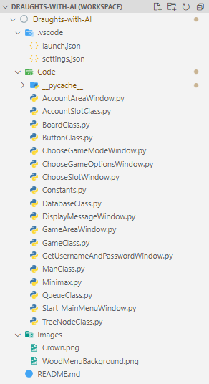

### Constants.py

The Constants file is used to store the various constants that are used in the different files that make up the game. This has been done because it means that the constants can be declared in one file and then imported into the other files as needed rather than having to declare the constants again in each file (which would result in lots of repeating data which would be hard to maintain). It also makes it extremely easy to change things such as the pygame window dimensions or the colour of the men/kings.

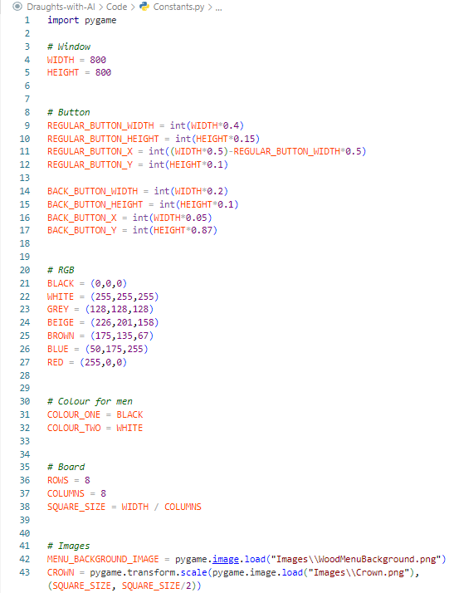

### Minimax.py

This file contains the minimax() subroutine/algorithm itself, which is used to carry out the AI’s move. Minimax is a common algorithm used for board-based games. To put it briefly, it takes a board (in this program a Board is an object created from the Board() class) and can score the board to determine how ‘good’ that board is. It uses recursion to find all the possible boards that can be created in a turn and repeats this until a certain depth. It then compares the scores of the different boards to determine what would be the best ‘turn to make’. I have gone a step further by implementing alpha-beta pruning to help reduce the processing time of the algorithm. The subroutines that make up this file will be explained in more detail in the table below.

**Terms**

**‘Move path collection’ -** A move path collection is a collection of all the move paths that are possible for a particular man/king.

**‘Move path’** - A move path is a 2D list which contains a list of moves that could be made in one turn. A move path is used to store a legal combination of possible moves in a given turn (which go from the start of a turn, to the end of a turn).

**‘Move’** - A move will usually be stored within a move path. It is a list that stores the required information for a move on the board to be carried out. It follows the structure: [moveNumber, isKing, oldRow, oldColumn, newRow, newColumn, capturesMan] -> [int, boolean, int, int, int, int, boolean].

|  |  |  |
| --- | --- | --- |
| **Method** | **Method Purpose** | **Method Description** |
| minimax() | To carry out an AI’s turn by working out the best ‘move path’ and returning a deepcopied Board() object with that ‘move path’ applied. | The minimax() subroutine is a recursive subroutine that is used to find the best possible move path for the AI to make. It does this by applying move paths to deepcopies of the Board object it is passed (the board object currently being used by the Game() object) and scoring them to determine what the best move path would be for the AI. It first checks if the board object in its current state would end a game (for example, black/COLOUR_ONE has no more pieces left) or if the depth limit has been reached. The depth dictates ‘how many turns into the future that the AI can work out/see’. This obviously links it directly to the difficulty of the AI as an AI with a harder difficulty will be a minimax with a larger depth to explore and so therefore can see more about what a potential move path could lead to. For example, if minimax is given a depth of 2 it will only be able to see the relatively immediate consequences (or lack of) of a move path. If it has a depth of 10, it would be able to see a lot further and so that potentially further along the line the same move that seemed good after 2 turns. turns out to actually lead to a large multi-capture for the opponent (the player) and so that move should be avoided. If either of these conditions are True, it will end the current call and return (unwind) back. Otherwise, it will use the ‘isColourOne’ boolean argument to determine which colour’s turn it is. For that colour, it will find all the possible move paths for that colour on the ‘board‘ argument (board object it has been passed) and then create a deepcopy of the board for each of the move paths (with a move path applied to each one). It will then call minimax() on all these deepcopied boards, decrementing the depth by 1 to show it has gone done a depth and changing the ‘isColourOne’ boolean, as this next call will be used to work out what move path the other colour will make in response (as the whole point of minimax is that it assumes that the opponent will make the best play and minimax’s role is to work out the best move based on that assumption). As it unwinds, it will scoreBoard() each board to determine its score (if it is better for the minimiser or maximiser). The maximiser is trying to maximise their score (pick the boards/move paths with the highest score, as that will be their best move path) and the minimiser is trying to minimise their score (pick the boards/move paths with the lowest score, as that will be their best move path). It uses an if statement to find the best scoring deepcopied board (and therefore move path). The best board is then returned. This will keep unwinding until the initial call to minimax() which will return the best board for the AI which will represent the best possible move path the AI could make (the ‘score’ of the board is also returned). The Game() object stores a Board() object. This returned board overwrites the board that is held in the game object, which will cause the pygame window to display the new board showing the move/s that the AI made and then the AI’s turn will end. Alpha-beta pruning has been implemented to make minimax more efficient and reduce how long it takes for minimax() to work. Alpha-beta pruning works by reducing the number of nodes/boards that need to be scored and compared. It does this by using the variables ‘alpha’ and ‘beta’. Alpha stores the highest score that the maximising player has found, and beta stores the lowest score that the minimising player has found. If the current score is lower than the alpha for the maximising player, then the branch can be pruned since the maximising player will never choose that path (as minimax assumes both COLOUR_ONE and COLOUR_TWO will always pick the best possible move path). The reverse goes for beta and the minimiser, it will prune a branch if the current score is higher than beta since the minimiser’s best move path/board will be the one with the lowest score. Alpha-beta pruning does not always have an effect but it does make at least one prune in the vast majority of cases and has certainly increased the speed of minimax() and was worth implementing. |
| makeAllDeepCopiedBoards() | Return a list of deepcopied boards which have a move path applied to them. | Takes a board and a list of move paths. It then uses deepCopyBoardAndApplyMovePath() to create a list of deepcopied boards with a move path applied to it. This list of deepcopy boards is then returned. |
| deepCopyBoardAndApplyMovePath() | Deepcopy a board and apply a move path to it. Then return it. | Take a board and a move path. Create a deepcopy of the board object. Then iterate through the move path to apply each move to the deepcopy. Then return the deepcopy. A deecopy of the board is made so that the move path being applied does not actual affect the original copy of the board as that is currently being used in the game and so changes to the board would be displaying on the screen as different move paths are applied. It is also used as otherwise all the move paths would be applied to the exact same board which would be an error as they would conflict with each other. A new deepcopy is made for each move path to be applied to so that each board represents the AI making a complete turn. minimax() will return the deepcopy which it works out to be the best (to simulate the AI making its move). |
| getAllMovePaths() | Return a list of all the move paths possible for a given colour | Takes a board and the colour that it needs to be getting move paths for. It gets a list of all the Man() objects and then goes through this list. If the current man is the colour that was previously passed, then it applies getLegalMoveAsMovePathList() to that Man() object. |
| getLegalMovesAsMovePathList() | Return a list of all the move paths for the man/king in a given row and column | Works very similar to part of the selectMan() method of the Game() Class so I will not go into as much detail here and save it for selectMan(). The comments explain in more detail the logic, but the basic overview of this function is that it gets the Man() object that is in the passed row and column and creates a tree of legal moves using the TreeNode() Class. The tree is structured so that the root is the starting row and column (as a list of two values) and each level down represents a possible move from the previous node’s row and column. This means that if a man is able to make two captures in one turn, at least part of the tree will go Root -> first capture/move -> second capture/move (leaf node shows end of turn). This is why the getAllRootToLeafPaths() method is called because it will get every possible root to leaf path in a list. This will be equivalent to every possible move path in the tree. |
| scoreBoard() | Take a board, evaluate it, return the score. This function is needed as any minimax algorithm needs to be able to ‘score’ a board to assess how good it is. | Creates a list of every Man() object still on the Board() object (that it has been passed). It then iterates through each man/king to count how many men and how many kings both COLOUR_ONE (C1) and COLOUR_TWO (C2) has. The total score is then calculated for both C1 and C2. C1’s score is then taken away from C2’s score and returned (in minimax, there is the maxer and the minimiser. In my program, C1 (black) is the maximiser and C2 (white) is the minimiser. So “colourOneScore-colourTwoScore” follows this logic as if C2 has more pieces left, taking away from C1 will push the returned score into the negatives which will tell minimax() that the board which scoreBoard() has been passed is a board that favours the minimiser/C2/White. This score will then be used to in minimax() to assess turns, etc. |

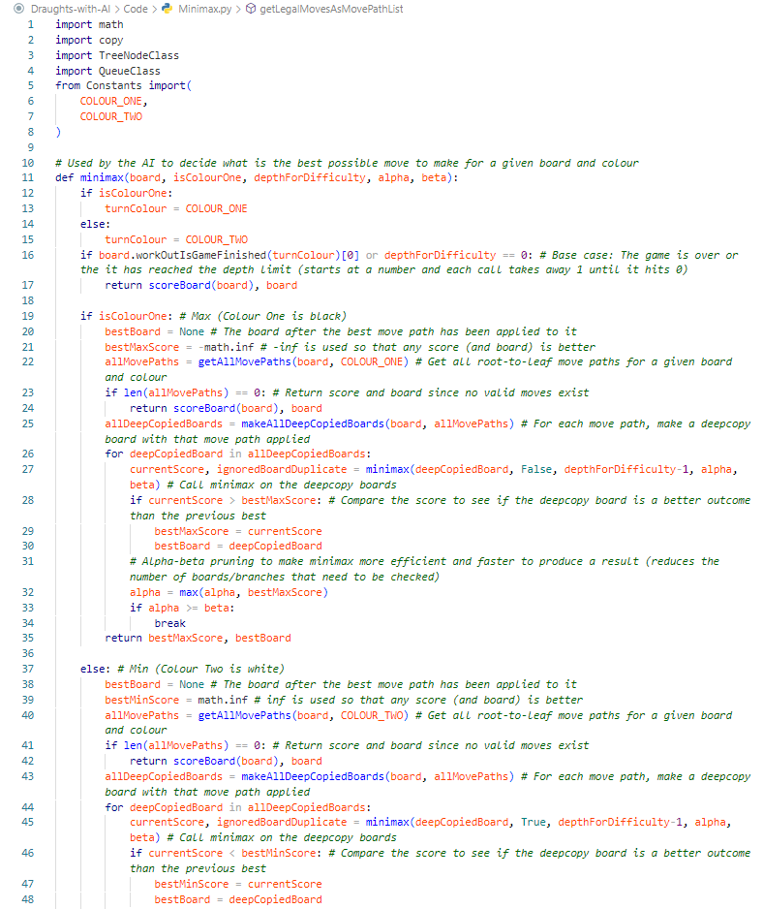

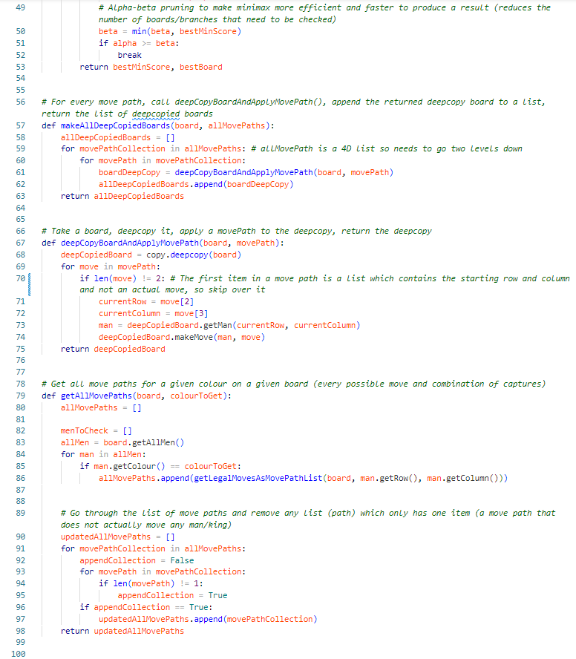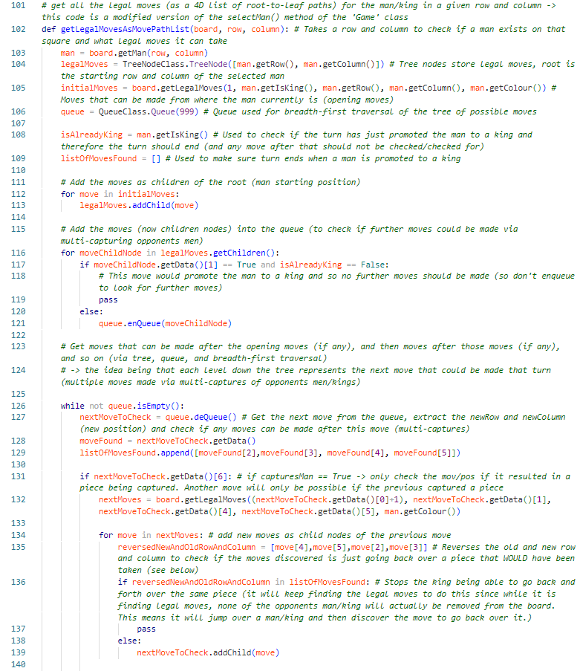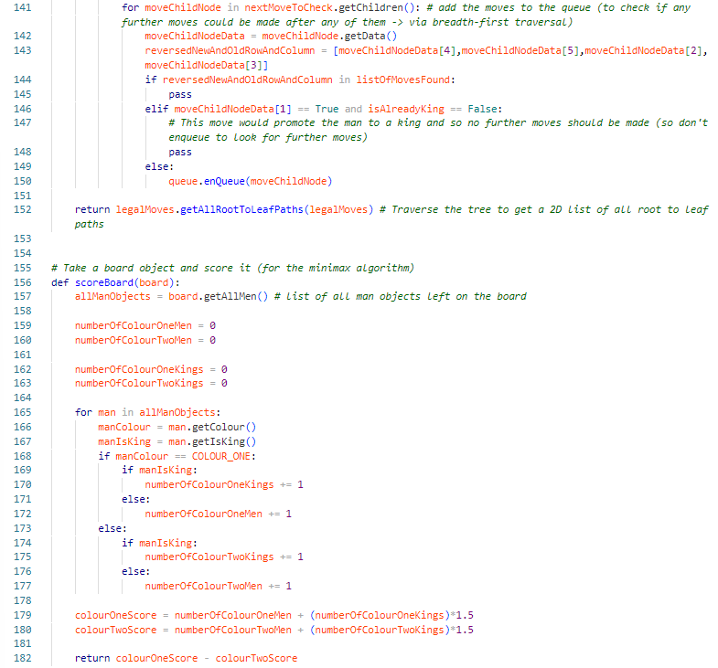

## Class Files

### QueueClass.py

The Queue class is used to create a queue which is used during an actual game. It, along with a tree, is used to carry out a breadth-first traversal to discover all legal moves for the man/king that the user has just clicked/selected. It is a linear queue that uses the shifting method which moves each item up one index (overwriting the item that has been dequeued). In the example given previously, each item in the queue would be a legal move (stored as a tree node object) and the node would be dequeued to check for the possibility of any further moves from that move (by getting the node’s data and checking if a multi-capture is possible). to find all the possible legal combinations of moves that could be made by a singular man/king in a turn.

|  |  |  |
| --- | --- | --- |
| **Method** | **Method Purpose** | **Method Description** |
| __init__() | Create a queue. | Creates an empty list to act as the queue. Sets the “maxSize” attribute with the integer that it was passed for the “maxSize” argument. |
| isFull() | Return a boolean value indicating if the queue is full or not. | Checks if the length of the queue is equal to the max size that was set. Return True if it is. Otherwise, return False. |
| isEmpty() | Return a boolean value indicating if the queue is empty or not. | Check if the length of the queue is equal to 0. If it is, return True. Otherwise, return False. |
| enQueue() | Add a new item to the queue | Check if the queue is full. If it isn’t, append the item passed to the “queue” list. |
| deQueue() | Apply the shift method to the queue. Remove and return the next item in the queue. | First the next item in the queue is stored in a variable so that it is not lost. Next the shift method is applied to the queue. This works by using a for loop to go through each index in the queue and make the value in each index equal to the value in the next index along. This means that every item is being shifted one place forward in the queue list. The value in the front of the queue is overwritten as this is the value that needs to be returned (the one that is being dequeued). pop() is applied to the list once to remove the item at the back of the queue as the shift method means that there will be a duplicate of the same item, in the last two indexes. pop() will remove one of these. |

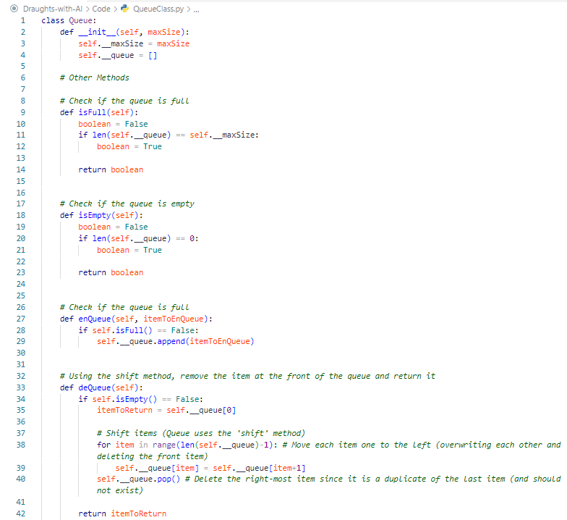

### TreeNodeClass.py

The TreeNode class is used to take some data and turn it into a tree node (or child node). This is used with the Queue class above to carry out a breadth-first traversal. When a legal move is found then it will be checked to see if any other moves could be made in that turn after that move (is there any multi-captures possible?) if there are further moves that could be made, these moves are stored as child nodes of the move that came before them and then enqueued to check those moves in the same way. g**etRootToLeafPaths()** is used to get every possible path from the root node to a leaf node (without going back up the tree). It is used by **Minimax.py** to find all the possible legal combinations of moves that could be made by a singular man/king in a turn. The reason for this is explained in more detail in the Minimax section of the implementation section above, but the basic overview is that each level down in the tree represents a possible move and a leaf node represents the last move of a turn. For example, one root-to-node path might be root (stores the starting row and column position) -> first capture (stores a **move**) -> second capture (stores a **move**). getRootToLeafPaths() would find this order of moves. These would be put into a list which would create a **move path**. A move path being a combination of legal moves that go from the start of a turn to the end of a turn.

|  |  |  |
| --- | --- | --- |
| **Method** | **Method Purpose** | **Method Description** |
| __init__() | Create a tree node. | Create a tree node by creating a TreeNode object which stores the data in an attribute. Store an empty list in the “children” attribute. This list will be used to store child nodes of this node. Those child nodes will be TreeNode objects themselves. |
| getData() | Get a TreeNode’s data | Return the value stored in the “data” attribute. |
| getChildren() | Get the list of children nodes | Return the list of TreeNode objects which are children of the TreeNode object this method has been called on. |
| addChild() | Create a TreeNode object and store it in the “children” attribute list. | Take the data that the child node stored, create the TreeNode child object (using this data), append the newly created child node to the TreeNode object’s list of child nodes. |
| getAllRootToLeafPaths() | Return a 2D list of all possible paths from the root node, to a leaf node (only being able to ‘go down the tree’). This is used by minimax() to find all the possible move paths (every possible legal combination of moves that could be made in a given turn). | This method uses a breadth-first search to find every way of going from the root, to a leaf node. It uses a queue to traverse the tree from the root node downwards and enqueues each child node along with the path that leads to it. Once it reaches a leaf node, it appends the path to a 2D list of paths. Once the queue is empty, it will stop running and return the paths list as no more items in the queue means that it has checked every child node. |

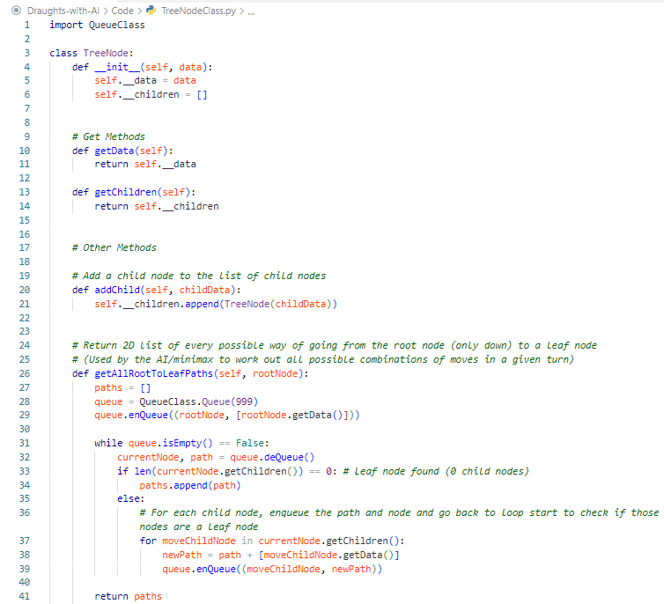

### AccountSlotClass.py

The AccountSlot class is used to create the two account slot objects needed for the game. The slots can have one account signed into it at a time. The slots are then used to play a game as a certain account/user. It stores the stats that are stored about the account that is currently signed into it. It then updates these stats and then calls the database object (that it also stores a copy of) to make those changes to the stats in the database.

|  |  |  |
| --- | --- | --- |
| **Method** | **Method Purpose** | **Method Description** |
| __init__() | Create an empty account slot, for accounts to be signed into. Created when the game is launched. | Create and set the object’s attributes (to none). Create the dictionary of stats (with the values of None as no account has been signed into the slots yet). |
| getUsername() | Get the username of the account that is signed in the account slot | Return the value of the “username” attribute. |
| getDatabase() | Get the database object that the account slot is storing and using. | Return the value of the “database” attribute. |
| getAccountID() | Get the AccountID (AccountID is a field in the database) of the account signed into the slot. | Return the value of the “AccountID” attribute. |
| getStatsID() | Get the StatsID (again, is a field in the database) of the account signed into the slot. | Return the value of the “StatsID” attribute. |
| getColour() | Get the colour that the account in the account slot is playing as. | Return the value of the “colour” attribute. |
| getAllAccountStats() | Get the full dictionary of stats that are stored about the account in the account slot. | Return the value of the “accountStats” attribute. |
| getAnAccountStat() | Get the value of a stat for an account signed into the account slot. | Takes a “statKey” as an input. If the key is a key in the “accountStats” dictionary, return the value that is stored for that key/stat. Otherwise, return None. |
| setUsername() | Update the value stored in the “username” attribute. | Update the value stored in the “username” attribute using the “username” the method was passed. |
| setDatabase() | Update the value stored in the “database” attribute. | Update the value stored in the “database” attribute using the “database” (which will be a database object) the method was passed. |
| setAccountID() | Update the value stored in the “AccountID” attribute. | Update the value stored in the “AccountID” attribute. |
| setStatsID() | Update the value stored in the “StatsID” attribute. | Update the value stored in the “StatsID” attribute using the “ID” the method was passed. |
| setColour() | Update the value stored in the “colour” attribute. | Update the value stored in the “colour” attribute using the “colour” the method was passed. |
| setAccountStats() | Replace the dicitonary stored in the “accountStats” attribute. | Replace the dicitonary stored in the “accountStats” attribute using the “accountStatsDictionary” the method was passed. |
| setAnAccountStat() | Update the value that is stored for a key. | Take a “key” and “value” as arguments. If the key appears in the “accountStats” dictionary, replace the value stored with that key. |
| applyDictionaryChangesToDatabase() | Reflect the changes made to the “accountStats” dictionary to the actual database. When a game is complete, it will update the stats in “accountStats”. This method is used to make those same changes to the database itself. | Call the updateDatabaseWithDictionary() method of the Database() object that is stored in the “database” attribute. |
| signIn() | Used to sign an account into the slot. | If an account with that username and password exists in the database, retrieve the information about that account and store it in the different attributes. |
| signUp() | The account slot’s connection to the database object is used to call the addNewUser() method of the Database() object that is stored in the “database” attribute. | Calls addNewUser() on the Database() object stored in the “database” attribute. |
| signOut() | Used to clear the data stored in the different attributes about an account when an account signs out of a slot. | Store None in all the required attributes. |

.

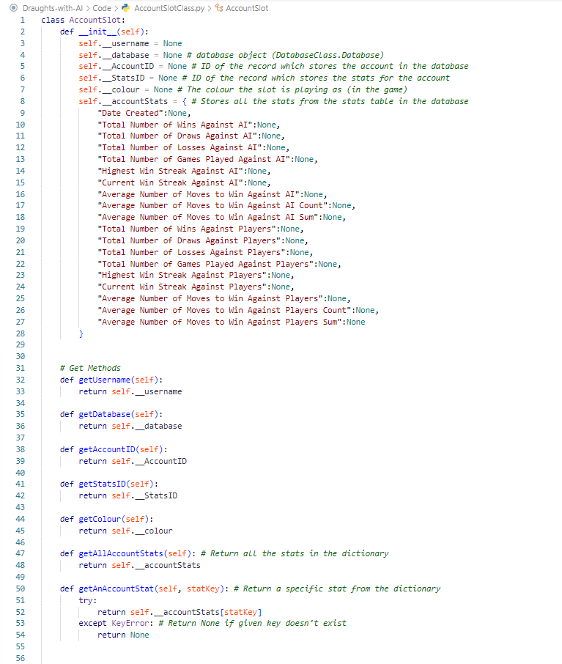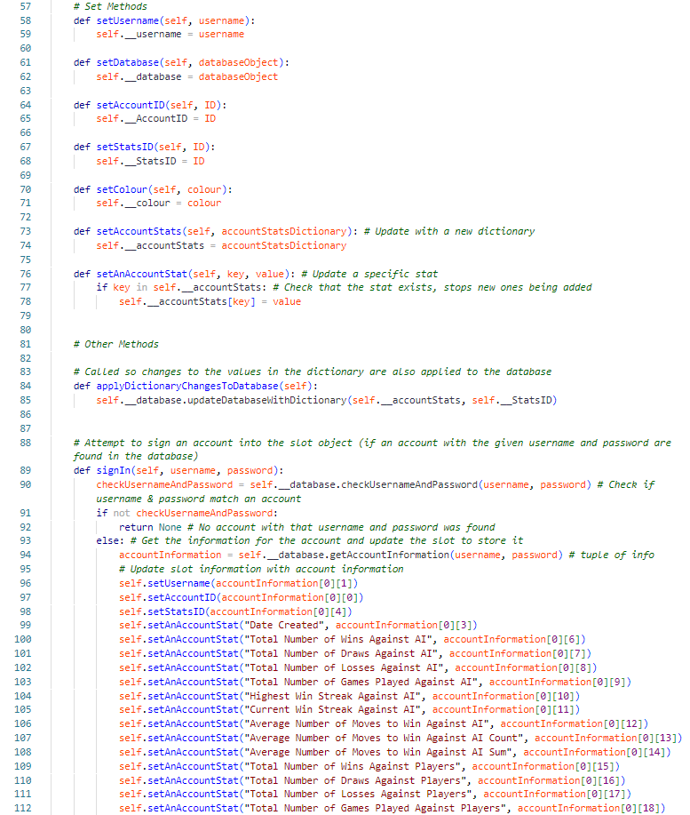

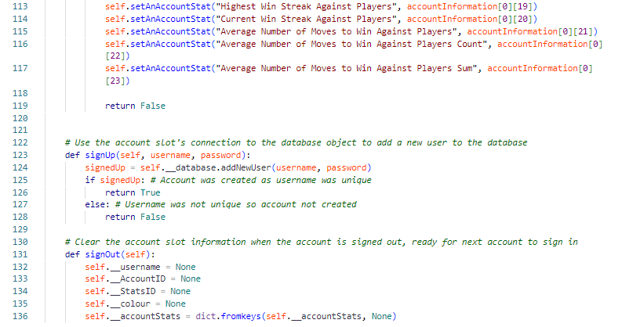

### ButtonClass

The Button class is used to create the buttons which are then displayed on the pygame window to let the user makes choices such as clicking which colour they want to play as, choosing which slot to sign out, choosing the difficulty for the AI, etc.

|  |  |  |
| --- | --- | --- |
| **Method** | Method Purpose | **Method Description** |
| __init__() | Create a button that can be displayed on the pygame window. | Create and set the attributes for the new object, using the values passed to it. |
| draw() | Draw the button onto the pygame window. | It first draws the button to the screen by using pygame.draw.rect() and the object’s attributes. Throughout the program, there are ‘special’ types of buttons which should alter how the button looks. The first if statement checks if the button is black or white. If the button is not, it draws black and white lines which give the button a light 3D effect which serves no purpose other than to make the menus look a bit nicer. Since the lines used to create the effect are black and white, the if statement makes sure that the button is not either of these colours as the effect will not work on them. The second if statement checks if the button is a back, back to menu, or start button. If the button is any of these, then the text is set to a smaller size (smaller compared to the elif statement which will be spoken about next). This is because these buttons are smaller than regular buttons (see the constants file) and so the text needs to be smaller to match this. If the button is a button with any other “text”, then the ‘standard’ font size is used. A button with no text should not have the text/font rendered as there isn’t any. Buttons which have no text are the two buttons, displayed when setting up a game, which allow the player/slot one to choose the colour they wish to play as (see ChooseGameOptionsWindow) |
| isOver() | Check if a button has been clicked. | Take a pygame window and a mouse position. “mousePos” is a tuple which follows the format: (x,y). If statements are used to check that the x and y fall within the area of the screen which the button covers. |
| drawSelectedLines() | Draw lines around the button (on the pygame window) to make it appear selected. This is needed for when the user is selecting the game options when starting a game. For example, four buttons will be displayed (one for each of the difficulty options for the AI: Easy, Average, Hard, Expert). When a user clicks one of these buttons. It will have red lines drawn around it to show which difficulty is currently selected and will be used if they continue, to play the game. | Draws four lines around edge of the edges of the button (which it works out through the attributes that each button object has). The parameters that pygame.draw.line uses are: surface, color, start_pos, end_pos, width=1). |

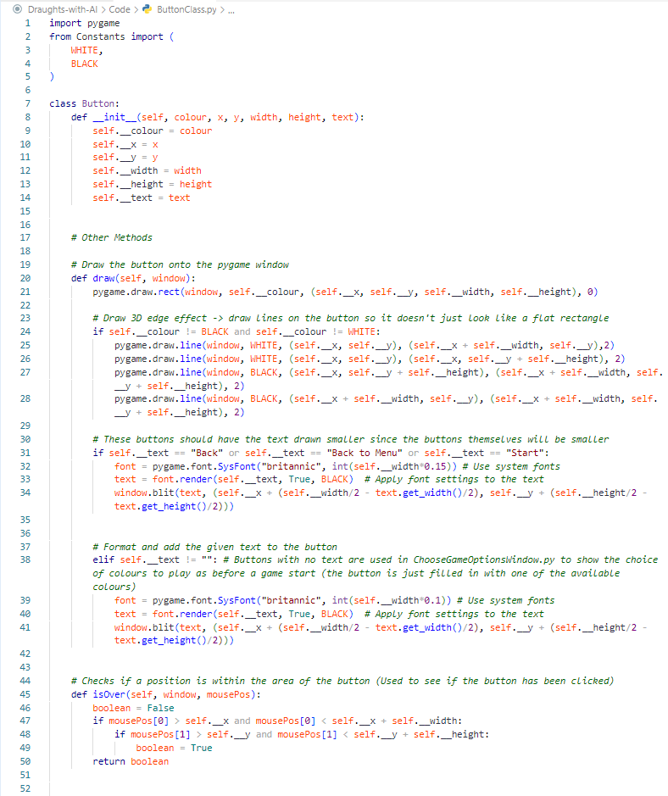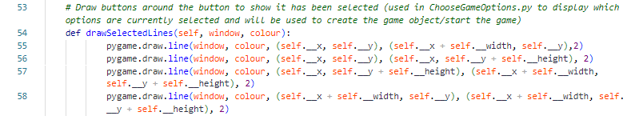

### DatabaseClass.py

The Database class is used to connect to a MySQL database using the **mysql.connector** module. It creates the database and tables if any of it doesn’t already exists. It connects to this database and is used by the account slots to sign accounts into themselves by retrieving data from the two tables in the database (see database designs).

|  |  |  |
| --- | --- | --- |
| **Method** | **Method Purpose** | **Method Description** |
| __init__() | Connects to the MySQL server and database . If the database and/or any of the tables do not exist, creates them. | It first makes the connection and cursor to the MySQL server by using the host, username, and password that has been passed. If the database does not exist, it will create the database. It will then reconnect to the server, but this time connect to the database directly. It will then create the tables if they do not already exist in the database. In good practice, it will then close the cursor and connections as they are no longer needed. |
| makeConnection() | Used by other methods to create a connection. | Creates and returns a connection. |
| makeCursor() | Used by other methods to create a cursor. | Creates and returns a cursor. |
| checkUsernameAndPassword() | Take a username and password and check if an account that uses them exists in the database. | Creates the connection and cursor. Since the passwords are stored as hashes in the database, the password must be encoded and then hashed, for the comparison to be made (as the “password” that is passed is in plaintext. A prepared query is used which allows you to have a query and slot different values into the placeholders. The cursor is used to execute the prepared query, filling in the placeholders with the appropriate values. A boolean is returned to signify whether an account exists in the database with that username and (hashed) password or not. |
| getAccountInformation() | Used to get the information/stats that are stored about an account in the database. Used when an account is signed into one of the account slots. | Creates the connection and cursor. Creates the hashed version of the plaintext “password” argument. A prepared query is used to get everything from both tables of the database. This is all stored as a list in the cursor. The list is returned by using the fetchall() method of the cursor, to retrieve the output of an executed query. |
| isUsernameUnqiue() | Used when the user is trying to create an account/sign up. Checks that the username they want is not already being used by another account. | Creates the connection and cursor. Uses a prepared query to check if an account has that username by getting all the data in the UserAccount table, that has that username. fetchall() is used to see if any data was returned. If no data was returned, no account with that username exists and so the username is unique and True should be returned. |
| addNewUser() | Used to ‘sign up’. Creates a new record in both tables therefore creating a new account. | Creates the connection and cursor. Creates the hashed version of the plaintext “passwor” argument. If the “username” that has been passed is not already in use (is unique in the database), the new records are inserted into the database tables. |
| updateDatabaseWithDictionary() | Called by an account slot so that the changes made to the dictionary of stats, for an account signed into the account slot, are also made in the database (updates the database with those same changes/new stats). For example, when a game has ended the stat that tracks how many games they have played against the AI (assuming they were just playing a game against the AI) will be incremented by 1 (other stats will also be changed). This changes will be made to the dictionary in the account slot they are using. The applyDictionaryChangesToDatabase() method of the account slot object will be called, which will then call this method of the database. | The connection and cursor are created. A list is created called “valuesForStatement” which will store all the values (stat values) of all the keys (stat names) as well as the StatsID which will be needed to ensure the UPDATE is applied to the right record. A prepared query is then used to carry out the UPDATE to each field of the correct record. |

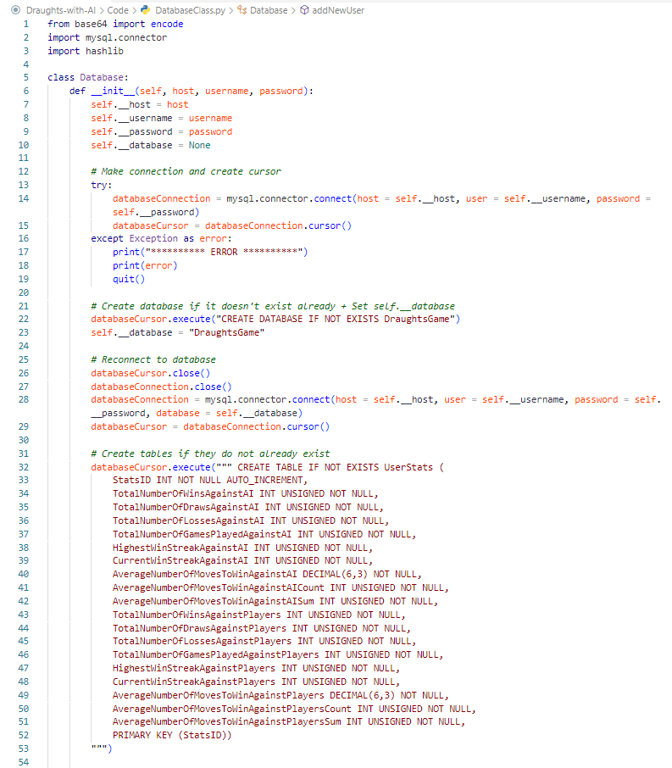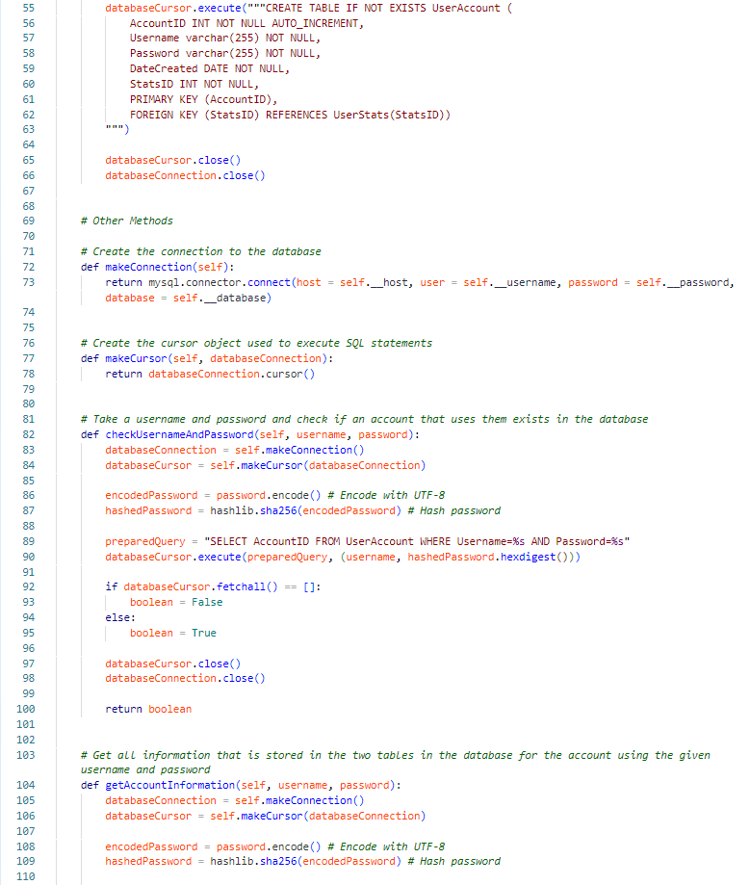

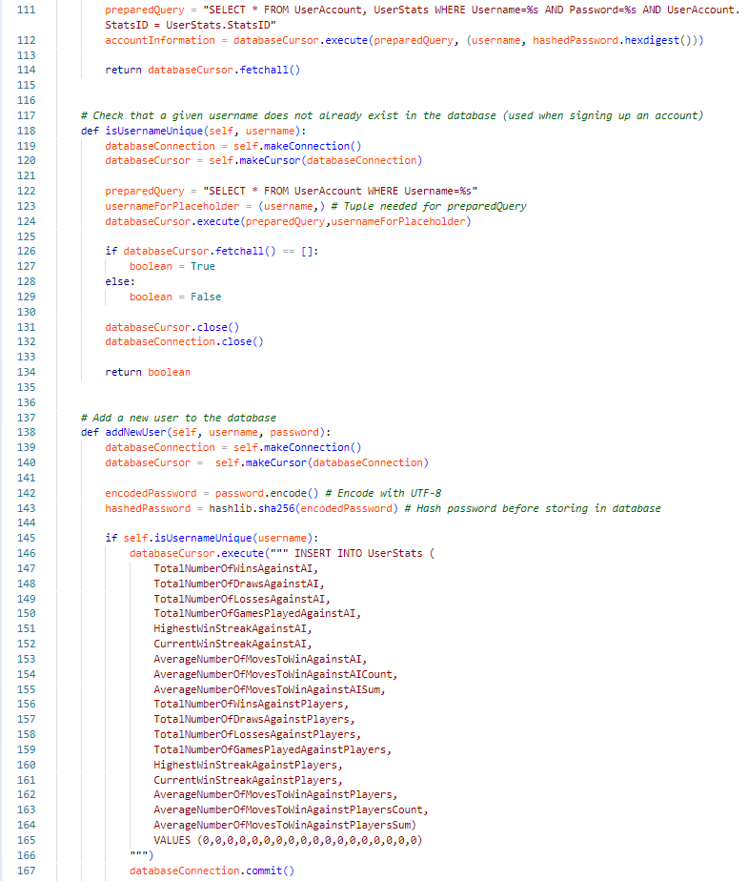

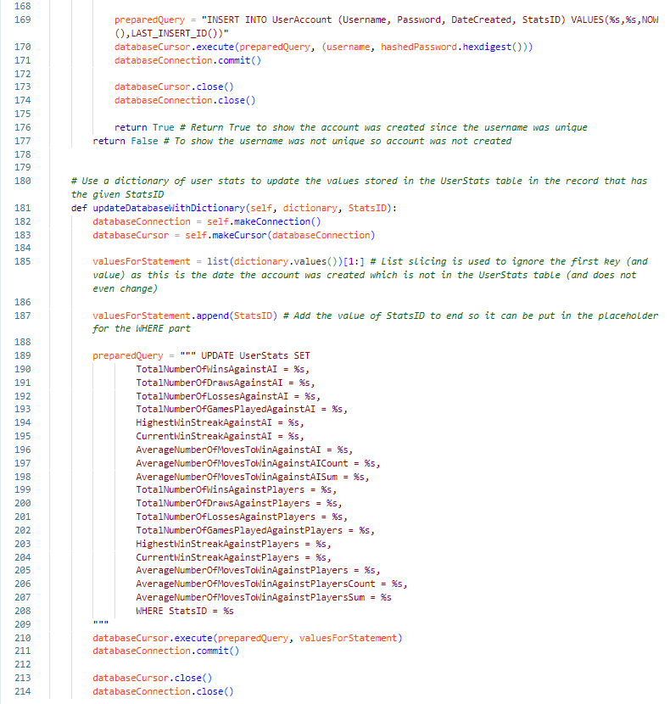

### ManClass.py

The Man class is used to create Man objects inside of a 2D list in a Board() object. These pieces can be moved, drawn onto the pygame window, etc. A Man object can be promoted to a king piece when reaching the other side of the board to where the man started. This changes how the piece can move and draws a crown over the piece (on the pygame window).

|  |  |  |
| --- | --- | --- |
| **Method** | **Method Purpose** | **Method Description** |
| __init__() | Create a Man object to be stored inside the 2D list in a Board() object. | Set attributes using arguments passed. Work out x and y coordinates of where the man/king will be displayed on the pygame window. IsKing is used to see if the man has been promoted to a king. isSelected is used when a player clicks on a piece to select it. The man/king will have a ring drawn around it to show which piece they currently have selected. |
| getRow() | Get the row that the man/king is on. | Return the value of the “row” attribute. |
| getColumn() | Get the column that the man/king is on. | Return the value of the “column” attribute. |
| getColour() | Get the colour of the man/king to work who it belongs to. | Return the value of the “colour” attribute. |
| getIsKing() | Work out if the man has been promoted to a king. | Return the value of the “isKing” attribute. |
| setIsSelected() | Change whether the man/king is selected or not so that the ring drawn around it are/are no longer displayed. | Update the value of the “isSelected” attribute using the argument “boolean”. |
| setIsKing() | Used when a man is promoted to a king. If True, will draw a crown over the piece and change what moves are legal for that piece. | Update the value of the “isKing” attribute using the argument “boolean”. |
| determineX() | Calculate where on the X-Axis the man/king will be displayed on the pygame window. Needed to draw the man/king in the correct place on the pygame window. | Return the X-Axis of where the man/king will be displayed on the pygame window. |
| determineY() | Calculate where on the Y-Axis the man/king will be displayed on the pygame window. Needed to draw the man/king in the correct place on the pygame window. | Return the Y-Axis of where the man/king will be displayed on the pygame window. |
| draw() | Draw the man/king onto the pygame window (which will already have the board drawn onto it). Draw the ‘selected ring’ or the crown if needed. | If the man/king is selected, a red circle is drawn around where the man/king will be drawn to show it is selected. The radius for this circle is larger than the radius used for the man/king. Next the man/king is drawn (over the red circle if it has been draw. Since the red circle will be behind the man/king it will look like a red ring has been put around the man/king). Next checks if it is a king. If it is, drawn the image of the crown in the centre of the king. |
| move() | Used when a man/king has been moved so that the attributes can be updated. | Update the “row” and “column” attributes by using the “newRow” and “newColumn” arguments. Update the “x” and “y” attributes as the piece will now have a different x and y coordinate. |

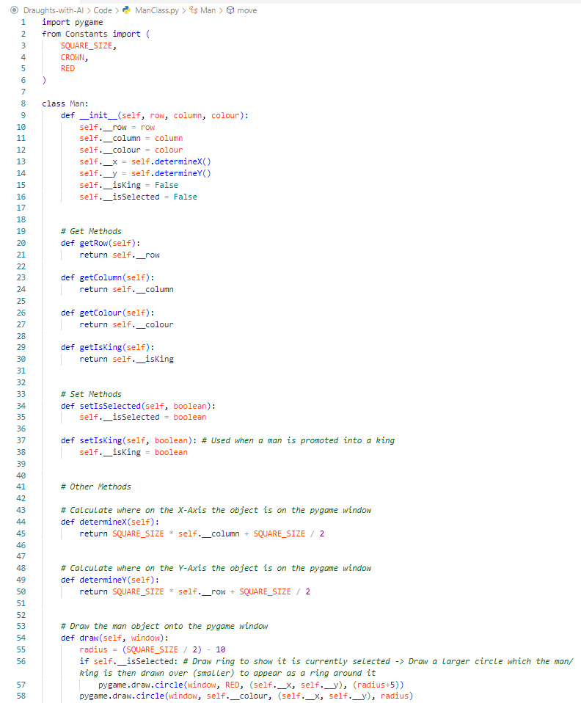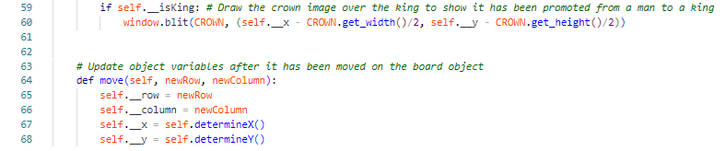

### BoardClass.py

BoardClass.py contains the Board class which is used by the Game class to carry out a game. The class contains a 2D list which is used to represent the board. Each list represents a row and each index in those lists represent a square.

|  |  |  |
| --- | --- | --- |
| **Method** | **Method Purpose** | **Method Description** |
| __init__() | Create a 2D list, which represents the board, and add Man() objects into it. This board is used to play the game. | Set two attributes to track how many of each colour both colours have left (12 pieces each at the start). It uses a series of if statements to put the pieces into the correct squares for the start of a game. |
| drawBoard() | Used to draw the board and men/kings onto the pygame window (create the GUI game for the user to click on the different pieces, make moves, etc). Repeatedly called in the event loop (see GameAreaWindow) to refresh the window/display the board. | It first draws the board by alternating between the colours of squares to create the chequer board pattern. Next it will go through the “board” attribute list and go through every index. When it gets to an index which has a Man() object in it (rather than a 0, which is used to show the square is empty), it will call the draw() method of that Man() object. It will use the “legalMoves” argument to (if there are any) draw legal moves onto the board. "legalMoves” will be a tree structure that stores the legal moves that the currently selected man could make. Each level down the tree represents the next move in a chain of moves that can be made in a given turn. “lastMoveMade" is used to track what TreeNode() object (move) the player made last. The children of this node/move are put into a list so that the next moves (if any) after that move can be displayed. Displaying a move involves drawing a smaller blue circle onto the pygame window in the square where the currently selected man/king could move to. The player will be able to click these circles to make the move (this code is not in this method). |
| getBoard() | Get the 2D list that is used to represent the board. | Return the value of the “board” attribute. |
| getMan() | Get a man/king from a row and column in the board. | Return the value found at the index in the 2D list. |
| getNumOfColourOneLeft() | Find out how many pieces COLOUR_ONE has left. | Return the value of the attribute “numOfColourOneLeft”. |
| getNumOfColourTwoLeft() | Find out how many pieces COLOUR_TWO has left. | Return the value of the attribute “numOfColourTwoLeft”. |
| getAllMen() | Get a list of all the Man() objects that are still in play. | Go through every index of “board” and return a list of every Man() object that is found. |
| makeMove() | Used to carry out a ‘move’ on the 2D list “board”. | First the Man() object is moved to the new row and column, and a 0 is put in its starting place to show this square is now empty. moveToMake[1] is a boolean which signifies if a move should make the man a king (once a man has been promoted to a king, this will always be True for any future moves that this king makes to show that the move is being made by a king piece, this is needed for getting further legal moves to add as child nodes of this move as a king will have more possible moves as it can travel in more directions). The row and column stored in the Man() object are updated. A check is made to see if the move was a move that should result in a capture. If it is, the row and column of the enemy piece that should be captured is worked out. The number of men/kings that the opponent has left is decremented by 1 and their man/king is replaced with a 0 (is deleted). |
| wouldMakeKing() | Check to check if a discovered legal move would promote the man to a king. | Takes the “newRow” of a move and checks if the new row (which row the man would move to if the move was made) would mean the man would reach the first or last row. Since a man can only move towards the other side of the board, you do not need to check the colour. A man will only be able to get to the opposite end row until it is promoted to a king. |
| getLegalMoves() | Used to find legal moves for a man/king using its row and column. | Calls getLegalMovesDown() and getLegalMovesUp() depending on the colour the man/king is and if it is a king (in which case it can go up and down the board). It will create a “legalMoves” 2D list. It then checks these moves to see if they would make a man into a king (using wouldMakeKing()). This list of legal moves is then returned. |
| getLegalMovesDown() | Makes a list of all valid moves that a man/king could make from its current row and column if it was going down/south the board. | Uses a series of if statements to work out what moves would be possible for the man/king to make. “moveNumber" is used to track what move these discovered moves would be in a single turn. In draughts, a piece can move one square if the square is empty, and they have not made a capture this turn. getLegalMoves() is called by a Game() object repeatedly to create a move tree. Every level down in the tree represents a different move number. This allows a chain of moves to be carried out in a single turn. |
| getLegalMovesUp() | Make a list of all valid moves that a man/king could make from its current row and column if it was going up/north the board. | Like getLegalMovesDown() it uses a series of if statements to check what moves would be legal for a man/king in the “row” and “column” to make and then returns a list of moves. |
| isPossibleMoves() | Used to work out if a game is over (called by the method below). If both colours are unable to move then the game is a draw, if one colour can move but the other can’t (and it is their turn) then the former will win. | Goes through every square of the board. Whenever it finds a man/king which is the colour that was passed as “colourToCheckFor”, check if it has any legal moves. If it does return True (no need to finish the loop). If it gets through every square and no legal moves were found, then return False. |
| workOutIsGameFinished() | Used to work out if a game is over. Needed to decide if the pygame event loop that carries out the game should end. | First checks if the colours (whoose turn it will be next if the game was to continue) has any men/kings left on the board. If they do not, the game is ended and it will add to “returnSet” a list containing a boolean to represent if the game is over or not, and the colour who is the winner. The statements below this are used to check if a game should finish but there are men/king left. It starts by checking if both colours are unable to make any moves. If true, it will add to the return set a boolean to show the game is over and None to show that the game is a draw. The other statements check if one colour can move but not the other. A final check is made to see if the return set is empty, if it is then it will add to the return set False to show that the game is not over and None to show that there is no winner. |

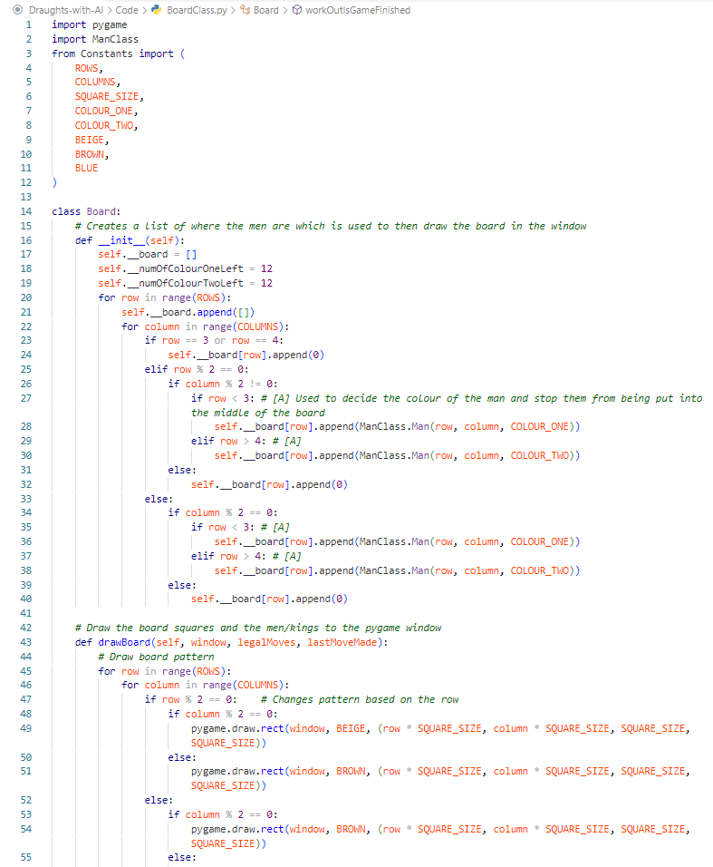

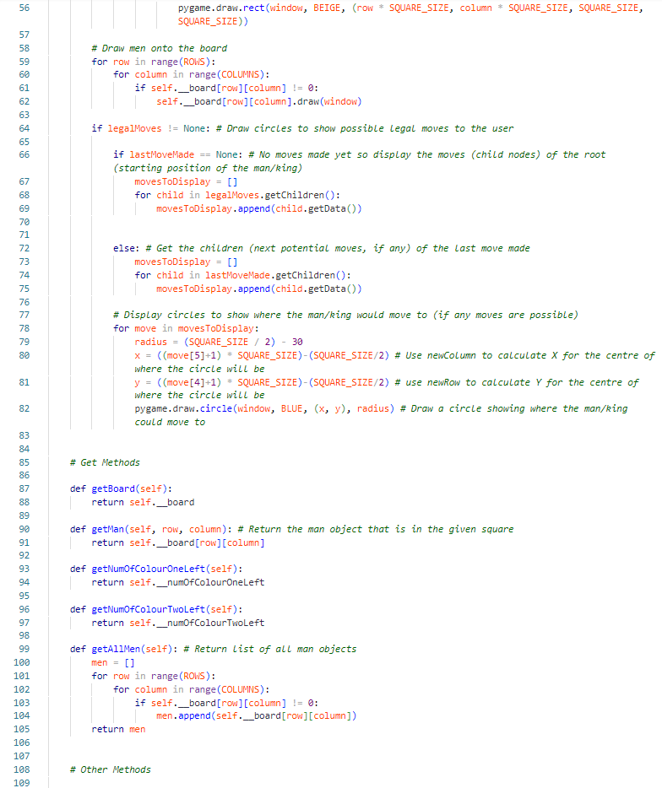

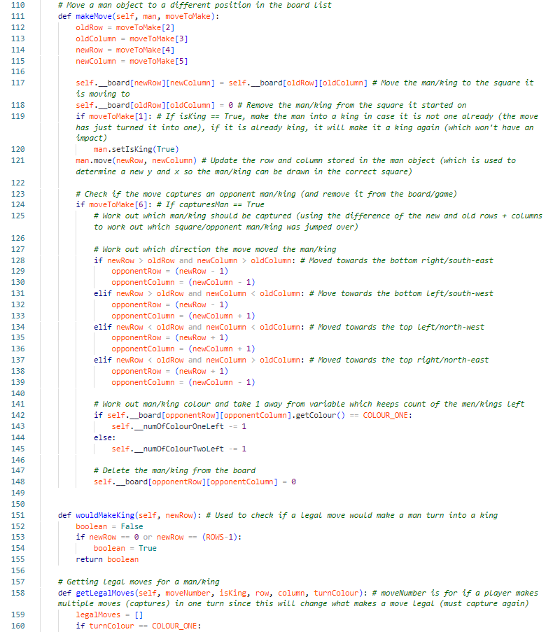

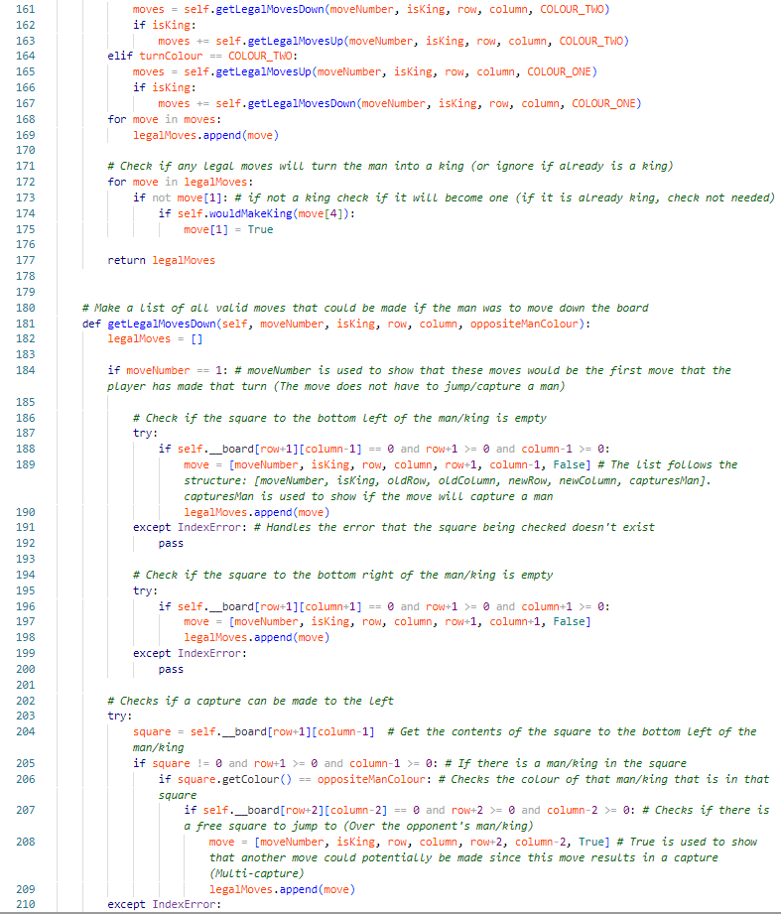

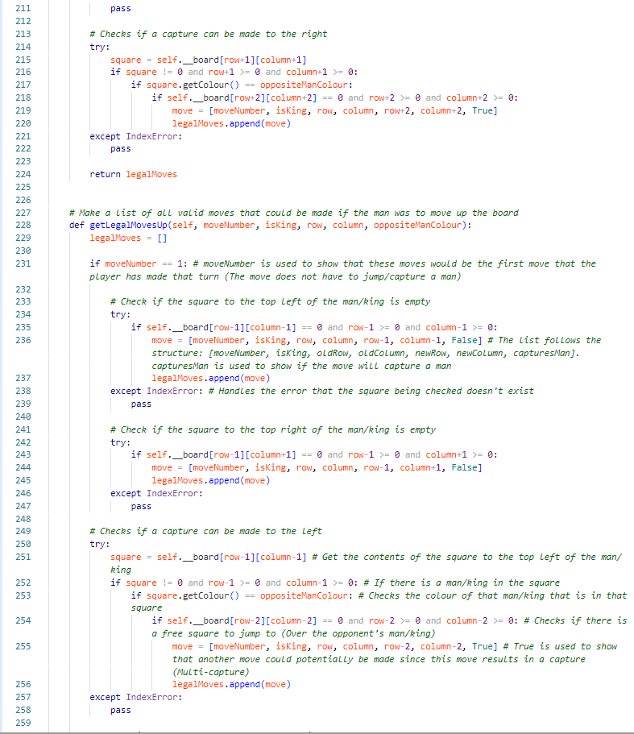

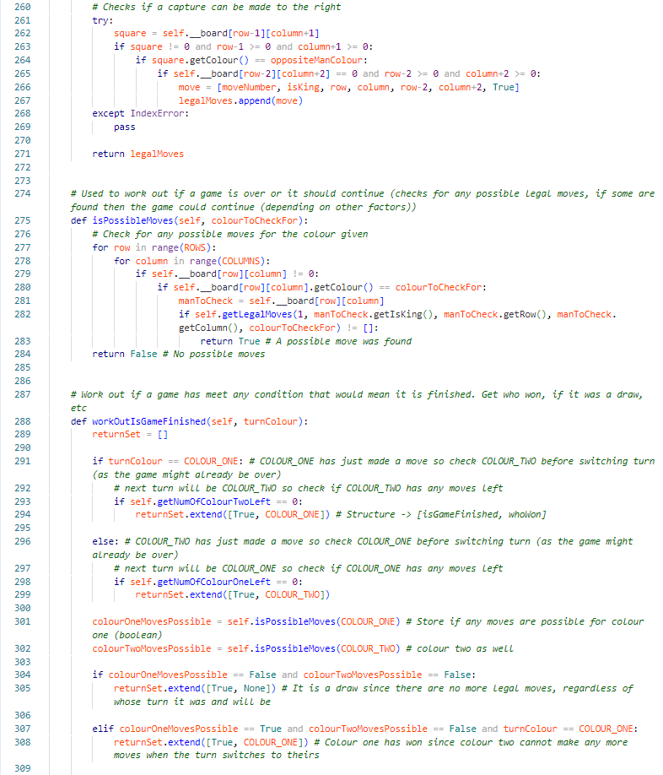

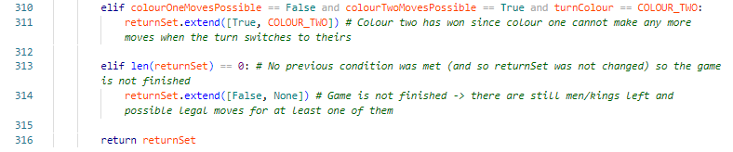

### GameClass.py

The Game() class is used to create a Game() object which is used to carry out a game. It stores a Board() object, allows the user to click on the pygame window to selected Man() objects or make a move, etc.

|  |  |  |
| --- | --- | --- |
| **Method** | **Method Purpose** | **Method Description** |
| __init__() | Create a game object that has the attributes and methods for carrying out a game. | Sets the attributes and determines who’s turn it is first. |
| getLegalMoves() | Get the tree (a TreeNode() object) of possible legal moves for the currently selected Man() object. | Return the value of the “legalMoves” attribute. |
| getRowAndColumnFromPos() | Get the row and column for the square where an x/y position on the pygame window would be on the board. | Take a tuple which is in the format: (x,y). Calculate the row and column of the square which that position is over on the board in the pygame window. |
| getGameFinished() | Get the value of the “gameFinished” attribute. Used to see if a game is finished (after using methods to update this attribute by checking different conditions to work out if the game is over) | Return the value of the “gameFinished” attribute. |
| getWinner() | Get who won after a game has finished. | Return the value of the “winner” attribute. |
| getSlotOneTotalNumberOfMoves() | Get how many Man() objects slot one has left. | Return the value of the “slotOneTotalNumberOfMoves” attribute. |
| getSlotTwoTotalNumberOfMoves() | Get how many Man() objects slot two has left. | Return the value of the “slotTwoTotalNumberOfMoves” attribute. |
| getTurn() | See whose turn it is. The value will a list in the format: [whose turn is it?, what colour are they playing?]. For example, [self.__slotOne, COLOUR_ONE] | Return the value of the “turn” attribute. |
| updateDisplay() | Used to update/refresh the whole pygame window. | Use the board’s draw method to draw the square, pieces, legal moves, etc. Use pygame.display.flip() to update the pygame window to show these new drawn things. |
| processClick | Called by the event loop in gameAreaWindow() when a use clicks on the pygame window. It is used to work out what should happen depending on where the user clicked and under what conditions. If anything needs to happen then it will carry out those actions. | This method uses a series of if statements to check what should happen based on where the user clicked and under what conditions. It first checks if the user has clicked while **not** having a man/king selected. If this is True then an attempt is made to select the man they clicked using selectMan() below (provided they clicked on one and it belongs to them). If they do have one selected, more if statements are used to check if they have already made a move this turn or not. If they have already made a move this turn, they should not be able to unselect their currently selected man/king (by clicking an empty square or another piece). They should be allowed to carry out further moves (until they can’t anymore in which case their turn ends) by clicking squares with blue circles on to show that they could make a legal move to that square). If they have not already made a move this turn, they should still be able to carry out a move (their first move of the turn in this case) but they should be allowed to unselect the man/king incase they have changed their mind and want to move a different piece instead. |
| selectMan() | Selects a Man() object. This will result in things such as finding and making a tree of its legal moves and drawing a ring around it to show the user it is selected. | Creates a tree of legal moves where each level down is a move in a chain of moves (even if it is only a single move). If part of the tree goes root (starting row and column) -> first move (capture) -> second move (capture). When a leaf node is reached, this will show that there are no more possible moves, and the turn should end. This tree is constructed using a breadth-first traversal using the TreeNode() class and the Queue() class. It does this by finding legal moves and then putting these moves into the queue. The row and column that the Man() object would move to are then used to find further moves after that move (if any). It returns a Tree of all legal moves that a piece could make in a single turn. |
| aIMove() | Used to carry out an AI’s turn. | Minimax requires a max depth and the higher this max depth, the more difficult the AI will be. Depending on the difficulty chosen by the player, a value will be assigned to “depthForDifficulty”. The numbers that were used to represent each difficulty happened to match the depths that I tested and chose to use. I left the if statements in just to make it easier to alter these depths in the future. After this, it calls minimax() which will then return a list following the format: [bestMovePath, deepCopiedBoardWithThatMovePathApplied]. The Board() object currently being used and stored in the “board” attribute is overwritten with the deep copied board that minimax returned. This means that the next time updateDisplay() is called, the pygame window will be updated to show the new board (and what move/s the AI made). endTurn() will then be called to end the AI’s turn and start the player’s turn. |
| endTurn() | Used after a person has made all the moves of their turn and the turn now needs to switch. | Starts by checking if the game should end as a result of the moves just made. If the game is over, then it will work out who is the winner, etc. The next section is used to wipe the values in some of the attributes in preparation for the next person’s turn. “turn” is then updated to switch whose turn it is when the method has finished. |

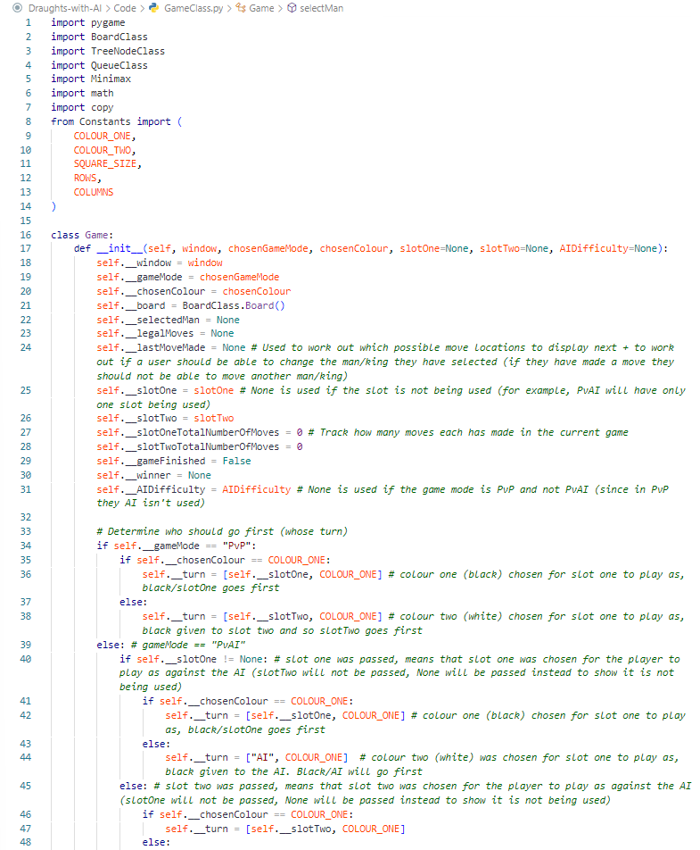

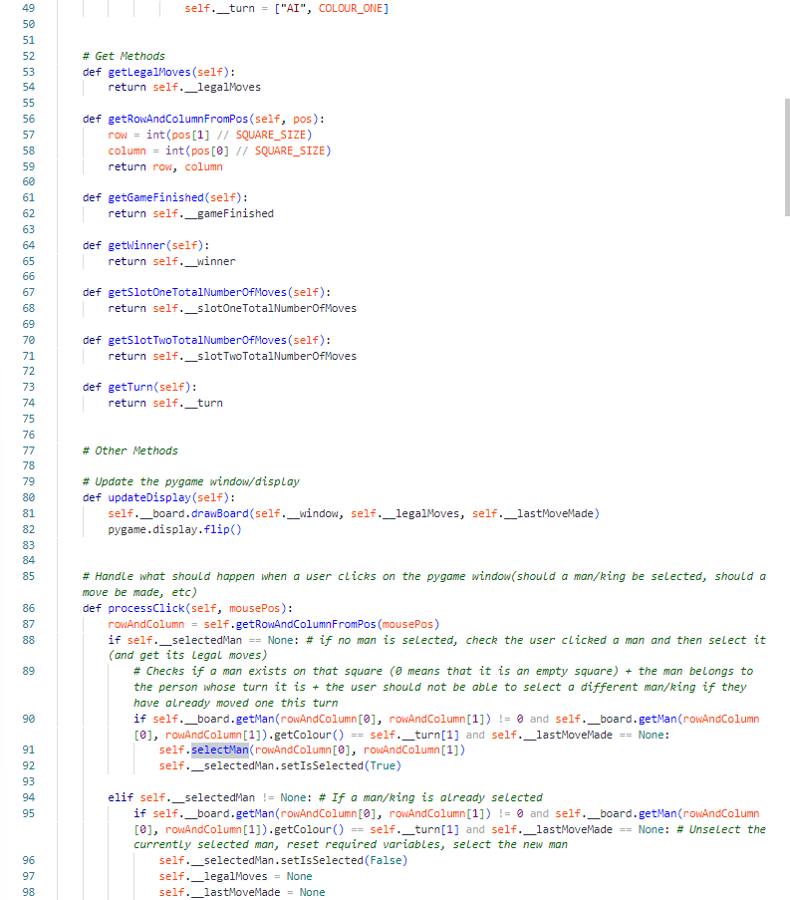

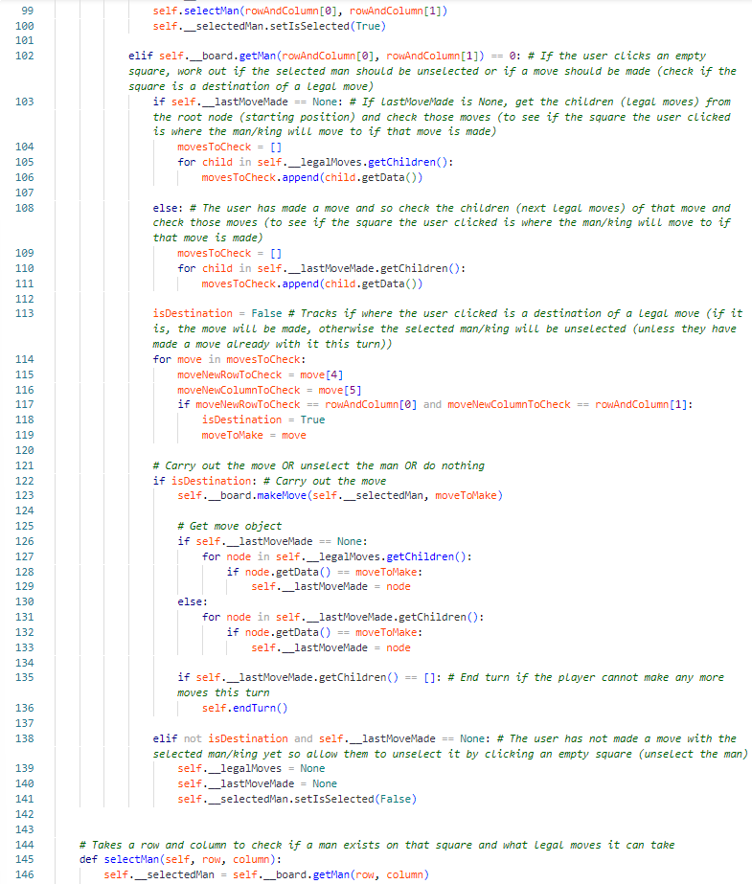

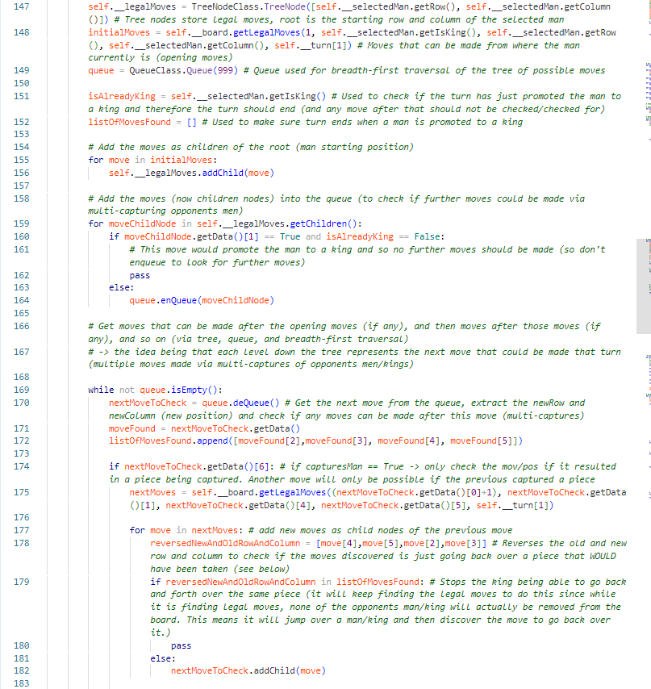

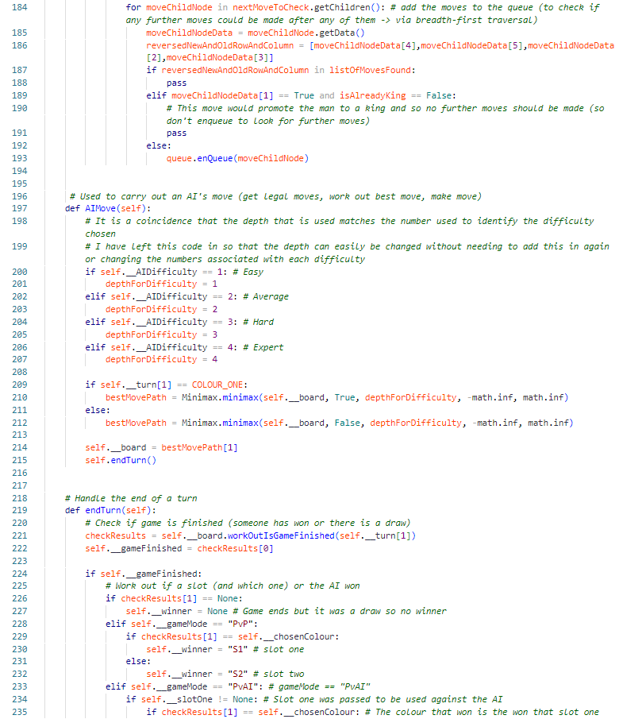

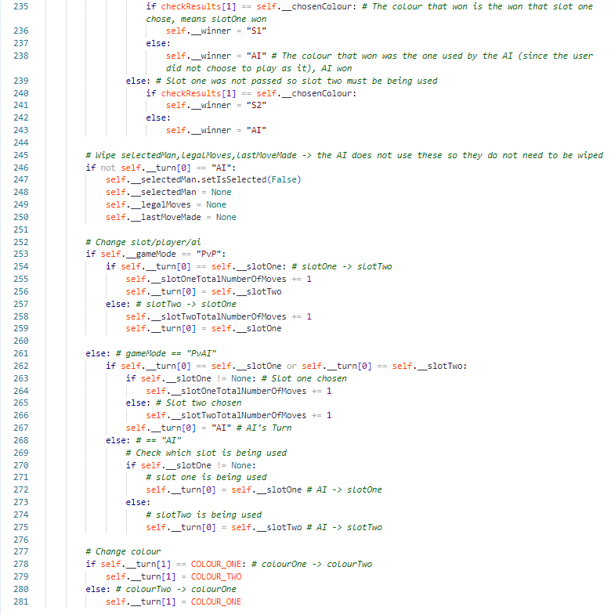

## Window Files

### Start-MainMenuWindow.py

This file is the main file of the programmer and is the file that should be ran first. It creates the pygame window, the AccountSlot() objects, the Database() object, and contains the subroutine “mainMenuWindow” which is used to draw the main menu to the pygame window and handle any events (such as a user clicking on the window).

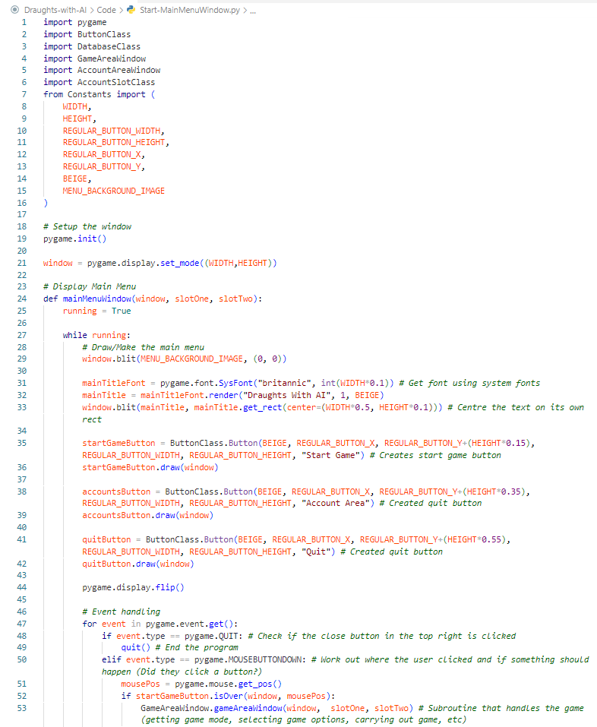

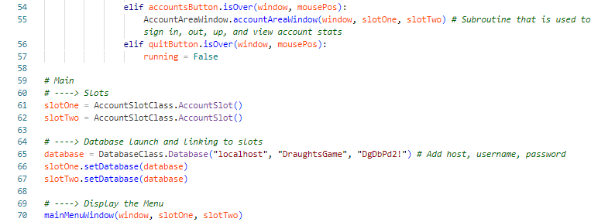

### AccountAreaWindow.py

This file contains subroutines involved with the account side of the game. a**ccountAreaWindow()** is used to display the account area menu which has the options; **Sign In, Sign Up, Sign Out,** and **View Account**. Each option has a subroutine in the file to handle it being chosen. **SignIn()** is used to allow a user to enter a username and password (via **GetUsernameAndPasswordWindow()**) to attempt to sign an account into one of the account slots. **SignUp()** is used to get a username and password, again with **GetUsernameAndPasswordWindow()**, to add a new account to the database. s**ignOut()** is used to get the user to choose a slot so that the account that is in it (if any) can be signed out. v**iewAccount()** is used to get the user to choose a slot so they can view the stats that are stored about the account that is in that slot.

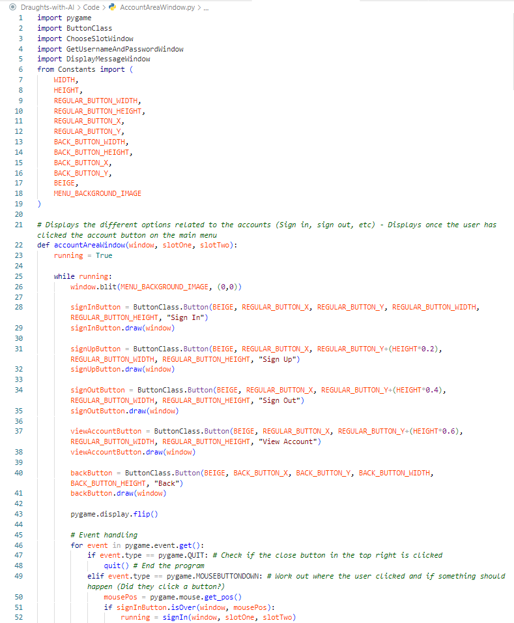

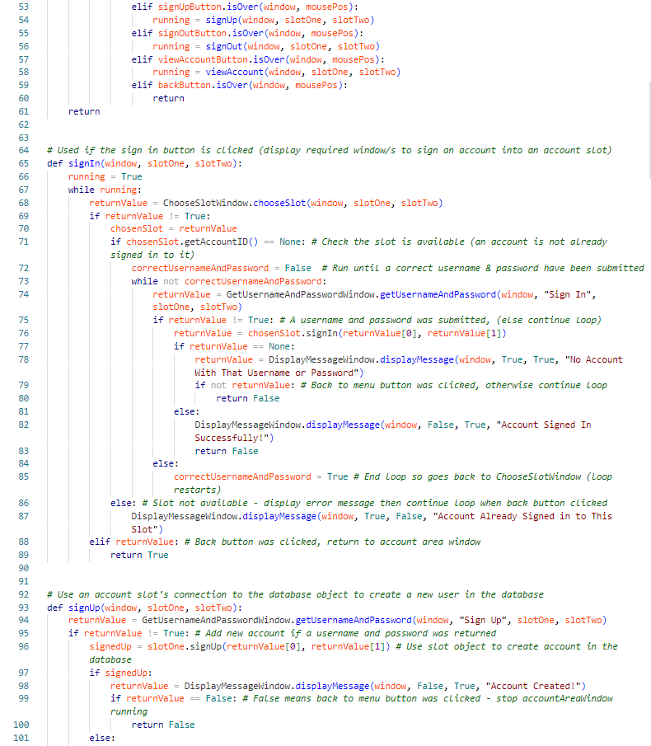

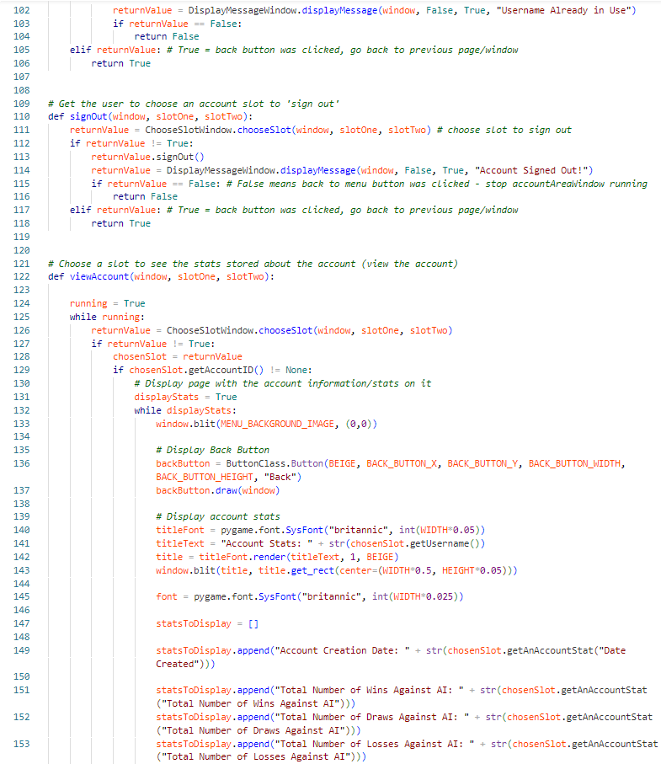

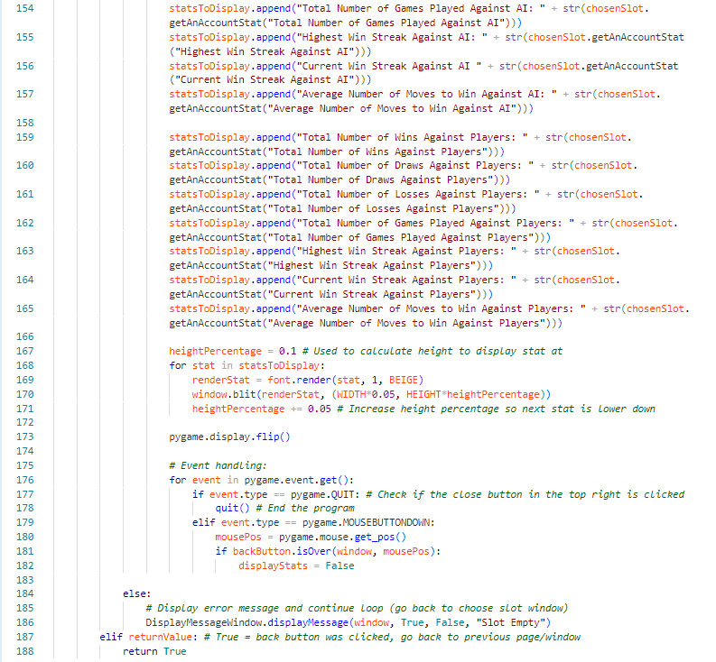

### ChooseSlotWindow.py

This file contains the **chooseSlot()** subroutine which is used to display a window to the user which has a “**Slot One**” and a “**Slot Two**” button. It returns what slot the user has chosen using the buttons. If they click the back button, True is returned (see Pseudocode Examples and Diagram Examples 1.1 and 1.2 for explanation of how “back” and “back to menu” buttons work).

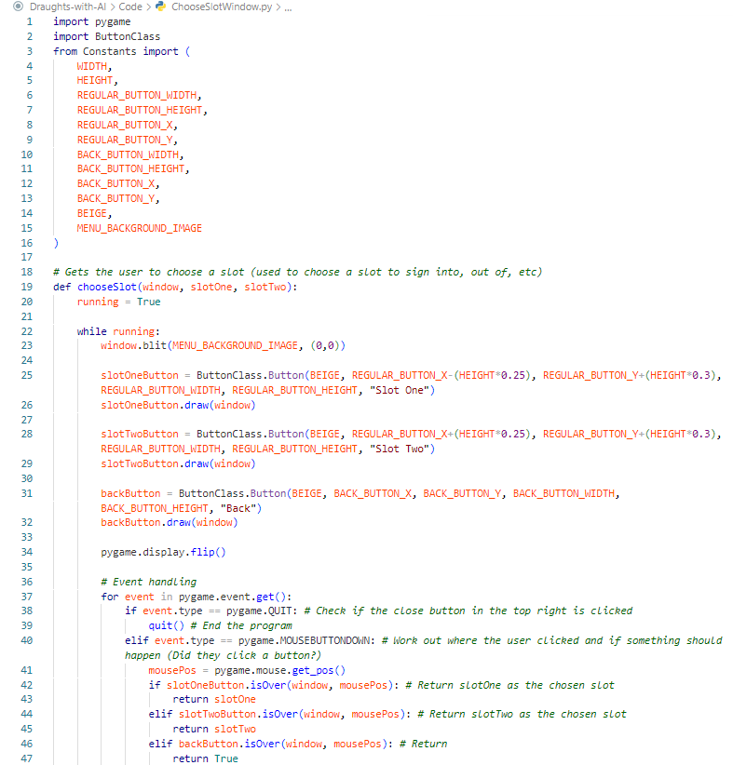

### GetUsernameAndPasswordWindow.py

This file contains the **getUsernameAndPassword()** subroutine which is used to display a window to the user which has two text boxes on it for them to enter a username and a password into. When they click the main button (acts as a submit button but will be named based on how it is being used via **textForButton** argument. This could be “**Sign In” or “Sign Up”.** The username and password are then returned.

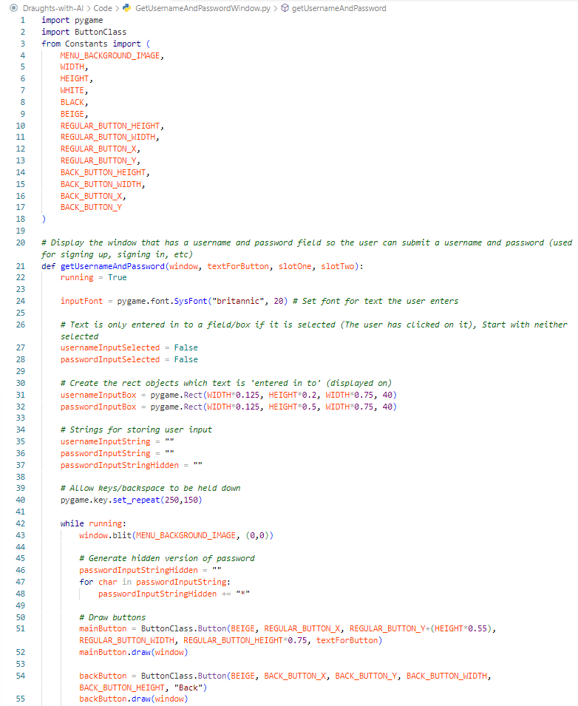

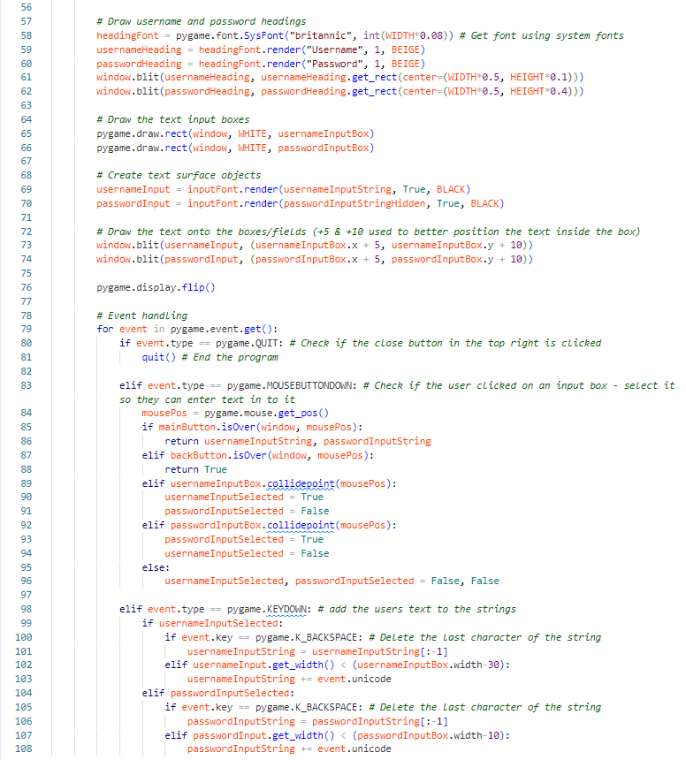

### DisplayMessageWindow.py

This file contains the **displayMessage()** subroutine which is used to display different messages throughout the program. The **enableBackButton** and **enableBackToMenuButton** arguments are used to determine if the window should contain a back button (will always have at least one although it is possible to have none). The **text** argument is used to get the string (the message) that should be displayed to the user. Some examples of this subroutine being used are displaying who won (or if there is a draw) and the end of the game, displaying that an account has been created successfully, and displaying to the user that they have not chosen the required game options (a colour to play as and/or a difficulty for the AI) when they try to start a game without selecting them. The **enableBackButton** and **enableBackToMenuButton** link to the explanation given in diagram examples 1.1 and 1.2 + pseudocode examples 1.1 and 1.2 .

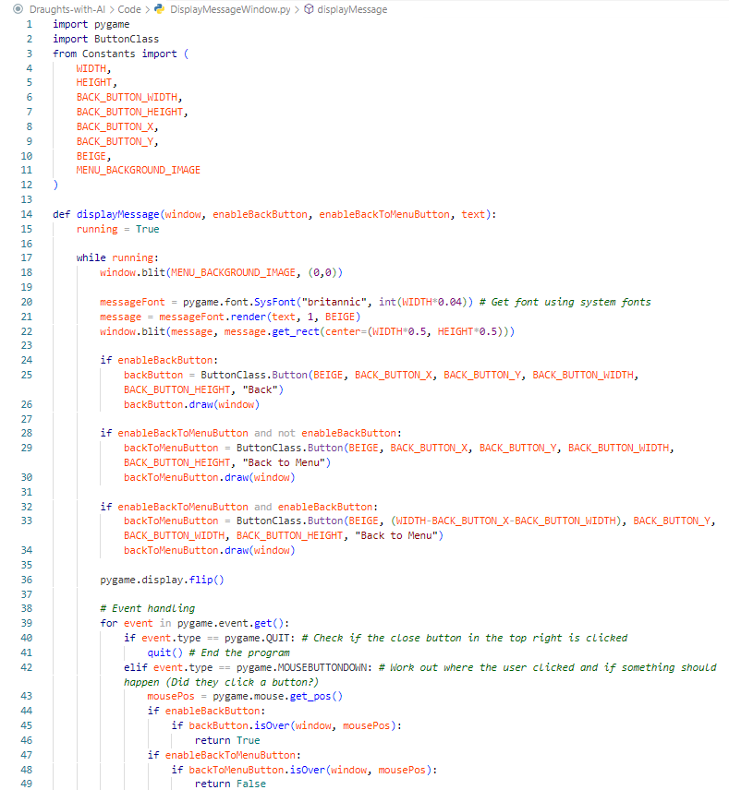

### GameAreaWindow.py

This file contains two subroutines which are used to setup and then run the game. g**ameAreaWindow()** gets the user to choose a game mode (using **ChooseGameModeWindow.py**). It then gets the user to choose the options for the game (using **ChooseGameOptions.py**). It then calls **runGame()** which is used to create a game object and then carry out a game. Once a game has finished, this same subroutine updates the stats for the slots/s. It uses a pygame event loop to let the user click on the pygame window to do things such as select a piece or carry out a move.

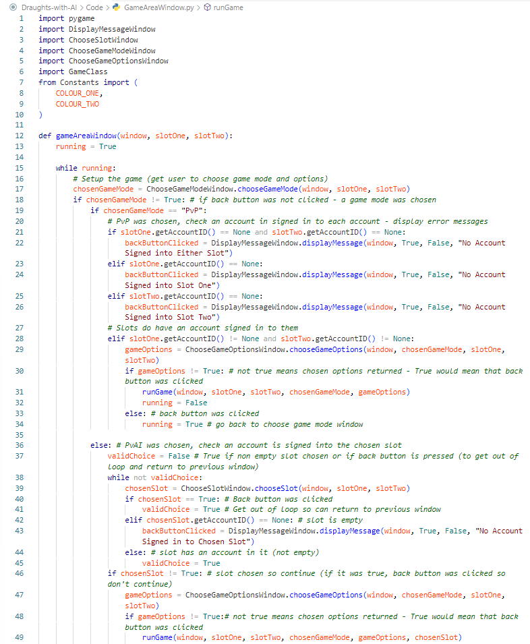

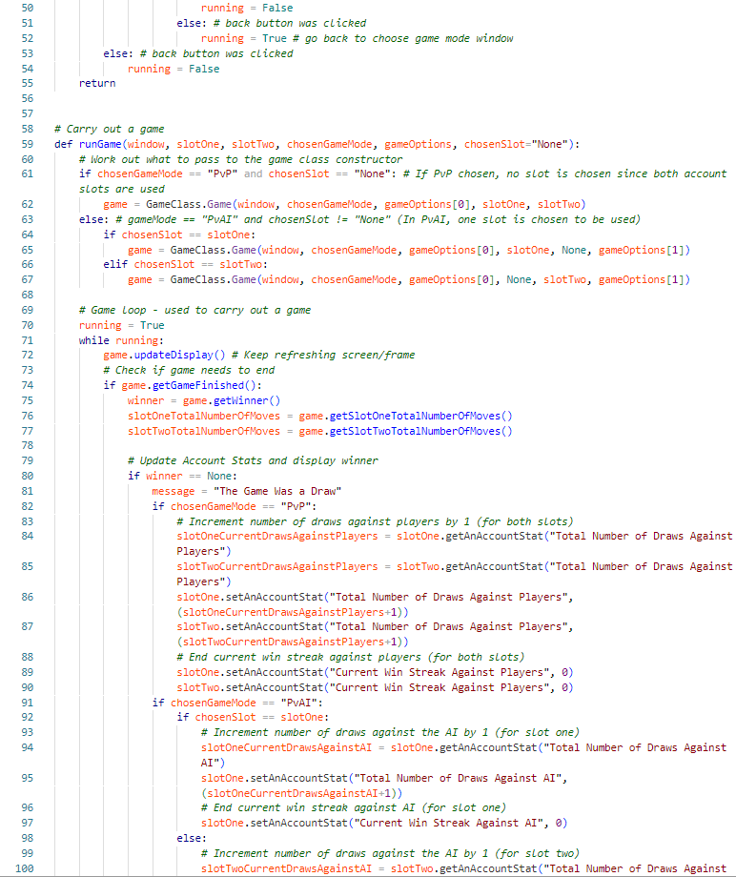

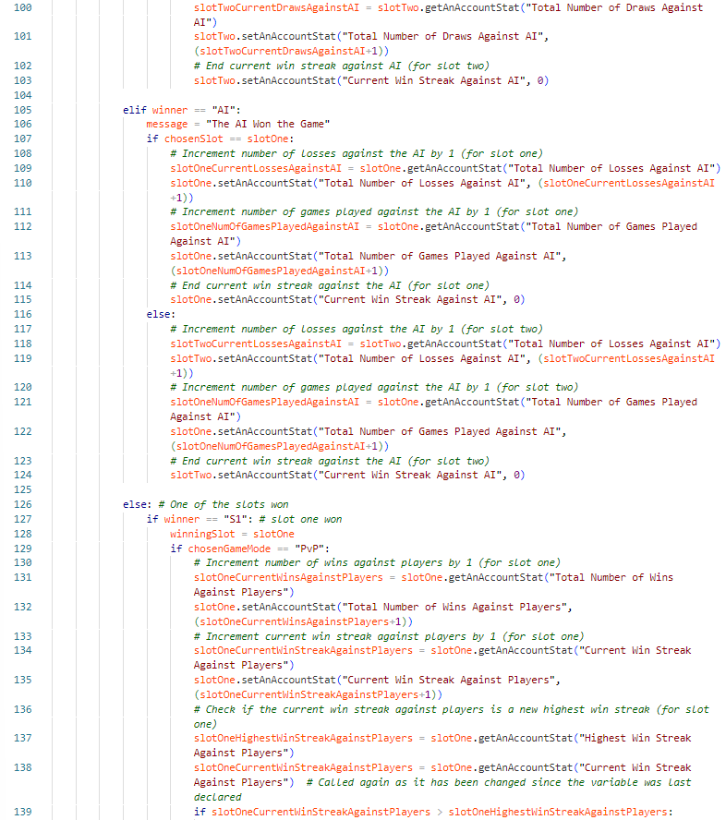

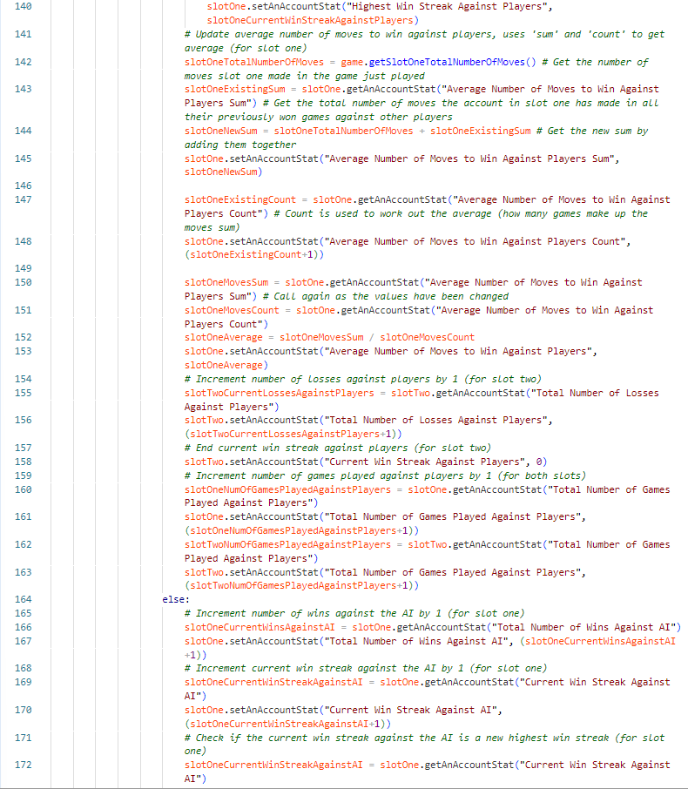

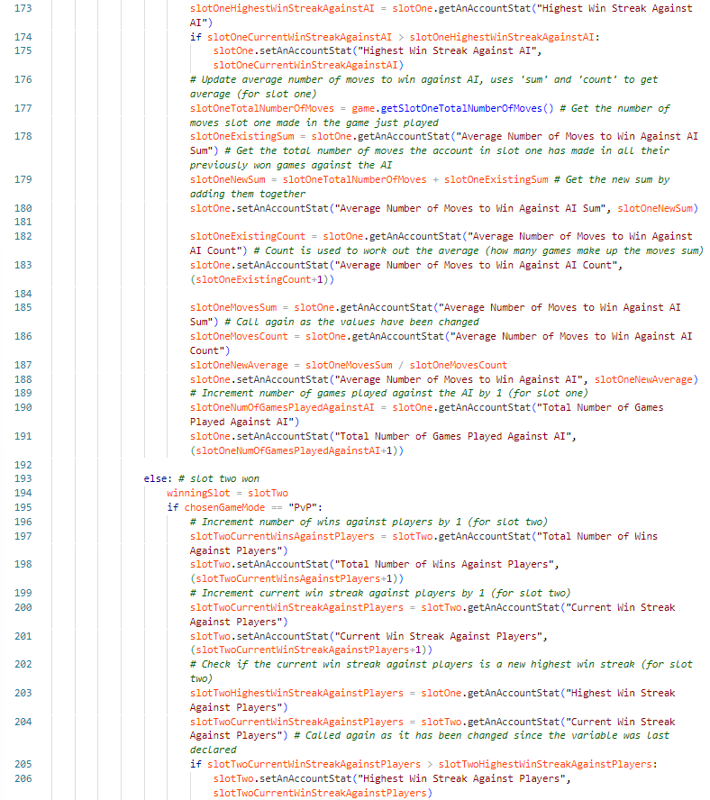

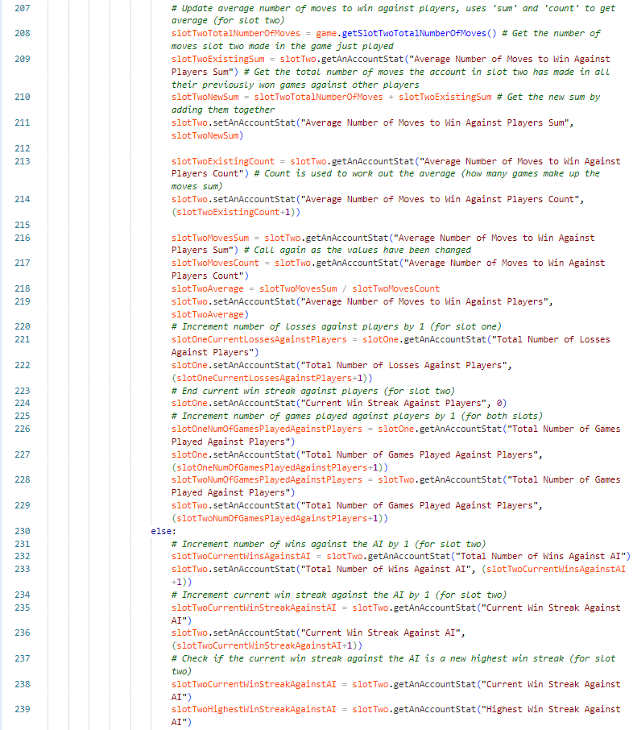

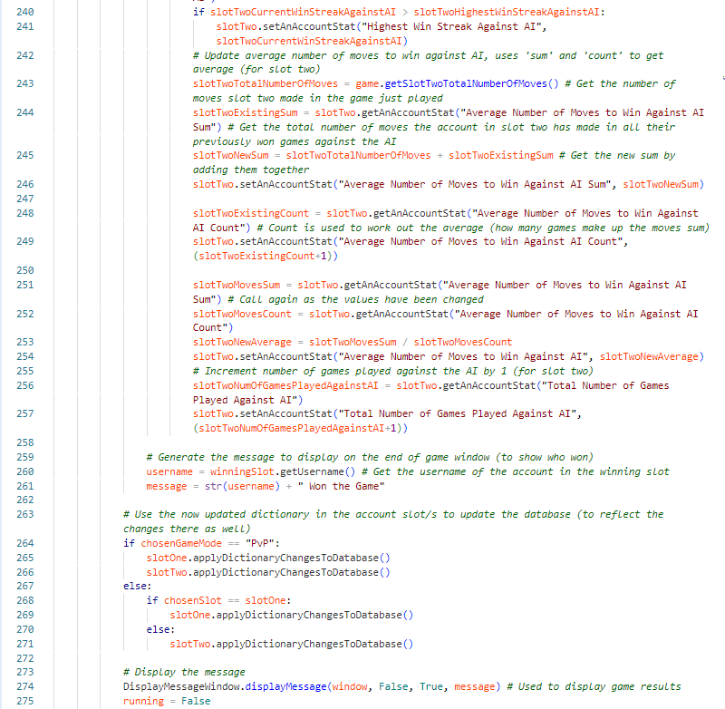

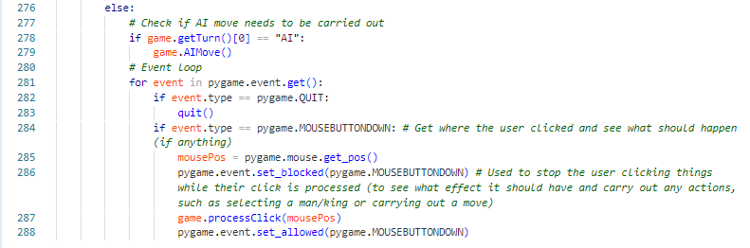

### ChooseGameModeWindow.py

This file contains the **chooseGameMode()** subroutine which is used to get the user to choose which game mode (player vs player or player vs AI). They choose by clicking on the associated button which will then return that game mode name as a string.

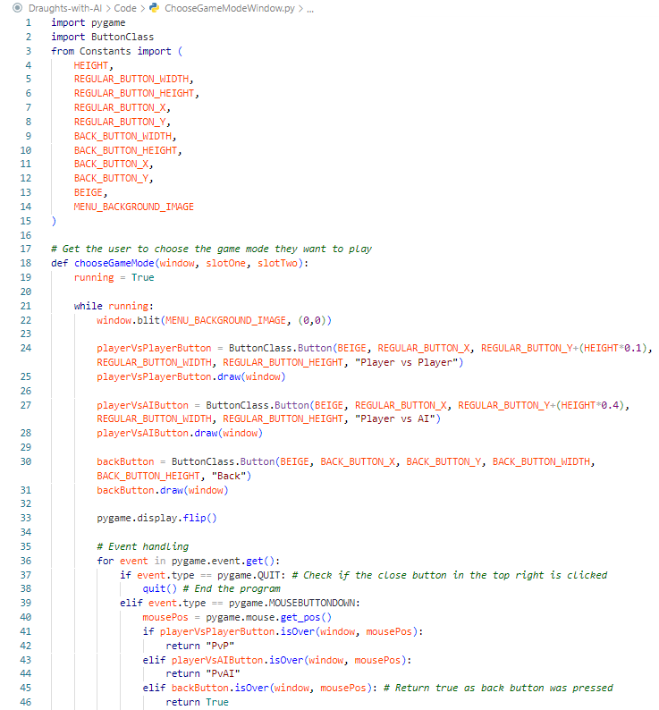

### ChooseGameOptions.py

This file contains two subroutines which are used to setup the game. c**hooseGameOptions()** is used to display a window which will have two buttons to display the colours to choose between to play as. If the game mode is PvP then the chosen colour will be given to slot one. If the game mode is PvAI then the chosen colour will be given to the player (who could be using either slot). If the game mode is PvAI then four buttons will be displayed to allow the user to select a difficulty for the AI. When the user clicks a button, that option will be made selected which means it will be displayed with a red outline to it as well as storing the option in variable. The start button is used to ‘submit’ the chosen options so the game can be started (the options will be returned). This will only happen, if the **areStartGameRequirementsMet()** subroutine returns True. **areStartGameRequirementsMet()** checks to see if a colour has been chosen (and if PvAI, a difficulty chosen as well). If the required options have been chosen, it will return true which will allow **chooseGameOptions()** to return the chosen options as a list.

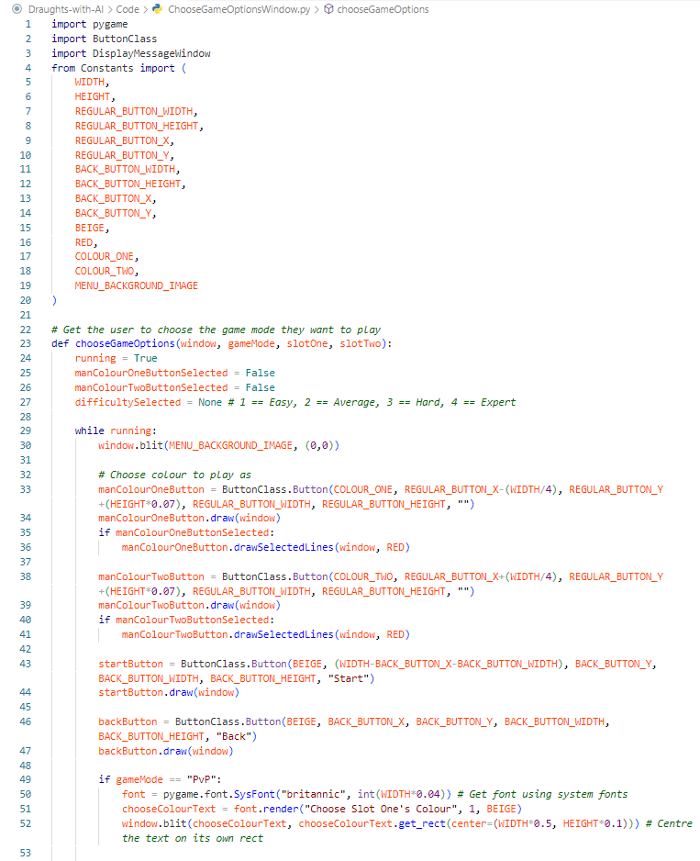

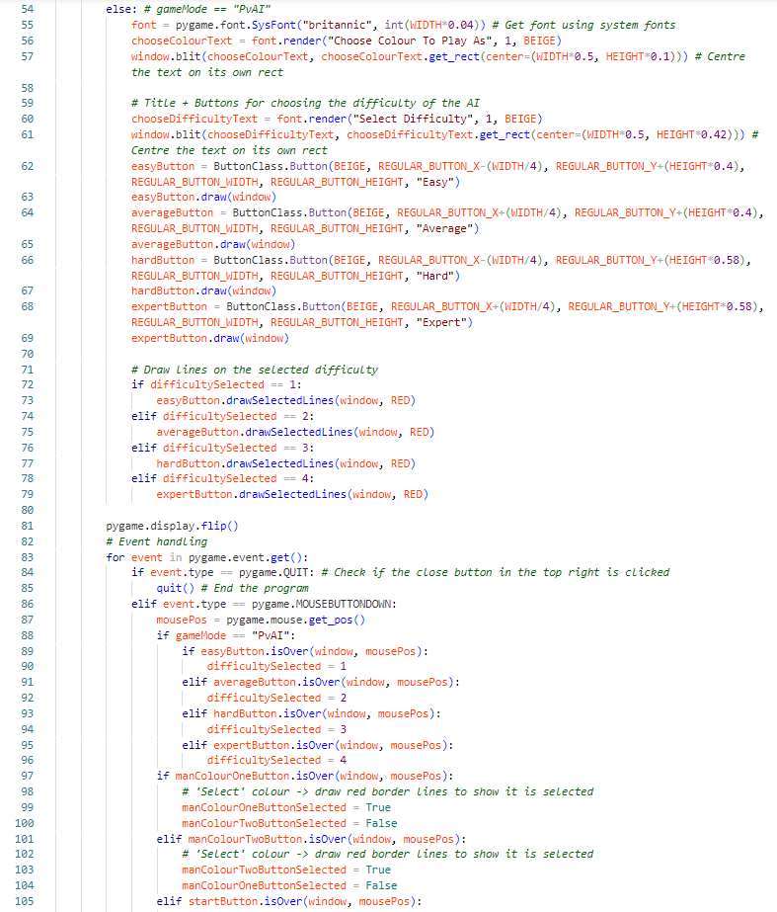

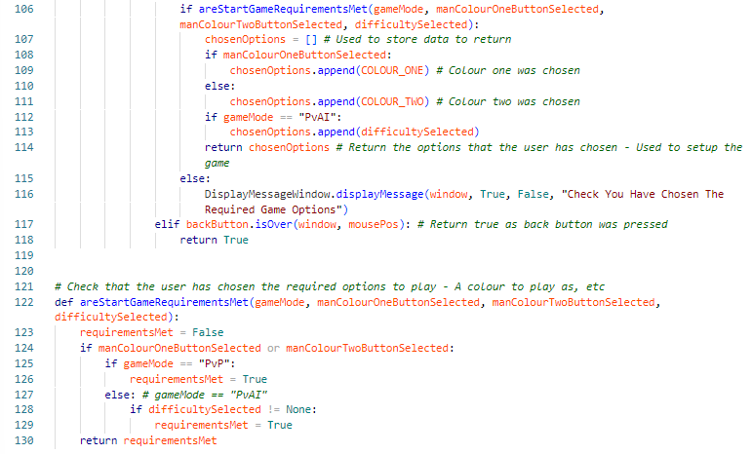

## Graphical User Interface

I have kept my design for the GUI simple so that people of all ages and skill levels will be able to navigate around it easily. I have based the design on the designs of the existing draughts games that I researched. I have made the buttons and text large so that it is easier to read. I have also used the pygame window functionality so that the window size can be adjusted (using the **HEIGHT** and **WIDTH**) constants without parts of the window not working properly, parts being cut off, etc. The size of buttons, fonts, squares of the board, etc will adjust in size if HEIGHT and WIDTH were adjusted so that the window can be resized easily. Below is an image of the main menu and the board during a game to give an idea of what the GUI is like.

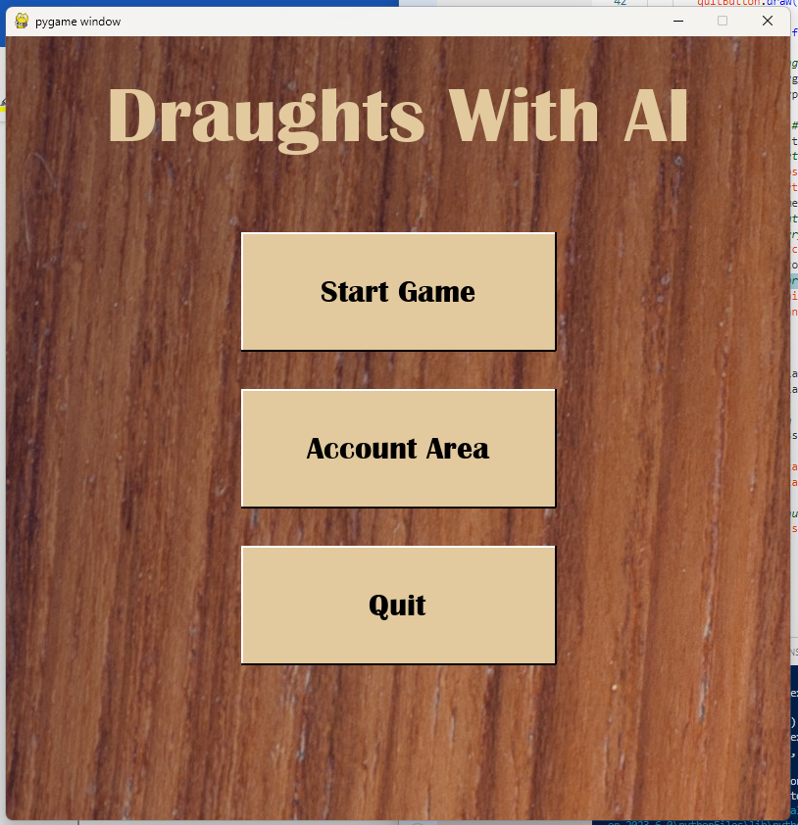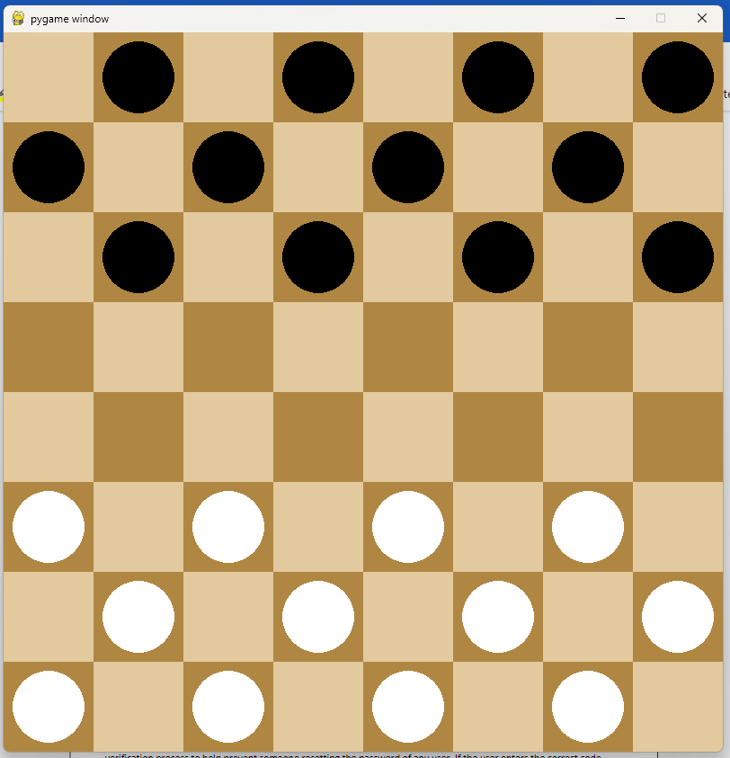

# Testing

Testing will be completed through a table which tests both ‘sides’ of the program. The ‘account area’ and the ‘game area’. The evidence for the tests will be shown through screenshots or within a video or both and will use a mixture of test data to check that the program handles different inputs/situations correctly and without crashing.

|  |  |  |
| --- | --- | --- |
| Test ID | Test Description | Expected Outcome |
| 1 | Accessing account area menu. | Clicking the “Account Area” button on the main menu should update the pygame window to show the account area menu. |
| 2 | Sign in process: Choosing a slot | Clicking the “Sign In” button should get the user to choose a slot to sign into by displaying the choose slot page. If a slot is chosen that already has an account signed into, an appropriate error message page should be displayed. Otherwise, they should be taken to a page which has a username and password input field. |
| 3 | Sign in process: Choosing a slot -> Entering username and password | If a username and password are entered which do not match an account stored in the database, an error message page should be displayed to tell the user this. Otherwise, the account should be signed into this slot and a message page should be displayed to tell the user they have signed in successfully. |
| 4 | Sign up process: Entering username and password | Clicking the “Sign Up” button should display the page for entering a username and password. If they enter a username that is already being used by an account in the database, the account should not be created, and an appropriate error message page should be displayed. Otherwise, the account should be created (in the database) and an appropriate message page should be displayed. |
| 5 | Sign out process: Choosing a slot | Clicking the “Sign Out” button should display a choose slot page. When the user chooses a slot, the signOut() method of the slot should be called to sign out any account that might be in that slot. An appropriate message page should then be displayed to tell the user this has been completed. |
| 6 | View account process: Choosing a slot | Clicking the “View Account” should display a choose slot page. If they choose a slot which does not have an account signed into it, an appropriate error message page should be displayed to tell the user this. Otherwise, the stats stored about that account should be displayed. |
| 7 | Choosing a game mode | Clicking the “Start Game” button on the main menu should display the choose game mode page. |
| 8 | Choosing PvP | When the “Player vs Player” button is selected, a check should be made to see if both account slots have an account signed into them. An appropriate error message page should be displayed telling the user which slot does not have an account signed into it or that both slots do not have an account signed into them. If both slots have an account signed into them, the choose game options page should be displayed. |
| 9 | Choosing PvAI | When the “Player vs AI” button is selected, the user should be shown the choose slot window. This is so they can choose which slot/account they want to use to play against the AI. If the slot chosen is empty (no account signed into it), an appropriate error message page should be displayed. If the chosen slot does have an account signed into it, the choose game options page should be displayed. |
| 10 | Choosing PvP Game Options | If PvP was chosen, the choose game options page should let the user choose which colour slot one will use (and the other colour will then be assigned to the other slot). The colour that the user has currently selected should have a red outline around to show which is currently selected and what will be used if they continue, to start the game. |
| 11 | Choosing PvAI Game Options | If PvAI was chosen, the choose game options page should let the user choose which colour slot will be used by them (the slot they have chosen) and what difficulty the AI should have (out of the 4 options: Easy, Average, Hard, Expert). The colour and difficulty that the user has currently selected should have a red outline around to show which options are currently selected and what will be used if they continue, to start the game. |
| 12 | Starting a game | Once a user has chosen the game option/s, they can click the “Start” button to begin a game. When they click this button, a check should be made that they have actually chosen the required game options (a colour and, if they chose PvAI, a difficulty for the AI). If they have not, an appropriate error message page should be displayed. If they have, the game should be setup and the pygame window updated to show the board and pieces. |
| 13 | Selecting a man/king | When the user clicks a man/king which belongs to them and during their turn, the man/king should be ‘selected’. Its legal moves should be found and displayed, and a ring drawn around the man/king to show that it is selected. If the user tries to select a different man/king while already having one selected that has started a move chain/path, they should not be able to. If they have a man that has not moved but is selected, they should be able to select another man/king or unselect the man/king by clicking an empty square (that is not a legal move). |
| 14 | Making a move (player) | A player should be able to make a move by ‘selecting’ a man/king and clicking the blue circles which indicate legal moves that the piece could make from its current position. A players turn should end when they have completed a ‘move path’ (they have moved until the man/king cannot make any more legal moves this turn). |
| 15 | Man to king promotion | When a man reached the opposite end of the board, it should be promoted to a king piece. This should mean it has a crown drawn over it and it can now move any direction diagonally. |
| 16 | Man/king capture | When a capture is made, the captured piece should be removed from the game and the capturer should be able to make further captures if there are any legal captures possible. |
| 17 | Checking if a game is over. | When a turn ends, checks should be carried out to see if the game should end or not. |
| 18 | AI’s turn | When it is an AI’s turn, minimax should be run and a deepcopied Board() object returned. This board should be used to overwrite the board that is currently being stored in the Game() object. This should mean that the AI’s turn ends and the pygame window is updated to show the updated board (that has the AI’s turn applied). |
| 19 | AI’s Difficulty | The difficulty option the user selected when setting up a game should have an expected effect on the difficulty/skill of the AI (it should take longer for minimax to run, and the AI should be more difficult to beat). |
| 20 | End of a game: Updating account stats | After a game has ended, the stats stored in the account slot’s dictionary should be updated (if PvP both slots will have changes to their stats. If PvAI only the slot used will have changes to its stats). These changes should also then be made to the stats stored in the database. |
| 21 | End of game: displayed message page | After a game has ended, a message window should be displayed to tell the user who won (the AI, slot one, slot two) or if the game was a draw. |

## Testing Evidence

Testing Evidence will be done through screenshots of the game as well as a video showing the program working (<https://www.youtube.com/watch?v=Tv95V3P-I30> ). Below there will be a section for each of the tests in the table above. Screenshot evidence will be given as well as the video which will cover many of these tests.

### Test 1

The screenshot shows what is displayed in the pygame window after the “Account Area” button has been clicked. It shows the correct page, with the correct options (sign in, etc). This test will also be proven in the video.

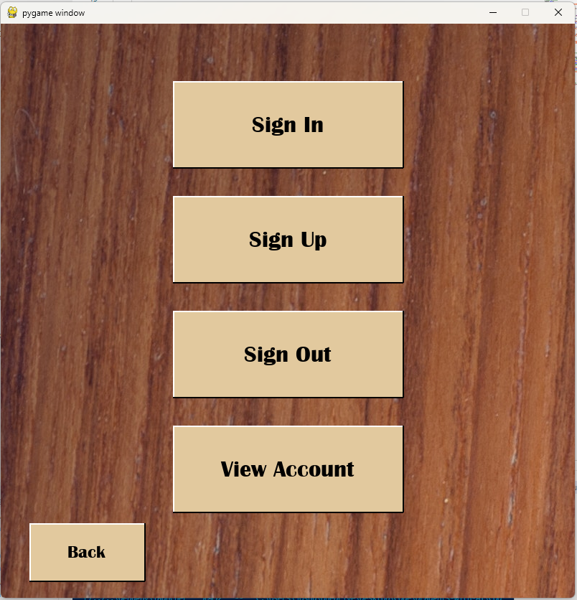

### Test 2

The screenshots below show the choose slot page, appropriate error message page and the username and password input page. The video shows an account be signed into a slot successfully.

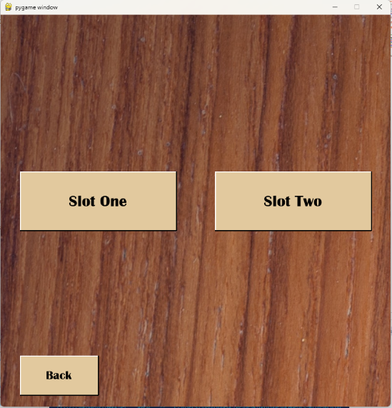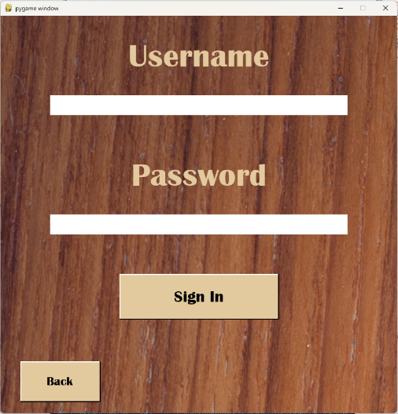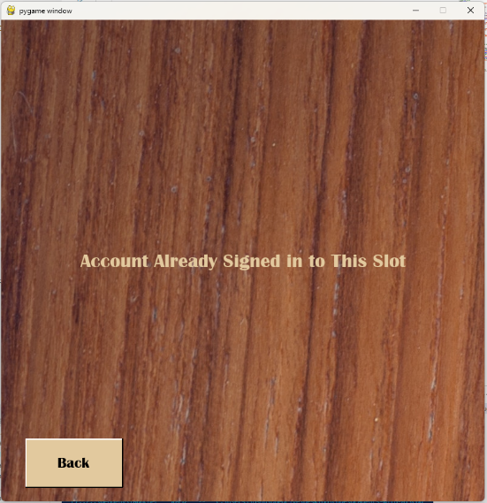

### Test 3

The screenshots show the success message page and the error message page. The success message page can be seen in the video.

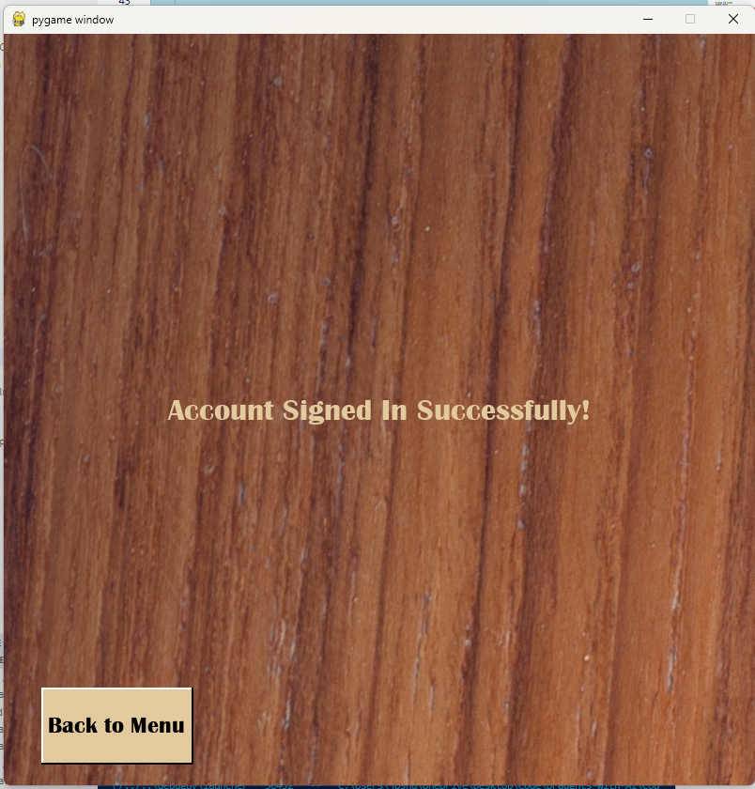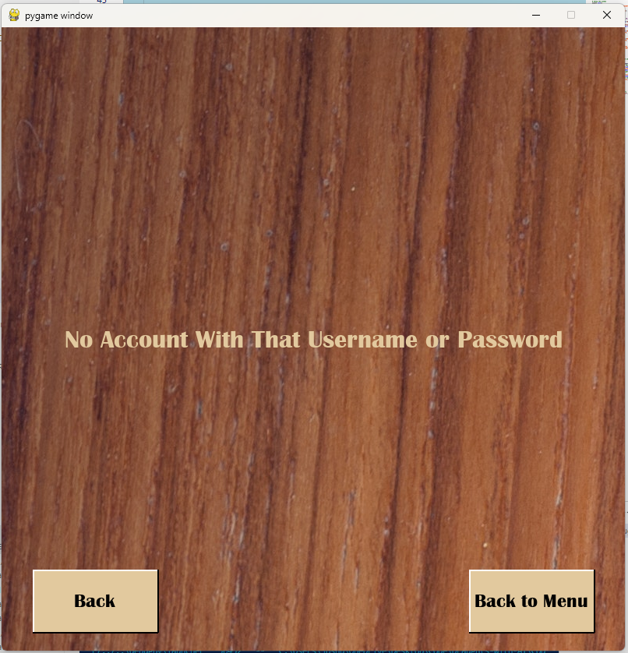

### Test 4

The screenshots below show the username and password input page as well as the success message page and the error message page. There are also two screenshots (before and after) of part of the database to show the account has been created. The video will show an account being created and show how the database changes.

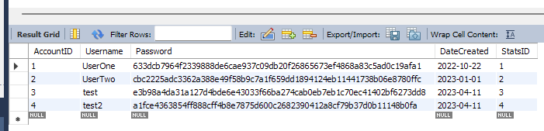

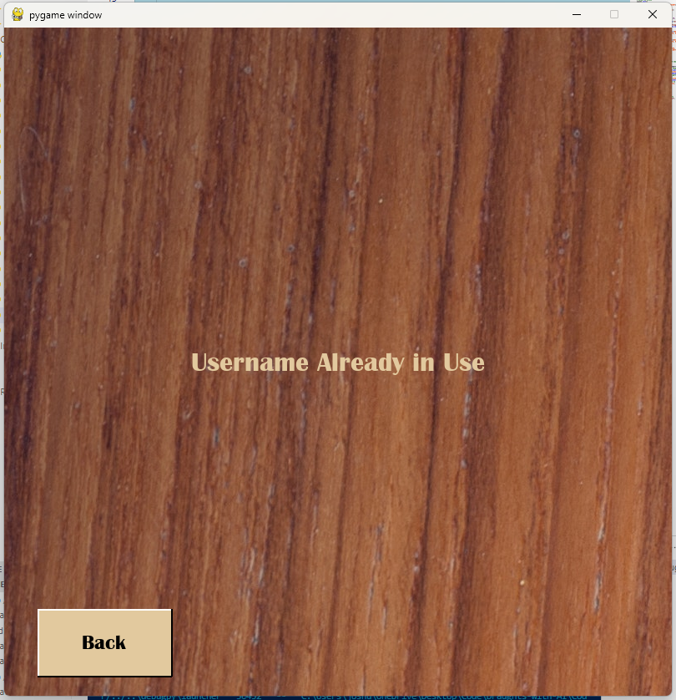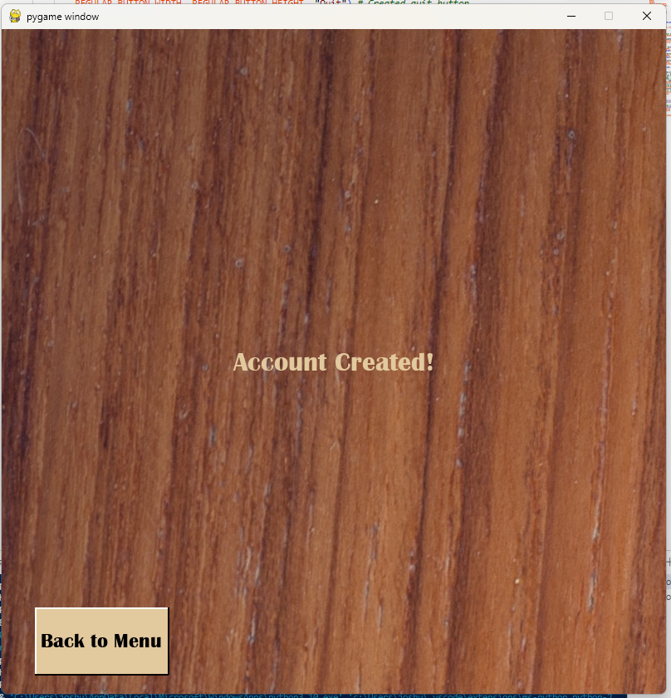

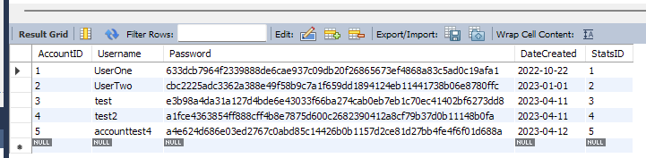

### Test 5

The screenshots below show the choose slot page being displayed and the success message page. Signing out will also be shown in the video.

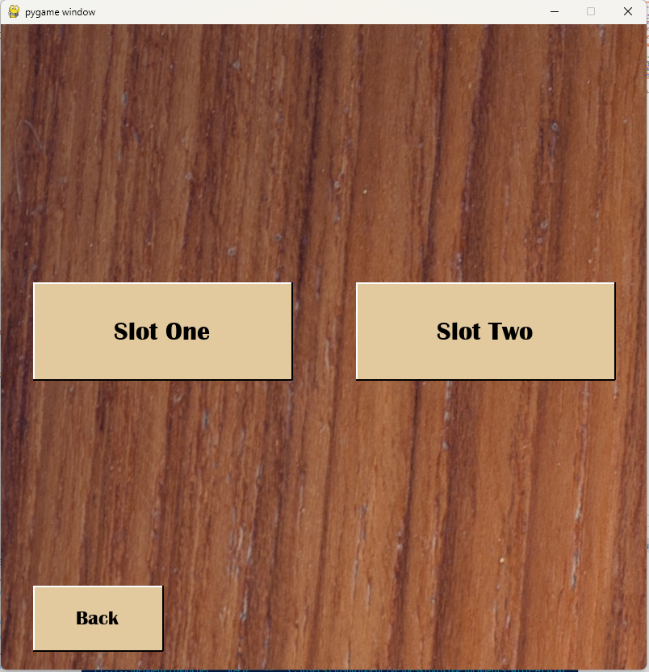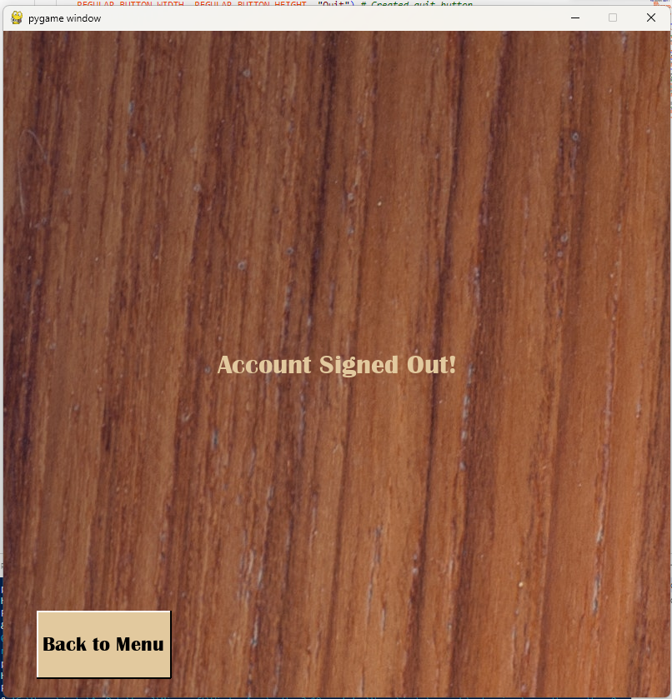

### Test 6

The screenshots below show the choose slot page, the error message page, and the page showing the stats of an account in the chosen slot. The video will show also show the stats of an account being viewed.

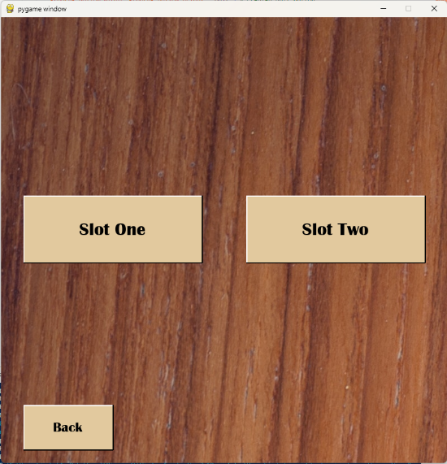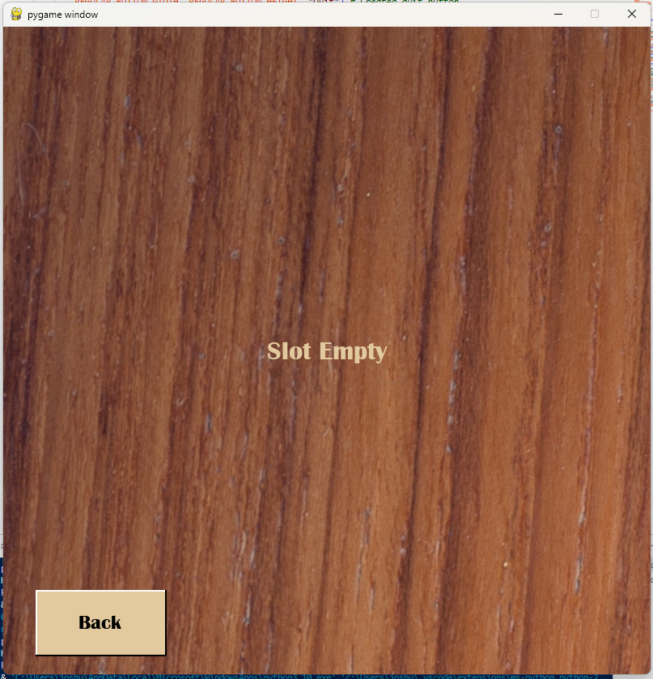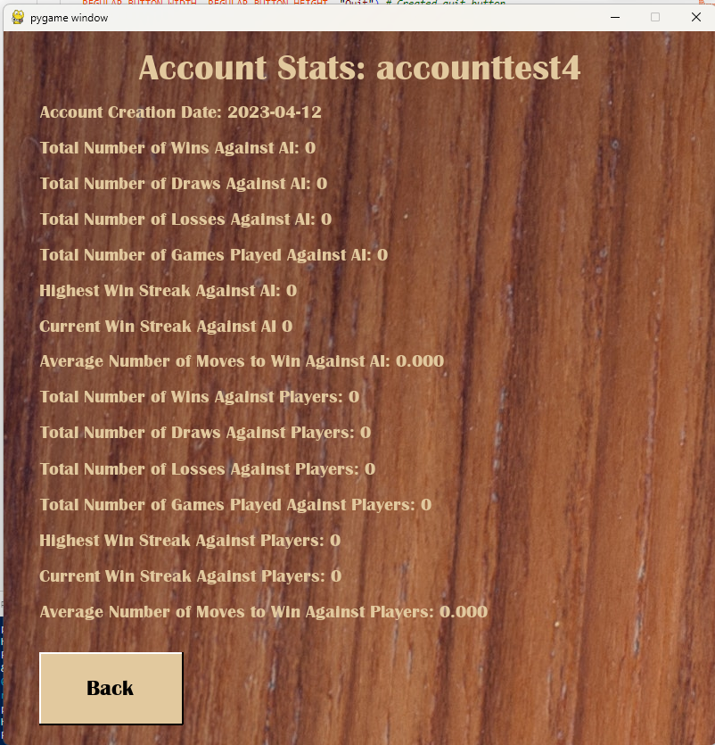

### Test 7

The screenshot below shows the choose game mode page being displayed. This will also be shown in the video.

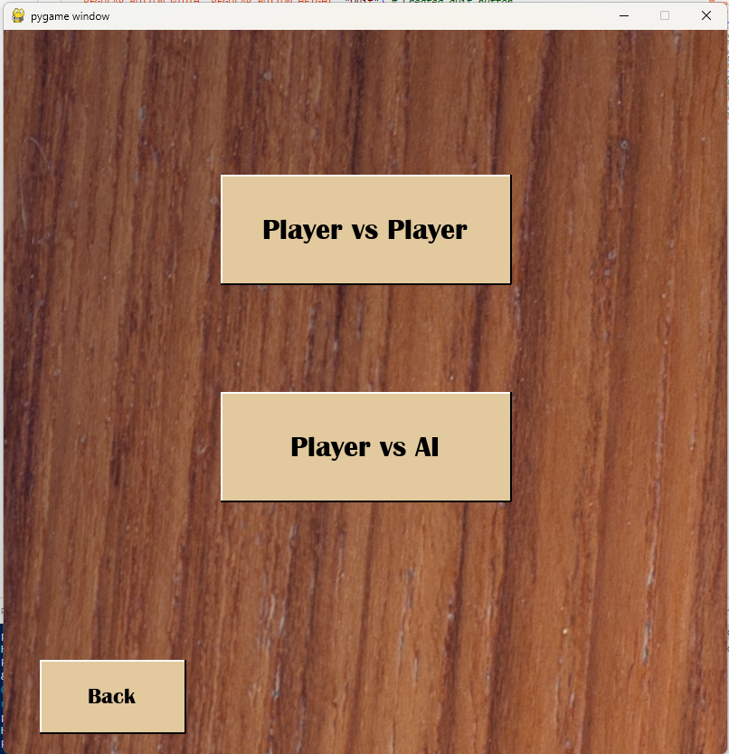

### Test 8

The screenshots show the different error messages that can be displayed as well as the game options page (which is displayed if there is no error). The video shows this option being selected and the game options page then being displayed.

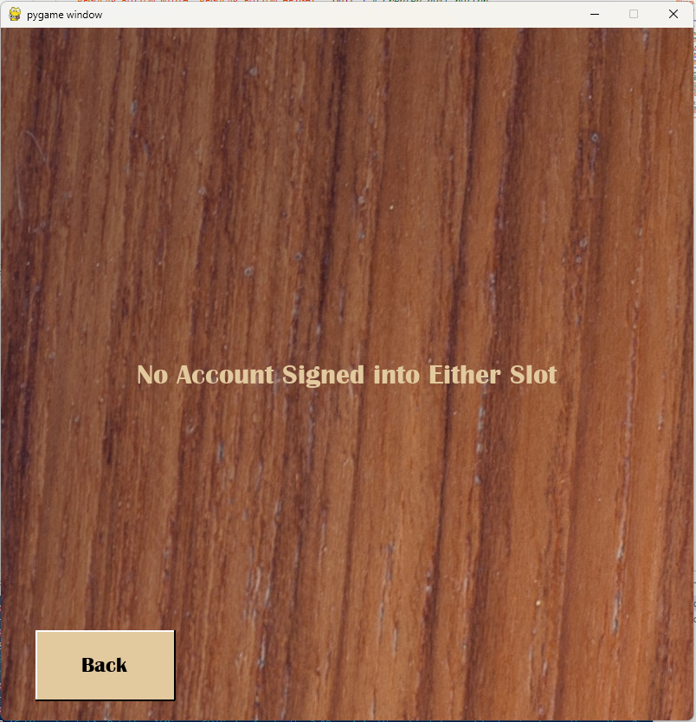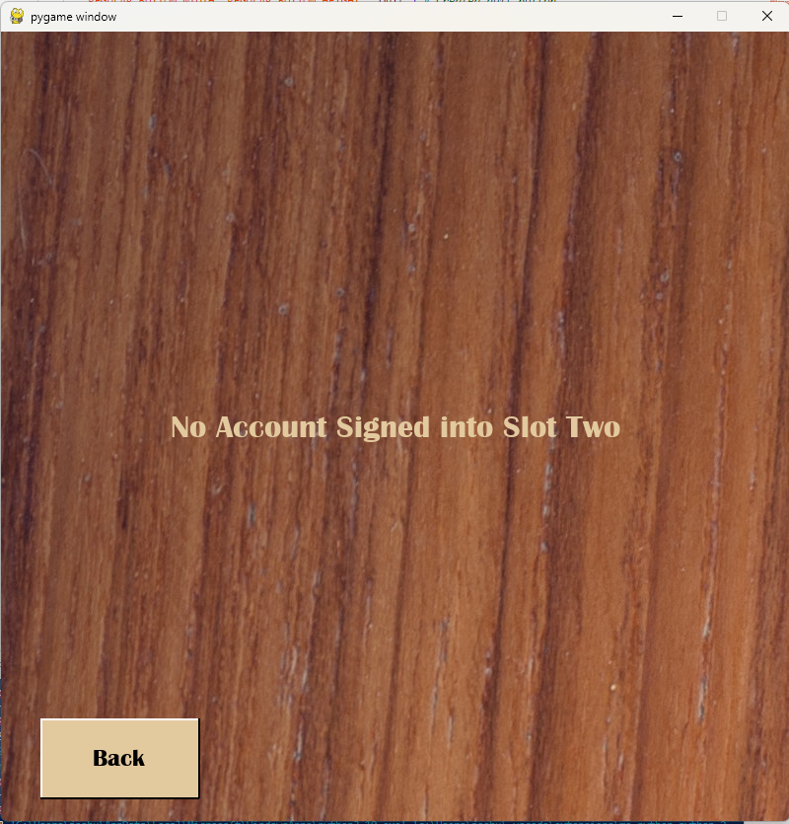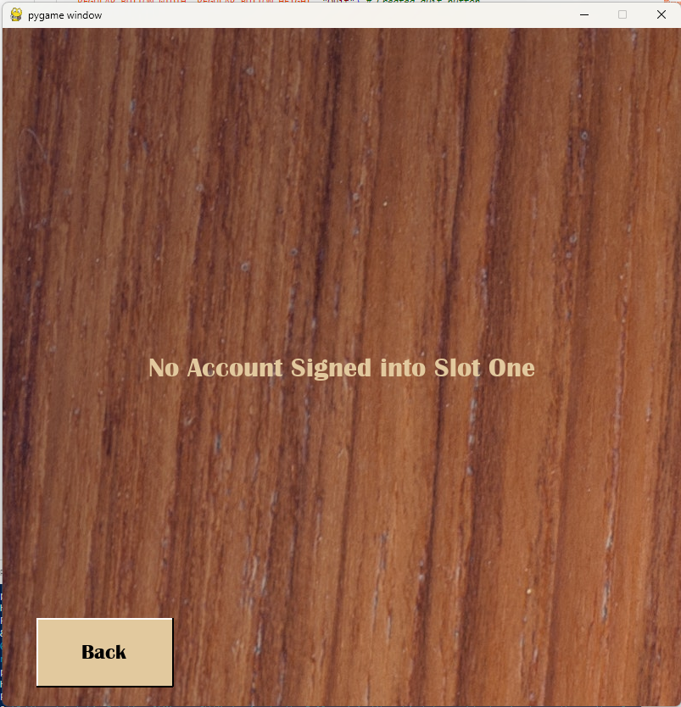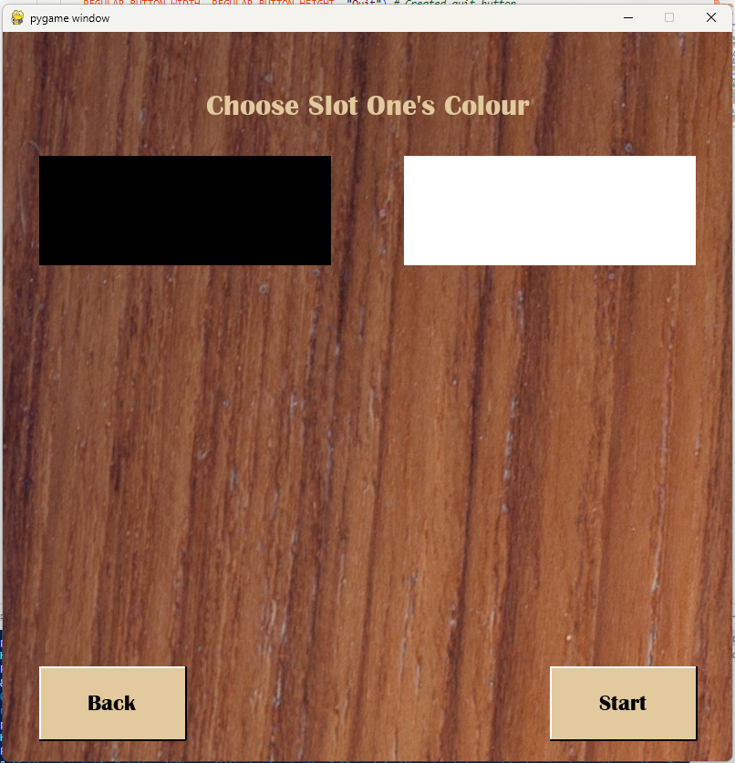

### Test 9

The screenshots show the choose slot page, the error message page, and the game options page (which is displayed if there is no error). The video shows this option being selected and the game options page then being displayed.

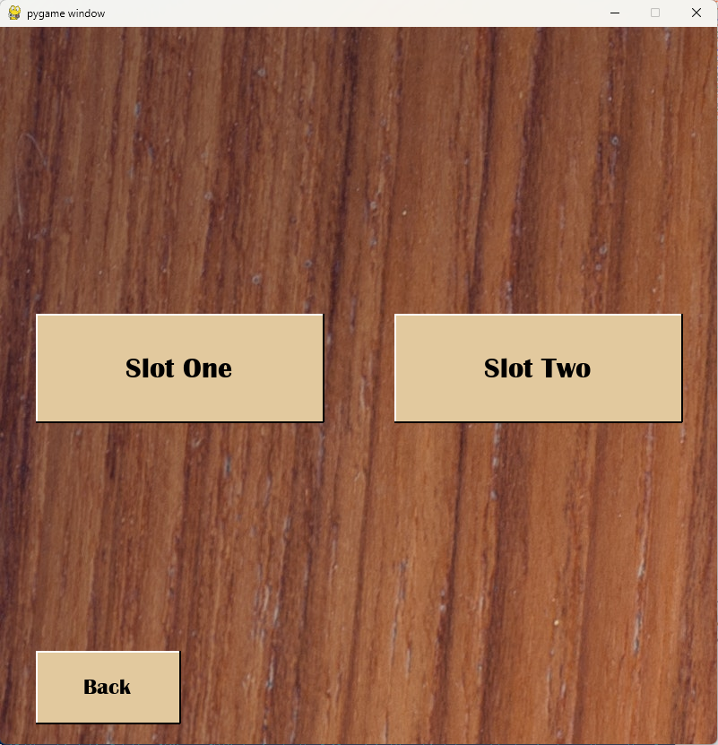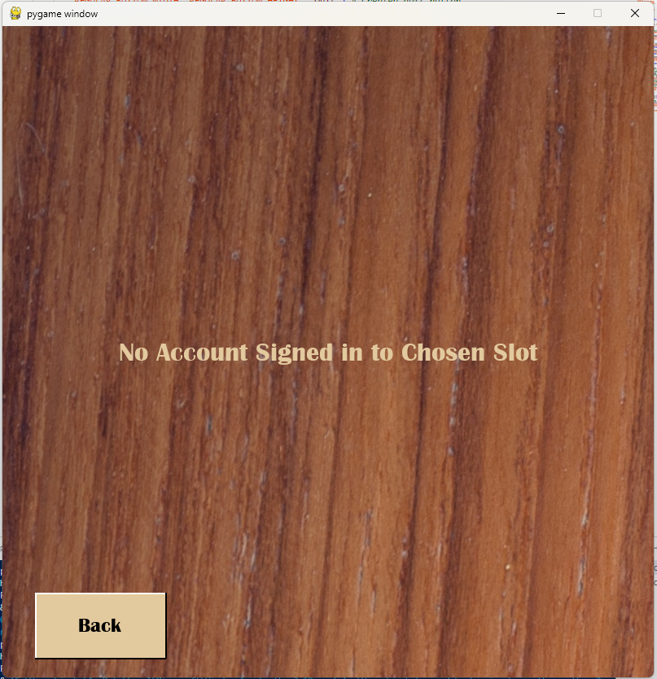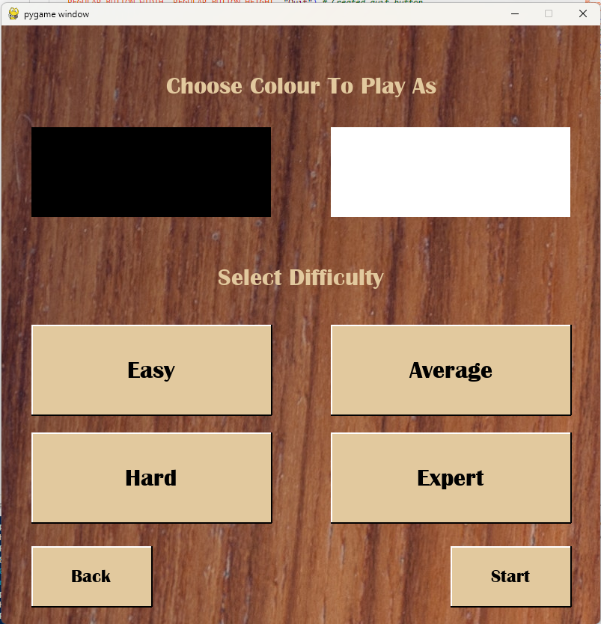

### Test 10

The screenshot shows the game options page with a colour selected, showing the red outline to show to the user which option they have selected. This will also be shown in the video.

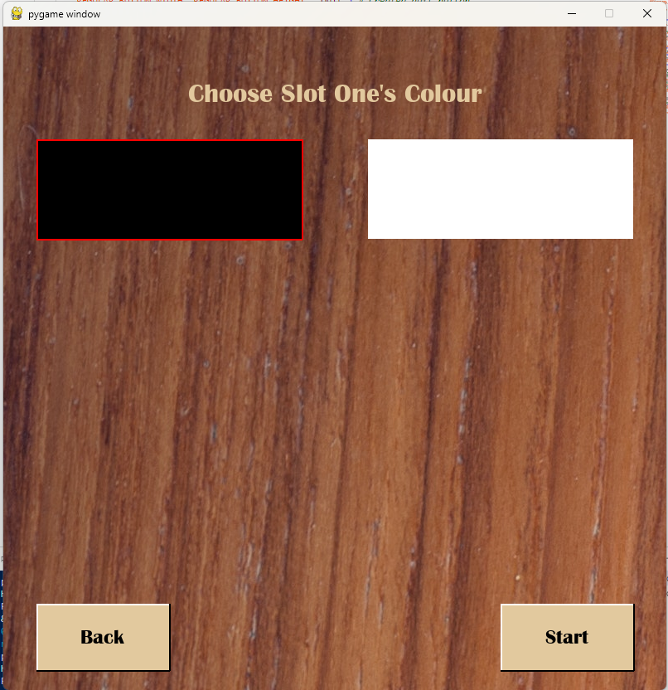

### Test 11

The screenshot shows the game options page with a colour and AI difficulty selected, showing the red outline to show to the user which option they have selected. This will also be shown in the video.

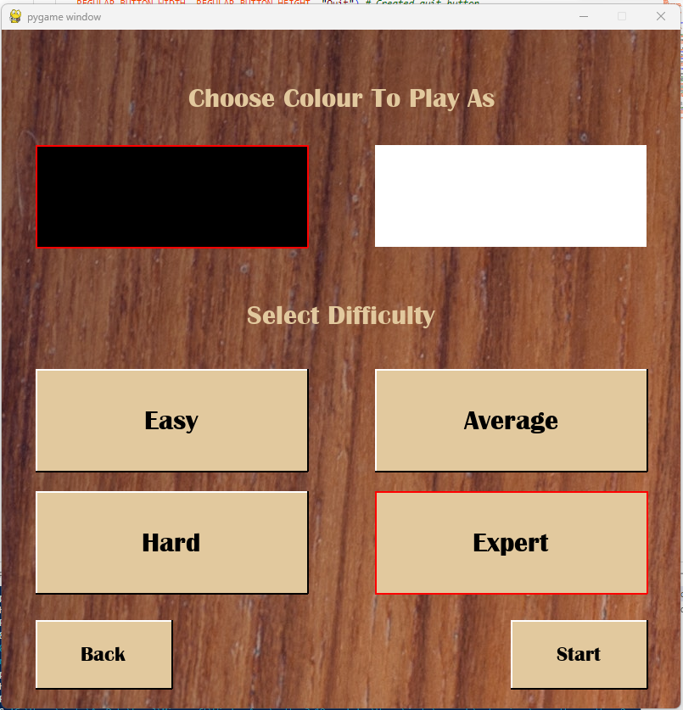

### Test 12

The screenshots below show the error message page and the board (which will be shown if the user has chosen the required game options for the game to start). The video will show the options being selected and a game starting.

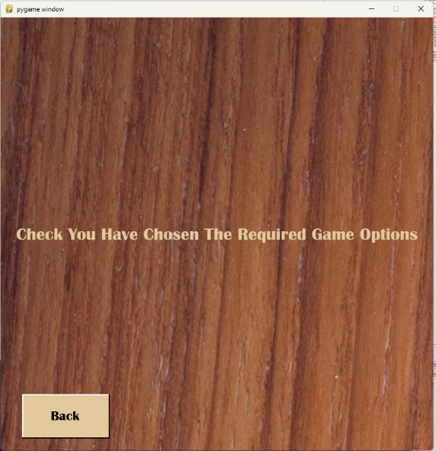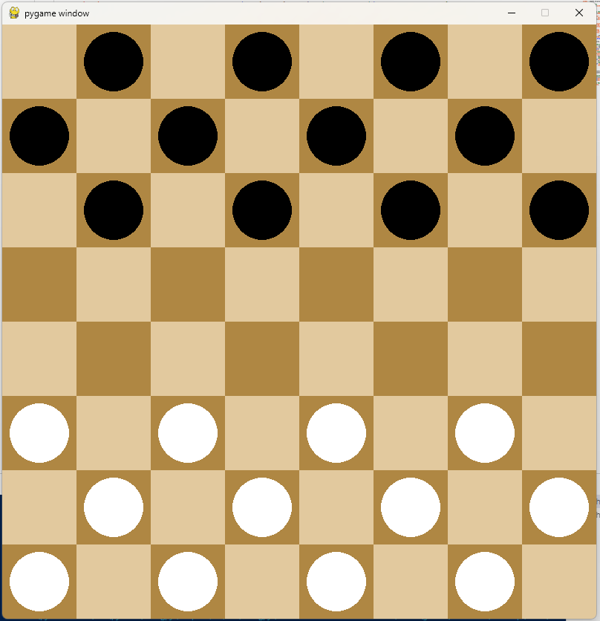

### Test 13

The screenshot below shows what the board will look like when a player has selected one of their pieces. This test is better proven and shown through the video.

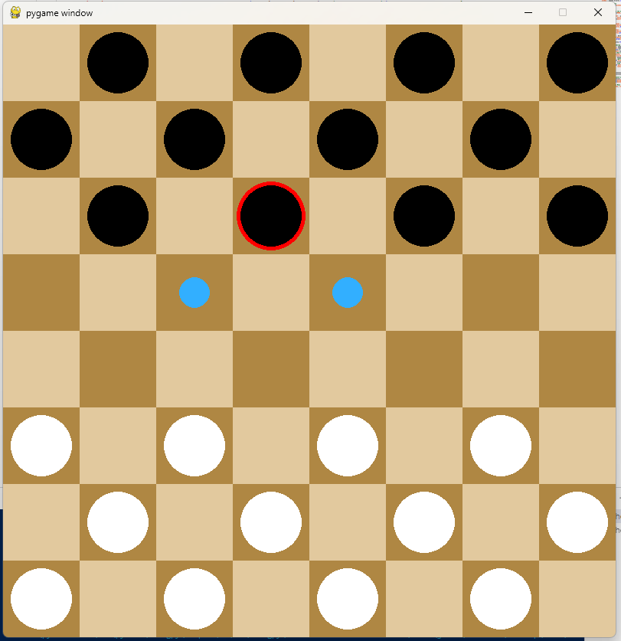

### Test 14

The screenshot below continues from the screenshot above showing that a move was made when the user clicked the blue circle which shows the user where they can legally move from the man/king’s current square. Like the previous test, this is better shown through the video.

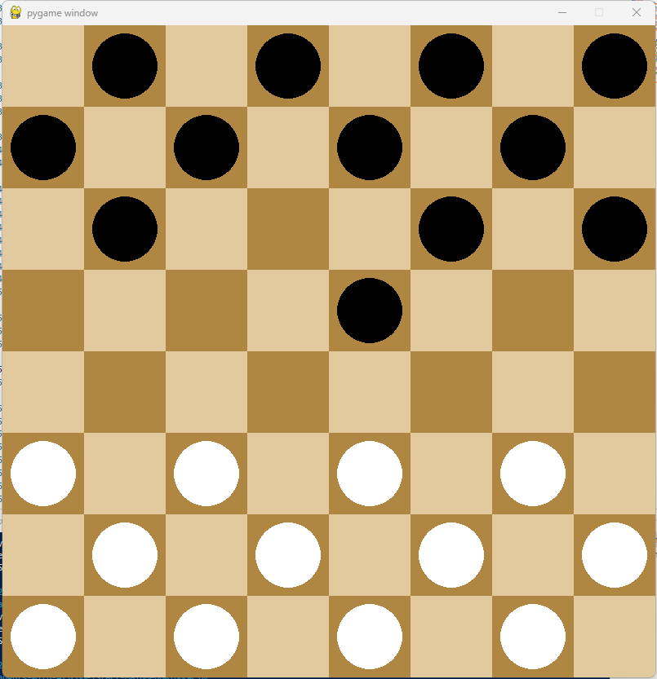

### Test 15

The screenshot below shows a board which has had a man reach the opposite side and therefore been promoted to a king. The video shows this test better as you can see the piece move and then being promoted.

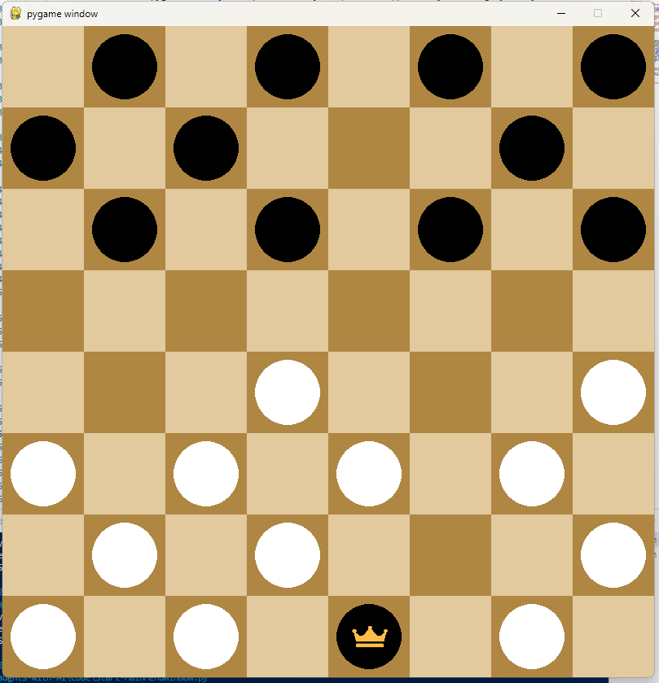

### Test 16

The screenshots below show and ‘before and after’ of the board and shows that a capture has been made and the captured man removed from the game. The capture is made from (counting from 0, as is done in the game) row 2, column 1 -> to row 4, column 3. The piece that was captured (in row 3, column 2) has been removed from the game/board. The video shows many examples of captures being made (regular moves, single captures, chain/multi-captures).

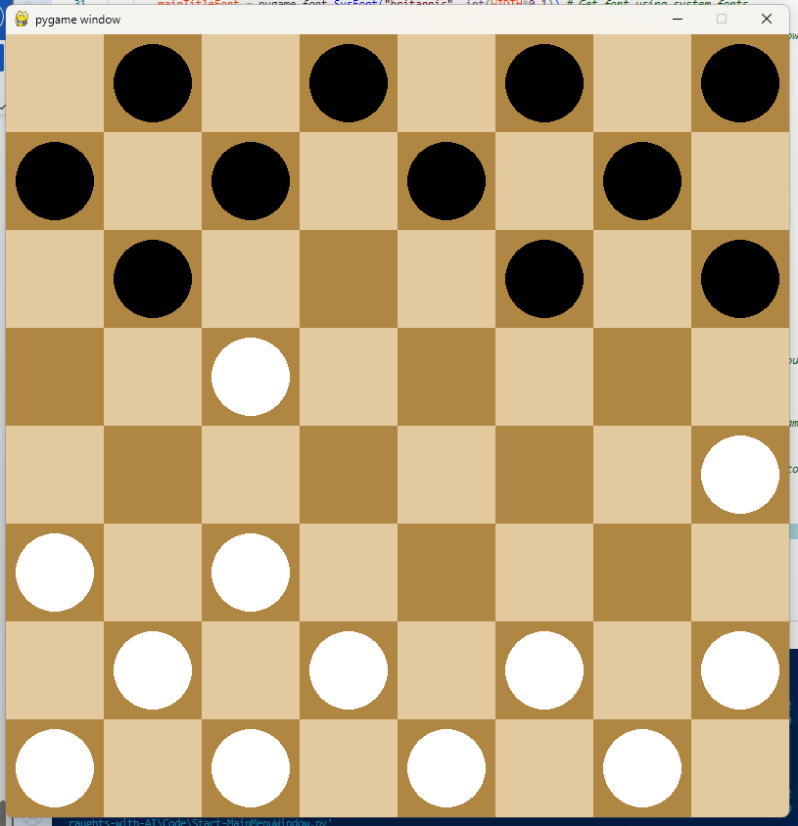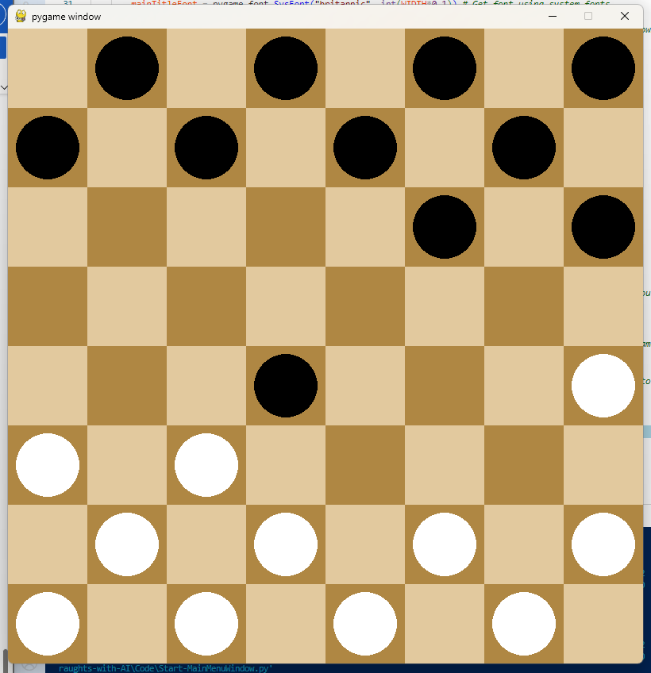

### Test 17

This test cannot really be shown through the GUI/pygame window and so the first screenshot below shows the code in the endTurn() method which checks if the game is over (by using the workOutIsGameFinished() method). The second screenshot is from the runGame() subroutine in GameAreaWindow.py and shows where in the loop it checks if the game is over (and therefore stops the pygame event loop and game from running). endTurn() is called and the end of every turn and so this meets the test description. The video shows games being played and then ending as a result of this code.

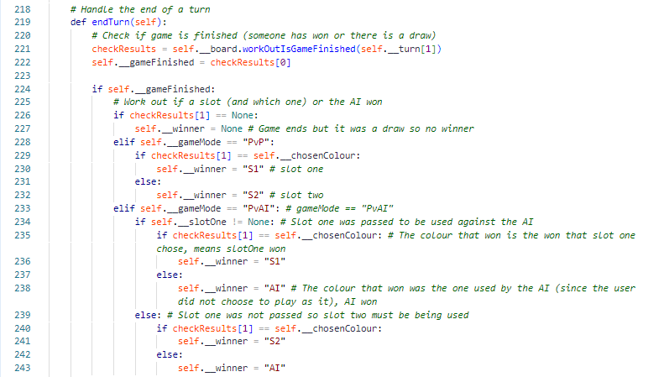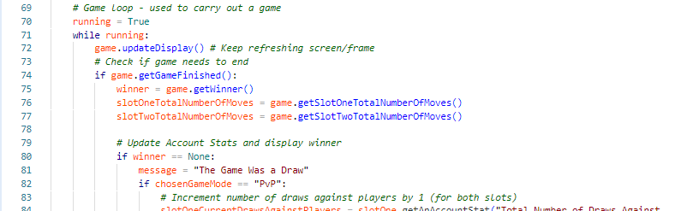

### Test 18

This test also cannot be really shown through screenshots of the pygame window. Below is a screenshot of part of the minimax() subroutine and shows that the deepcopied board and its score is returned. The video shows AI moves being made and the pygame window being updated to show the board that was returned by minimax().

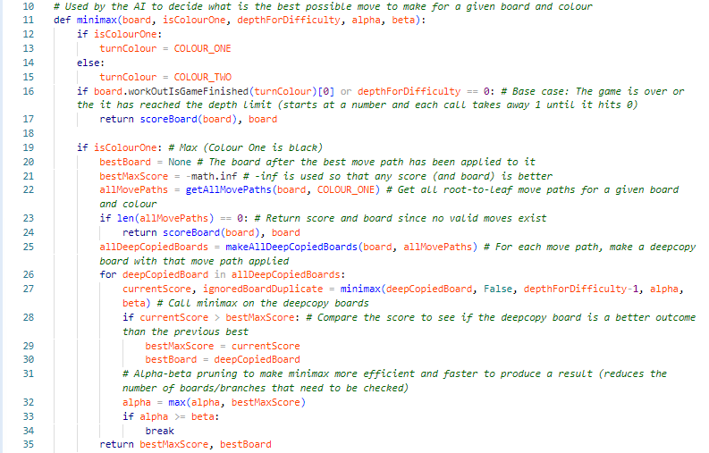

### Test 19

This cannot be shown through screenshots of the board/pygame window however a screenshot of the code showing different values for the depth of minimax being passed based on the difficulty has been put below. In the video, different AI difficulties are used to show the AI is harder to beat and that it takes a noticable longer amount of time for minimax to run as it has a higher max depth.

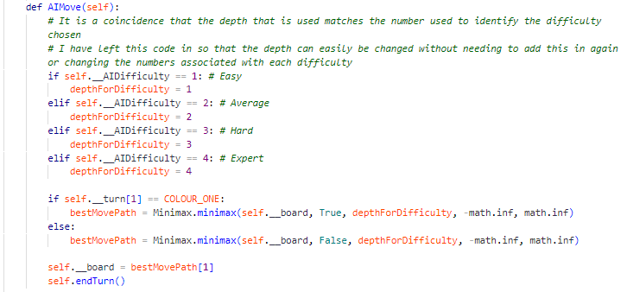

### Test 20

In the video, games are played and then the change to the stats in the dictionary (in the account slot) and the database itself are shown. Below is a screenshot of part of the userstats table which shows examples of user accounts that have stats recorded for the account.



### Test 21

Below is a screenshot of an example of an end of game message window telling the user who won. In the video, a few different games are played, and you can see this page being displayed once a game is finished.

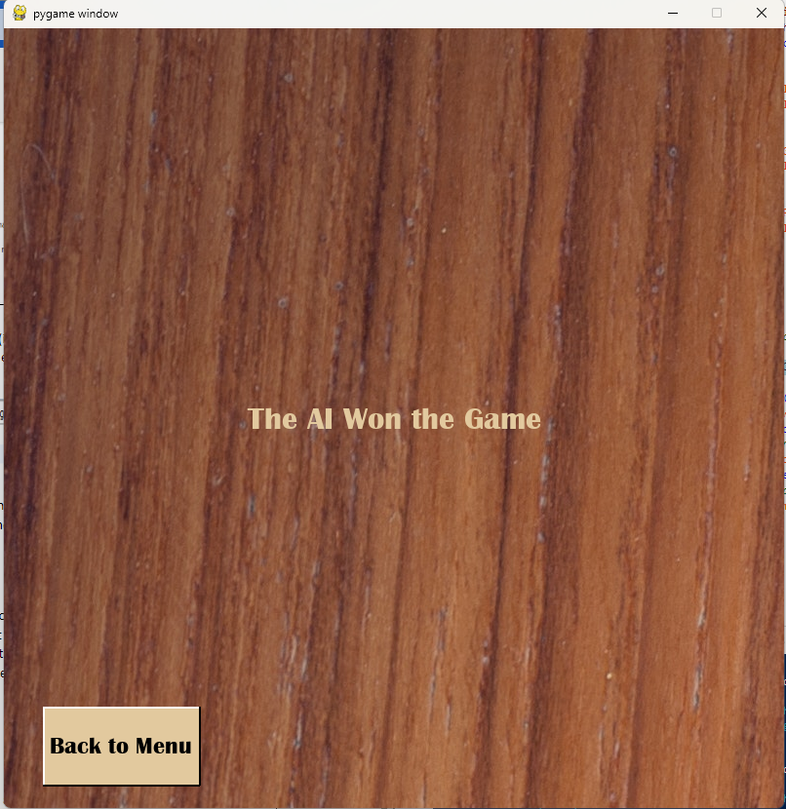

# Evaluation

The evaluation will be broken down into two sections. The first section will go through the success criteria that was set out in the analysis section of this document to evaluate to what extent each point has been met and if any have not been met. The second section will consider some improvements or new features that could be made/added to the program to make the program better in terms of performance and/or provide a better experience to the user.

## Evaluation of Success Criteria

In this section I will go through each of the points of the success criteria set out in the analysis section and evaluate how well they have been met. I will copy the success criteria below first for convenience. Some points will be evaluated collectively as they all refer to one aspect of the program.

1. When the game is launched, the pygame window should be created, two account slot objects should be created, the database object should be created (database is connected to), and the slot objects updated to store the database object for future use.
2. When connecting to the database, if the tables do not exist in the database then they should be created. There should be a “UserAccount” table which has the columns: AccountID, Username, Password, DateCreated. There should also be a “UserStats” table which has the columns: AccountID, StatsID, TotalNumberOfWinsAgainstAI, TotalNumberOfDrawsAgainstAI, TotalNumberOfLossesAgainstAI, TotalNumberOfGamesPlayedAgainstAI, HighestWinStreakAgainstAI, CurrentWinStreakAgainstAI, AverageNumberOfMovesToWinAgainstAI, AverageNumberOfMovesToWinAgainstAICount, AverageNumberOfMovesToWinAgainstAISum, TotalNumberOfWinsAgainstPlayers, TotalNumberOfDrawsAgainstPlayers, TotalNumberOfLossesAgainstPlayers, TotalNumberOfGamesPlayedAgainstPlayers, HighestWinStreakAgainstPlayers, CurrentWinStreakAgainstPlayers, AverageNumberOfMovesToWinAgainstPlayers, AverageNumberOfMovesToWinAgainstPlayersCount, AverageNumberOfMovesToWinAgainstPlayersSum.
3. The ‘Close’ button of the pygame window should stop the program running throughout the program.
4. **Main Menu** 
   1. When the game is launched, the window should be updated to display the main menu. It should have the options which resemble: ‘Start Game’, ‘Account Area’, and ‘Quit’.
   2. The ‘Start Game’ button should take the user to the game area (should call the game area subroutine which will setup and carry out a game).
   3. The ‘Account Area’ button should take the user to the account area (should call the account area subroutine which will be used to let a user sign in, sign up, etc.
   4. The ‘Quit’ button should be used to quit the program.
5. **Account Area**
   1. The Account Area should display options that resemble: ‘Sign In’, ‘Sign Up’, ‘Sign Out’, and ‘View Account’.
   2. There should be a ‘back’ button which takes the user back to the main menu
   3. **Sign In**
      1. If the user clicks the ‘Sign In’ button, the window should be updated to show a ‘Account Slot One’ button and a ‘Account Slot Two’ button (‘Choose Slot’ window) which will be used to decide which slot the user wants to use/sign in to. It should also display a ‘back’ button which allows the user to return to the previous window (Account Area)
      2. If the slot is in use, an error window should be displayed to tell the user that the slot already has an account signed into it. There should be a ‘back’ button on this window so that the user can go back to the ‘Choose Slot’ window.
      3. If the slot is not in use, the window should be updated to show a username field, password field, ‘submit’, and a ‘back’ button.
      4. When the user submits a username and password, a check should be made to see if an account exists in the database that uses that username and password.
      5. If there is, the account should be signed into the slot (using the account slot objects methods). This will involve retrieving data from the database to the account slot object stores the username, AccountID, a dictionary of all the stats stored, etc.
      6. If there isn’t, an error message window should be displayed. It should have a ‘Back’ button which takes the user back to the page with the username and password field.
   4. **Sign Up**
      1. If the user clicks the ‘Sign Up’ button, the window should be updated to show a username field, password field, ‘submit’, and a ‘back’ button.
      2. When the user submits a username and password, the account should be created in the database (new record required in each table) as long as the username is not already in use.
      3. When the account has been created, then an appropriate message window should be displayed which includes a ‘Menu’ button. The ‘Menu’ button should take the user back to the main menu.
   5. **Sign Out**
      1. If the user clicks the ‘Sign Out’ button, the window should be updated to show a ‘Account Slot One’ button and a ‘Account Slot Two’ button (‘Choose Slot’ window) which will be used to decide which slot the user wants to sign an account out of. It should also display a ‘back’ button which allows the user to return to the previous window (Account Area)
      2. When the user has chosen a slot, the account slot object should be ‘cleared’/the account in that slot should be signed out (using the signOut() method in the account slot class) and the window should be updated to show an appropriate message window which includes a ‘Menu’ button. The ‘Menu’ button should take the user back to the main menu.
   6. **View Account**
      1. If the user clicks the ‘View Account Information’ button, the window should be updated to show the ‘choose slot’ window.
      2. If the user chooses a slot which doesn’t have an account signed into it, an appropriate message window should be displayed which includes a ‘back’ button. The window should tell them that an account is not signed into the chosen slot.
      3. If the user chooses a slot which does have an account signed into it, the stats that are stored about the account (using the dictionary inside the account slot class and the object’s variables) should be displayed to the user.
6. **The Game**
   1. **Setting Up the Game**
      1. After the ‘Start Game’ button is clicked, the window should be updated to show two new buttons. The window should be updated to show a ‘Play against an AI’ button and a ‘Play against a Player’ button.
      2. There should be a ‘Back’ button which takes the user back to the main menu
      3. **Setting Up a Game Against the AI (PvAI)**
         1. If the ‘Play Against an AI’ button is clicked, the window should be updated to show the ‘choose slot’ window which allows the user to choose which slot (and therefore account) they want to use to play against the AI.
         2. If the user chooses a slot that does not have an account signed into it, an appropriate message window should be displayed which includes a ‘back’ button. The message should tell the user they have chosen an empty account slot.
         3. If the user chooses a slot that does have an account signed into it, the window should be updated to show the different game options. The user should be able to choose the colour that they want to play as and the difficulty for the AI (there should be 4 options “Easy”, “Average”, “Hard”, “Expert”.
         4. When the user chooses an option, the option should change appearance to show that it is currently selected (for example, it should be given a red border). If they already had an option of the same type selected, that option should have the ‘selected effect’ removed from it. (For example, if they selected “Easy” for the AI but then click on “Average”, “Easy” should no longer have the red line effect.)
         5. There should be a ‘Start Game’ button that starts the game if the game start conditions have been met (the user has chosen a colour to play as and they have chosen a difficulty for the AI) The game object, board object, etc should be created and the game board displayed to the user. If the conditions are not met, then an error message window should be displayed to tell the user the error.
      4. **Setting Up a Game Against another Player (PvP)**
         1. If the ‘Play against a Player’ button is clicked, a check should be made to make sure that an account in signed into each of the account slots. If one or both the slots does not have an account signed into it/them then an error message window should be displayed. If both the slots do have an account signed into them, the window should be updated to show the game options for setting up a game against the AI (the only option is what colour slot one wants to play as).
         2. When the user chooses an option, the option should change appearance to show that it is currently selected (for example, it should be given a red border). If they already had an option of the same type selected, that option should have the ‘selected effect’ removed from it.
         3. There should be a ‘Start Game’ button that starts the game if the game start conditions have been met (the user has chosen a colour for slot one to play as) The game object, board object, etc should be created and the game board displayed to the user. If the conditions are not met, then an error message window should be displayed to tell the user the error.
   2. **Playing the Game**
      1. If a (human) player clicks on a man/king on the board then that piece should be ‘selected’ this means that its legal moves should be found, and it should have a ring drawn around it to show that it is selected. This should happen unless the man/king is not of the colour whose turn it is or the player has a man/king already selected **that has already made a move this turn (this means that if they select a man which is able to capture two opponent men one after the other (this would be two separate moves within one turn) and they make the first move (capture the first opponent man) they should NOT then be able to select a different man/king and move that. They must complete a ‘path’ of legal moves until the man/king cannot make any more moves this turn (in this case, make the two captures) and which point their turn ends.**
      2. Referring to the ‘path’ concept made in the previous point, when a man/king is selected and its legal moves have been found it should have the next moves of every possible path displayed on the board as smaller circles on the board to show the user where to click to make that move with the selected man/king. When the user clicks on one of these small circles, the move should be made (the man/king moved and the opponents man/king removed from the board if a capture was made) Using the example from the point above, a small circle should be displayed where the player’s man would land after making the first capture. Once they have made this move, another small circle should now be displayed which shows where the player’s man would land after making the second capture.
      3. When a player has completed one of these ‘move paths’ and there are no more legal moves for them to make with the selected man/king this turn, their turn should end. A check should be made to see if the game is over. It should be made the other players turn if the game mode is ‘PvP’ otherwise it should be made the AI’s turn. Once the turn has been changed, a check should be made to see the results of the check to see if the game is over. If the game is over, the game loop should be ended. [see point 6.2.6]
      4. For an AI’s turn, the minimax algorithm should be used to work out the best possible move the AI can make. The algorithm should return a board object that has had those moves applied to it. The game object should overwrite the board object it is currently storing (the board at the beginning of the AI’s move) and replace it with what the minimax algorithm worked out as the best possible board for the AI. This should update the pygame window to show the new board. The AI’s turn should end and like in the previous point, a check should be made to see if the game is over, the turn should be changed back to the slot that is being used to play against the AI, a check should be made to see the results of the check to see if the game is over. If the game is over, the game loop should be ended [see point 6.2.6]
      5. The minimax algorithm should use a different depth depending on the difficulty chosen for the AI. The harder the difficulty, the higher the depth.
      6. When the game loop is ended, the account stats should have their dictionary of account stats as needed. The changes to the dictionaries should then be made to the account stats in the database.
      7. The window should be updated to display who won the game. The window should have a ‘back to menu’ button which when clicked will take the user back to the main menu.

|  |  |
| --- | --- |
| **Point/s** | **Evaluation** |
| 1 | The program makes the pygame window, two account slots, and the database object when the game is launched. The database object is put into each slot as well. This is proven in testing as the program launches with no issues and the pygame window is displayed. The user can make accounts, etc and the stats for an account can be updated by the program proving the objects are created successfully and the database object works as expected. |
| 2 | The SQL queries use the “IF NOT EXISTS” syntax to check if the tables exist in the database and “IF NOT”, it will create them. This query is run every time the program is launched/the database object is made (which it is when the game is launched). |
| 3 | The ‘Close’ button refers to the button marked “x” in the top right corner of every pygame window. Every pygame event loop if in the program has the line “if event.type == pygame.QUIT:” which allows this button to be used by checking if the use clicked on it. If they user has, it runs the line “quit()” to close the program. |
| 4: 4.1, 4.2, 4.3, 4.4 | The points under point 4 are to do with the main menu page that is displayed, and each point is met successfully. 4.1 has been completed as the testing shows that the main menu page is displayed when the game is launched and contains the required button options. 4.2 - is also met as when this button is clicked, the testing showed that it calls the required subroutine which updates the pygame window to display the page which allows the user to choose which game mode they want to play. 4.3 is met as testing showed that when the button is clicked, the pygame window is updated to show the account area menu. |
| 5: 5.1, 5.2 | 5.1 is successfully met as the menu that is displayed contains the required options as button objects which the user can then click. 5.2 is met as there is a button which the user can click to go back to the main menu. |
| 5.3: 5.3.1, 5.3.2, 5.3.3, 5.3.4, 5.3.5, 5.3.6 | The points under point 5.3 all are to do with the “sign in” part of the account area and have all been successfully met. 5.3.1 Has been met as when the “sign in” button has been clicked, the pygame window is updated to show the choose slot window page which contains the required butttons. 5.3.2 is met as the testing showed that if a slot is chosen which already has an account signed into it, an error message page is shown to tell the user this. 5.3.3 has been met as the testing showed that choosing an empty slot takes the user to the page enter a username and password which contains the required input fields and buttons. 5.3.4 has been met as there is a button which allows the user to submit a username and password that they have types into the fields. Submitting a username and password then calls the required subroutines to check for an account with that username and password (although is hashed form) in the database. 5.3.5 is met as the testing showed that if there is an account in the database with that username and password, the account is signed into the slot object and the required data is retrieved and stored in the slot object. This is proved in testing as you can sign in an account and then go to the ‘view account’ part of the account area to see the stats for that account (that are stored in the slot). 5.3.6 has been met as the testing showed the error message page that is shown to the user if no account with that username and password can be found. It contains a back button as well which allows the user to return to the username and password input page. One improvement that could be made to the “sign in” part of the program is some sort of password reset or recovery feature as none currently exists. This will be described in more detail in the next section. |
| 5.4: 5.4.1, 5.4.2, 5.4.3 | The points under 5.4 refer to the “sign up” part of the program. 5.4.1 has been met as the testing showed that when the “sign up” button is clicked, the window is updated to show the username and password input page which contains the required fields and buttons. 5.4.2 has been met as the testing showed that the account is added to the database when a username and password is submitted by the user (as long as the username is unique). This could be improved by getting the user to enter the password twice to increase the chance that they have entered the password they want correctly. 5.4.3 has been met as the testing showed that when an account is created, a success message page is displayed which has a button to take the user back to the main menu. |
| 5.5: 5.5.1, 5.5.2 | The points under 5.5 refer to the “sign out” part of the program. 5.5.1 has been as when the “sign out” button is clicked, the choose slot page is displayed with the required buttons on it. 5.5.2 has been met as the required attributes in the slot are cleared to none and the dicitonary values for all the keys set to None. This is proven in testing as once a slot has been signed out of, you can sign an account into it whereas before it would not let you as it already had an account signed into it. |
| 5.6: 5.6.1, 5.6.2, 5.6.3 | The points under 5.6 refer to the “view account” part of the program which lets a user view the data stored about their account (stats, date created, etc). 5.6.1 has been met as the testing showed that the correct page is displayed. This allows a user to choose an account slot so they can view the stats of the account signed into it. 5.6.2 has been met as the the testing shows that an error message page is shown which has a back button to allow the user to return to the choose slot page to try again or then go back again to the account area menu. This could be improved by adding a button to the error message page to take them straight to the sign in part of the account area, so it is quicker for them to sign an account into the slot they chose. 5.6.3 has been met as the testing showed the page with the data to be shown is displayed successfully and the font is large enough and clear enough to read. This could be improved by adding a feature that allows the user to compare their stats to the stats of someone else’s account by searching for their username. |
| 6.1: 6.1.1, 6.1.2 | 6.1.1 has been met as the testing showed that the required page was shown when the “Start Game” button was clicked. It correctly shows the page which allows the user to choose which game mode they wish to play. 6.1.2 has been met as that same page has a back button which takes the user back to the main menu when clicked. |
| 6.1.3: 6.1.3.1, 6.1.3.2, 6.1.3.3, 6.1.3.4, 6.1.3.5 | The points under point 6.1.3 refer to setting up a game against the AI. 6.1.3.1 has been met as the window is updated to show the required choose slot page. This allows the user to select which slot (and therefore account) they want to use against the AI. 6.1.3.2 has been met as when the user chooses a slot to use, a check is made to see if an account has been signed into that account slot object. If there is not an account signed into it, it correctly displays an appropriate error message page. 6.1.3.3 has been met as if the user chooses a slot that does have an account signed into it, the pygame window will be updated to show the page/window for choosing the options to setup the game with (where they can choose a colour to play as and a difficulty for the AI). 6.1.3.4 has been met as the testing showed that when an option is selected by clicking on it, a red outline is drawn around it to show the user which option is currently selected. 6.1.3.5 has been met as when a user attempts to try and start a game after choosing their options, checks are made to see if they have chosen a colour to play as and a difficulty for the AI. If they have not, an appropriate error message page is shown. Otherwise, the game is setup (by making the board object, etc) and the pygame window updated to show the board. This could be improved by making the error message tell the user what option they have not chosen (for example, tell them they have chosen a colour but not an AI difficulty) however this is not really needed as they only need to choose a colour and a difficulty. |
| 6.1.4: 6.1.4.1, 6.1.4.2, 6.1.4.3 | The points under 6.1.4 refer to setting up a game between two players. 6.1.4.1 has been met as the required checks are carried out and unique error message windows are shown depending on what condition has failed (if both slots are empty, if slot one is empty, if slot two empty). If both slots have an account signed into them then the window will be updated to show the page for choosing the game options (which for PvP is only choosing a colour for slot one to use). 6.1.4.2 has been met as when the user clicks a colour button, a red outline is drawn around it to show which colour they have currently selected. 6.1.4.3 has been met as when the user tries to continue to playing the game, it will only setup and start the game if they have meet the condition of choosing a colour. If they haven’t then an appropriate error message page is displayed. This could be improved to make it so the button which is used to submit the game option (chosen colour) and start the game is ‘greyed out’ and will not work until they have chosen a colour to play as. This would save time as the user would not need to click the submit button just to see the error message page and then click the back button on this page to go back and choose a colour. |
| 6.2.1 | This point has been met as when a human player clicks on a man/king on the GUI representation of the board, the man object is selected depending on the required conditions. If the man/king is selected, then a red outline is put around it to show to the user which one they currently have selected. |
| 6.2.2 | This point has been met as when a man/king is selected, its legal moves are found. The legal moves are stored in a tree where each level down the tree is the next move in a move path. The next possible moves are shown to the user by drawing blue circles on the squares which show where the piece could move to. |
| 6.2.3 | This point has been met and can be seen from the testing. Every time a turn is ended, checks are carried out to see if the game should end. When the endTurn() subroutine finished, the pygame event loop that is used to carry out the game will check if the result of these checks and end the loop and therefore game if it should end. |
| 6.2.4 | This point has been met and has been shown through the testing. The minimax() subroutine I called when it is the AI’s turn. The max depth that minimax is given changes depends on the difficulty option chosen by the player. minimax() returns the best deepcopied board that it finds and this is then used to overwrite the Board() object that the Game() object is currently storing. This means that when the pygame event loop starts running again, the pygame window is updated which updates the GUI representation of the board to show the board that was returned and has had the best move/move path found by minimax applied to it. |
| 6.2.5 | This point has been met as a different value is stored into the variable that is passed to minimax for the max depth depending on which difficulty the player chose on the game options window. |
| 6.2.6 | This point has been met and shown through the testing. When a game is complete, the stats for a slot are updated. Once the slot/s dictionaries’ have been updated, the dictionaries are used to update stats in that account’s record in the userstats table of the database. |
| 6.2.7 | This point has been met as once the stats have been updated (after a game has finished), a message page is shown which tells the player if it was a draw or if not, who won. This could be improved by giving additional information such as the duration of the match, how many moves each player made, etc. This could make the page more informative and less plain as currently it just contains who won or if it was a draw. |

## Potential Improvements to the Program

This section will go over some of the ways that the program could be improved in the future.

### Password Reset/Recovery

One way that the program could be improved is by adding, into the account area, a way to either reset a password or recover a password that a user has forgotten. This feature would be useful as it is common for users to forget passwords for accounts and currently if a user forgets the password for their account, there is no way to reset it unless they had direct access to the database to execute the SQL commands themselves (which a user would realistically not have). For resetting a password, this could be done by adding a button to the ‘sign in’ window which says something like “reset password”. When this button is clicked, the user should be taken to a window to enter the username or email address of the account that they want to reset. Then an email could be sent to that email address (or if they entered a username, the email used for the account with that username). Currently a user does not enter an email address to sign up and there is no way to store this email in the database, this would need to be changed. In the program, the user could be taken to a window that gets then to enter a code that has been sent to that email address. This would work as the verification process to help prevent someone resetting the password of any user. If the user enters the correct code, then they should be taken to a new window that displays to password input fields. This would then let the user to enter a new password twice (to help prevent them from entering a new password incorrectly) and submit it. This would then update that account in the database to update the password (or more accurately, the hashed password) that is stored for that account. For recovering a password, the process would be similar to a point. Rather than sending a code to the email address, the password that they use could be sent to the user to remind them of what it is. This would not be as good as resetting the password for a few reasons. Firstly, resetting a password would be better than just reminding the user as it would mean that they are able to update it (giving them more control) and resetting the password entirely might be preferred by a user as they might not like their current password because it might be too long or too difficult to remember. Secondly, the database does not store the password in plaintext, instead it stores a hashed version of the password. Since hashes cannot be reversed, the program and database logic would need to change to store the plaintext password (which would be an easier change but not worth it due to the security concerns) or using encryption instead of hashing (which would work but is less secure than a hash). Overall, a way to reset or recover a password would be better than having nothing as the program currently has. This would change should probably be at the top of the list if the program where to be updated in the future.

### Show Individual Moves the AI Made in a Turn

Currently when the AI’s turn is carried out it does not show the individual moves that make up the turn. It just updates the board object stored in the game object with all the AI’s moves that turn already applied to it. This can sometimes make it hard to work out which moves the AI made to get to where it is in the updated board. A better way of doing this is rather than the minimax subroutine returning the deepcopied board and then updating the board object in the game object with it, minimax should return the move path (that is currently applied to the deepcopied board). The move path could then be applied to the board object in the game object to show the individual moves that AI is making in that turn. This will make the game better for new players as they will be able to see each individual move that AI is making and help work out what mistake they as a player made to allow the AI to make certain captures/moves. The downside is that it will make the game/a turn for the AI go on for longer as the player will have to watch each move. Likely the sleep() subroutine would have to be used in between each move in the move path that is being applied to give the player enough time to see each move as otherwise all the moves would be near enough instant. This could be annoying for more experienced players who do not particularly need to see each move.

### Hosting the Database Online Not Locally

Currently the database is stored locally on the device the program is on. The program connects to the database using “localhost”/”127.0.0.1”. This means that the accounts stored in the database are only stored in their database on their device. If this game was going to be properly released as a game that anyone can download, it would be better to pay to have the database hosted on an actual server which all the copied of the program connect to. This would be much better as it means that an account can be accessed from any device (that has the game installed) and users will not need to create a new account for every different device that they play the game on. This change would be relatively simple as it should only be the case of changing the argument for the host parameter to be the IP address of where the database is stored, instead of how currently the argument “localhost” is given. This would definitely be one of the first changes that are made to the program if it was to be updated in the future.

### Improve Menu Graphics and Page Animations

Currently the pygame windows are almost entirely unresponsive to user actions (other than loading the next page when clicked). The menus could be improved to make it more engaging for users and clearer for a user to navigate. One example is when the cursor is moved from part of the window where there is no buttons and then over to a button. Currently nothing will change when this happens which makes the menu/program seem plain and dull. It could be changed to act more like menus/windows you would find in other programs or websites. For example, the cursor could change from the regular arrow cursor to the selecting hand cursor to show to the user that the cursor is now hovering over part of the window which can be clicked on. Additionally, the button itself could change to show that it is being hovered over. For example, it could look like the button has been pressed down, it could change colour or it could have a border put around it.

# Full Code

This section contains just the full screenshots of the code for my program. It is the same screenshots found in the implementation section but without the tables and descriptions.

## Constants.py

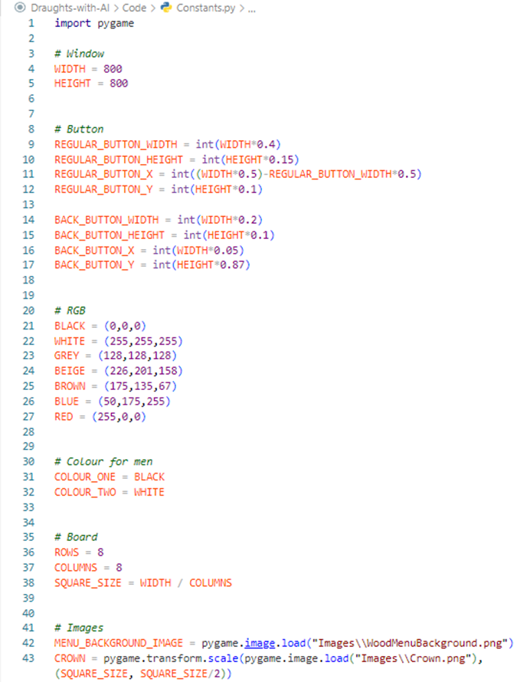

## Minimax.py

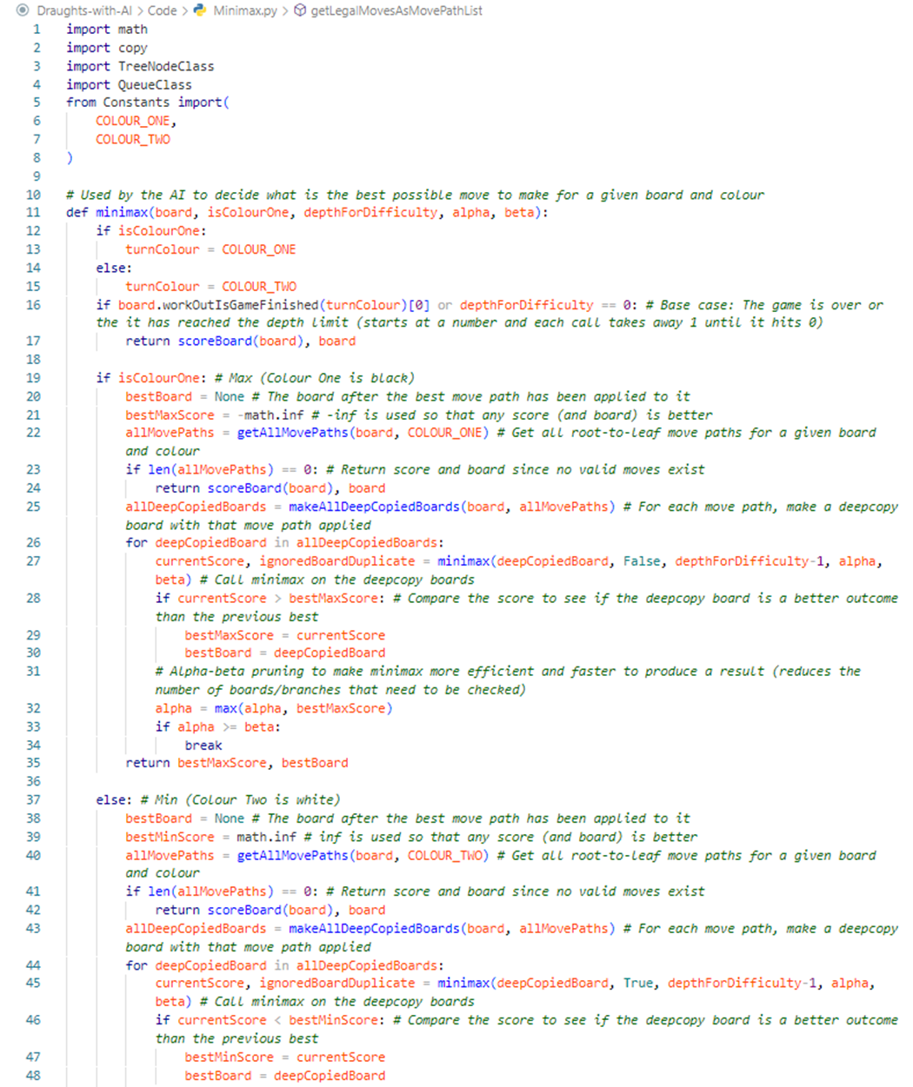

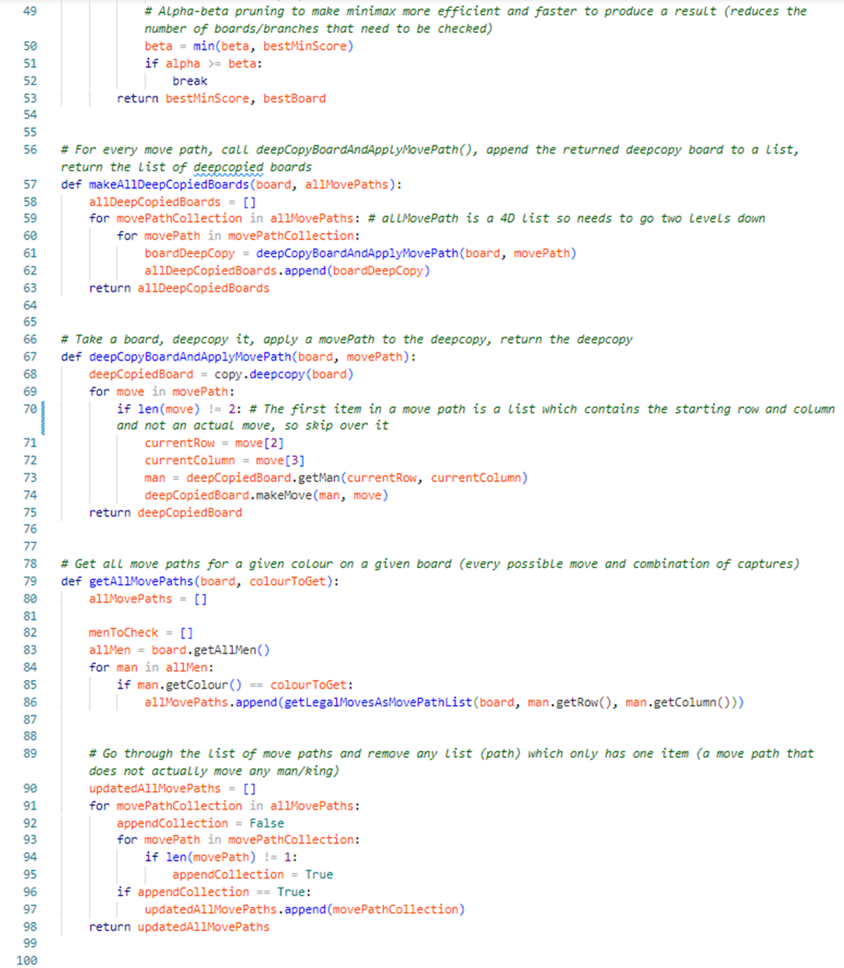

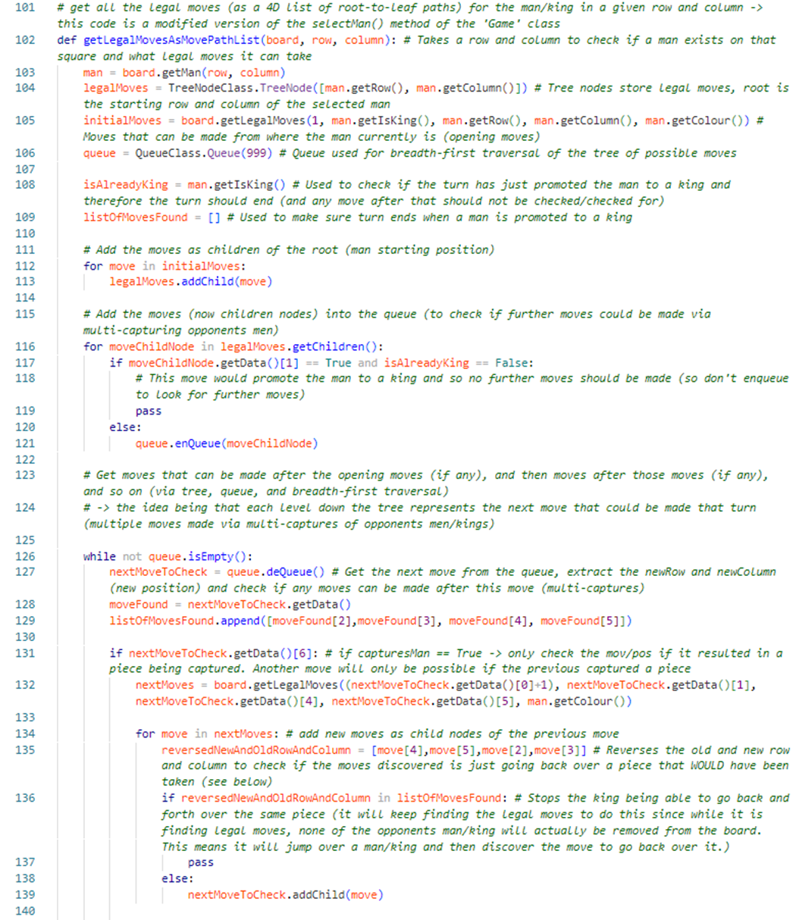

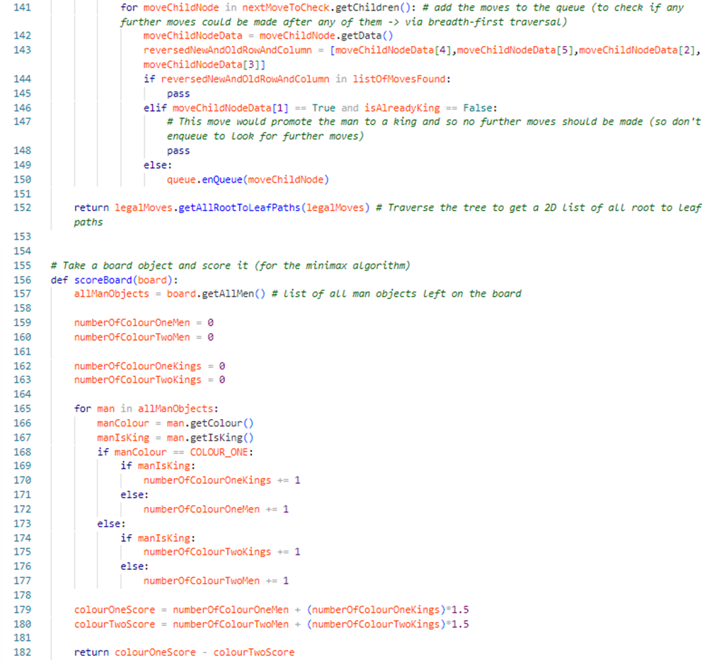

## QueueClass.py

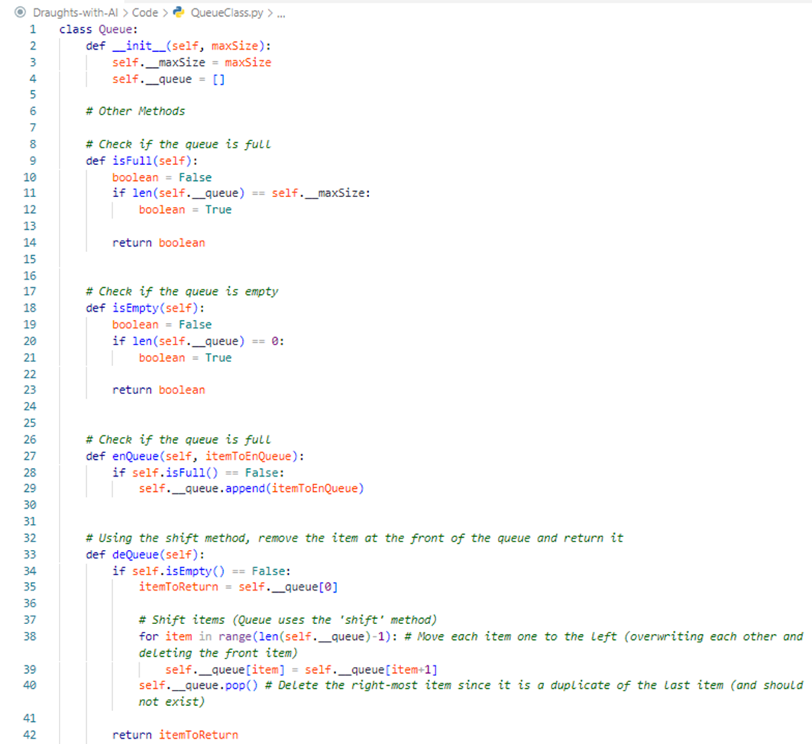

### TreeNodeClass.py

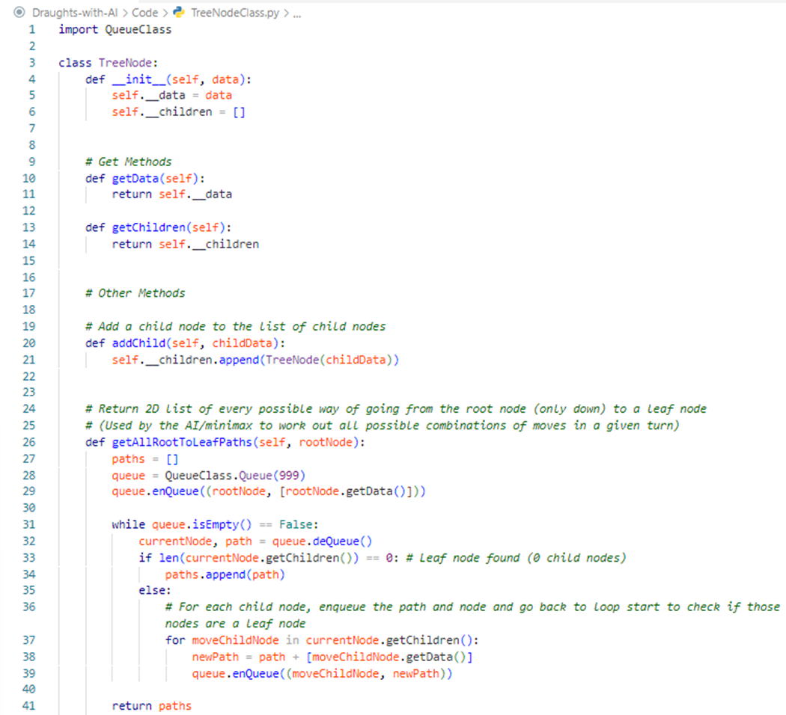

## AccountSlotClass.py

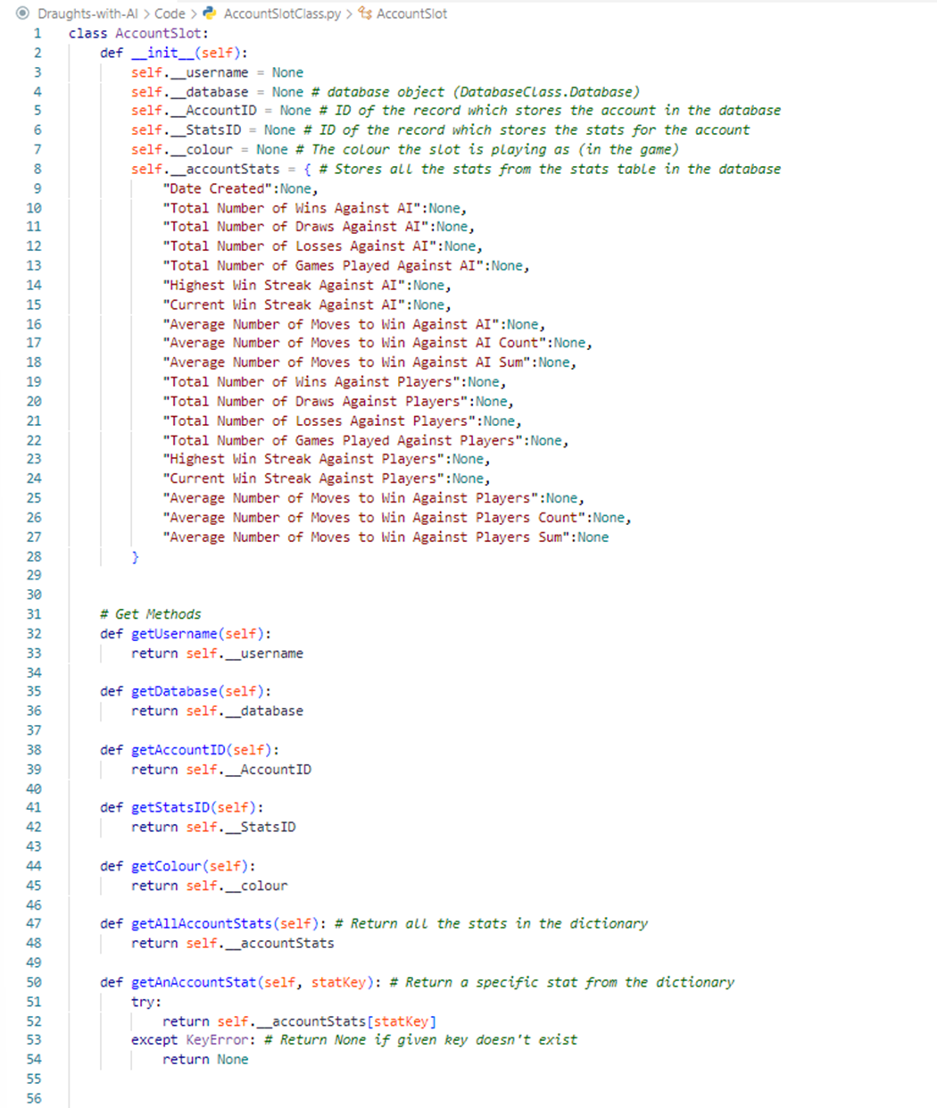

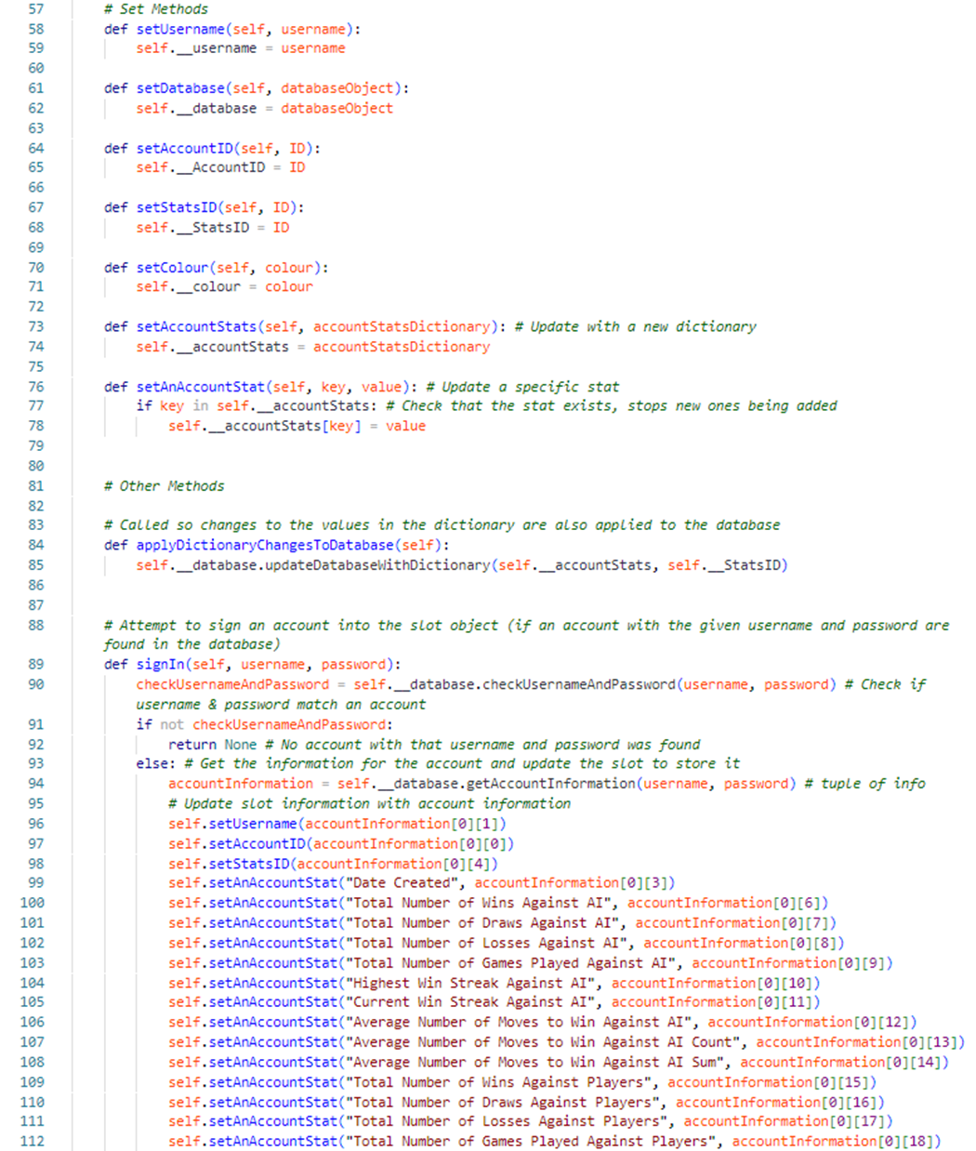

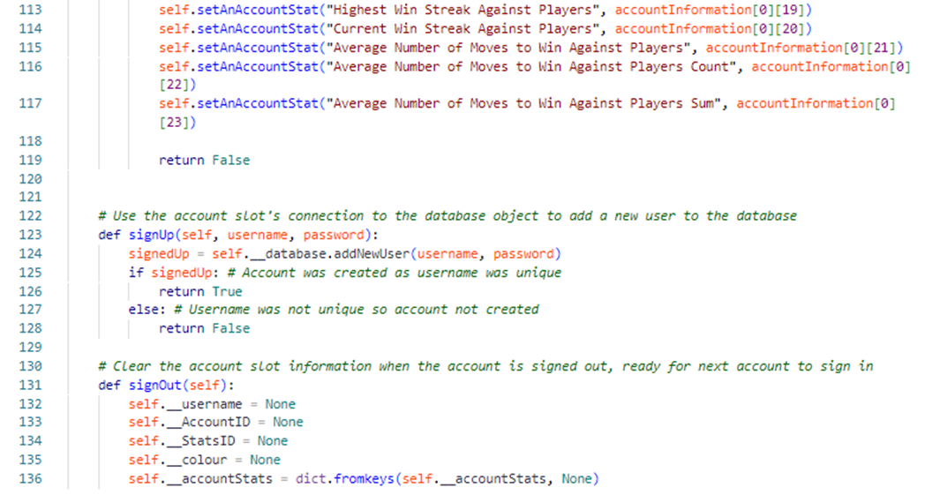

## ButtonClass.py

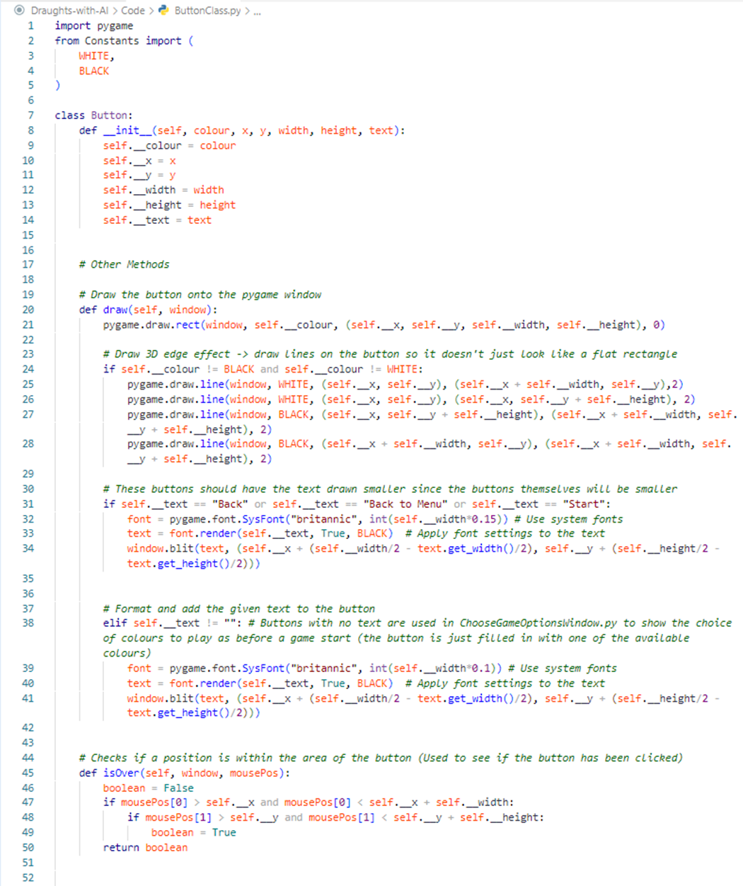

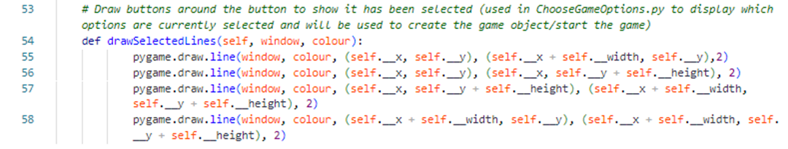

## DatabaseClass.py

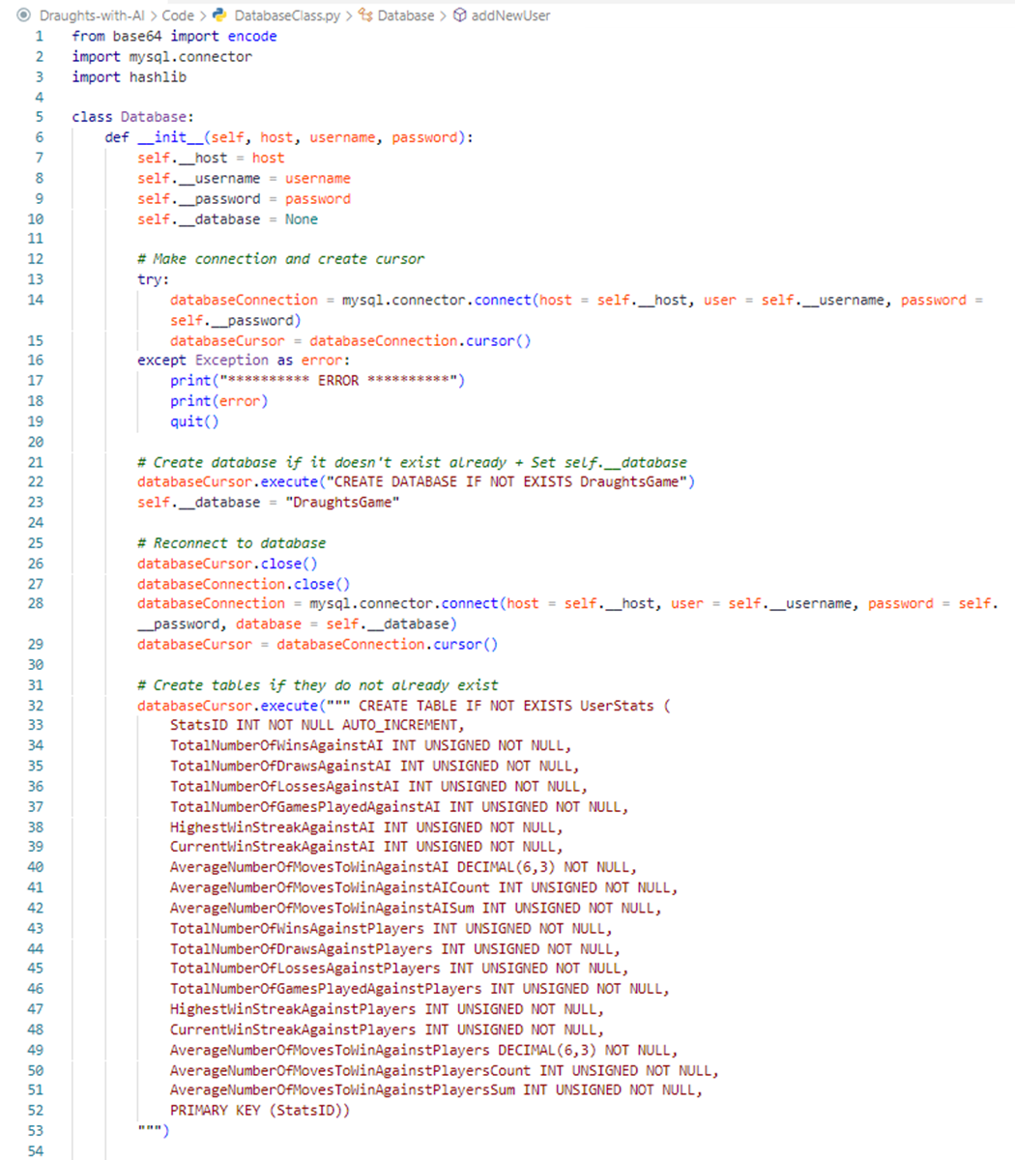

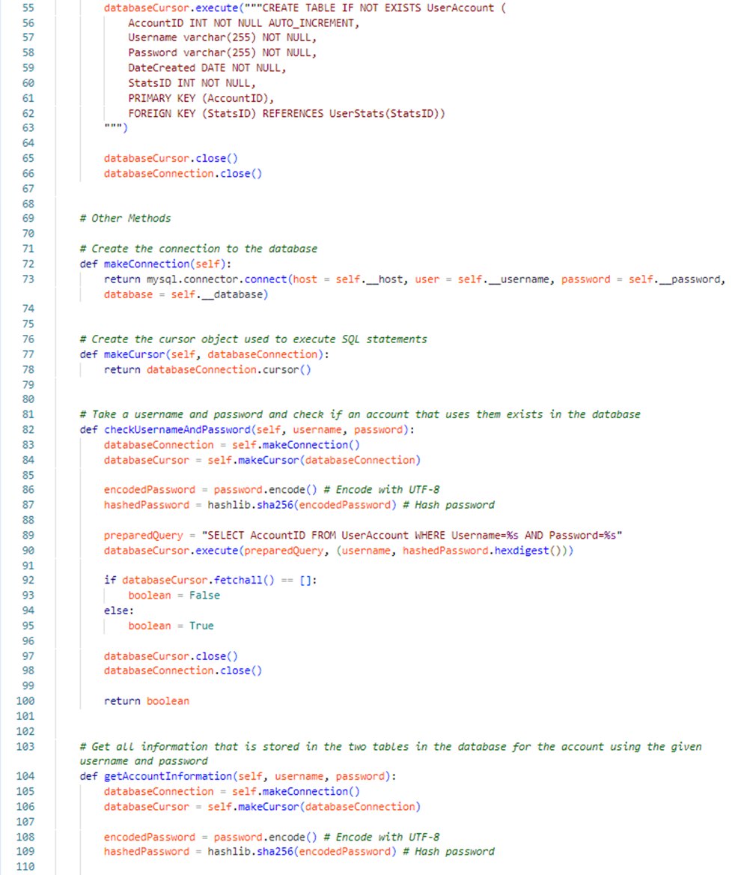

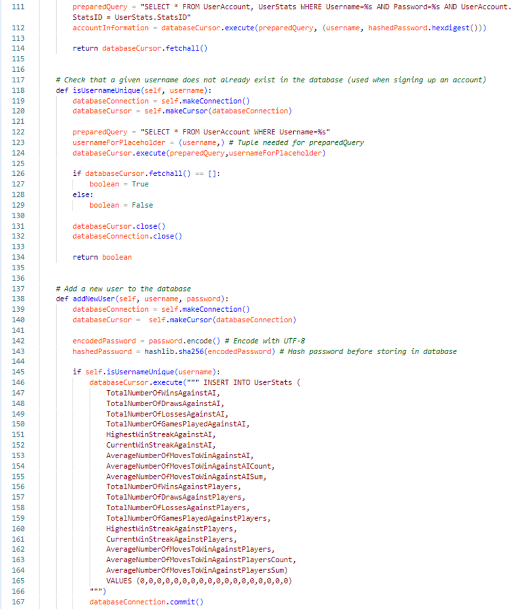

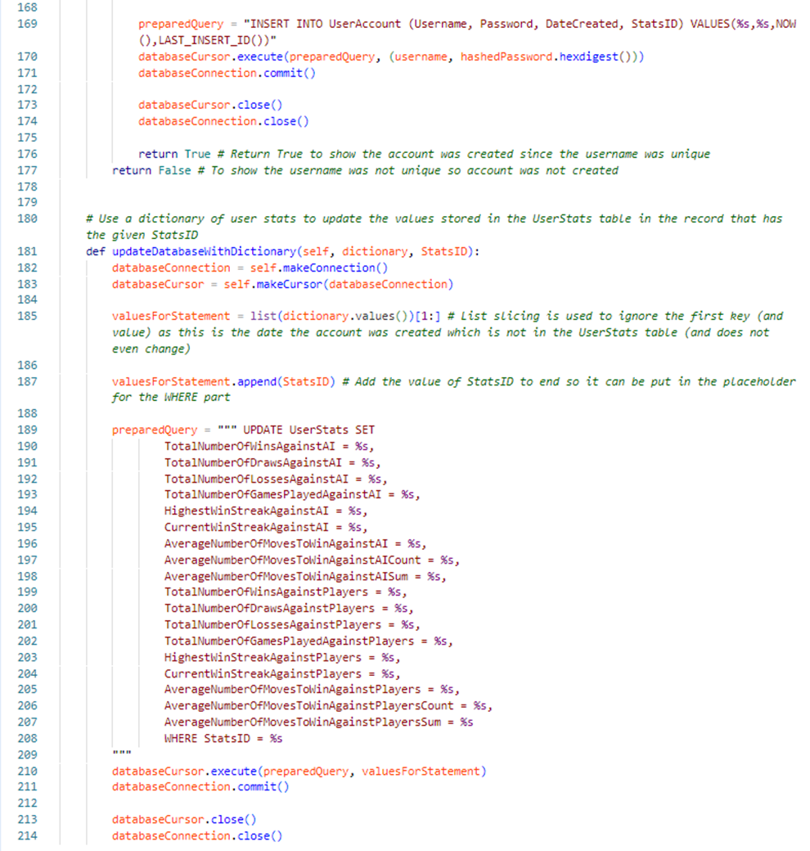

## ManClass.py

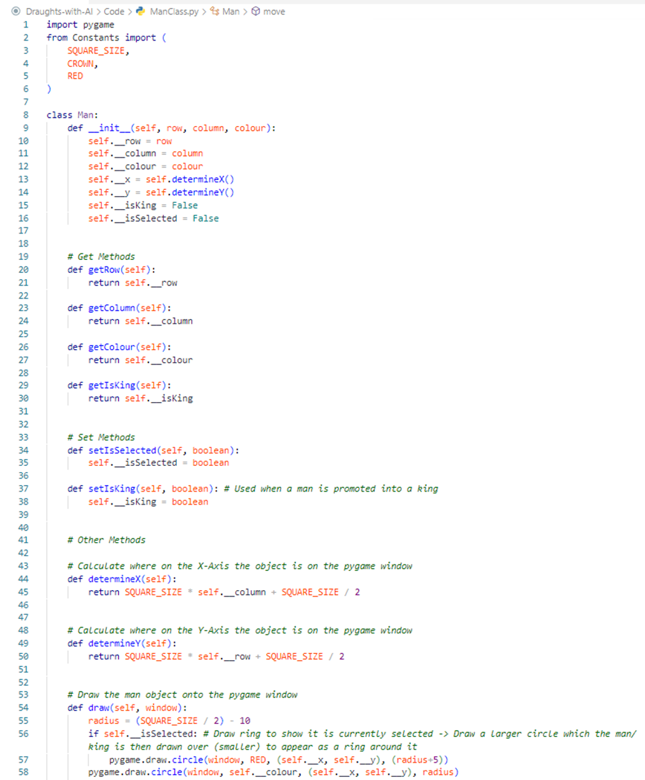

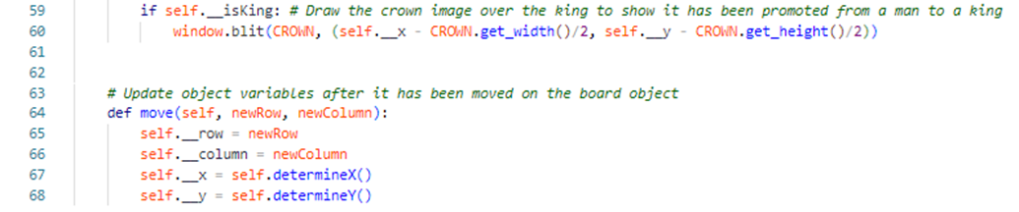

## BoardClass.py

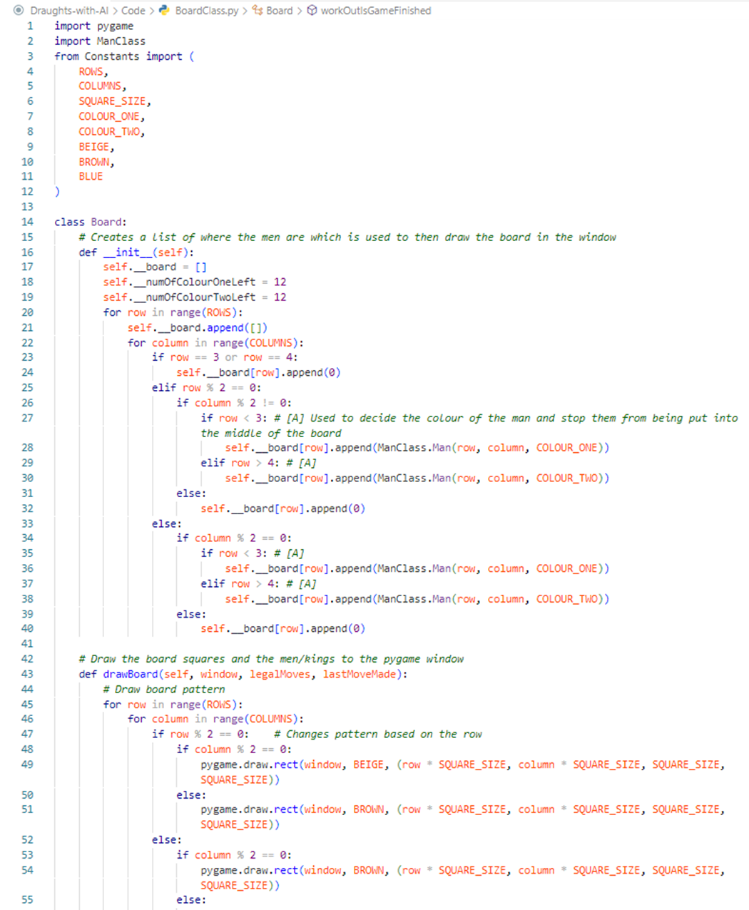

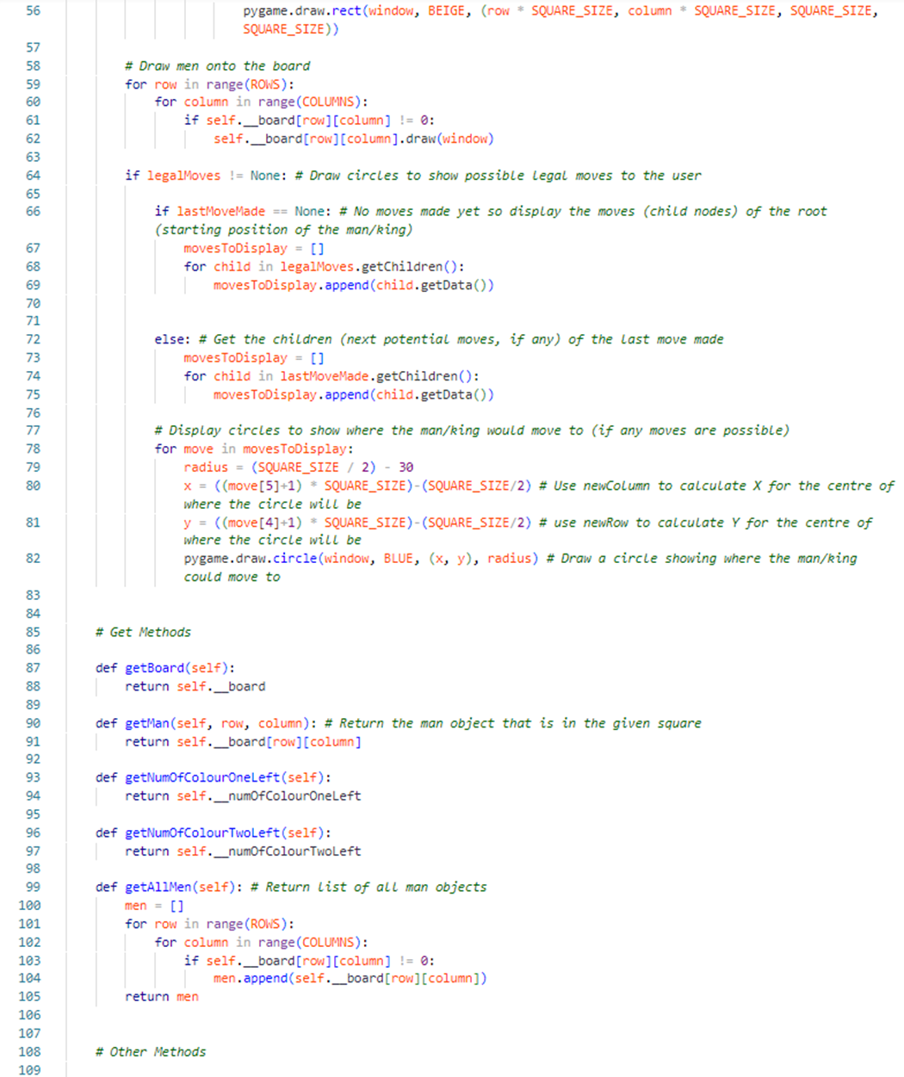

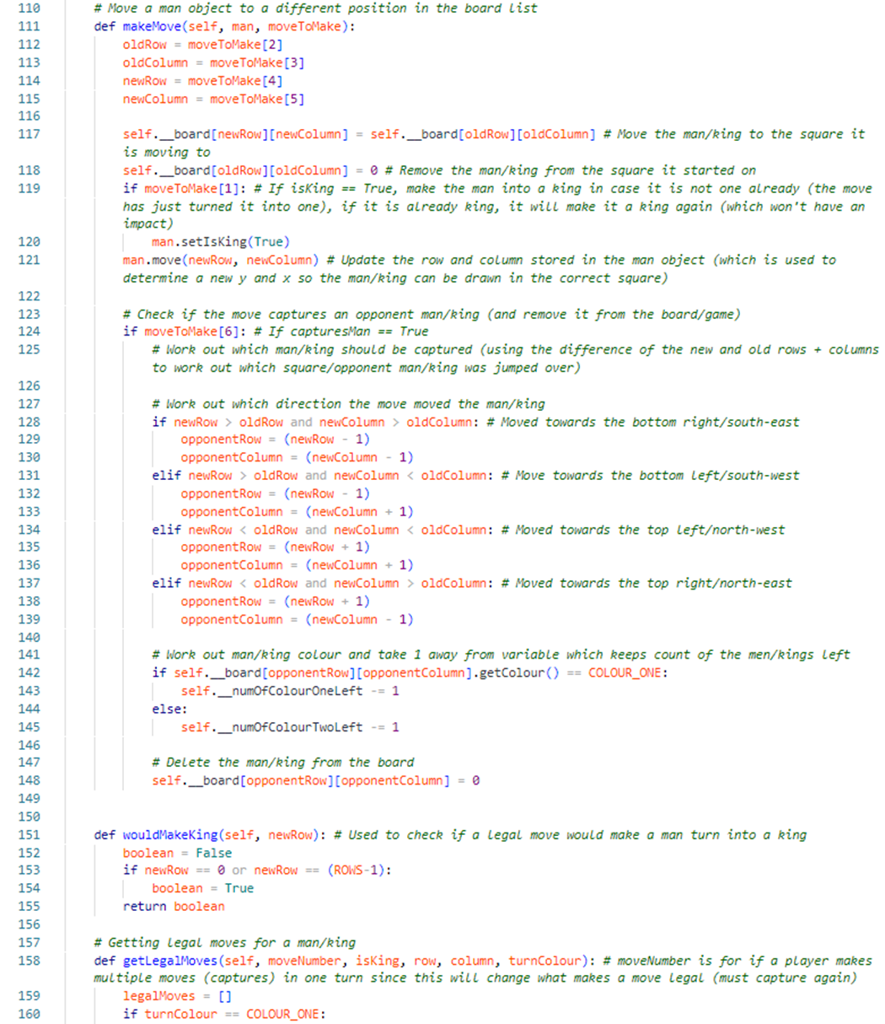

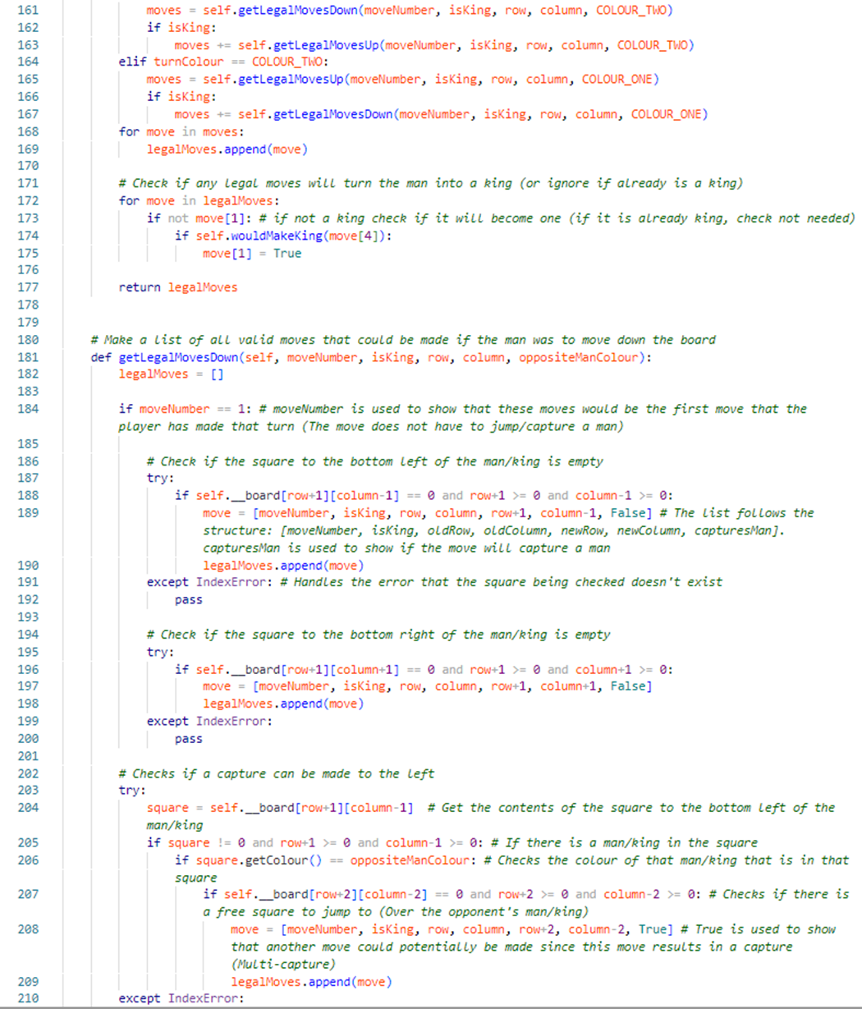

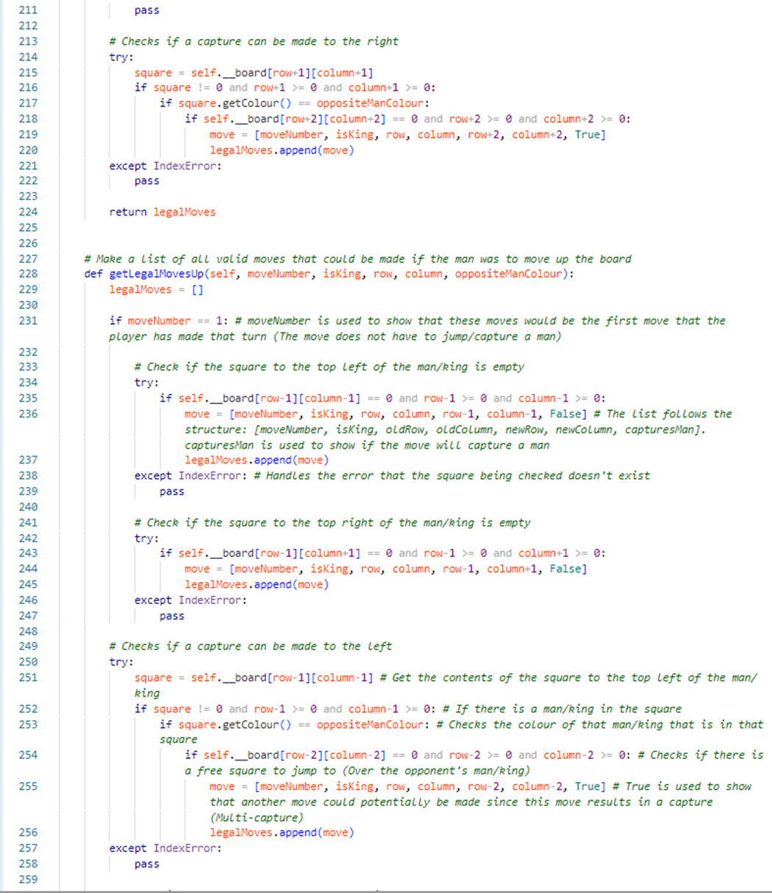

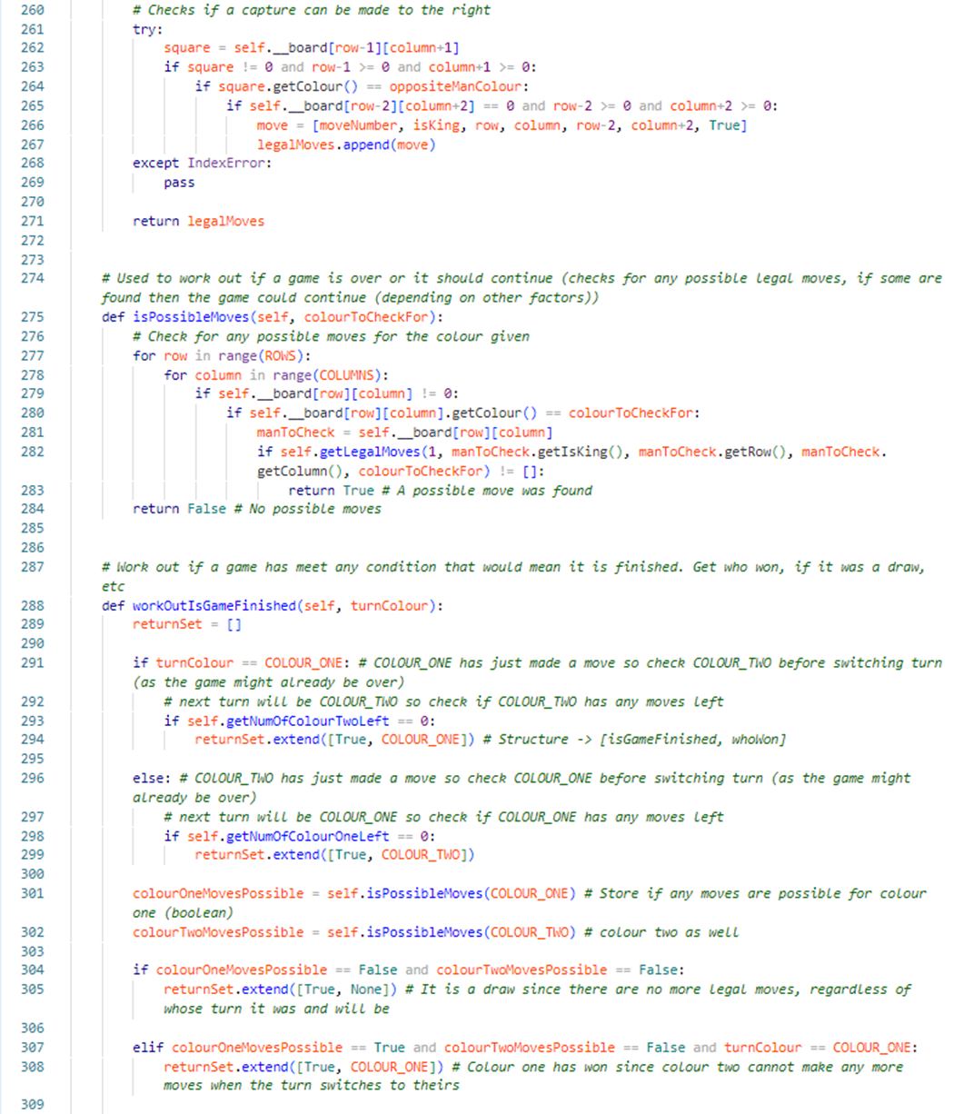

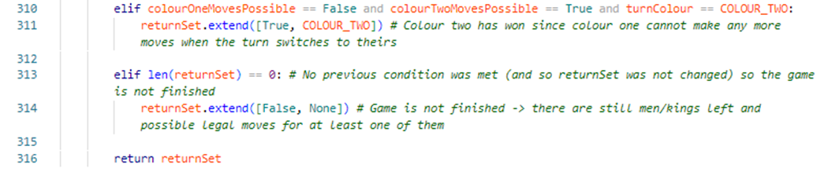

## GameClass.py

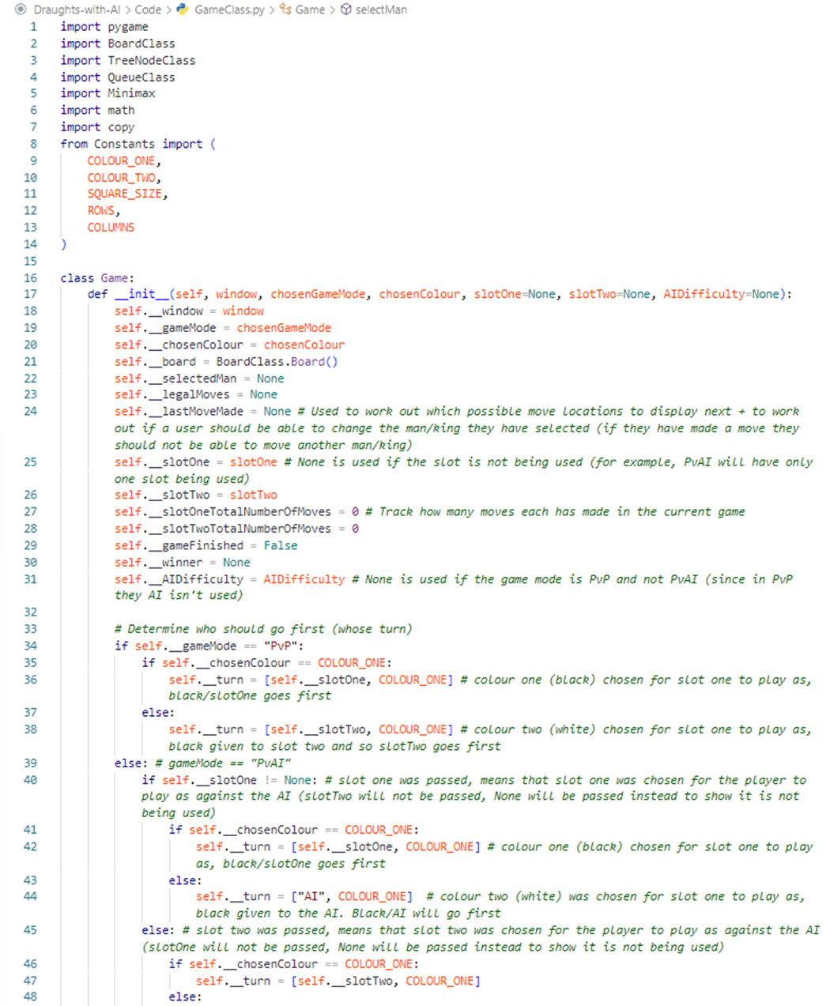

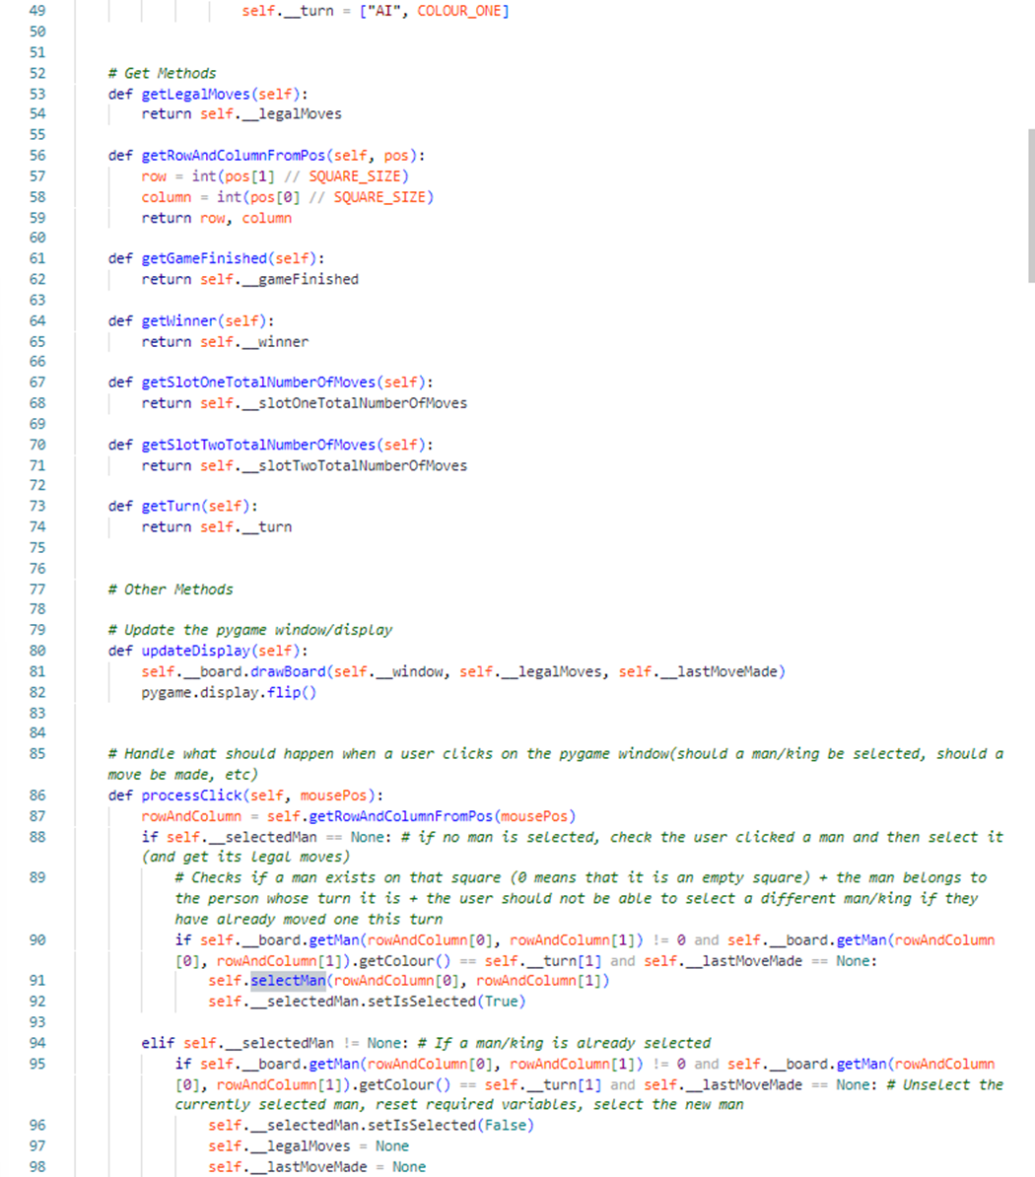

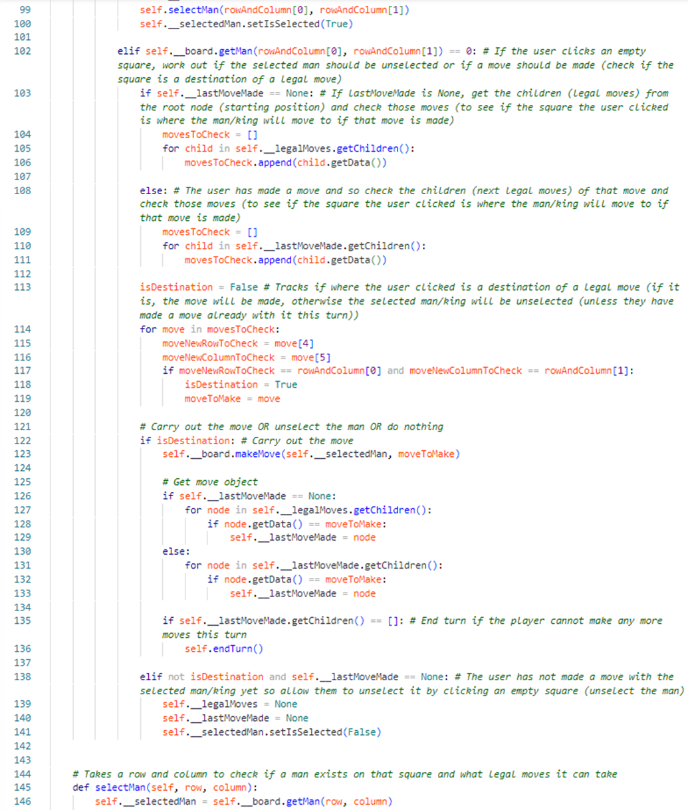

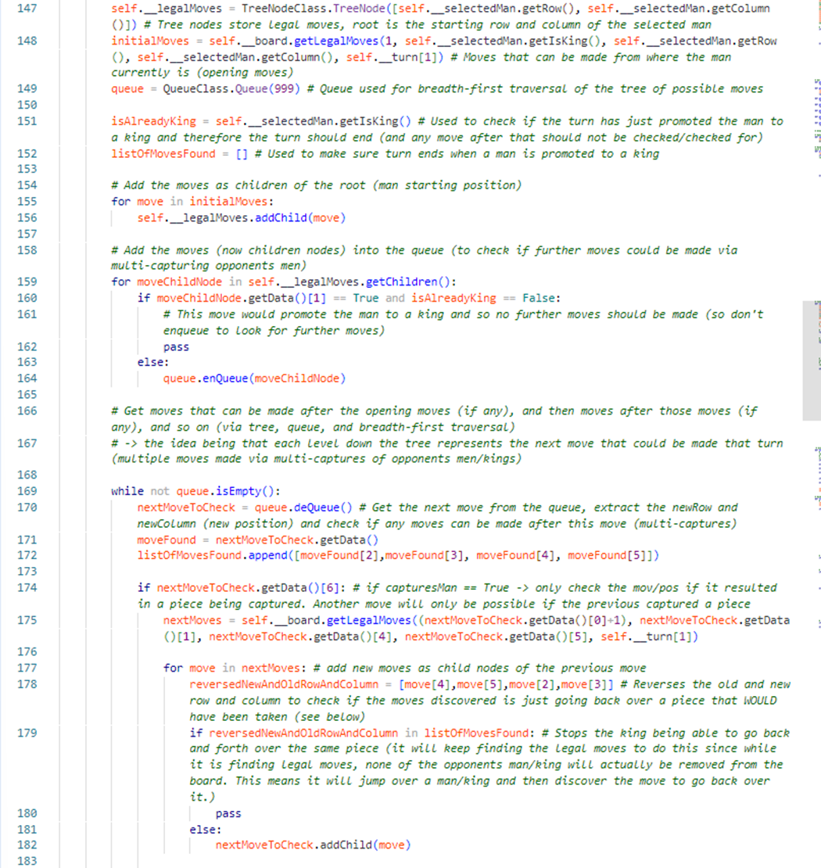

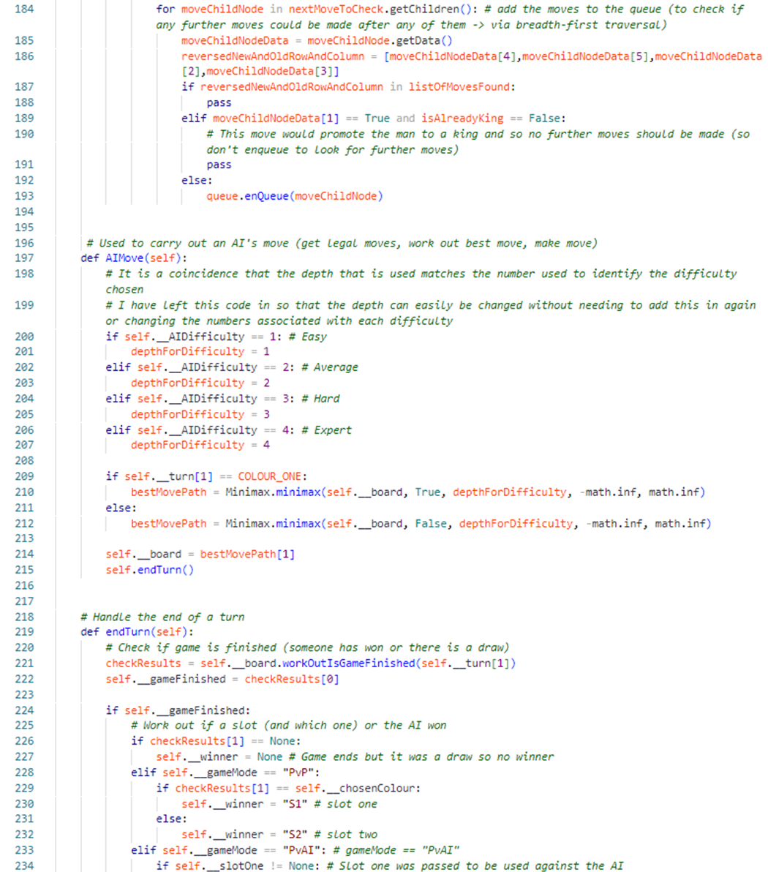

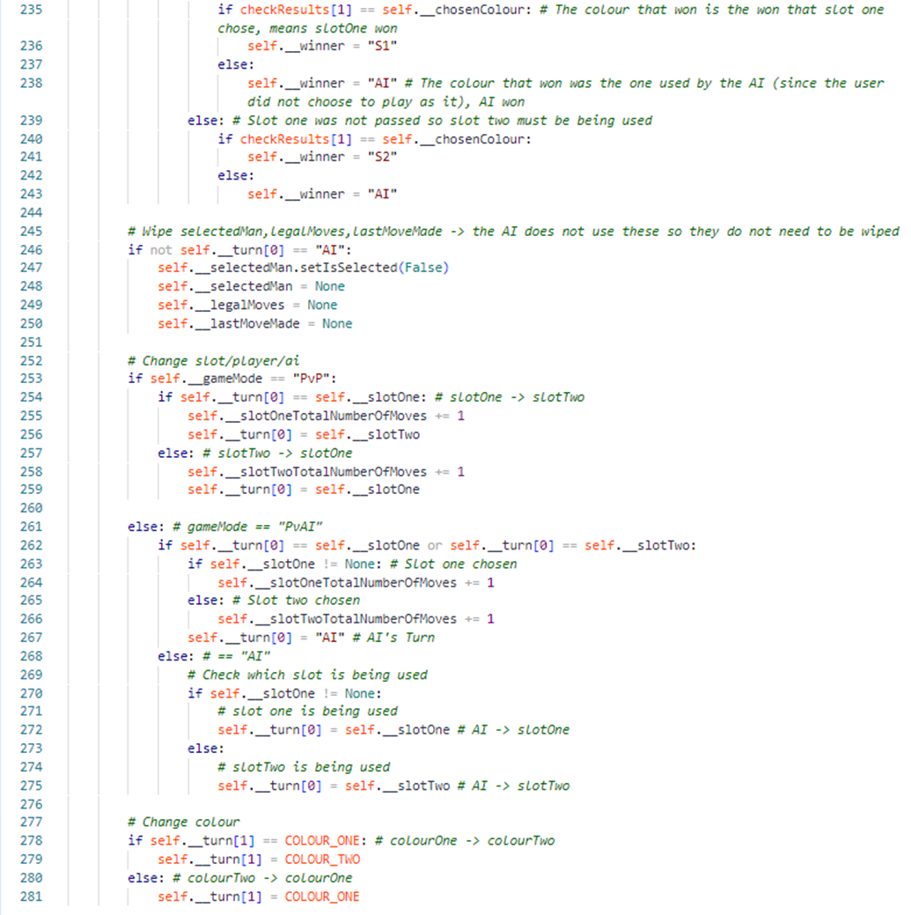

## Start-MainMenuWindow.py

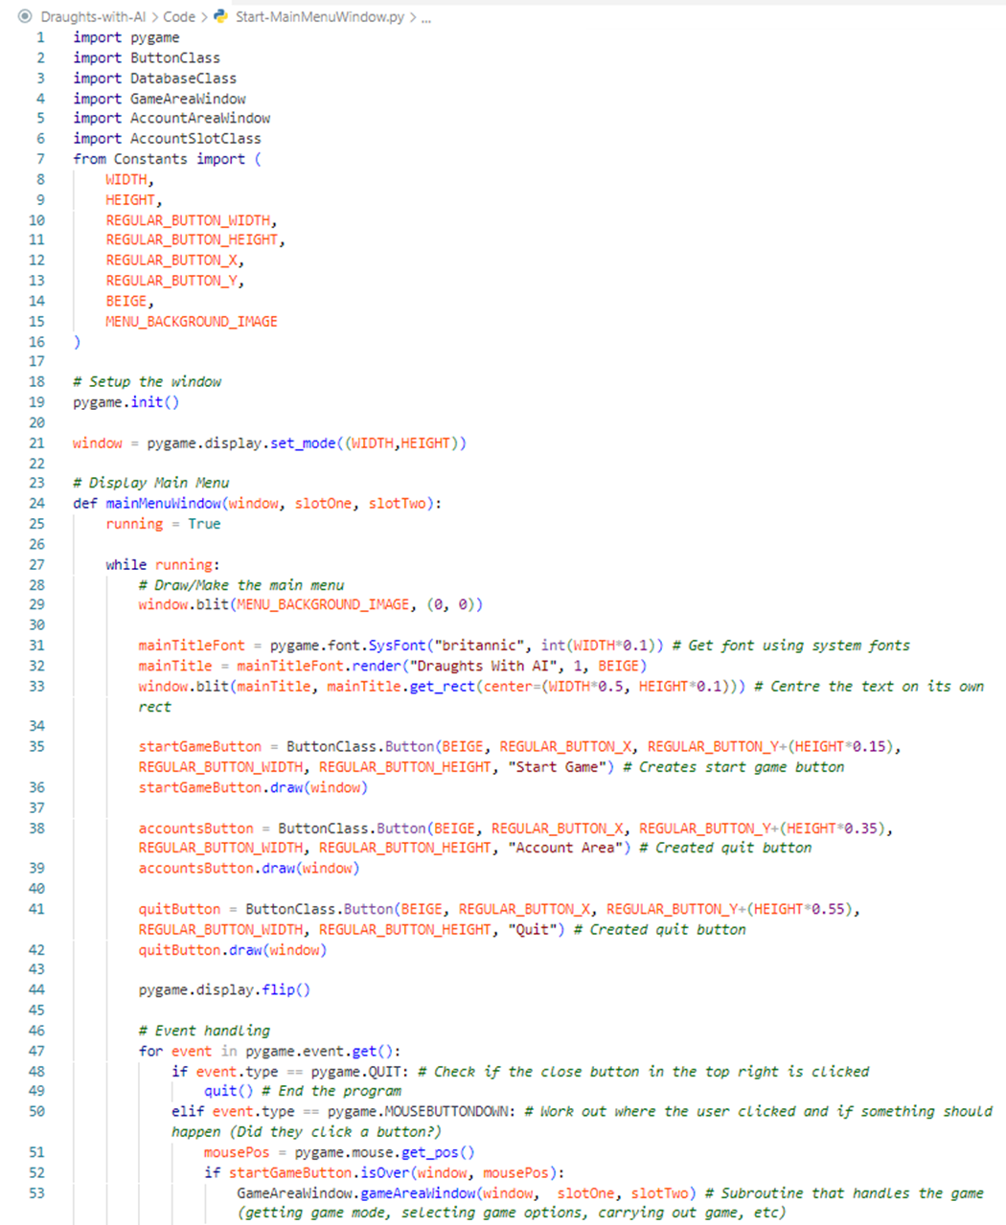

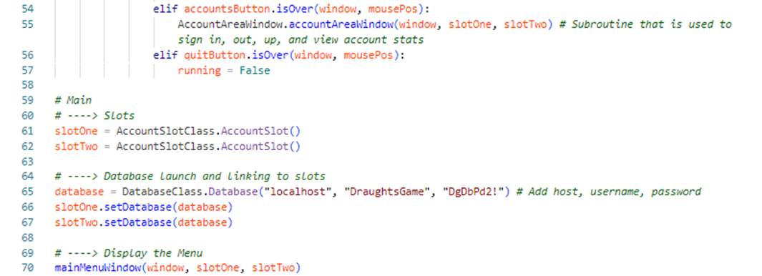

## AccountAreaWindow.py

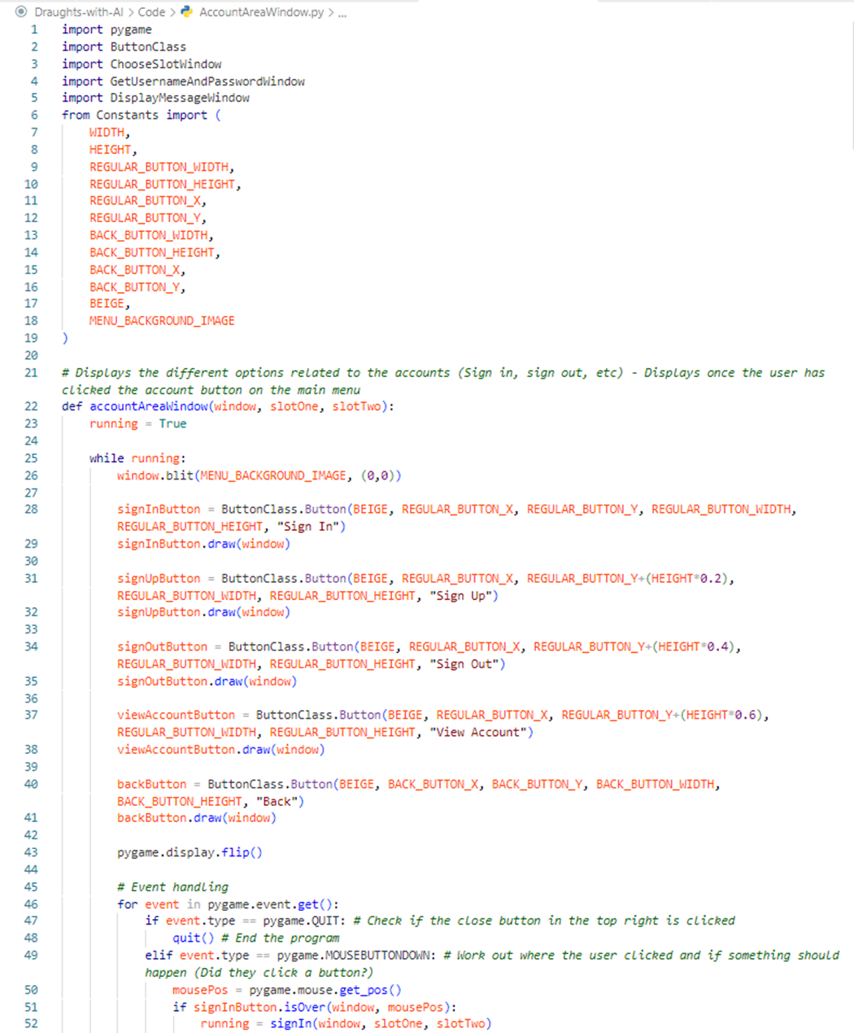

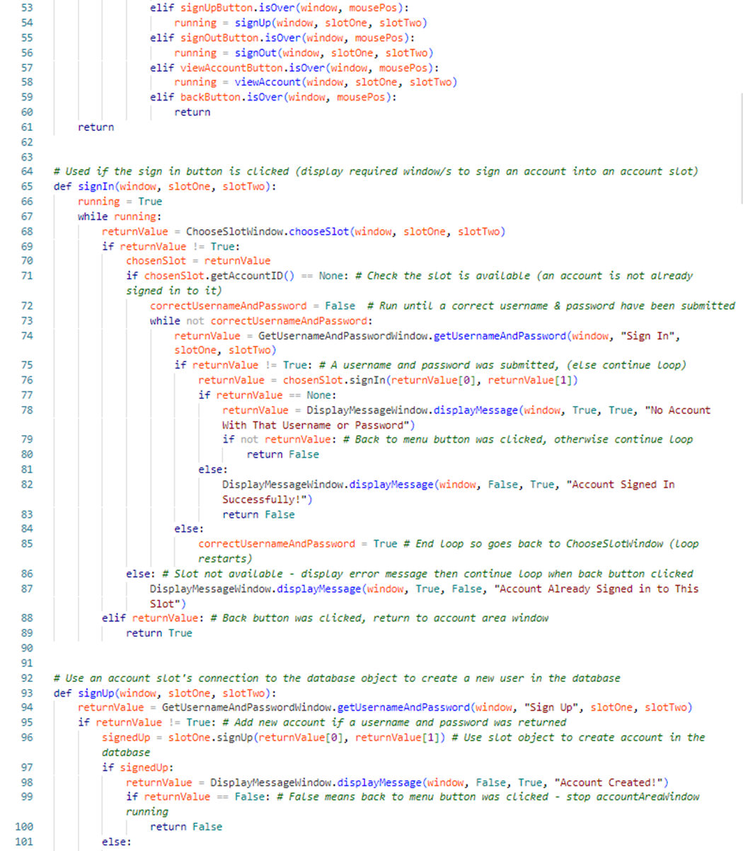

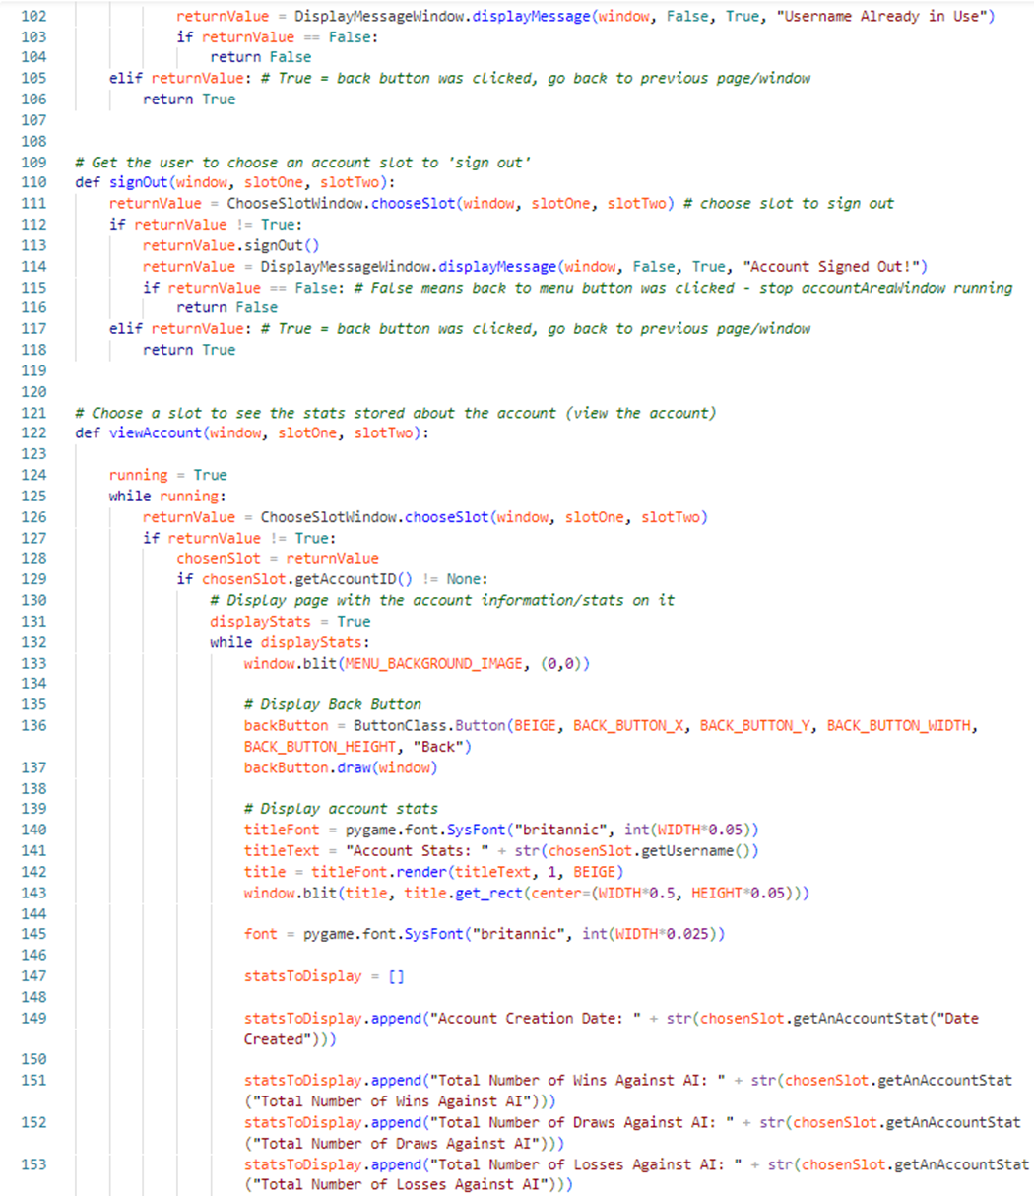

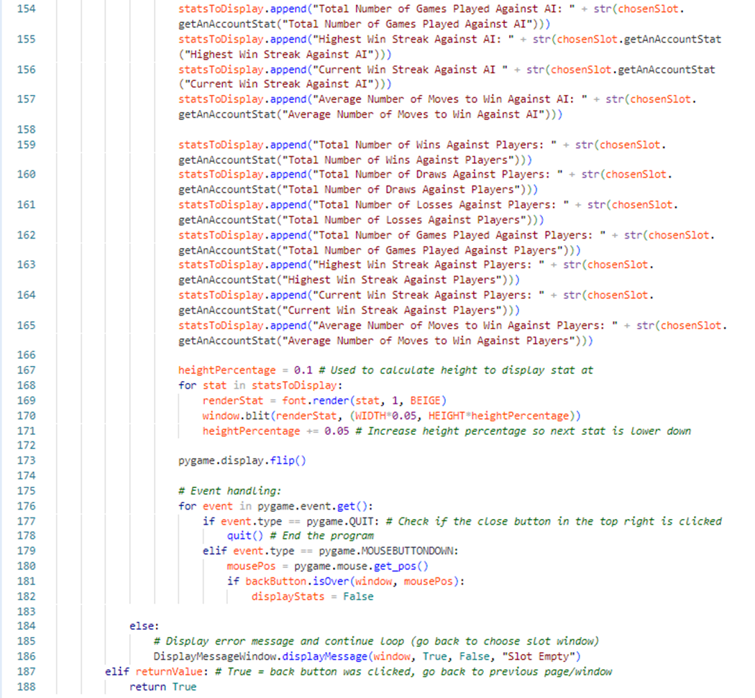

### ChooseSlotWindow.py

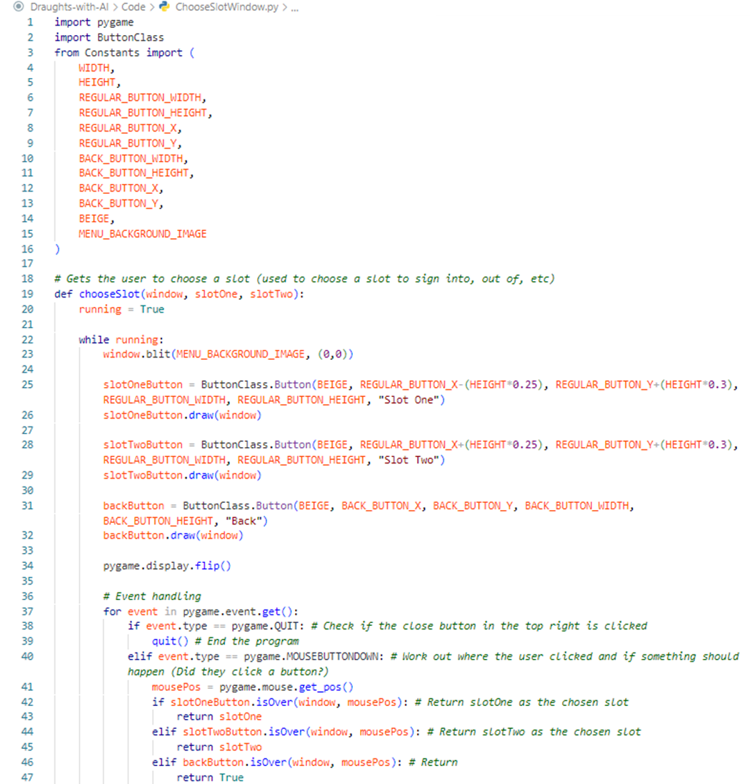

## GetUsernameAndPasswordWindow.py

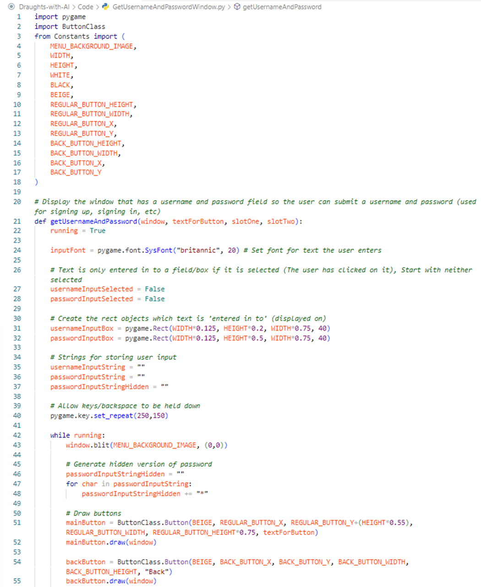

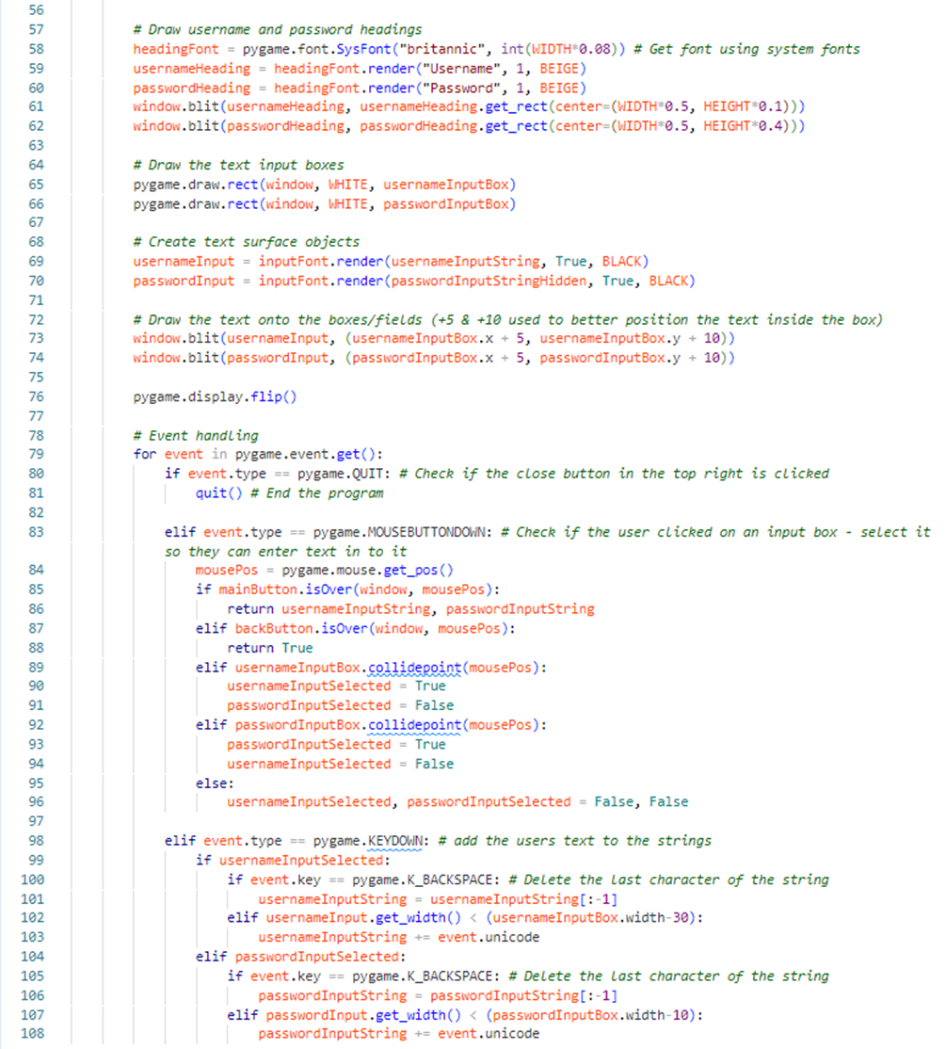

## DisplayMessageWindow.py

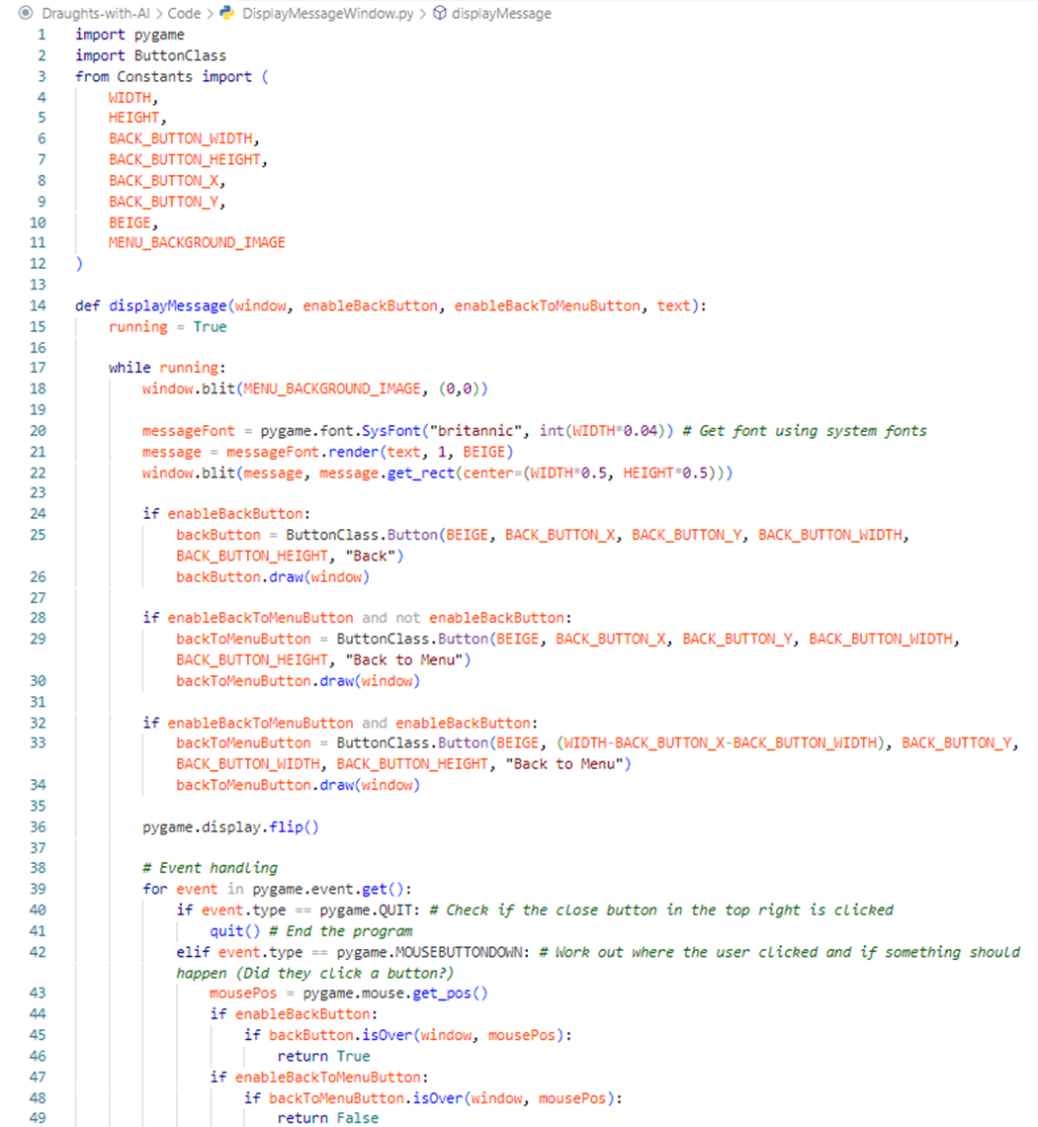

## GameAreaWindow.py

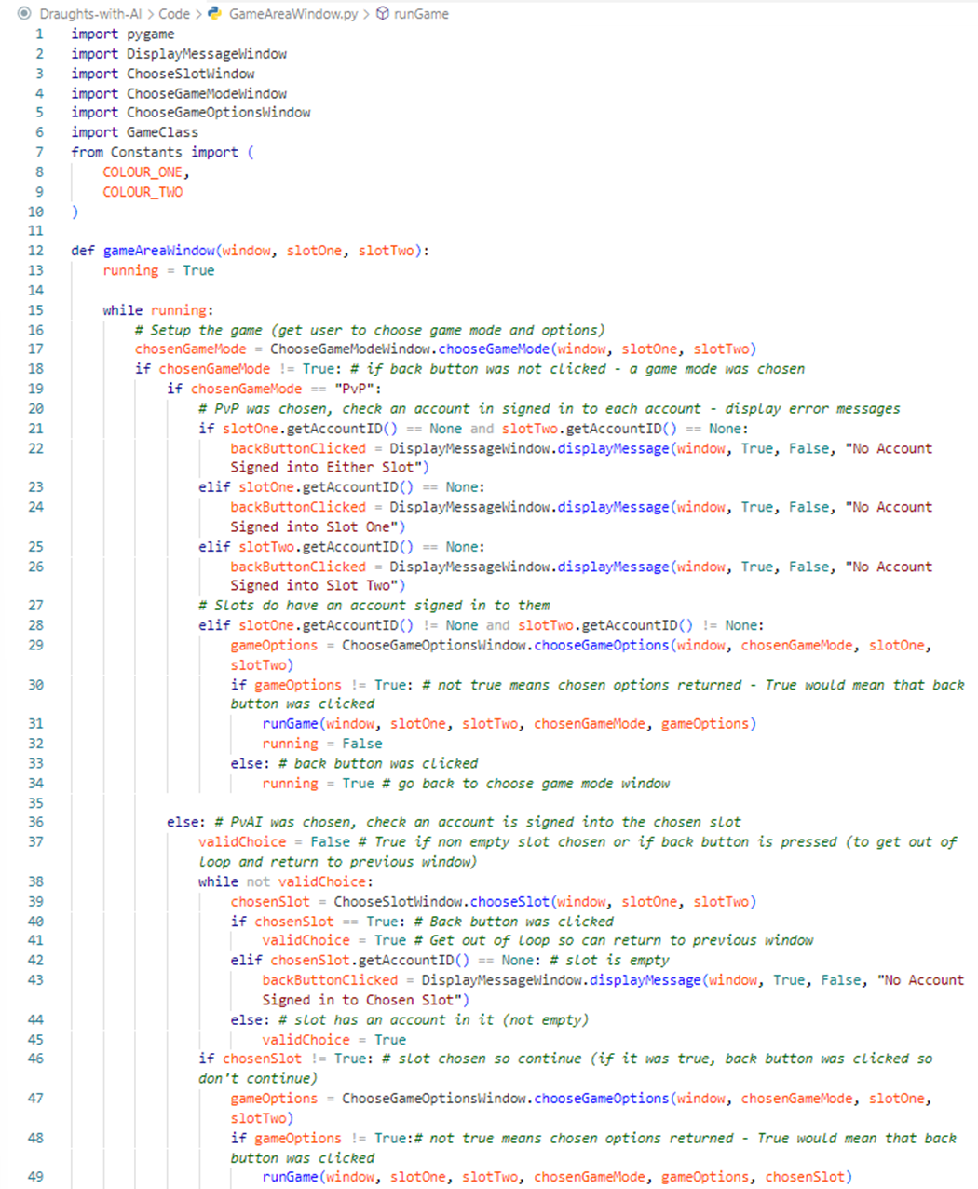

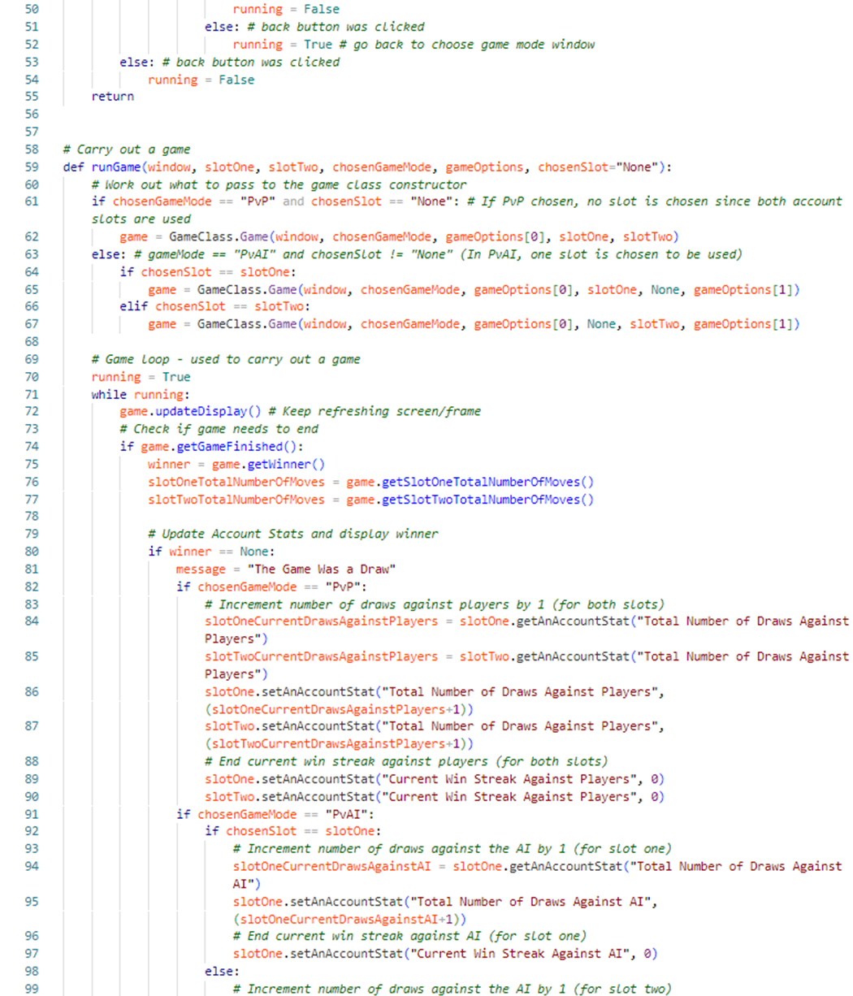

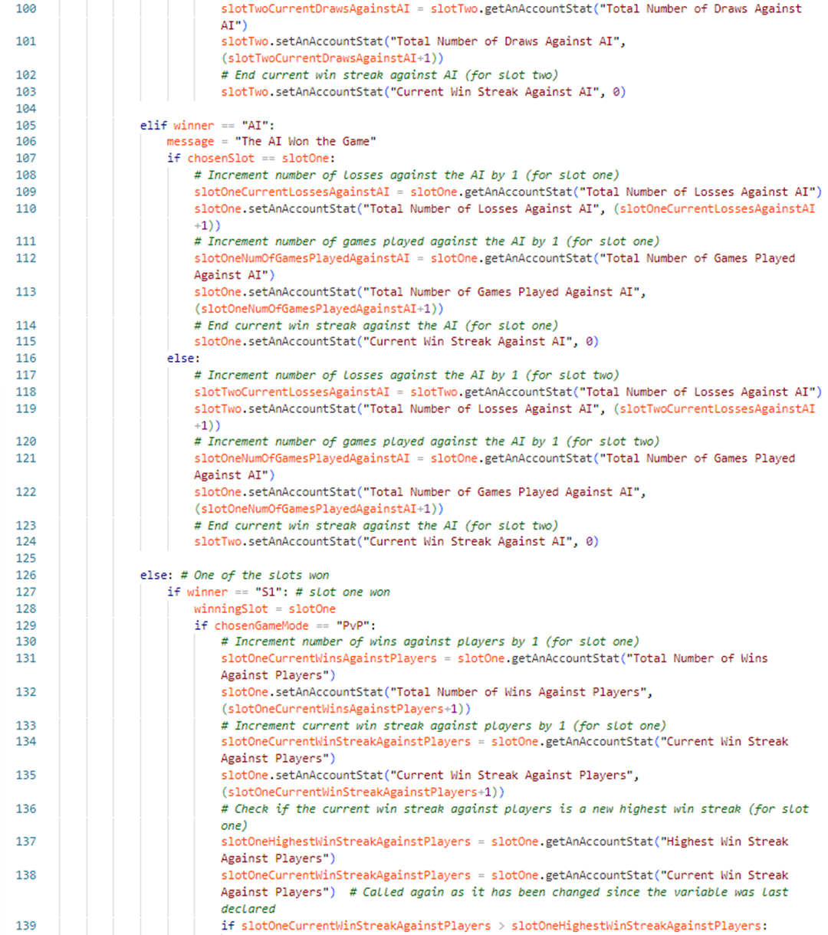

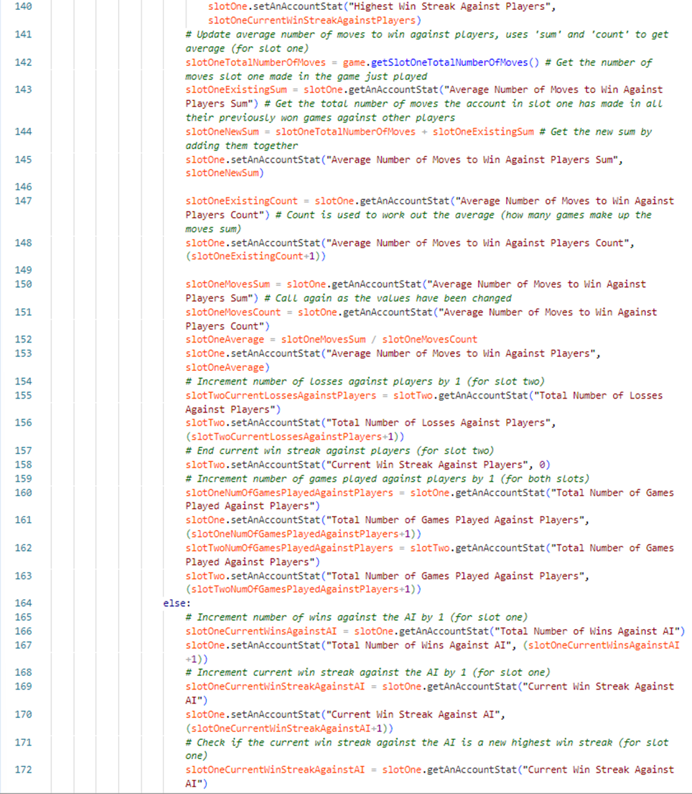

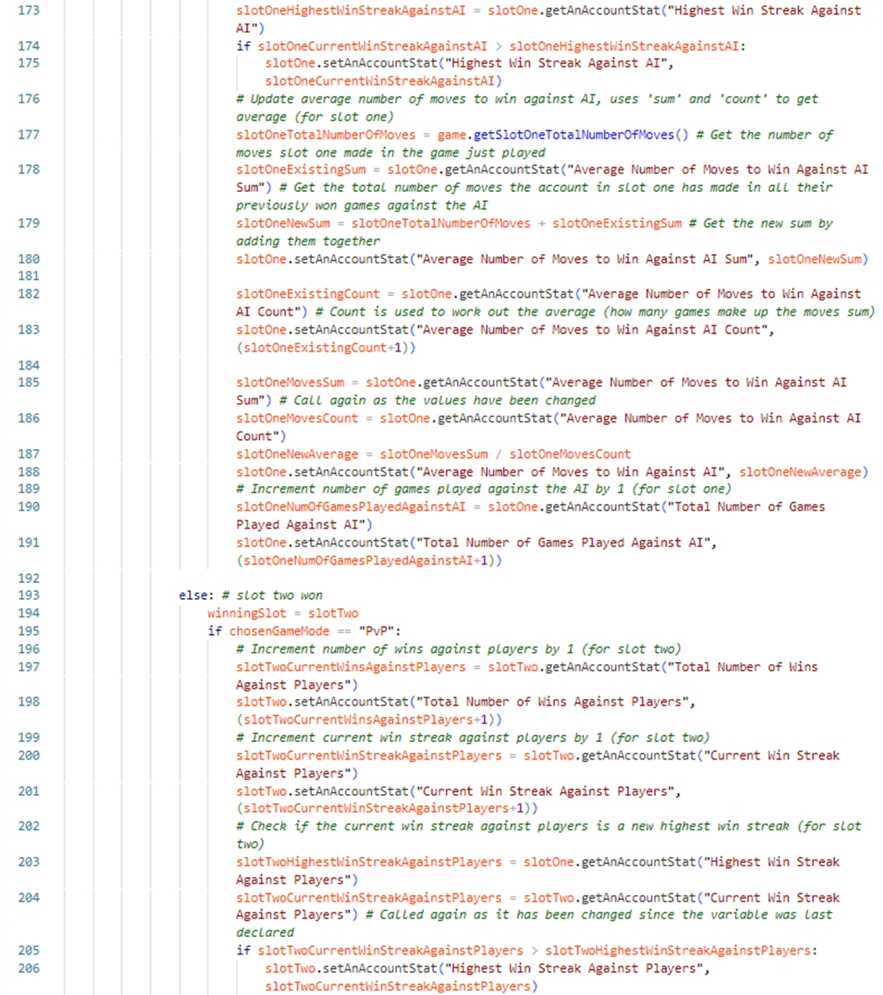

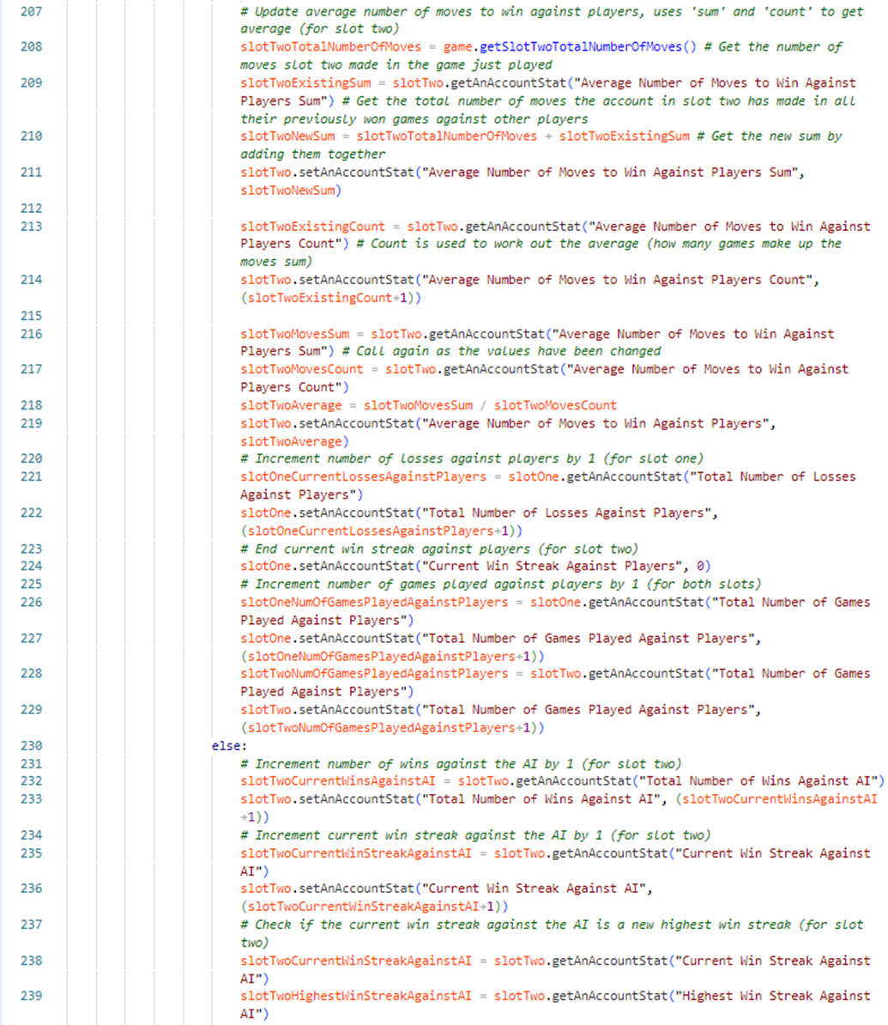

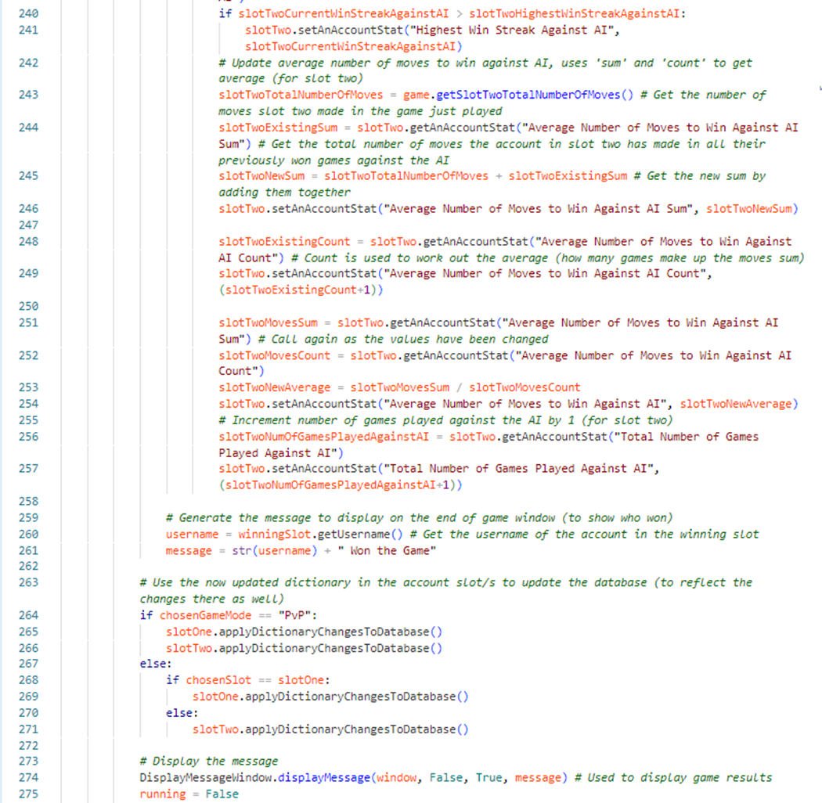

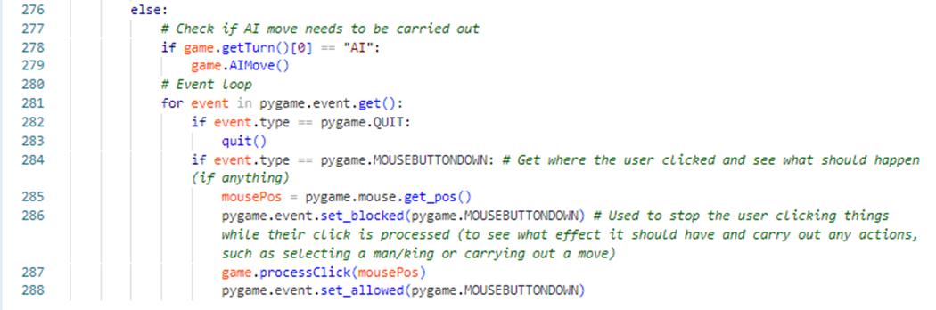

## ChooseGameModeWindow.py

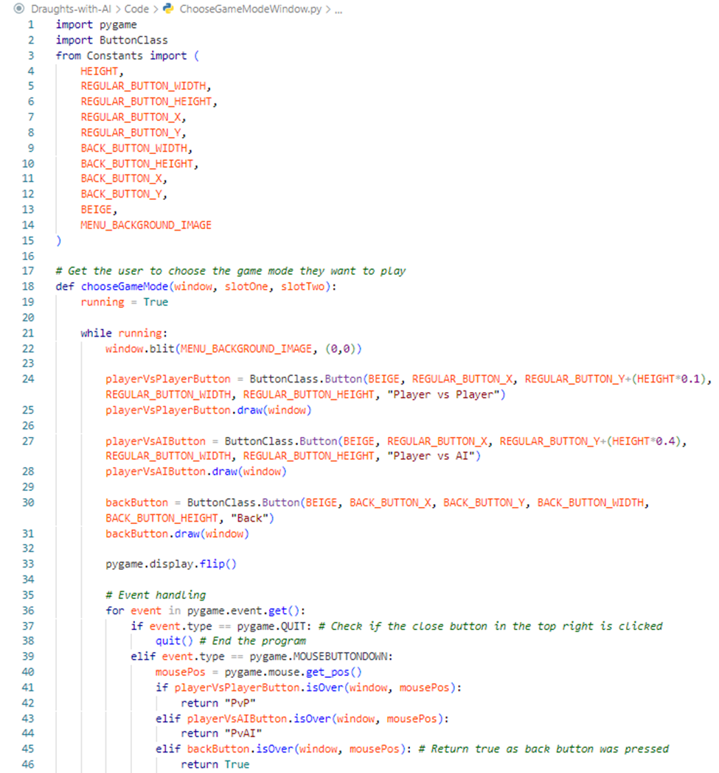

## ChooseGameOptionsWindow.py

